CAMM update

We got Sassena and NAMD to work on the local cluster Chadwick. We tested the installation with a search for the optimal water polarization in a LiCl aqueous solution and compare to the same study performed in Hopper supercomputer at NERSC. This is a molecular dynamics study. We also did a scaling study of the optimal number of cores for each code and found that using all the cores was best for NAMD. The scaling study jobs were submitted remotely from a Kepler workflow running on a workstation. The workflow submitted both codes, but Sassena was held by the batch queue until NAMD finished so the NAMD results could be copied into Sassena’s working directory.

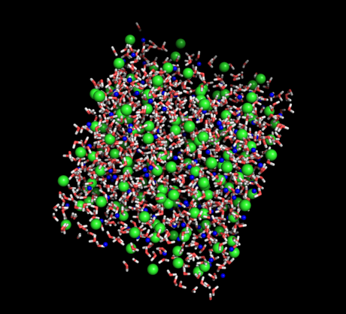

System: a 30Å x30Å x30Å box containing 1128 water molecules along with 154 Cl- and 154 Li+ ions

Comparison of experimental S(Q,E) to simulated S(Q,E) shows that some water polarization values (here inplemented though a positive charge at the hydrogen atoms and negative charge at the oxygen atoms) work better than others

|  |  |
| --- | --- |
| fit_q0.7.jpeg  Hydrogen charge=0.38e | fit_q0.7.jpeg  Hydrogen charge=0.47e |

A plot of the goodness of fit between experiment and simulated S(Q,E) versus partial hydrogen charge shows an optimal value close to 0.43e, which is slightly higher than the values of standard water models TIP3P and SPC/E. This is expected since the Li and Cl ions will polarize water.

In the plot, the black dots were computed with HOPPER@NERSC and the red circles were computed with CHADWICK@SNS.

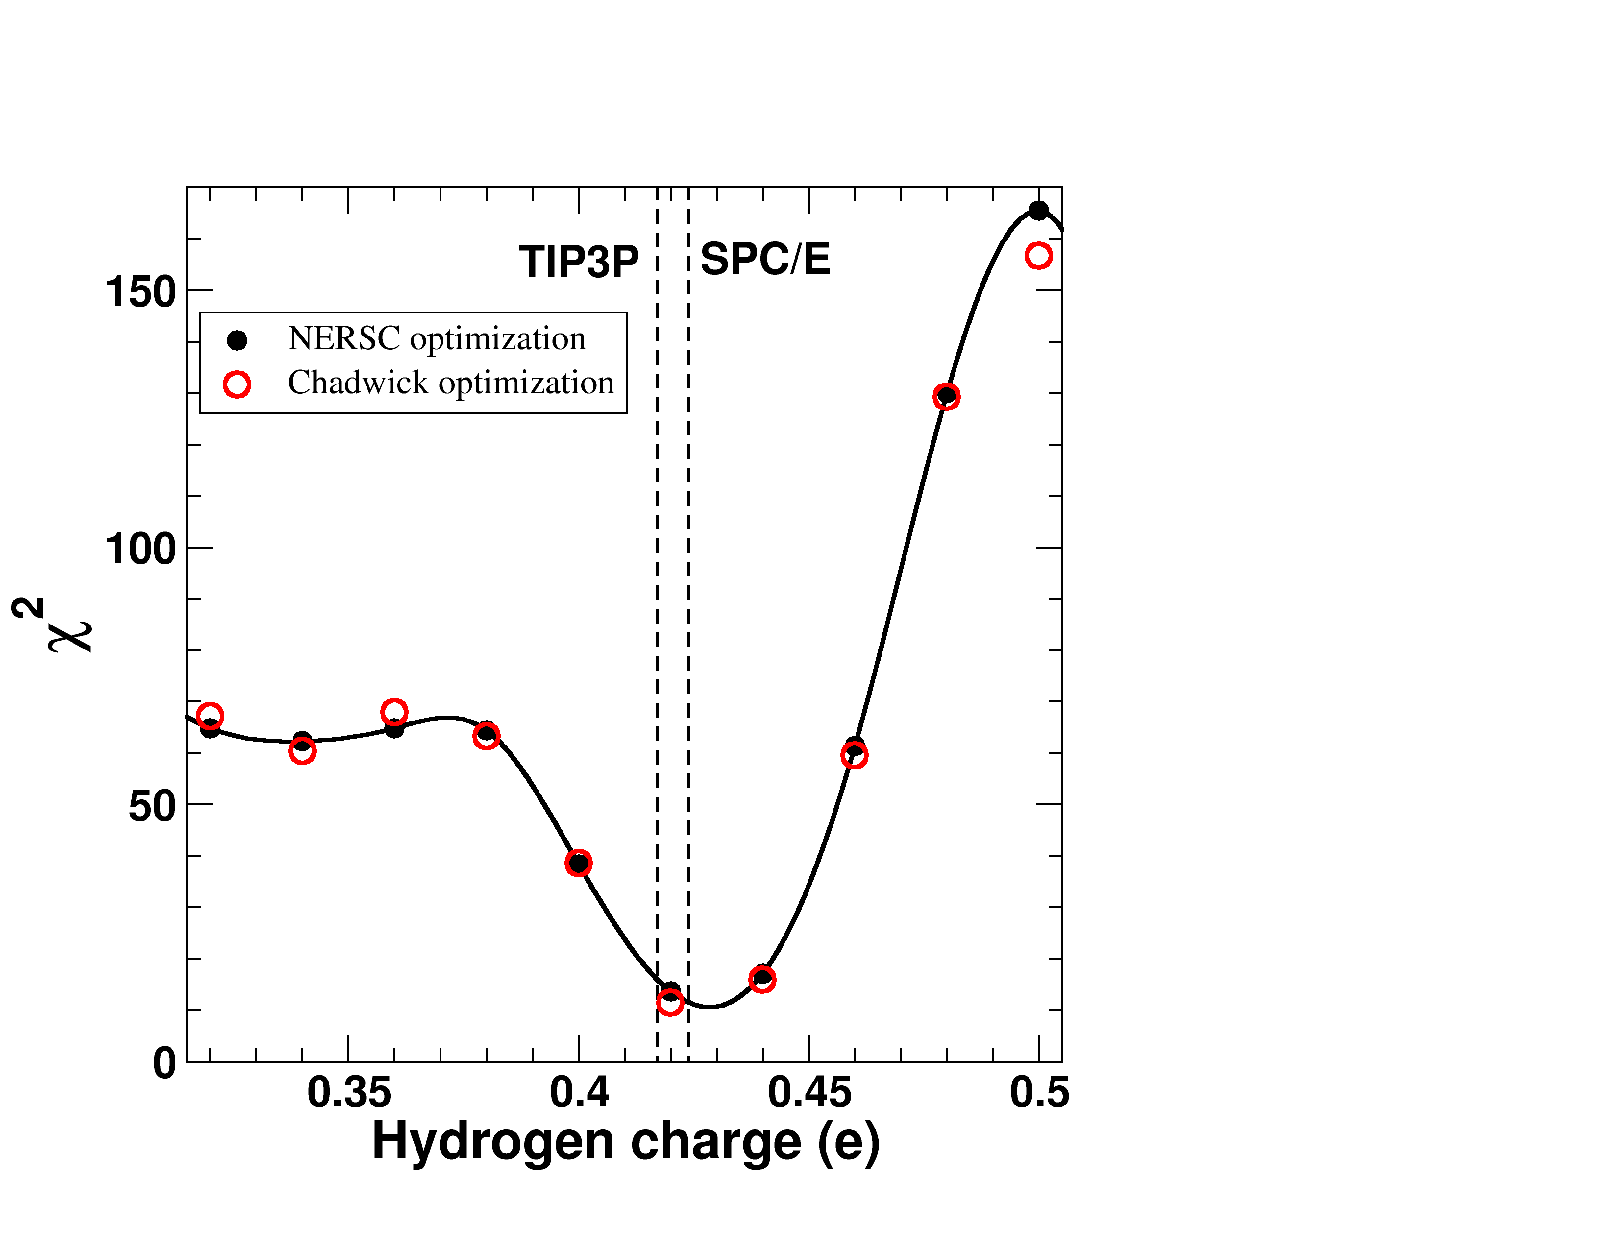

…so what? ;)

Concentrated LiCl solutions are a useful tool to study bulk water at low temperatures where water naturally freezes (typically below 220K). Nano-confined water does not free either, but does not allow study of bulk properties of water. However, the presence of LiCl will arguably alter the properties of water and one should not blindly use computational models that were developped under a very different set of conditions.

Data from quasi-elastic neutron experiments allows us to refined the water model so as to make the model able to provide complementary details to the experimental findings.