Car price prediction

To answer the questions of the car price prediction challenge, 6 different models were trained. From these **2 were chosen to be discussed in this report**. One is an XGB Regressor model (XGB)[1] based on trees, and the other is a Linear Regression model (LR)[2].

# Most important features

## XGB

The top 7 feature importances calculated based on gain are:

| **feature** | **importance** |
| --- | --- |
| model_key | 0.292450 |
| feature_7 | 0.136117 |
| age_in_months_when_sold | 0.118553 |
| feature_8 | 0.076528 |
| engine_power | 0.059833 |
| mileage | 0.049596 |
| model_initial | 0.041771 |

The features calculated based on SHAP values are:

According to both methods, the most important feature is model_key. Also, in the top 7 for both methods are age_in_months_when_sold, mileage, feature_8, and engine_power.

## LR

The largest regression coefficients, in absolute value, were:

| **feature** | **importance** |
| --- | --- |
| model_key_i8 | 41117.183922 |
| model_key_i3 | -23978.791365 |
| model_initial_i | 17138.392556 |
| model_key_M4 | 16772.597677 |
| model_key_650 | -16461.724894 |
| model_key_X1 | -12736.289962 |
| model_key_X6 M | 12098.244366 |

These are all indicator variables coming from model_key or model_initial (car model series). The values can be compared amongst themselves because they are on the same scale (0 or 1), but not to other features in different scales.

To measure how much impact each feature had on the model output, we can use SHAP:

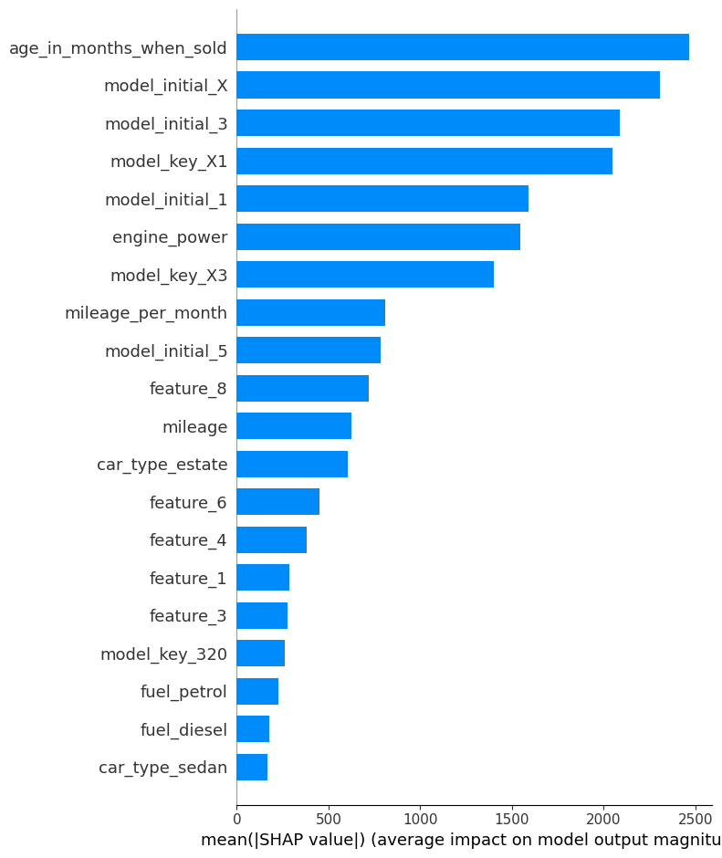

According to this, the most important feature was age_in_months_when_sold; and engine power also made it to the top 7.

NOTE: none of the coefficients were individually significant, but together they were (the p-value for the F-test was 1e-16).

# Change in estimated value over time

## Change by feature

### Descriptive (no model)

The following insights were found after exploring the data.

* Except for feature_7, **cars with True in the other car features have in average higher prices than cars without them**. This suggests that these features will be important for predictive models.
* There seems to be a peak average price in Aug 2018. This was caused by a **sale of a highly priced car precisely in August**.
* **Hybrid and electrical cars are more expensive on average**.

### XGB

The model captures the data well and produces very similar insights. Note how it seems to overestimate extreme values (Aug).

### LR

The model captures the data well and produces very similar insights. Note how it seems to underestimate extreme values (Aug).

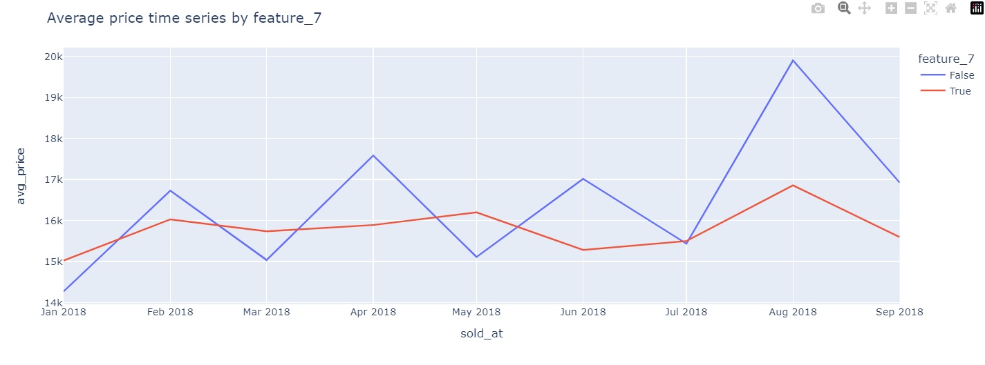

## Seasonal patterns

### Descriptive (no model)

* **Electrical cars average prices were stable** from winter to summer and were not sold in autumn.
* **Diesel and petrol cars had similar average prices**, although petrol cars had a drop in average prices starting summer 2018.
* **The most expensive car type is, on average, SUV,** although coupe was the most expensive at the start of the year and then dropped below SUV also starting in summer.
* **Coupe and convertible cars were, on average, more expensive in winter than in summer**.
* **Vans were more expensive, on average, in spring, summer, and autumn, than in winter.**
* Subcompact had generally the lowest average prices.
* Paint color does not seem to generally determine or be associated with the average price, except for **color green, which consistently had prices much lower than other colors**. Maybe it is not very popular.
* **Orange and white cars were sold for more, on average, during summer** than during winter and spring.
* **Red cars were the opposite,** with lower average prices during summer than during winter and spring.

### XGB

The model captures the data well and produces very similar insights.

In addition, t-tests for the difference of means were performed to find if there were significant differences between the average estimated prices during summer and winter for different categorical features values. Below are the cases where the tests found significant differences (alpha=0.05).

|  |  |  |  |
| --- | --- | --- | --- |
| **feature** | **feature_value** | **t_stat** | **p_val** |
| car_type | sedan | 4.321558 | 0.000018 |
| car_type | coupe | 3.560600 | 0.000936 |
| car_type | estate | 2.881445 | 0.004071 |
| car_type | van | -2.601545 | 0.018620 |
| paint_color | white | -2.311843 | 0.021562 |

### LR

The model captures the data well and produces very similar insights.

In addition, t-tests for the difference of means were performed to find if there were significant differences between the average estimated prices during summer and winter for different categorical features values. Below are the cases where the tests found significant differences (alpha=0.05).

|  |  |  |  |
| --- | --- | --- | --- |
| **feature** | **feature_value** | **t_stat** | **p_val** |
| car_type | sedan | 4.295961 | 0.000021 |
| car_type | coupe | 2.675371 | 0.010595 |
| paint_color | white | -2.559119 | 0.011056 |
| car_type | estate | 1.999919 | 0.045869 |

# What car to buy to minimize loss after 1 year

To answer this question the models were used to predict the price of cars today and 1 year after. It was decided to **set today to March 2024** (time of presenting these results), **but also as a month after the last action, as data today is already more than 5 years old**.

As the results show, **it is preferable to choose the linear model to answer this question**, because it better captures the general fact that as time passes cars’ prices decrease.

In summary, **models of the series X were found to be good candidates** for buying, according to the models. Using the LR model, **a diesel fuel BWM X5 with an average mileage per month of 30.6** was found to be the best option to buy as of March 2024.

NOTE: When changing the date of buying and selling, the features age_in_months_when_sold and mileage were changed accordingly. Mileage was updated using the mileage_per_month calculated based on the mileage and age from the original data set. Other time dependent variables like month_sold_at and season_sold_at were only updated for the XGB model, where they showed some importance.

## XGB

### Today is March 2024

The car, in the original dataset, with the lowest loss was:

maker_key BMW

model_key M3

mileage 29925

engine_power 309

registration_date 2012-09-01 00:00:00

fuel petrol

paint_color silver

car_type coupe

feature_1 True

feature_2 True

feature_3 False

feature_4 False

feature_5 True

feature_6 True

feature_7 True

feature_8 True

price 47000

sold_at 2018-04-01 00:00:00

age_in_months_when_sold 67

month_sold_at 4

season_sold_at spring

model_initial M

mileage_per_month 446.641791

The calculated loss based on predictions was -184.783203. It is expected that the real loss won’t be negative, but relatively low.

Between the candidates with low calculated loss values (less than 2,000) these many cars by model_key were found:

X4 13

X6 3

M3 3

640 Gran Coupé 3

X5 M 2

The **predicted prices as well as the SHAP values** for the predictions are shown in the plots below.

Prediction today:

Prediction 1 year later:

### “Today” is a month after last auction

The car, in the original dataset, with the lowest loss was:

maker_key BMW

model_key X3

mileage 46409

engine_power 135

registration_date 2014-04-01 00:00:00

fuel diesel

paint_color silver

car_type suv

feature_1 True

feature_2 True

feature_3 False

feature_4 False

feature_5 False

feature_6 False

feature_7 False

feature_8 True

price 22800

sold_at 2018-05-01 00:00:00

age_in_months_when_sold 49

month_sold_at 5

season_sold_at spring

model_initial X

mileage_per_month 947.122449

The calculated loss based on predictions was -15594.402344. This result **does not make sense in the context of the question**.

Between the candidates with low calculated loss values (less than 2,000) these many cars by model_key were found:

X3 34

X4 27

420 23

520 23

420 Gran Coupé 19

The **predicted prices as well as the SHAP values** for the predictions are shown in the plots below.

Prediction today:

Prediction 1 year later:

## LR

### Today is March 2024

The car, in the original dataset, with the lowest loss was:

maker_key BMW

model_key X5

mileage 612

engine_power 183

registration_date 2016-10-01

fuel diesel

paint_color black

car_type suv

feature_1 True

feature_2 True

feature_3 False

feature_4 False

feature_5 False

feature_6 False

feature_7 True

feature_8 True

price 49100

sold_at 2018-06-01

age_in_months_when_sold 20

month_sold_at 6

season_sold_at summer

model_initial X

mileage_per_month 30.6

The calculated loss based on predictions was 1508.460034.

Between the candidates with low calculated loss values (less than 2,000) these many cars by model_key were found:

X5 114

X4 35

X6 30

740 15

X5 M 15

The **predicted prices as well as the SHAP values** for the predictions are shown in the plots below.

Prediction today:

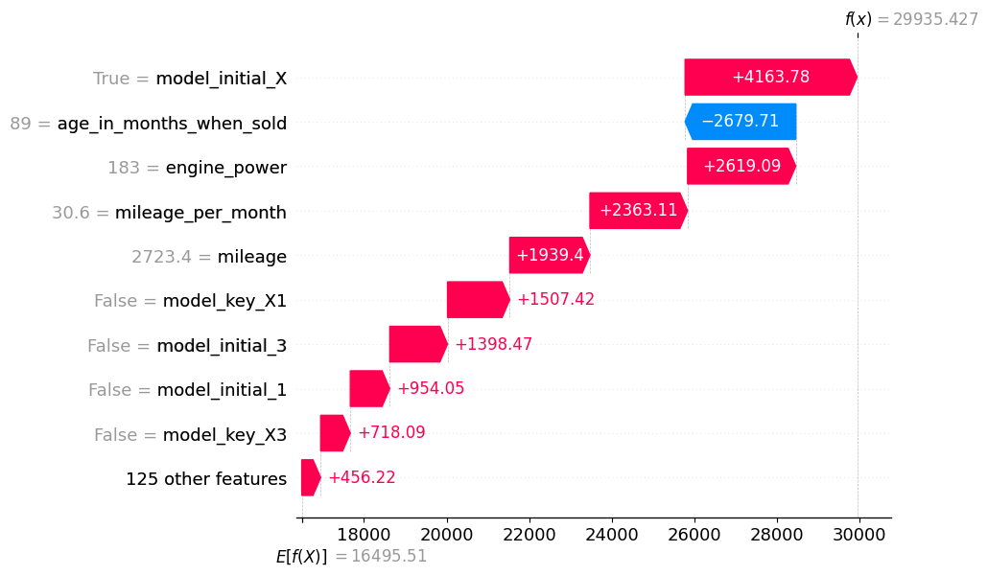

Prediction 1 year later:

### “Today” is a month after last auction

The car, in the original dataset, with the lowest loss was:

maker_key BMW

model_key 420 Gran Coupé

mileage 476

engine_power 120

registration_date 2014-05-01

fuel diesel

paint_color blue

car_type hatchback

feature_1 True

feature_2 True

feature_3 False

feature_4 False

feature_5 False

feature_6 True

feature_7 True

feature_8 True

price 30300

sold_at 2018-08-01

age_in_months_when_sold 51

month_sold_at 8

season_sold_at summer

model_initial 4

mileage_per_month 9.333333

The calculated loss based on predictions was 1504.906043.

Between the candidates with low calculated loss values (less than 2,000) these many cars by model_key were found:

X5 182

X3 106

530 59

520 47

X6 40

The **predicted prices as well as the SHAP values** for the predictions are shown in the plots below.

Prediction today:

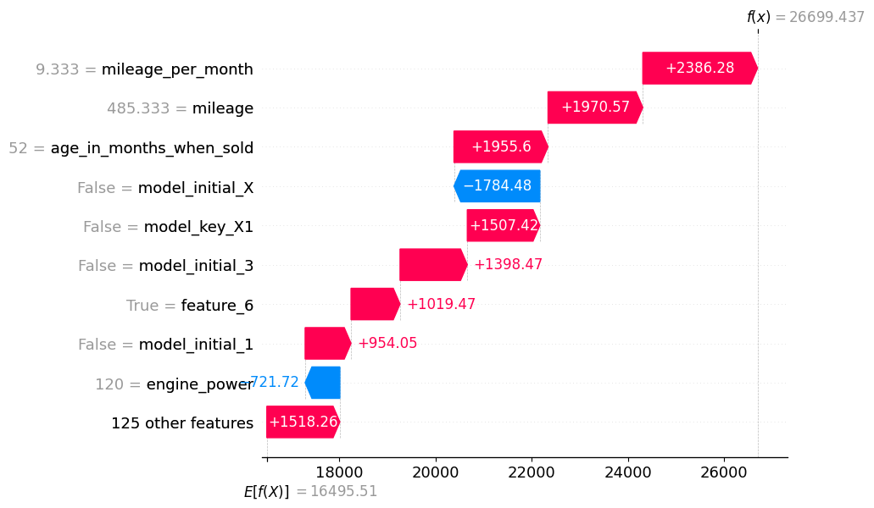

Prediction 1 year later:

# Out of sample metrics for the model

The models were initially trained on 80% of the data and tested on 20% of the data. The data split was random.

## XGB

The train metrics for the model were:

Train MSE: 7223111.16

Train RMSE: 2687.58

Train MAE: 1524.56

Train R2: 0.92

The test metrics for the model were:

Test MSE: 8705488.27

Test RMSE: 2950.51

Test MAE: 1914.02

Test R2: 0.87

## LR

The train metrics for the model were:

Train MSE: 22040928.92

Train RMSE: 4694.78

Train MAE: 2355.72

Train R2: 0.75

The test metrics for the model were:

Test MSE: 11259962.94

Test RMSE: 3355.59

Test MAE: 2273.41

Test R2: 0.83

# Additional insights

## Data quality

There are no null values in the data.

There are no infinite values in the data.

There are no duplicates.

From the number of unique features values we can observe that:

- **There is only one maker (BWM).** So, this feature will not give information to the models.

- There are 199 different registration dates.

- feature_1 to feature_8 are binary variables.

- The auction happened on 9 different dates.

Looking at the description of numerical features, hints that there are possibly erroneous observations. For example:

- **a car with -64 miles**,

- **a car with 0 (I assume hp) engine power**,

- **and a car that cost 100 (I assume USD).**

Therefore, data needs some further cleaning.

There is a 640 Gran Coupé with negative mileage which is not possible. Also, there are other 18 cars of the same model key, so this row will be removed.

This is a 13-year-old car (159 months) with more than a million miles. Although strange, it is not impossible that it has driven this many miles (about 210 on average daily). So, this observation is not recommended to be removed.

**There is a wrong observation with 0 engine power for an X1 which is a SUV**. This is impossible. Since there are more than 200 other X1 this observation can be removed.

**Very likely the engine power of 25 (hp) for two i3 is wrong.** These cars should have 75 (hp) engine power, so this is probably a typo. Since there are very few other i3 cars, data imputation might be a better alternative here to dropping the records. According to most values, a good candidate value for imputation is 75.

Regarding models 316 and 318, since there are more than 200 hundred other observations with the same model, and these cars typically have at least 75 of engine power, these records can also be deleted.

**There were 62 cars sold at less than 1,000 which is very unusual**. Looking at a description of the numerical features of these cars we find:

- The newest car sold at this price was less than 3 years old. This seems unusual.

- The oldest car was 24 years old.

- Minimum and max mileage seem sensible.

**Prices below 800 seem more unusual** and might correspond to cars with important damages. Since cars with engine damage were removed before, these other cars with important damages could be removed as well and maybe priced with another strategy.

## Data distribution (after cleaning)

The features still have very high values after removing the data that probably had errors.

Examples are:

- **1M miles drove**. This can be rare but possible for old cars.

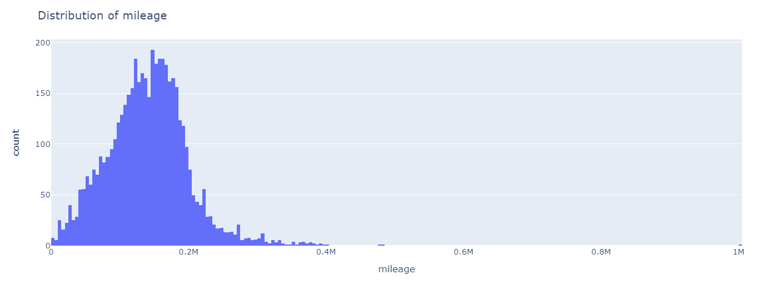

- **A few cars cost more than 100k**, which is also possible depending on the car.

- There are **some cars with engine power above 400**, which can happen for sports cars.

- There are **cars as old as 22 years**, which is also possible.

These values do not suggest that further data cleaning is needed.

## Numerical features vs. price

Based on the scatter plots, the following observations can be made:

- As expected, prices tend to decrease with mileage.

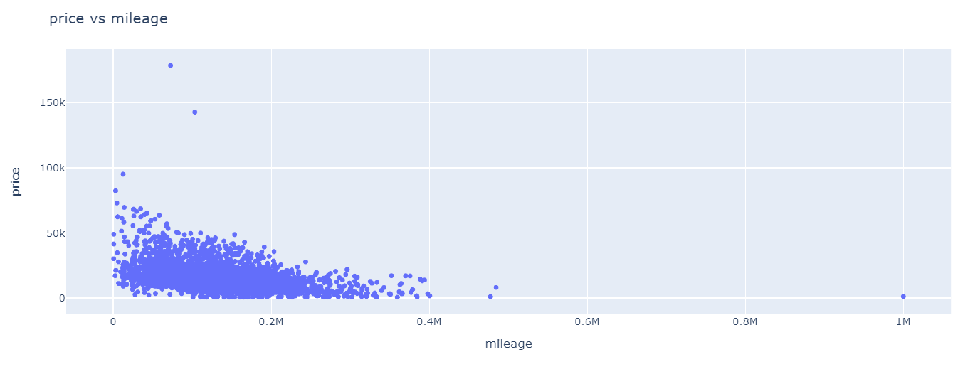

- As expected, prices tend to increase with engine power.

- As expected, prices tend to decrease with age.

## Improvements

In the context of the problem of finding the best car to buy, it can be a good idea to retrain a model after removing cars with prices over 50k, since recommendations are for cars with prices (as recorded in the data) between 20k and 50k. This can help models achieve lower MAE.

Also, if predictions were to be made as of March 2024, more recent data is needed.

1. Comes from notebook 04_xgb_trees_model_tuned.ipynb in the project’s code.
2. Comes from notebook 08_linear_model.ipynb in the project’s code.