When More Omics Is Not Always Better: Drug- and Dataset-Conditional Value of Multimodal Cancer Pharmacogenomics
Carlos Victor Montefusco-Pereira
Affiliation 1: Independent Researcher in Data Science and AI for Pharmaceutical Industry
Affiliation 2: Member of Brazil-Africa Group for Scientific Research and Writing (GPEC), Portuguese-Speaking African Countries (PALOPs)
Corresponding information: Friedrich-Wilhelm 28, 12103 Berlin, Germany; cmontefusco@gmail.com

Article type: Research article
Declarations: No external funding. The author declares no competing interests. Ethics approval is not applicable because the study uses publicly available, de-identified cell-line and molecular datasets and involves no human participants, patient intervention, or animal experimentation. CRediT: Carlos Victor Montefusco-Pereira-Conceptualization, Methodology, Software, Validation, Formal analysis, Investigation, Data curation, Writing, Visualization, and Project administration. Generative AI tools assisted with language editing, document formatting, and coding under author review; the author verified the final content. DepMap/GDSC/CTD² files were obtained under the provider’s applicable terms; raw provider files are not redistributed.

Abstract
Does adding more molecular data really improve cancer drug-response prediction? I tested this question using expression, copy-number, and damaging-mutation data from GDSC1, GDSC2, and CTD² across 15 compounds. I compared an expression-only Ridge model with a model that combined all three modalities. Feature selection, missing-value handling, and scaling were performed separately inside each training fold. In five grouped drug-held-out splits, the combined model had a mean RMSE of 0.2322 versus 0.2328 for expression alone, a difference of −0.0006. Fusion performed better in four splits and worse in one. However, fusion was less favorable in all three leave-one-dataset-out tests. Modality availability also differed across datasets, with copy-number data less consistently available than expression or mutation data. The practical conclusion is simple: additional assays should not be added automatically. They are worth retaining when their benefit is reproducible in the intended population, the data are available, and the gain remains after external validation. This study does not support arbitrary new-drug prediction, clinical treatment selection, or causal biological claims.
Keywords: information fusion; drug response; multi-omics; cancer; missing data; cross-study validation

1. Introduction
Cancer pharmacogenomics increasingly combines multiple molecular assays to predict drug response [1,2,3,14,15,16,17]. More measurements can capture complementary biology, but they also increase dimensionality, missingness, and sensitivity to study-specific measurement processes [6,14,18]. I therefore specified a workflow that treats incremental predictive value, missingness, and modality conflict as joint evaluation targets.
Drug response is a heterogeneous phenotype shaped by lineage, genomic alterations, transcriptional state, assay conditions, and drug-specific mechanisms. The Cancer Cell Line Encyclopedia established a large-scale link between cancer cell-line molecular profiles and pharmacologic sensitivity [1]. The Genomics of Drug Sensitivity in Cancer subsequently provided a broad pharmacogenomic map across drugs and cell lines, showing that response associations are distributed across tissue context and molecular features rather than being reducible to a single biomarker class [2]. DepMap and related resources further consolidated molecular and functional measurements for systematic cancer-model analysis [3]. These resources made computational response prediction possible, but they also made the data-integration problem more visible: assays are not uniformly measured across all models, and response data are generated under source-specific experimental protocols.
For pharmaceutical research, the relevant endpoint is not only predictive accuracy but whether a model can support transparent prioritization of compounds, biomarkers, and follow-up experiments [14-17]. A model that performs reliably across a declared validation target may help rank candidate molecular contexts for early discovery studies; however, cell-line prediction alone does not establish clinical utility, prospective benefit, or suitability for dosing decisions [16,18]. These boundaries motivate an evaluation that reports transfer failures and data-availability constraints alongside average error metrics [14,15].
The specific unresolved issue is whether mutation and copy-number measurements provide reproducible incremental value after an expression-only baseline has already captured lineage and transcriptional state. Multimodal studies such as MOLI have shown that combining expression, copy-number, and mutation information can improve prediction under particular model architectures and evaluation settings [5]. Other biologically structured or deep-learning approaches likewise use multiple molecular blocks and, in some cases, drug representations [8-10]. These studies establish the plausibility of complementary signal, but they do not imply that the incremental contribution of each assay is stable across response resources. Comparisons are difficult because studies differ in feature budgets, learners, response definitions, split units, and whether validation is within-source or external. In particular, a modest gain in a cell-line random split does not establish that the gain persists when drugs or an entire response dataset are held out. The present study addresses this narrower gap by comparing expression-only and concatenated expression-copy-number-mutation models under the same fixed learner, fold-local preprocessing, grouped drug-held-out validation, and source-held-out transfer.
The literature contains several complementary modeling strategies. Expression-only models have often been competitive because transcriptomic state captures pathway activity and lineage context, whereas mutation and copy-number features can provide sparse but mechanistically informative signals. Multimodal models combine these signals through early concatenation, late integration, multitask learning, or biologically structured architectures. MOLI, for example, integrates expression, copy-number, and mutation information through modality-specific encoders and reported gains in external validation [5]. DrugCell uses a biologically structured neural network and drug representations to model response and synergy [8], while other deep-learning frameworks have reported strong performance in cell-line settings and more variable transfer to clinical or external cohorts [9,10]. These results motivate multimodal integration, but they do not imply that adding an assay is beneficial under every population, response definition, or validation design.
The practical question is therefore not whether a modality is biologically informative in isolation, but whether it adds reliable information after the strongest available baseline and the data-construction rules have been fixed. An additional block may improve predictions because it captures complementary biology, because it changes the effective regularization of the learner, or because it changes which rows and features are usable. These explanations have different implications for deployment. A gain that depends on complete-case filtering, a particular response scale, or a shared source protocol may not survive when the model is moved to another screening resource. Conversely, a small gain that persists under entity-level holdout could be useful even if it does not imply a mechanistic contribution from every included feature.
This distinction also matters for interpreting negative results. A fusion model that fails to improve a compact expression baseline does not show that copy-number or mutation data are irrelevant. It may indicate that the chosen learner, feature budget, imputation rule, or response universe did not convert those measurements into additional predictive accuracy. The appropriate conclusion is consequently conditional: the benchmark estimates incremental value under a declared construction, rather than ranking the biological importance of the assays themselves. I designed the analysis around that narrower estimand.
There are three reasons to be cautious when comparing such results. First, the prediction target can change from continuous viability or IC50 to a binary responder label, making error metrics and biological interpretations non-equivalent [4,5]. Second, random splitting of cell-line-drug pairs can place related observations, or the same cell-line molecular profile, on both sides of a split; this answers a different question from transfer to a new drug or a new study. Recent work has explicitly identified leakage risks from random tuple splits in drug-response modeling [9]. Third, feature selection and preprocessing performed before validation can leak information from held-out observations even when model fitting itself is separated. These concerns are particularly important in high-dimensional multi-omics data, where dimensionality and preprocessing choices materially affect model behavior [6,7].
Published comparisons therefore leave a practical gap: it remains difficult to tell whether a reported multimodal gain reflects complementary biology, a favorable split, source-specific assay coverage, or preprocessing choices [6,14,15]. Cross-study transfer is also less frequently treated as a primary test than within-dataset cross-validation, despite differences in response scales, cell-line coverage, and molecular measurement between screening resources. I address this gap with a deliberately modest benchmark: the same Ridge learner, the same feature budget, fold-local selection from the full raw modality universe, explicit single-modality baselines, drug-held-out evaluation, and leave-one-dataset-out transfer. The aim is not to outperform deep-learning systems, but to estimate the incremental value of adding modalities under a transparent and leakage-controlled comparison.
The workflow is intended as a decision-support and benchmarking tool for early drug-discovery data science. Figure 1 summarizes the practical decision sequence used to interpret the benchmark. In an assay-prioritization setting, a team with broad expression coverage but incomplete copy-number or mutation data can use the comparison to ask whether harmonizing or acquiring additional assays is likely to provide a gain large enough to justify its cost and maintenance burden [14,15]. In biomarker-model development, the same procedure provides a check against adopting a complex multimodal model when a strong expression-only baseline performs similarly. In external-validation planning, the contrast between within-universe and source-held-out results illustrates why a model should be tested across response resources before being described as portable [14,15]. The availability audit can also serve as data-integration quality control by showing whether adding a modality changes the population of usable cell lines. Finally, persisted split manifests, fold-local preprocessing, and per-compound reporting provide a reproducible benchmarking pattern that can be reused for future model comparisons.
Figure 1. Decision framework for applying the benchmark in pharmaceutical data science. The main branch emphasizes intended use, drug-specific inputs, missingness, validation estimand, and uncertainty reporting.
These uses are deliberately operational rather than clinical. The study does not support prediction for an arbitrary new drug, patient-treatment selection, causal claims about mutation or copy-number biology, a universal ranking of fusion versus expression, replacement of experimental validation, or clinical, manufacturing, or regulatory decisions. Those applications would require drug-aware inputs, stronger external validation, prospective experiments, and task-specific evidence.
I asked three questions: (Q1) Does feature-level fusion improve prediction when drugs, rather than cell lines alone, are held out? (Q2) Does any improvement transfer when an entire response dataset is held out? (Q3) Are fusion effects accompanied by structured missingness or modality redundancy? I specified the following directional expectations before interpreting the results: H1, fusion may improve drug-held-out prediction relative to expression alone; H2, fusion gains may not transfer across datasets; and H3, missingness and redundancy may vary across source datasets and coincide with unstable fusion effects. These are benchmark hypotheses, not claims of biological causality.

2. Methods
I harmonized DepMap response and molecular data from GDSC1, GDSC2, and CTD² using release identifiers recorded in the repository manifest. The response variable was the source-provided AUC value; response scales were retained by source and were not interpreted as identical assay measurements. Expression, copy-number, and damaging-mutation features were evaluated separately and in concatenated fusion models. Within each held-out fold, the top 2,000 features per modality were selected from the complete raw feature universe using training rows only. Models used training-fold median imputation, training-fold standardization, and Ridge regression with alpha = 1.0. Drug-held-out splits grouped rows by drug; leave-one-dataset-out folds held out each source dataset in turn. Outer joins were retained for structured missingness analyses.

2.1. Evaluation scope
The declared evaluation universe contains 15 compounds: five from GDSC1, five from GDSC2, and five from CTD². This is a declared cross-dataset subset, not the complete drug universe available in any one portal release. The exact compound identifiers, source-specific row counts, and cell-line counts are provided in Supplementary Table S1. Because the datasets do not contain a broad common set of identical compounds, leave-one-dataset-out results measure cross-study transfer rather than same-drug replication.

2.2. Metrics and interpretation
I report mean absolute error (MAE) and root mean squared error (RMSE). Fusion deltas are defined as fusion RMSE minus expression RMSE; negative values favor fusion and positive values favor expression. Because response distributions and assay scales differ among GDSC1, GDSC2, and CTD², absolute RMSE and MAE are interpreted only within the corresponding dataset and split. I do not use the LOOD RMSE values to rank intrinsic dataset difficulty or to claim that one source is easier or harder than another. Cross-dataset comparisons are limited to the direction and within-fold change from expression to fusion. Missingness strata are descriptive availability strata, not a replacement for imputation-aware model evaluation. All formal result tables and split manifests are versioned with the workflow.

2.3. Dataset harmonization and response definition
The workflow treats the response table as the analysis backbone and joins molecular features through stable cell-line identifiers. Drug identifiers were normalized within source datasets before defining the declared compound universe. The analysis does not assume that nominally similar compounds across sources are interchangeable. Consequently, source-specific response measurements remain associated with their originating dataset, and leave-one-dataset-out evaluation is interpreted as a domain-transfer test.

2.4. Feature construction and leakage control
The 15 compounds were defined before the formal benchmark as a source-balanced analysis subset: five compounds from each source-specific response table. Inclusion required an exact source-table response identifier, sufficient response records for the prepared analysis table, and compatibility with the existing cell-line identifier and molecular-table joins. Compounds were excluded when they were not present in the declared source table, could not be matched consistently, or were not part of the locked prepared benchmark. No compound was added or removed after inspecting the formal held-out metrics. The selection was pragmatic and source-balanced, not random and not intended to represent the complete drug universe. Exact identifiers and response-row counts are provided in Supplementary Table S1.
The broader source tables contain approximately 316 GDSC1 drugs, 286 GDSC2 drugs, and 544 CTD² drugs, compared with five selected compounds per source. The selected tables contain 4,503, 4,731, and 3,926 response rows for GDSC1, GDSC2, and CTD², respectively, and 940, 947, and 808 unique response cell lines. These counts show that the benchmark is a small, deliberately constructed subset rather than a representative sample of the available drug universe. Because the present model has no chemical or target representation, a comparison of drug molecular characteristics was not part of the estimand; future drug-aware analyses should compare scaffold, target, mechanism, and response-distribution coverage explicitly. The current conclusions are therefore limited to the declared 15-compound universe.
Cell lines were matched through the stable DepMap identifier (depmap_id) present in the response and molecular tables. Display names were retained for auditability but were not used as the primary join key. For each source-specific response record, molecular blocks were joined by this identifier. Missing modality rows were retained in outer-join availability audits and were handled by model preprocessing rather than silently discarded from the structural missingness analysis.
Expression and copy-number blocks were represented by their numeric feature columns. For mutations, I used the provider-defined DepMap Public 26Q1 file ‘Damaging Mutations (Public 26Q1)’ rather than rebuilding the matrix from variant-level calls. The file contains gene-level columns for the provider’s damaging-mutation subset; the exact variant inclusion and damaging classification rules are therefore those documented by the DepMap release, not rules introduced by this study. In the prepared matrix, an encoded zero denotes no damaging-mutation signal for that gene where the source file supplies a zero, while an unavailable value remains missing. I did not infer benign status from a missing entry, reclassify variants, or fit a new pathogenicity model. Before modeling, the metadata columns were excluded, the numeric gene columns were eligible for fold-local variance selection, and any remaining missing selected values were imputed with training-fold medians. This analysis therefore evaluates the public gene-level damaging-mutation representation and does not establish the effect of any particular variant-classification rule.
Feature selection was performed separately for each modality inside every training fold. Candidate columns were restricted to the numeric feature universe after excluding the seven metadata columns. Features were ranked using training-fold variance, and the top 2,000 features per modality were retained. The test fold was never used for ranking. Fusion concatenated the three independently selected 2,000-feature blocks, giving a nominal 6,000-feature input before model fitting.
For each selected feature, missing values were imputed using the training-fold median. The same fitted medians were applied to the corresponding test rows. Features were then standardized using training-fold means and standard deviations, with the fitted transformation applied unchanged to the test fold. Rows were not imputed using quantities calculated from held-out observations.
The estimator was ordinary Ridge regression with an L2 penalty and alpha = 1.0, fit separately for each modality and for the concatenated fusion block. This alpha was fixed for all comparisons and was not selected using held-out responses. The fixed learner provides a transparent ablation of modality addition; it is not presented as an optimized or universally superior model specification.
The model contains no drug identity, chemical structure, target, dose, or other drug-related feature. It therefore cannot learn a drug-specific response function in the usual sense and should not be described as a conventional predictor for an arbitrary unseen compound. In the grouped drug-held-out analysis, the model applies a cell-line molecular response relationship learned from the remaining declared compounds to held-out compound records. This is a limited stress test of transfer within the selected response universe, not evidence that molecular features alone can predict any new drug without drug-related information. A drug-aware model with explicit compound descriptors is a future extension.
Expression, copy-number, and damaging-mutation matrices were processed as separate modality blocks. Feature selection was repeated inside every training fold, using only training-row variance and the declared feature budget. The selected blocks were then imputed and standardized using training-derived quantities before model fitting. Test rows were transformed with those fitted quantities. This ordering prevents response information from the held-out drugs or datasets from influencing feature selection or preprocessing.

2.5. Model specification and baselines
Each modality was evaluated as a standalone baseline, and fusion was defined as concatenation of the selected expression, copy-number, and mutation blocks. All models used the same Ridge estimator and alpha value so that the comparison isolates the effect of adding blocks rather than changing the learner. This deliberately conservative design does not claim that Ridge is optimal; it provides a reproducible reference against which more flexible fusion methods can be compared.
This is a fixed-learner fusion ablation rather than a state-of-the-art model comparison. It does not include drug chemical structure, drug-target information, pathway representations, imaging, foundation-model embeddings, or learned modality-completion modules. The design therefore isolates the incremental value of the three cell-line molecular blocks under one transparent model specification.
The present study does not perform independently tuned alpha values, equalized total feature budgets, or modality-specific/group-wise penalties. Those analyses would help distinguish complementary signal from dimensionality and regularization effects. I therefore interpret the observed fusion delta as the result of adding the three selected blocks under the declared 6,000-feature Ridge construction, not as a pure estimate of the biological information contributed by copy number and mutation.
The benchmark also does not evaluate drug representations, nonlinear learners, late-fusion or stacking strategies, modality-specific regularization, learned modality completion, or missing-modality-aware architectures. The resulting estimand is therefore model-conditional: it concerns early concatenation of the three cell-line molecular blocks under one fixed Ridge specification. Broader claims about multimodal pharmacogenomic prediction require comparison with these alternative strategies.

2.6. Split manifests and reproducibility
Five drug-held-out manifests were persisted before model evaluation. Grouped splitting prevents rows from the same drug from appearing in both training and test partitions. These five random grouped splits are not equivalent to a complete leave-one-drug-out design: they cover eight unique compounds, and some compounds recur across seeds. The leave-one-dataset-out manifests hold out one complete response source at a time. Result JSON files retain the seed, row counts, selected-feature counts, model label, and error metrics. The supplementary package provides the complete manifest and artifact inventory needed to audit these choices.

2.7. Analysis sequence and implementation controls
The executable workflow follows this logic: (1) read the source-specific response tables and the three DepMap molecular matrices; (2) restrict response records to the declared 15-compound universe; (3) match response and molecular records by depmap_id; (4) preserve source-specific dataset labels and response values; (5) create grouped drug-held-out or dataset-held-out manifests; (6) within each training fold, select the top 2,000 features per modality by training-fold variance; (7) calculate training-fold medians, means, and standard deviations; (8) apply those fitted transformations to training and test rows; (9) fit Ridge models with alpha = 1.0 for each modality and for concatenated fusion; and (10) calculate held-out MAE and RMSE and write the split, row-count, feature-count, and metric records to JSON artifacts. No test response values enter steps 6-9.
Cross-dataset alignment is deliberately conservative. The response tables retain dataset_id and source drug identifiers; nominally similar compounds are not treated as identical across sources unless they are represented within the source-specific declared table. Cell lines are aligned through depmap_id, with display names retained only for audit. Molecular matrices use the same seven excluded metadata fields and their remaining numeric columns are treated as modality features. The workflow does not rescale response values across datasets, infer missing drug measurements, or force an inner join for the availability audit. Consequently, LOOD evaluates transfer of the complete source-labelled pipeline rather than a perfectly matched multi-study experiment.
The primary implementation is contained in the repository scripts that build the combined analysis tables and run the full-universe drug-held-out and LOOD benchmarks. Machine-readable outputs include the dataset manifest, split manifests, full-universe result JSON files, missingness summaries, and the dataset-characterization table. The repository records the environment specification and commit history; raw provider files remain subject to DepMap, GDSC, and CTD² access terms and are not redistributed.
The analysis sequence was fixed before interpreting performance: define the 15-compound response universe; normalize dataset and cell-line identifiers; construct outer-joined modality tables for availability auditing; create grouped split manifests; select features using training rows only; fit training-derived imputation and scaling; fit the same Ridge specification for each modality; and calculate held-out MAE and RMSE. No test response values were used for feature ranking, imputation, scaling, or model selection. The formal comparisons therefore estimate the incremental predictive value of concatenating modality blocks under a common pipeline, not the value of a separately tuned learner for each modality.
All formal seeds, selected-feature manifests, row counts, and model metrics are retained as machine-readable artifacts. The clean-environment rerun used the locked dependency specification and regenerated the reported tables and figures. Earlier candidate-table and cell-line-held-out analyses are retained as exploratory history and are not used for the manuscript headline claims.

3. Results

3.1. Dataset characteristics and response scales
Table 1 summarizes the declared 15-compound universe before model fitting. The response distributions are descriptive summaries of source-provided AUC values, not evidence that the three resources use an identical measurement scale. GDSC1, GDSC2, and CTD² differ in compound composition, assay procedures, cell-line coverage, and response construction; therefore, RMSE values are interpreted within dataset and validation fold, not ranked directly across datasets. Raw feature counts refer to the subsetted DepMap matrices before fold-local selection. Modality coverage is reported for the cell lines represented by the selected response rows.
Table 1. Dataset characteristics for the declared 15-compound universe. AUC values are min / Q1 / median / Q3 / max; feature counts are expression / copy number / damaging mutation; coverage is the percentage of selected response cell lines represented in those modalities.
Dataset | Compounds | Response rows | Cell lines | AUC distribution | Raw features | Modality coverage
GDSC1 | 5 | 4503 | 940 | 0.059 / 0.587 / 0.746 / 0.861 / 1.000 | 19215 / 18613 / 19505 | 74.0% / 53.2% / 98.9%
GDSC2 | 5 | 4731 | 947 | 0.056 / 0.528 / 0.726 / 0.863 / 1.000 | 19215 / 18613 / 19505 | 74.0% / 52.8% / 98.9%
CTD2 | 5 | 3926 | 808 | 0.011 / 0.288 / 0.448 / 0.603 / 1.000 | 19215 / 18613 / 19505 | 98.0% / 70.2% / 98.3%

3.2. Drug-heldout validation
Drug-held-out performance was small and seed-sensitive across five full-universe splits. The mean RMSE across seeds was 0.2322 for fusion versus 0.2328 for expression alone; this arithmetic mean is not a pooled observation-level RMSE and should not be interpreted as a universal gain. Per-seed and per-model values are reported in Tables 4 and 5 and Supplementary Table S3.
As a secondary diagnostic, a training-set mean-response baseline was worse than expression and fusion in four of five seeds; in the fifth seed it was better than both. The paired drug-group audit covered 15 drug-seed cells spanning eight unique held-out compounds. The fusion-minus-expression RMSE difference had mean −0.0009, sample SD 0.0019, median −0.0019, interquartile range −0.0023 to 0.0006, and range −0.0031 to +0.0022; fusion improved RMSE in 11 cells and worsened it in four. These are empirical variability summaries, not confidence intervals, because compounds recur across seeds and the cells are not independent replicates. They show that the average improvement is small relative to its drug-group variability and does not establish a stable effect across compounds.
Supplementary Table S3 reports individual compound results. For the eight compounds observed in the held-out groups, mean fusion-minus-expression RMSE ranged from −0.0029 for ACY-1215 to +0.0019 for GSK1059615 and STAUROSPORINE. The compact per-compound summary is shown below; repeated-seed values are retained in the machine-readable artifact.
Held-out compound | Seeds | Mean fusion delta | Fusion helped | Fusion worsened
ACY-1215 (GDSC1:264) | 2 | -0.0029 | 2 | 0
AICA RIBONUCLEOTIDE (GDSC1:1001) | 2 | -0.0007 | 2 | 0
DACOMITINIB (GDSC1:363) | 2 | -0.0020 | 2 | 0
GSK1059615 (GDSC1:374) | 2 | +0.0019 | 0 | 2
NAVITOCLAX (GDSC2:1011) | 2 | -0.0014 | 2 | 0
SR-II-138A | 2 | -0.0023 | 2 | 0
STAUROSPORINE (GDSC2:1034) | 2 | +0.0019 | 0 | 2
TENOVIN-6 (GDSC1:342) | 1 | -0.0023 | 1 | 0

3.3. Cross-study transfer
In leave-one-dataset-out validation, expression was consistently stronger than fusion within each held-out source fold, with the largest within-fold degradation on CTD². These folds test transfer of the complete modeling pipeline across source datasets, not replication of the same drugs under a controlled assay. The result therefore cannot be attributed specifically to multimodal integration: source, compound, cell-line, assay, response-scale, and modality-availability differences change simultaneously. The signed fusion-minus-expression RMSE deltas are shown in Figure 3 and Supplementary Table S4; Figure 2 provides the compact source-transfer overview. The modality-resolved version is retained as Supplementary Figure S3A.
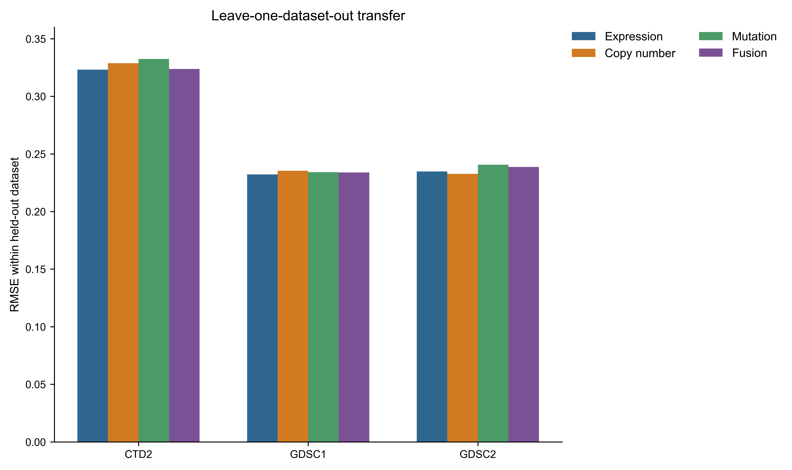
Figure 2. High-level leave-one-dataset-out comparison. This figure summarizes the cross-study transfer stress test; it is not a cross-dataset ranking of RMSE difficulty.
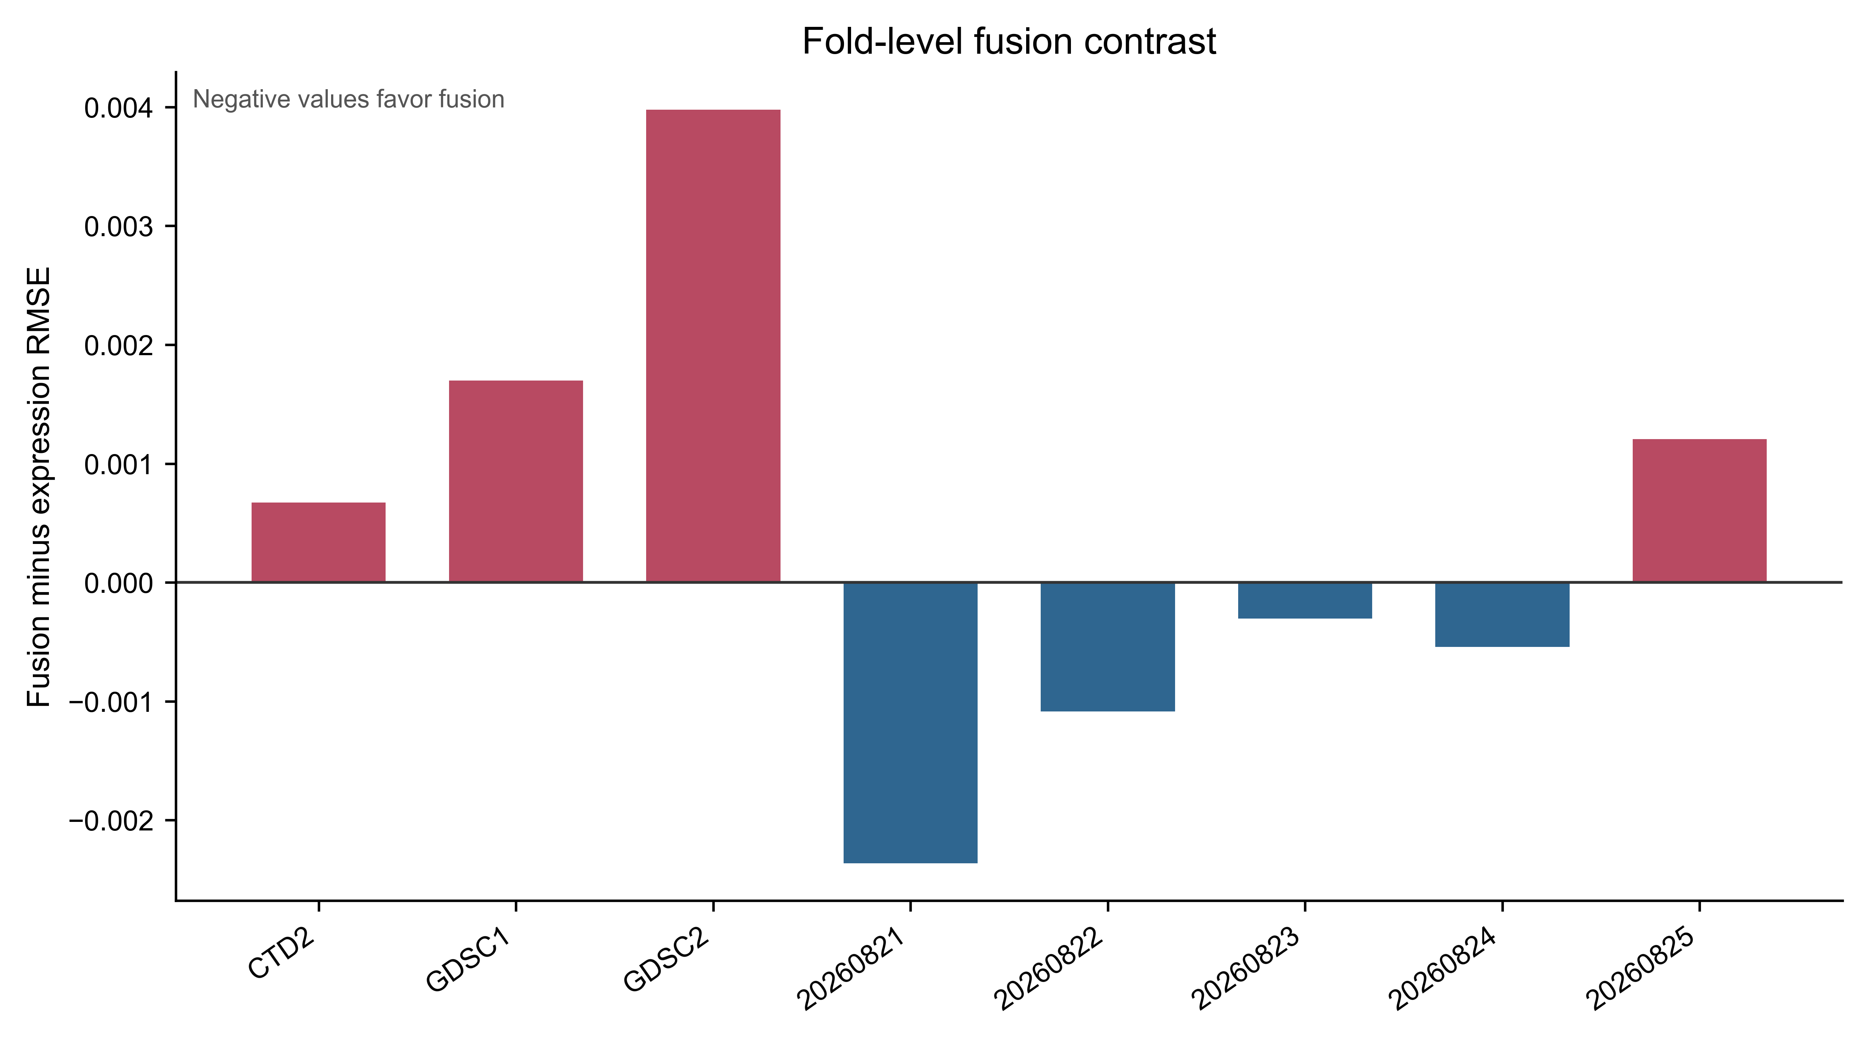
Figure 3. Fusion-minus-expression contrast and modality conflict. Negative fusion deltas favor fusion within the corresponding fold; values are not comparable across response scales.
The magnitude of the transfer differences should not be compared as if the three datasets shared a common response scale. I therefore emphasize the within-fold fusion-minus-expression contrast and report the raw metrics only to make each fold auditable. The magnitude of the transfer differences should be read together with the source-specific row counts and response construction. The held-out datasets are not interchangeable partitions of one identical experiment: they differ in compound composition, cell-line coverage, assay procedures, and the availability of molecular blocks. Thus, the LOOD comparison asks whether the complete modeling pipeline transfers to a new response source, not whether the same drug effect is reproduced in a second assay. It is a stress test for portability, but it cannot isolate whether poorer fusion performance arises from multimodal integration, source shift, compound composition, assay differences, response-scale differences, or interactions among these factors. I therefore treat the observed degradation as an association with the transfer setting, not as evidence of a causal incompatibility of multimodal models.

3.4. Missingness and redundancy
Row-level modality summaries showed weak-to-moderate correlations, while outer-joined tables showed dataset-dependent modality availability. These analyses describe data structure and model behavior; they do not establish that missingness or redundancy caused the observed performance differences. Figure 4 is therefore interpreted as a structural diagnostic for Q3, not as a performance comparison.
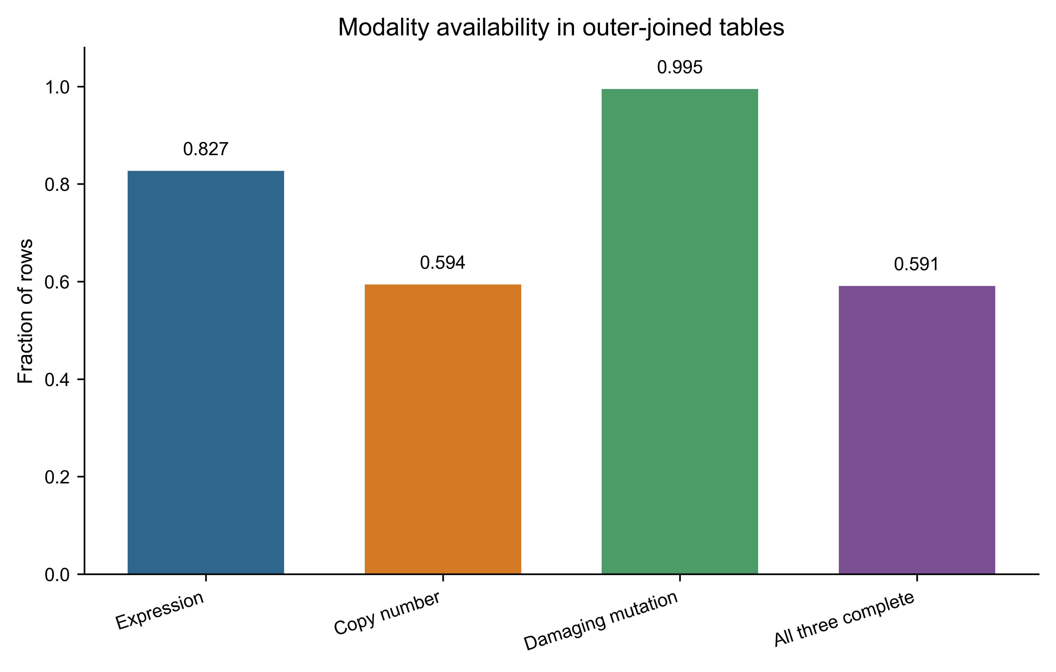
Figure 4. Outer-join modality availability. This supports the missingness analysis and is not a performance metric.
The outer-join audit found mean availability of 0.827 for expression, 0.594 for copy number, and 0.995 for damaging mutation, with 0.591 of rows complete across all three blocks. These values are calculated from the prepared outer-joined tables before fold-specific feature selection. They describe the 15-compound tables and selected cell-line intersection, not complete-case availability of the selected fold-specific 2,000-feature blocks, portal-wide availability, or clinical assay availability. Models retained incomplete rows through training-fold median imputation.

3.5. Interpretation against the research questions
The metrics answer the three research questions at different levels. For Q1, the grouped drug-held-out benchmark produced a small mean fusion advantage, but the direction changed across repeated seeds and the model lacked drug-related features; this is conditional evidence within the declared response universe, not arbitrary unseen-drug prediction. For Q2, the LOOD folds showed a less favorable fusion-minus-expression contrast within each held-out source, but the simultaneous changes in source, compounds, cell lines, assays, response construction, and modality coverage prevent attribution to multimodal integration alone. For Q3, the availability and correlation analyses showed structured differences among modality blocks and source tables; these are descriptive model-context findings, not evidence that missingness or redundancy caused the performance pattern. Accordingly, the conclusion is about the dependence of observed incremental value on validation context, not about the universal superiority or inferiority of any modality.
The displays are organized by estimand. Table 1 describes the source-specific response and feature context before modeling. Tables 4 and 5 report the primary drug-held-out result for Q1, while Table 3 documents the compound-level response counts used in that analysis. Table 2 and the more detailed Table 6 report the LOOD transfer result for Q2; the latter adds train/test strata and MAE rather than duplicating the summary comparison. Figure 2 is the compact LOOD overview, Figure 3 focuses on signed fusion-minus-expression contrasts and modality conflict, and Figure 4 provides the availability diagnostic for Q3. The modality-resolved transfer view formerly shown as Figure 3A and the fold-level effect view formerly shown as Figure 3B are retained as individual supplementary figures and machine-readable outputs, but are not repeated in the main display sequence.
Table 2. Leave-one-dataset-out RMSE.
Held-out dataset | Expression | Copy number | Mutation | Fusion
CTD2 | 0.3231 | 0.3287 | 0.3325 | 0.3238
GDSC1 | 0.2322 | 0.2353 | 0.2342 | 0.2339
GDSC2 | 0.2347 | 0.2326 | 0.2406 | 0.2387

Table 3. Declared compounds and response-row counts.
Dataset | Compound | Response rows
CTD2 | AZD-8055 | 779
CTD2 | LEPTOMYCIN B | 786
CTD2 | OUABAIN | 778
CTD2 | SR-II-138A | 781
CTD2 | VINCRISTINE | 782
GDSC1 | ACY-1215 (GDSC1:264) | 889
GDSC1 | AICA RIBONUCLEOTIDE (GDSC1:1001) | 903
GDSC1 | DACOMITINIB (GDSC1:363) | 889
GDSC1 | GSK1059615 (GDSC1:374) | 889
GDSC1 | TENOVIN-6 (GDSC1:342) | 888
GDSC2 | MG-132 (GDSC2:1862) | 938
GDSC2 | MK-2206 (GDSC2:1053) | 937
GDSC2 | NAVITOCLAX (GDSC2:1011) | 937
GDSC2 | PICTILISIB (GDSC2:1058) | 936
GDSC2 | STAUROSPORINE (GDSC2:1034) | 938

Table 4. Drug-held-out repeated-seed RMSE.
Seed | Expression | Fusion | Fusion delta
20260821 | 0.1696 | 0.1672 | -0.0024
20260822 | 0.2538 | 0.2527 | -0.0011
20260823 | 0.2329 | 0.2326 | -0.0003
20260824 | 0.2299 | 0.2294 | -0.0005
20260825 | 0.2776 | 0.2788 | +0.0012

Table 5. Drug-held-out MAE and RMSE by model and seed.
Seed | Model | MAE | RMSE | Selected features
20260821 | expression | 0.1398 | 0.1696 | 2000
20260821 | copy_number | 0.1483 | 0.1786 | 2000
20260821 | mutation | 0.1374 | 0.1674 | 2000
20260821 | fusion | 0.1370 | 0.1672 | 6000
20260822 | expression | 0.2226 | 0.2538 | 2000
20260822 | copy_number | 0.2319 | 0.2620 | 2000
20260822 | mutation | 0.2208 | 0.2529 | 2000
20260822 | fusion | 0.2206 | 0.2527 | 6000
20260823 | expression | 0.1913 | 0.2329 | 2000
20260823 | copy_number | 0.1939 | 0.2332 | 2000
20260823 | mutation | 0.1904 | 0.2325 | 2000
20260823 | fusion | 0.1902 | 0.2326 | 6000
20260824 | expression | 0.1955 | 0.2299 | 2000
20260824 | copy_number | 0.1991 | 0.2313 | 2000
20260824 | mutation | 0.1937 | 0.2293 | 2000
20260824 | fusion | 0.1937 | 0.2294 | 6000
20260825 | expression | 0.2396 | 0.2776 | 2000
20260825 | copy_number | 0.2349 | 0.2699 | 2000
20260825 | mutation | 0.2395 | 0.2787 | 2000
20260825 | fusion | 0.2397 | 0.2788 | 6000

Table 6. Leave-one-dataset-out MAE, RMSE, and evaluation strata.
Held-out dataset | Model | Train rows | Test rows | MAE | RMSE
CTD2 | expression | 9144 | 3906 | 0.2745 | 0.3231
CTD2 | copy_number | 9144 | 3906 | 0.2779 | 0.3287
CTD2 | mutation | 9144 | 3906 | 0.2803 | 0.3325
CTD2 | fusion | 9144 | 3906 | 0.2744 | 0.3238
GDSC1 | expression | 8592 | 4458 | 0.1961 | 0.2322
GDSC1 | copy_number | 8592 | 4458 | 0.2015 | 0.2353
GDSC1 | mutation | 8592 | 4458 | 0.1966 | 0.2342
GDSC1 | fusion | 8592 | 4458 | 0.1963 | 0.2339
GDSC2 | expression | 8364 | 4686 | 0.1973 | 0.2347
GDSC2 | copy_number | 8364 | 4686 | 0.1980 | 0.2326
GDSC2 | mutation | 8364 | 4686 | 0.2000 | 0.2406
GDSC2 | fusion | 8364 | 4686 | 0.1986 | 0.2387

4. Discussion
The three validation questions produce a coherent but bounded result. Q1 used grouped drug-held-out splits and found a small average fusion advantage, with the direction changing across seeds; H1 is therefore only partially supported. Q2 used LOOD folds and found a less favorable fusion-minus-expression contrast within each held-out source, but the design cannot identify whether that pattern reflects fusion, source shift, or their interaction; H2 is a transfer-setting observation rather than a causal claim. Q3 used availability and correlation audits and found structured modality differences, supporting a descriptive missingness and redundancy diagnosis without establishing mechanism. Together, the results show that the observed incremental value depends on the validation target. They do not establish universal multimodal superiority or inferiority.
The methodological implication is straightforward: the split defines the claim. The drug-held-out design tests whether a cell-line-only relationship transfers to held-out records within the declared universe, not whether the model can predict arbitrary new drugs. The LOOD design tests portability across response sources, not same-drug replication. Reporting these estimands separately makes the small within-universe effect and the less favorable transfer result interpretable without treating them as contradictory.
For early drug discovery and biomarker prioritization, the practical implication is a decision-support role rather than an autonomous selection rule. Expression-only models may be preferable when they provide similar accuracy with broader availability and lower maintenance burden; additional modalities should be retained when they yield reproducible gains for a clearly defined use case. The present analysis does not test prospective compound prioritization, biomarker clinical validity, manufacturing decisions, or patient treatment selection, so these implications remain hypotheses for future validation.
The fixed feature-budget asymmetry is an additional reason to interpret the small within-universe effect cautiously: fusion has three times as many selected features as expression under the same alpha. The small size of the observed within-universe effect is itself informative for model development. The paired drug-group summaries show variability of similar order to the mean difference, the seed-level direction changes in two of five comparisons, and the drug-group direction changes in four of 15 cells. This pattern does not justify selecting fusion solely because its arithmetic mean is lower. A reasonable decision rule would also consider the cost of obtaining and maintaining the extra modalities, the completeness of those modalities in the intended population, and whether the improvement is reproduced under a declared external test. Under the present evidence, expression remains a competitive reference and fusion is best treated as a candidate extension requiring further validation.
The analysis also suggests a reproducibility principle for future information-fusion studies: preserve the split manifests and the feature-selection scope as first-class artifacts. Without them, a later rerun can silently change the estimand while retaining the same model name and headline metric. Reporting the sign of each fold-level delta, rather than only an aggregate score, makes such changes easier to detect. This is particularly important when the expected effect is small, as in the present benchmark.
The drug-held-out result is compatible with a limited benefit from complementary features when the training and test rows share a source-defined response system. It should not be interpreted as evidence that the current cell-line-only model can predict responses for arbitrary new compounds, because it receives no drug-related input. Fusion improved the mean across five seeds, but four of five seed-level comparisons favored fusion and the effect sizes were small relative to the absolute error. I therefore describe this result as uncertain, conditional evidence that fusion can be useful under a matched evaluation regime, not as evidence that fusion should replace a strong single-modality baseline.
The compound-level audit provides limited support for the ‘drug-conditional’ framing: the direction of the fusion delta differed among the eight compounds observed in held-out groups. ACY-1215 and DACOMITINIB showed the largest negative mean deltas in this audit, whereas GSK1059615 and STAUROSPORINE showed positive mean deltas; the remaining compounds were closer to zero or favorable by small amounts. These patterns are descriptive and should not be interpreted as mechanism-of-action effects. The current design has no drug features, does not provide a complete leave-one-drug-out estimate for all 15 compounds, and does not formally test mechanism-stratified heterogeneity. A stronger biological interpretation would require a larger compound set, reliable target or mechanism annotations, drug-aware inputs, and pre-specified interaction analyses.
The cross-study result is a portability warning within this specific set of source-held-out folds. A model that performs well within the declared response universe may lose accuracy when the source changes, so transfer validation is necessary before making general-purpose claims. The present design does not separate assay, compound, cell-line, response-scale, and modality-coverage effects.
The outer-join analysis shows that the usable intersection of modalities differs by dataset. A complete-case fusion analysis can therefore change the population being evaluated before any model is fitted. Conversely, median imputation preserves rows but may weaken modality-specific structure. The current analysis reports both availability and model performance, but it does not compare missingness-aware architectures, learned imputation, modality dropout, or late-fusion weighting. Those are appropriate follow-up tests rather than conclusions supported here.
Recent benchmarking studies reinforce the importance of the validation choices used here. Partin and colleagues assembled a cross-dataset framework with standardized data, models, splits, and metrics, and reported substantial performance drops when models were tested on datasets different from those used for training [14]. Bernett and colleagues reached a related conclusion with DrEval: complex drug-response models often showed limited improvement over simpler baselines when evaluated with standardized tuning, cross-study testing, and biologically motivated splits [15]. These studies do not prove that simple models are universally preferable, but they support treating external transfer and baseline strength as central evidence rather than optional sensitivity analyses.
The present results extend that caution to a narrower multimodal question. I observed only a small and variable difference between expression-only and early fusion under the declared Ridge construction, while the source-held-out setting was less favorable for fusion. This is consistent with the broader benchmarking literature in one respect: the apparent value of added complexity depends on the evaluation target. It differs in scope because my analysis does not compare a large model library, tune competing algorithms, or include drug representations. The appropriate consequence is therefore procedural. A pharmaceutical data-science team should define the decision use case, audit assay availability, choose a validation split that matches the intended deployment, compare against a strong expression baseline, and require a gain large enough to justify the added measurement and maintenance burden.
For the research questions, the practical interpretation is similarly bounded. Q1 suggests that a small gain may occur within the declared response universe, but its variability argues against treating the mean as a stable property. Q2 shows why source transfer should be tested, while its confounding prevents a causal explanation of the less favorable fusion contrast. Q3 shows that missingness and modality structure are part of the modeling context and should be reported with performance. These consequences support the decision tree in Figure 1 and the detailed decision audit in the Supplementary Material.
The findings do not contradict prior reports that multimodal integration can improve drug-response prediction under particular data and validation settings [4-6,8]. Recent reviews and benchmarking frameworks further emphasize drug representations, missing-modality handling, broader metric sets, and clinically relevant validation designs [11-13]. Instead, they emphasize that the reported gain is inseparable from the response universe, split strategy, preprocessing, and transfer target. The distinction is especially relevant when a study combines data sources that differ in coverage or measurement. A fair comparison should therefore report the single-modality baseline, fold-local processing, held-out entities, and the direction and size of the fusion delta. In practical terms, a multimodal model should be retained only when its incremental accuracy is large enough, stable enough, and transferable enough to justify the added data requirements.
The main limitations are the small 15-compound universe, limited identical-drug overlap, fixed Ridge learner, descriptive per-drug audit, and absence of prospective validation. The modality set also excludes potentially informative assays such as proteomics, methylation, drug chemical structure, and lineage-aware representations. I report RMSE and MAE but do not provide a complete ranking-oriented evaluation using Pearson or Spearman correlation, and I do not test chemical-scaffold separation between training and held-out drugs. Source-specific AUC scales were retained rather than harmonized, so LOOD error magnitudes should not be read as directly comparable biological difficulty across datasets. Because LOOD changes dataset source, compounds, cell lines, assay protocols, and response construction together, the analysis cannot identify a causal effect of multimodal integration on transfer performance. No patient, organoid, PDX, or prospective external cohort was evaluated. Future work should repeat grouped validation across more seeds and more complete leave-one-drug-out partitions, compare equalized total feature budgets, tune regularization within training folds, test modality-specific or group-wise penalties, enlarge the common-drug benchmark, compare response harmonization strategies, evaluate modality dropout and missingness-aware models, and predefine an external test set before model selection. These steps would test whether the observed transfer failure is specific to the current construction or a broader property of multimodal pharmacogenomics.

5. Conclusion
For assay-prioritization decisions, the present evidence does not justify acquiring or harmonizing additional copy-number and mutation assays solely because they are expected to improve prediction; their value should be demonstrated in the intended population and validation setting. For biomarker-model development, expression remains a competitive reference, and the small, variable fusion effect does not justify replacing it without a larger and complexity-matched comparison. For external-validation planning, the less favorable source-held-out result supports testing transfer before describing a multimodal model as portable. For data-integration quality control, the modality-availability audit shows why missingness and usable-population changes should be reported with model accuracy. For reproducible benchmarking, the main contribution is the preserved sequence of data release, split manifest, fold-local feature selection, preprocessing, model fit, and per-group reporting.
These conclusions are limited to the declared 15-compound benchmark and the fixed Ridge early-fusion construction. I do not claim arbitrary new-drug prediction, clinical treatment selection, causal biological effects, universal superiority or inferiority of fusion, or replacement of experimental validation. Drug-aware inputs, equalized feature budgets, tuned and group-wise regularization, complete leave-one-drug-out validation, and larger external tests are needed before extending the conclusions to broader pharmaceutical or clinical use.

6. Data and code availability
Code, split manifests, derived result summaries, figures, and reproducibility notes are provided at https://github.com/camontefusco/more-omics-is-not-always-better and archived at https://doi.org/10.5281/zenodo.23054361. The revision package should be evaluated from the immutable resubmission commit or release tag identified in the accompanying response letter; the working repository is not sufficient as a version identifier by itself. The release inventory includes the full-universe drug-held-out and LOOD runners (scripts/run_full_universe_benchmark.py and scripts/run_full_universe_lood.py), the dataset manifest (configs/dataset_manifest.yaml), the pinned environment specification (configs/requirements-release.txt), persisted split and feature manifests, machine-readable result JSON files, and scripts for regenerating the main figures and tables. The declared data releases are Harmonized GDSC 25Q2, Harmonized CTD² 25Q2, and DepMap Public 26Q1. Raw provider files must be obtained from the providers under the applicable terms; the repository does not redistribute raw molecular matrices.

7. References
[1] Barretina J, et al. The Cancer Cell Line Encyclopedia enables predictive modelling of anticancer drug sensitivity. Nature. 2012;483:603-607. doi:10.1038/nature11003.
[2] Iorio F, et al. A landscape of pharmacogenomic interactions in cancer. Cell. 2016;166:740-754. doi:10.1016/j.cell.2016.06.017.
[3] Tsherniak A, et al. Defining a cancer dependency map. Cell. 2017;170:564-576.e16. doi:10.1016/j.cell.2017.06.010.
[4] Azuaje F. Computational models for predicting drug responses in cancer research. Brief Bioinform. 2017;18:820-829. doi:10.1093/bib/bbw065.
[5] Sharifi-Noghabi H, et al. MOLI: multi-omics late integration with deep neural networks for drug response prediction. Bioinformatics. 2019;35:i501-i509. doi:10.1093/bioinformatics/btz318.
[6] Cai Z, et al. Machine learning for multi-omics data integration in cancer. iScience. 2022;25:103798. doi:10.1016/j.isci.2022.103798.
[7] DepMap. How should I cite DepMap data? DepMap Portal. Updated 2025.
[8] Kuenzi BM, et al. Predicting drug response and synergy using a deep learning model of human cancer cells. Cancer Cell. 2020;38:672-684.e6. doi:10.1016/j.ccell.2020.09.014.
[9] Chawla S, Rockstroh A, Lehman M, et al. Gene expression based inference of cancer drug sensitivity. Nat Commun. 2022;13:5680. doi:10.1038/s41467-022-33291-z.
[10] Baptista D, Ferreira PG, Rocha M. Deep learning for drug response prediction in cancer. Brief Bioinform. 2023;24:bbac605. doi:10.1093/bib/bbac605.
[11] Gouru G. Precision oncology: Computational methods for multi-omics data integration to improve drug response prediction. Cambridge Prisms Precis Med. 2025;3:e6. doi:10.1017/pcm.2025.10003.
[12] Li D, et al. Multi-omics modality completion and knowledge distillation for drug response prediction in cervical cancer. Front Oncol. 2025;15:1622600. doi:10.3389/fonc.2025.1622600.
[13] Del Real KS, et al. Foundation models and deep learning for cancer drug response prediction: a framework for data, metrics, and validation. Brief Bioinform. 2026;27:bbag225. doi:10.1093/bib/bbag225.
[14] Partin A, et al. Benchmarking community drug response prediction models: datasets, models, tools, and metrics for cross-dataset generalization analysis. Brief Bioinform. 2026;27(1):bbaf667. doi:10.1093/bib/bbaf667.
[15] Bernett J, et al. Critical evaluation of drug response prediction models with DrEval. Nat Commun. 2026;17:4238. doi:10.1038/s41467-026-72903-w.
[16] Carli F, et al. CellHit: a web server to predict and analyze cancer patients’ drug responsiveness. Nucleic Acids Res. 2025;53(W1):W143-W150. doi:10.1093/nar/gkaf414.
[17] Wang Q, et al. scDrugMap: benchmarking large foundation models for drug response prediction. Nat Commun. 2026;17:730. doi:10.1038/s41467-025-67481-2.
[18] Automated real-world data integration improves cancer outcome prediction. Nature. 2024;629:123-131. doi:10.1038/s41586-024-08167-5.

Appendix A. Reproducibility and reporting specification
This appendix makes explicit the decisions that determine the benchmark’s estimand. It is included so that a future implementation can reproduce the same comparison without inferring choices from code or from the headline results. The appendix is procedural: it does not add new biological claims.

A.1. Analysis sequence
The analysis sequence is: (i) identify the declared response rows and source dataset; (ii) normalize identifiers and join modality matrices; (iii) create grouped split manifests; (iv) fit all preprocessing steps on training rows; (v) select the feature budget separately within each modality; (vi) transform training and test rows; (vii) fit the same Ridge specification for each modality and fusion; (viii) calculate MAE and RMSE on the held-out response rows; and (ix) write metrics, row counts, and manifest identifiers to machine-readable result files. The order is part of the method and should not be changed when comparing extensions.
Table 7. Reproducibility controls and their purpose.
Control | Implementation | Reason
Drug grouping | GroupShuffleSplit by drug_id_raw | Prevents the same drug response group crossing train/test
Feature selection | Top 2,000 per modality inside training fold | Prevents test-informed feature ranking
Imputation | Training-fold median applied to test rows | Avoids test-derived preprocessing parameters
Scaling | Training-fold standardization | Places feature blocks on a common fitted scale
Learner | Ridge, alpha = 1.0 for every block | Keeps the model comparison controlled
Primary metrics | MAE and RMSE | Reports typical and squared-error sensitivity
Transfer test | Hold out one full source dataset | Measures domain transfer rather than same-drug replication

A.2. Estimands and comparison rules
The primary within-universe estimand is the change in held-out response error produced by concatenating the three modality blocks relative to expression alone under the same drug-grouped split. The primary transfer estimand is the analogous change when the response source is held out in full. A negative fusion-minus-expression RMSE indicates lower error for fusion; a positive value indicates lower error for expression. No statistical significance claim is made from the five seeds or three transfer folds, because these are repeated benchmark partitions rather than independent biological experiments.

A.3. Missingness and availability audit
Availability was audited before interpreting fusion results. For each source table, the audit records the number of rows with each modality available, the number complete across all selected blocks, and the number requiring imputation. Outer joins are used for this audit because an inner join can conceal the extent of modality-specific attrition. These counts characterize the constructed analysis table; they are not estimates of missingness in all DepMap data.
Table 8. Interpretation guardrails for the reported evidence.
Observed result | Permitted interpretation | Not supported
Fusion improves in 4 of 5 drug-held-out seeds | Small conditional improvement under this benchmark | Universal multimodal superiority
Fusion worsens all 3 LOOD folds | Transfer failure in these source-held-out folds | Proof of a biological incompatibility
Availability differs by dataset | Data structure is source-dependent | Missingness caused the error difference
Modality correlations are weak-to-moderate | Some redundancy and complementarity coexist | A causal redundancy mechanism
Ridge is reproducible and controlled | A transparent reference baseline | The best possible learner
15 compounds are declared | Results are bounded to the declared universe | Generalization to all compounds

A.4. Recommended extensions
The next validation layer should preserve the current manifests while adding a larger common-drug universe and a completely external test partition. Candidate model extensions include late fusion with modality-specific regularization, modality dropout during training, explicit missingness indicators, and domain adaptation. Each extension should retain expression-only and single-modality baselines, report the same error metrics, and separate model selection from final evaluation. This will allow improvements in architecture to be distinguished from improvements caused by a more favorable split or response harmonization.

A.5. Minimum reporting checklist for future comparisons
For comparability, future benchmark reports should identify the data release, response scale, compound inclusion rule, cell-line identifier rule, modality availability rule, feature-selection scope, imputation scope, split grouping variable, number of repeated seeds, model-selection procedure, primary baseline, primary metric, and external-transfer target. They should also report the number of rows entering each fold and the number excluded or imputed. These fields are more informative for interpretation than a single pooled accuracy value.
Table 9. Minimum fields to preserve with each future result table.
Field | Required record
Data provenance | Provider, release label, download date, checksum
Population | Dataset, compound list, cell-line identifier, row count
Preprocessing | Imputation, scaling, filtering, feature-selection order
Validation | Split type, grouping unit, seed, train/test counts
Model | Modality, learner, hyperparameters, feature count
Performance | MAE, RMSE, delta to expression baseline
Availability | Complete rows, modality-specific availability, missing rows
Interpretation | Transfer target, limitations, and whether claims are causal

Supplementary material
Supplementary Table S1 reports the declared compound universe and source-specific response rows. The initial three-seed missingness audit is reported separately in the frozen result tables; the five-seed performance benchmark is also reported separately. Supplementary Table S2 records the frozen artifact and validation scope. Figures are supplied separately in the submission package.
Supplementary Table S2. Drug-held-out missingness strata.
Seed | Complete rows | Missing rows | Total rows
20260821 | 1513 | 1046 | 2559
20260822 | 1458 | 1271 | 2729
20260823 | 1530 | 1078 | 2608

Supplementary Table S3. Release scope and limitations.
Item | Status
Evaluation universe | 15 declared compounds across GDSC1, GDSC2, CTD²
Drug-held-out validation | 5 persisted seeds; fold-local top-2,000 features from full raw modality universes
Cross-study validation | LOOD folds for CTD², GDSC1, and GDSC2
MoA mapping | 15/15 declared compounds; 5/316 full GDSC1 universe
Raw data | Provider files not redistributed; checksums recorded

Revision marking legend
This file uses native Microsoft Word tracked-revision markup. Revised text, figures, and tables are marked as insertions authored by Carlos Victor Montefusco-Pereira. The baseline was the initial manuscript PDF supplied with the editorial request. The clean manuscript is the authoritative version.

