Homework: Computers Matter

Contents

Objective 1

Document Requirements 1

Content 1

Presentation 1

Submission 2

# Objective

The objective of this exercise is to explore the impact computer technology has had on various fields of study. Pick a field of interest, then research the methodologies of the past and the present to see how your field has evolved as computer technology has progressed. Some key points to look at could include reduction in manual labor with automation, and increased scale of research with big data.

Computer technology is still developing at a rapid pace. Construct a theory as to how your field might continue to evolve in the future as computer technology advances even further. Some new technologies being developed right now include a connected “Internet of Things”, “Artificial Intelligence”, and “Cloud Computing”.

Present your findings and predictions in a professional Word document using the techniques you have learned.

# Document Requirements

## Content

* Your own insight into how computer technology has influenced the past and present of your field, and how it may influence the future.
* At least 2-3 **good** sources
* Informative graphics
* Aim for no more than 3 pages

## Presentation

* A cover page including your name, course, instructor, and a graphic of your choice
* An automatically generated **Table of Contents**
  + This means your document must properly use *Styles* to create a sensible structure
* The headers and/or footers of every page, **excluding the cover page**, must include:
  + Your name and course number
  + Page numbers that begin on page 1 of the main report
  + A Word *field*displaying the file name of your document
    - While editing a header or footer, the Fields option is found in the *Design* ribbon tab (see next page below)
* An automatically generated **References** section
* 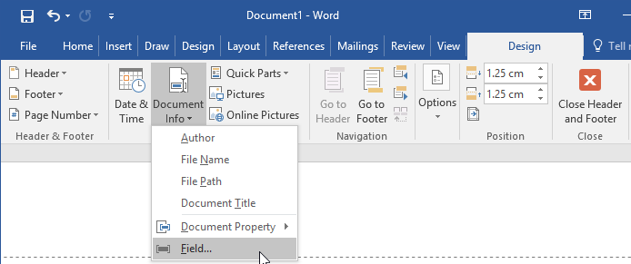**Captions** on any inserted figures

# Submission

Save your docx file as **Computers-Matter_Firstname_Lastname**.

|  |  |
| --- | --- |
| **Criteria** | **Marks** |
| Content | 5 |
| * 2-3 page report * Multiple sections * 1 or more captioned images | |
| Presentation | 5 |
| * Sensible document structure * Correct use of Word’s automated features * Cover page * Header and Footer information | |
| **Total** | 10 |