13331231 孙圣 Part2

Set2
- What is the role of the instance variable sideLength?

Since the boxBug traces out a square box, sideLength is the length of the side of the square, which is also the maximum step that a bug can move on one side.

- What is the role of the instance variable steps?

Steps records how many steps the bug has finished on one particular side, if steps is equal to sideLength, the bug will no longer move forward, instead it will begin to turn.

- Why is the turn method called twice when steps becomes equal to sideLength?

For each turn, the bug turns right by 45 degree. In order to turn 90 degree, the bug has to turn twice.

- Why can the move method be called in the BoxBug class when there is no move method in the BoxBug code?

Because class BoxBug extends class Bug, and in class Bug there is a method called move(), so BoxBug inherits that method.

- After a BoxBug is constructed, will the size of its square pattern always be the same? Why or why not?

Yes. There is no method that can change the sideLength, so once a bug is constructed, its walking pattern is also determined.

- Can the path a BoxBug travels ever change? Why or why not?

Yes. If there is a barrier in front of the bug, say a rock, the bug will try to turn instead of moving forward. Under such circumstance, the course of the bug has been changed.

- When will the value of steps be zero?

Firstly, when the bug is constructed, its steps is zero; secondly, when the bug faces a wall and it cannot move, its steps is zero too; thirdly, when the number of steps the bug has walked equals sideLength, its steps is also reset to zero.

Exercises
- CircleBug
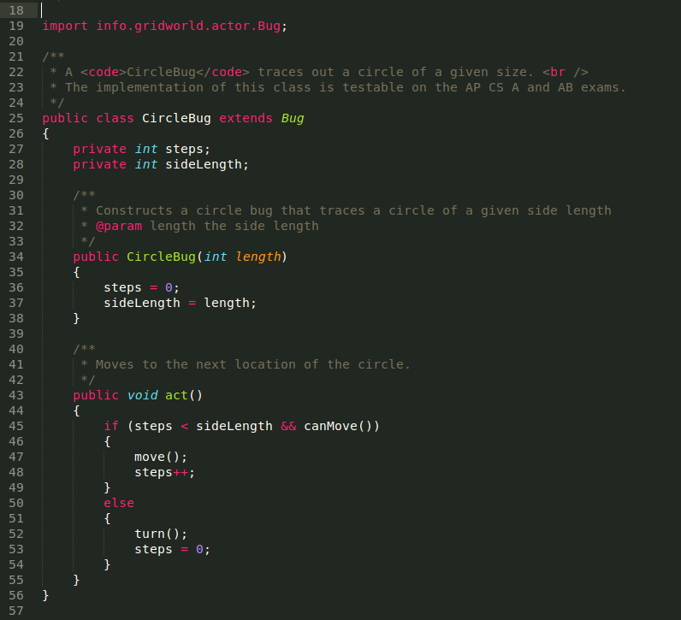
CircleBug covers the route of an octagon instead of a square if there is no barrier in front of it.

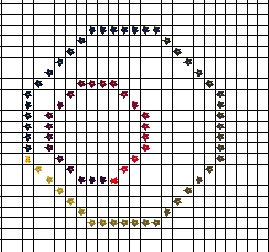

- SpiralBug
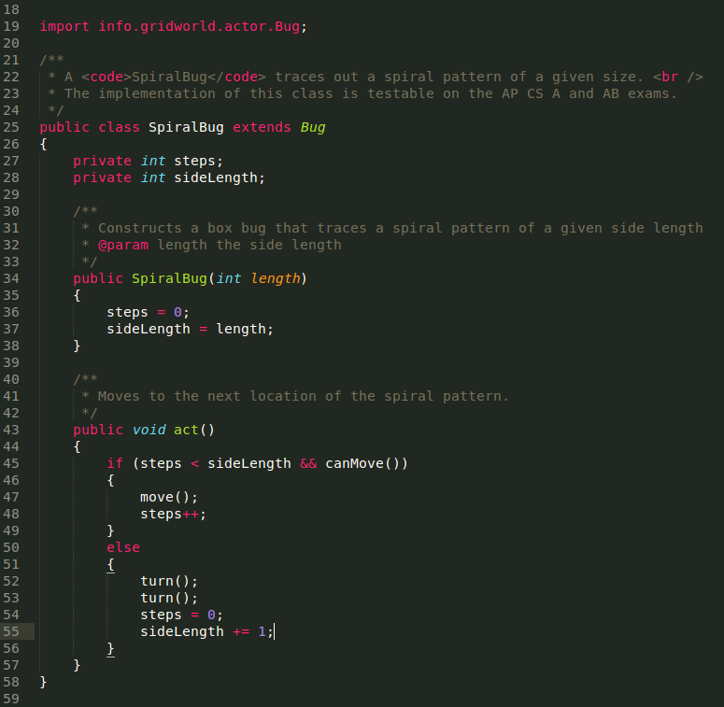
Pattern:

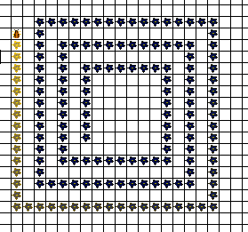

- Zbug
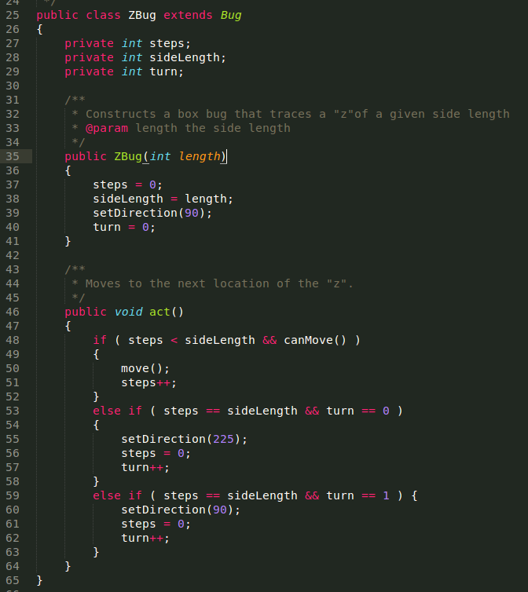
Pattern:
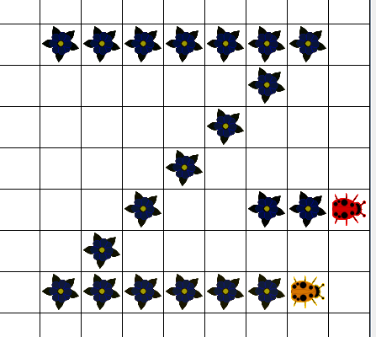

- DancingBug
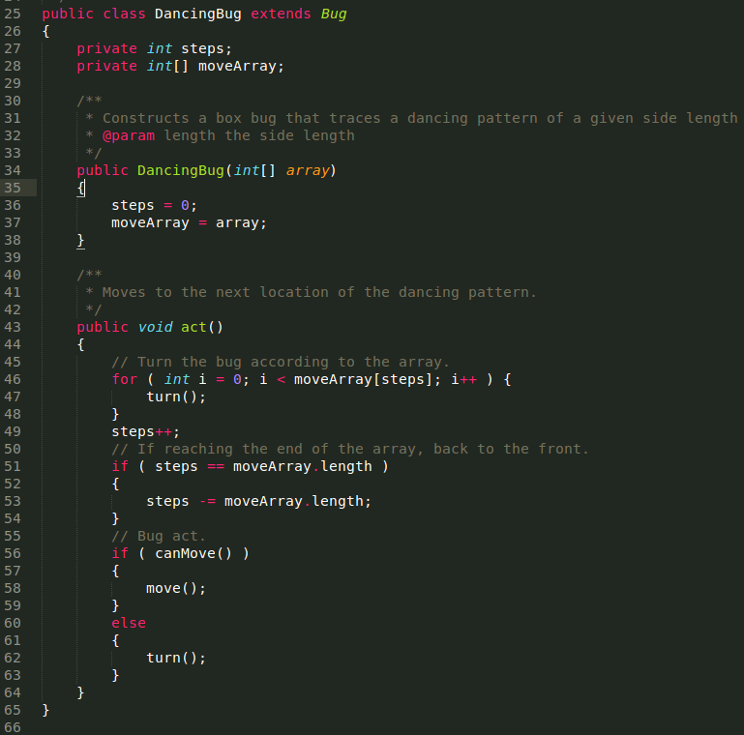
Pattern: (moveArray = {0, 1, 2, 3, 4, 5})

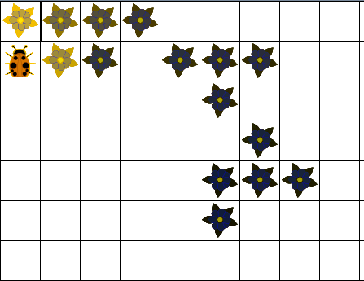

  - Firstly, create an instance of BoxBug and pass the sideLength as parameter.
BoxBug cat = new BoxBug(4);
Secondly, add the bug to the world and specify its lacation.
world.add(new Location(3, 5), cat);

Sonar Report:
