***Admin page***

Navigation bar with links to manage Employees, Departments, and Projects.

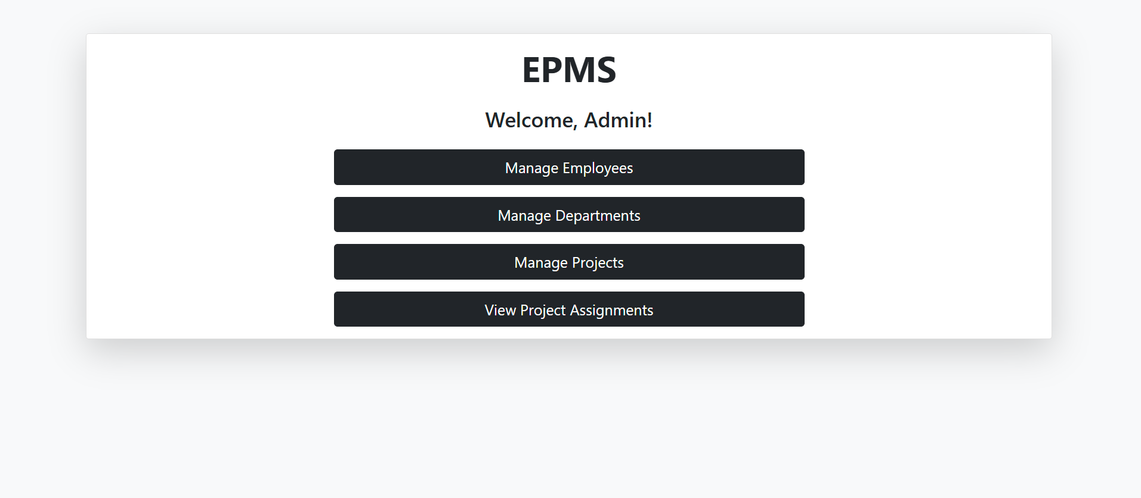

**Manage Employees**

1. Landing page of employee

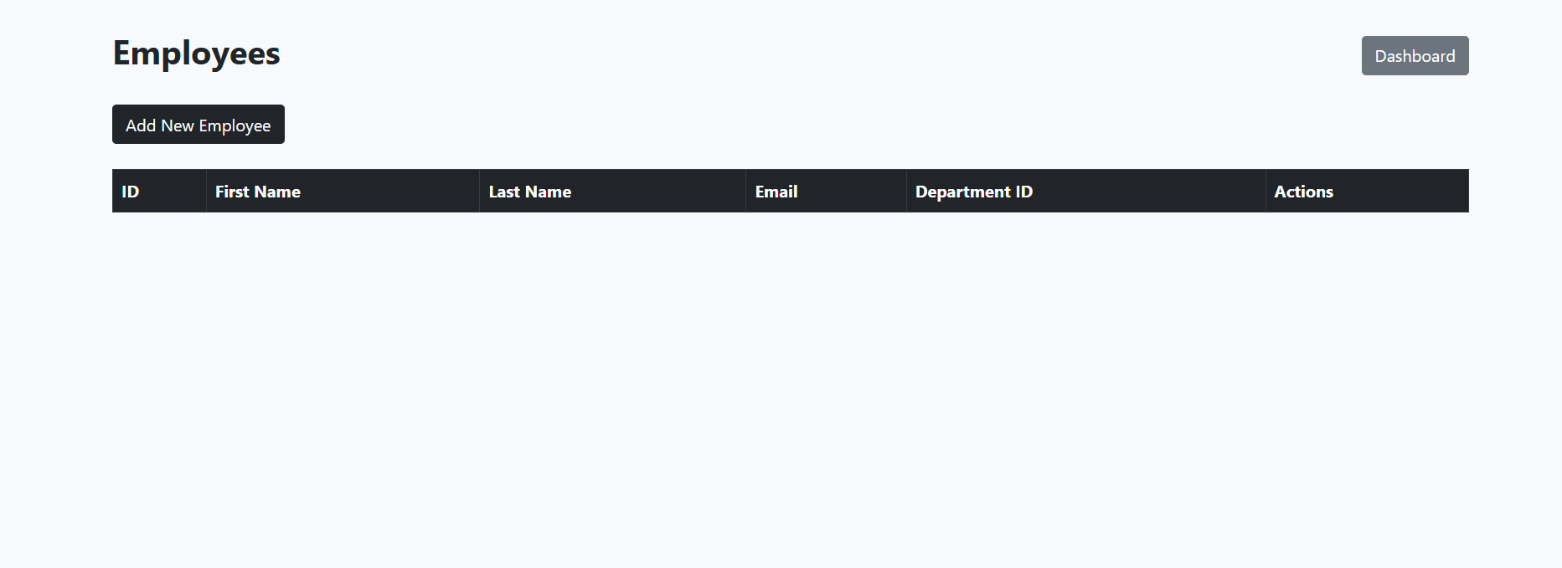

1. Click on “Add New Employee’

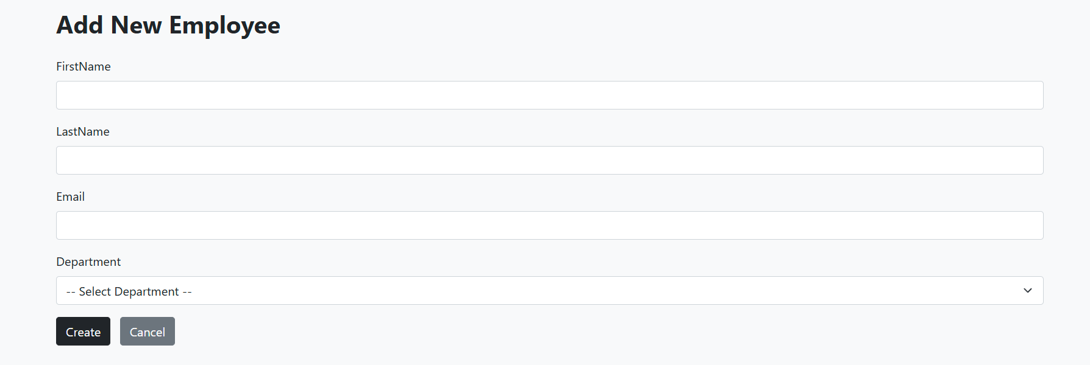

Fill the Employee details and click in create button.

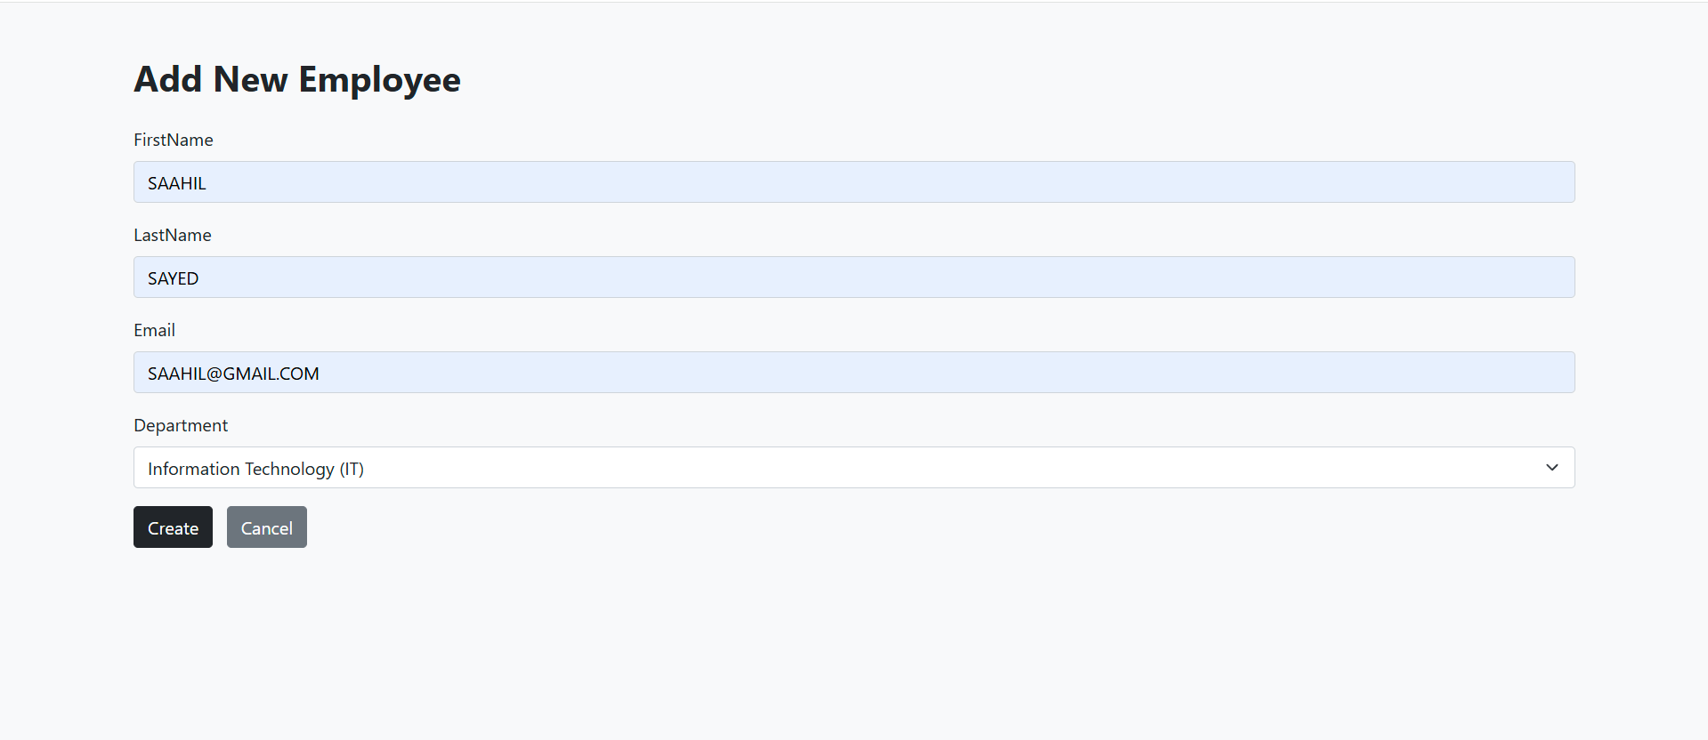

Employee has been created.

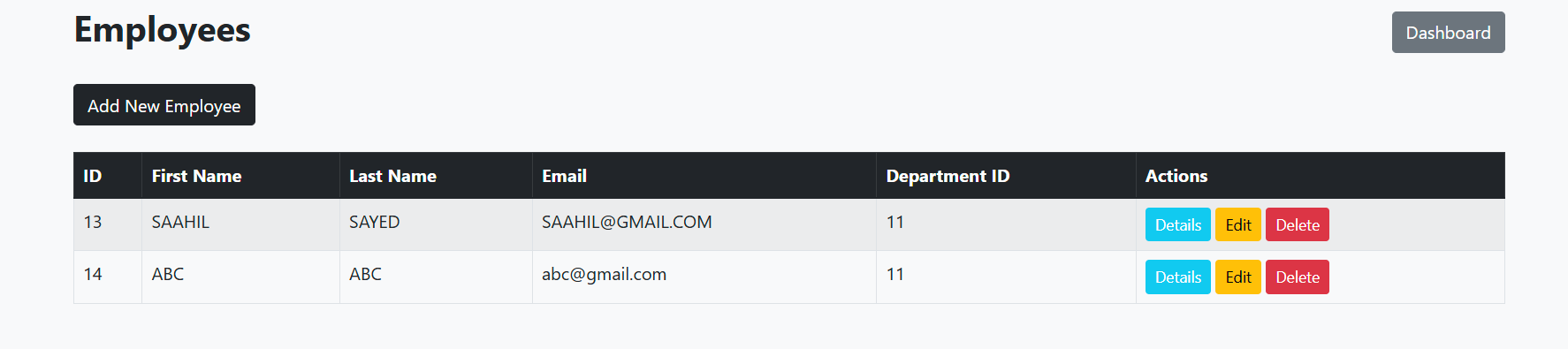

1. To edit, click on edit button under Action.

Edit the details and save changes.

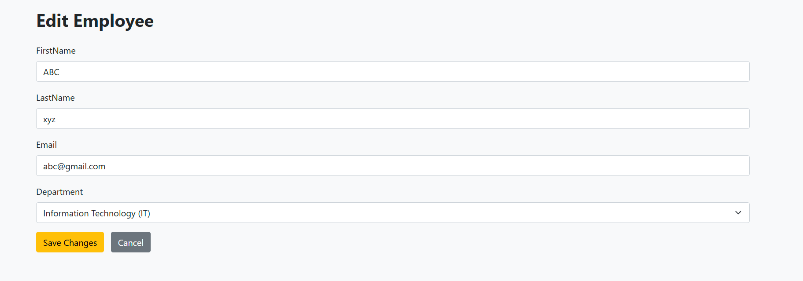

Changes will reflect in index page.

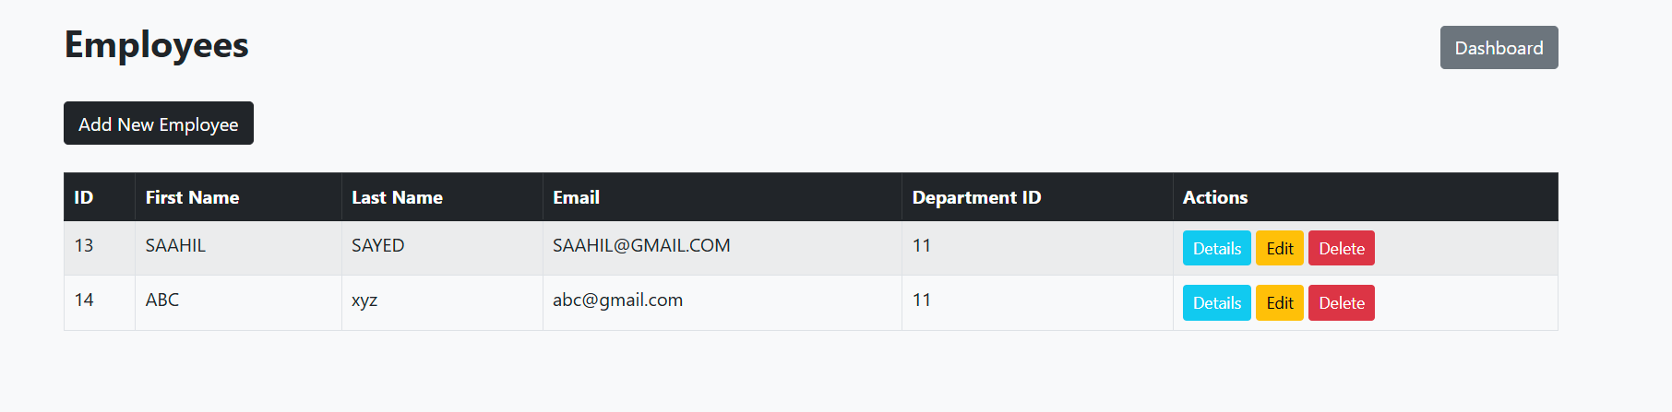

1. To Delete employee, click delete under action.

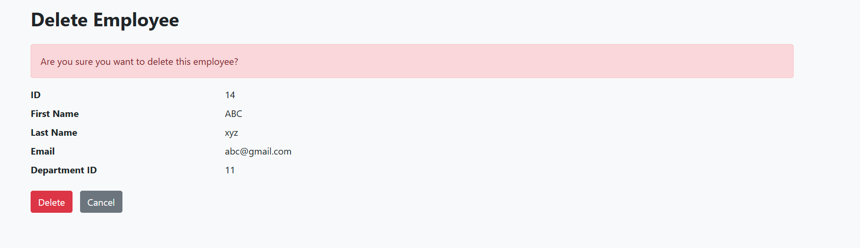

Employee will get deleted.

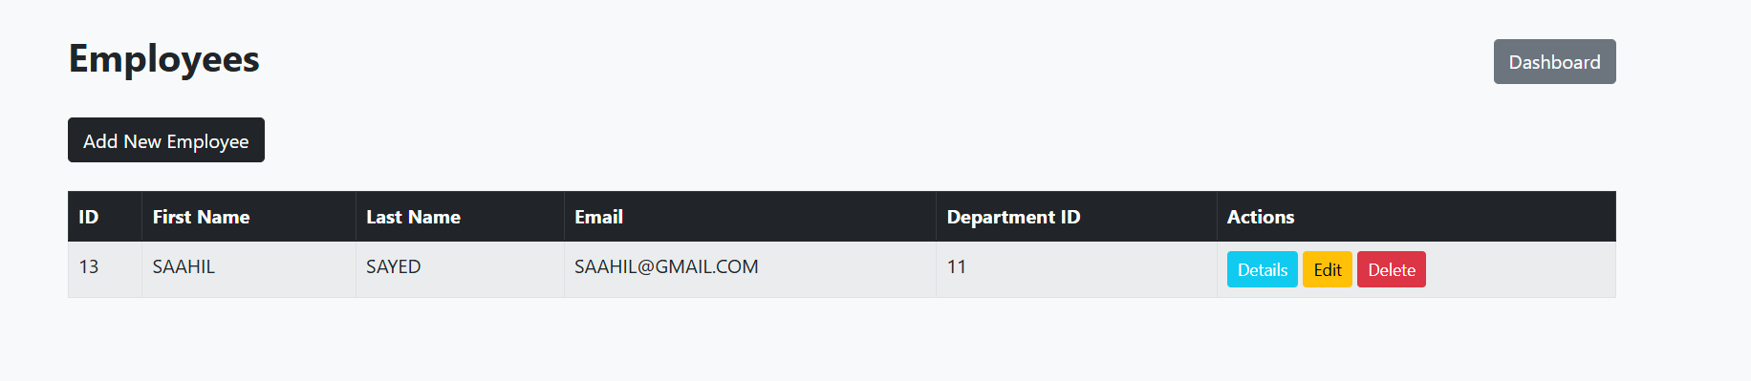

1. Click on ‘Details’ button under action to get the full information.

Employee with one project.

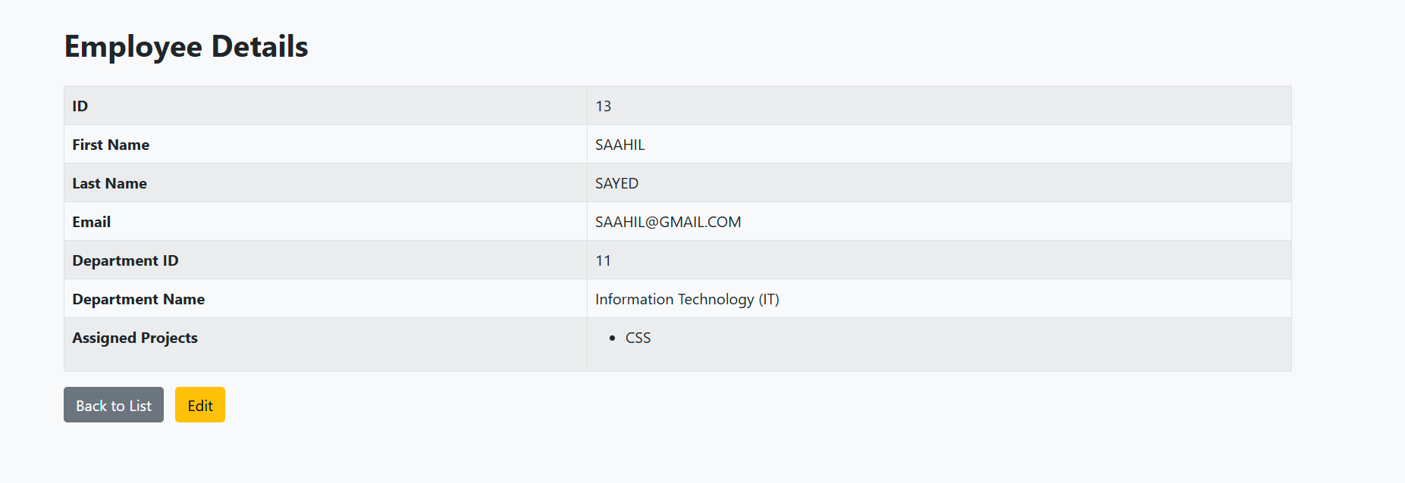

Employee with Multiple projects.

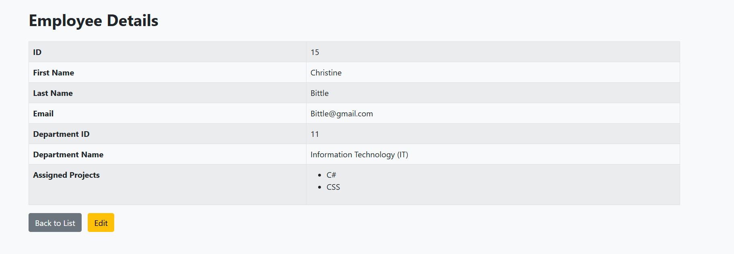

**Manage Departments**

1. Landing page of department.

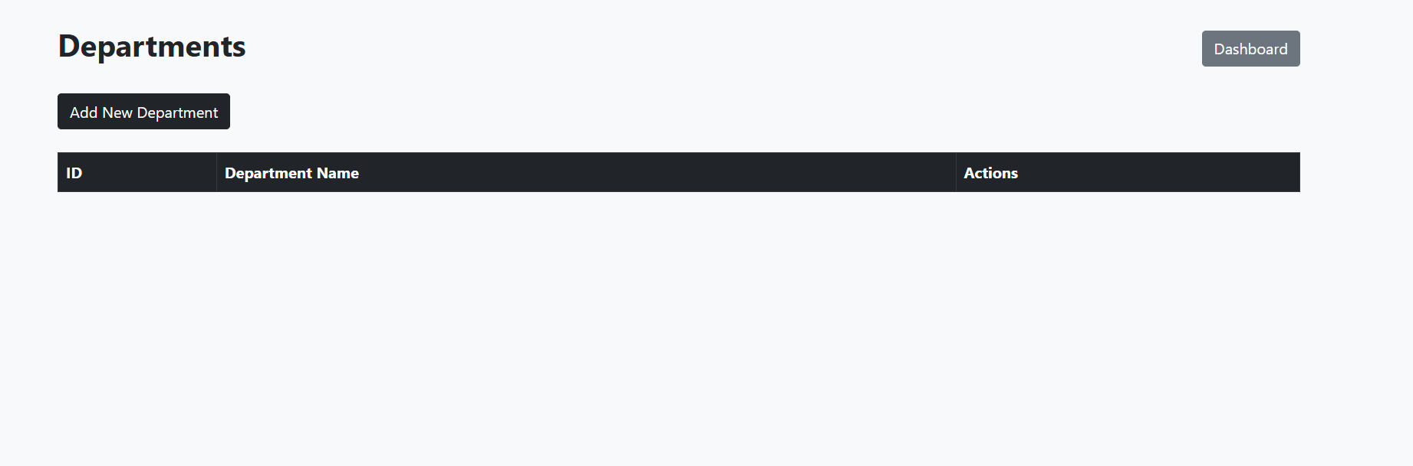

1. Click on “Add New Department’.

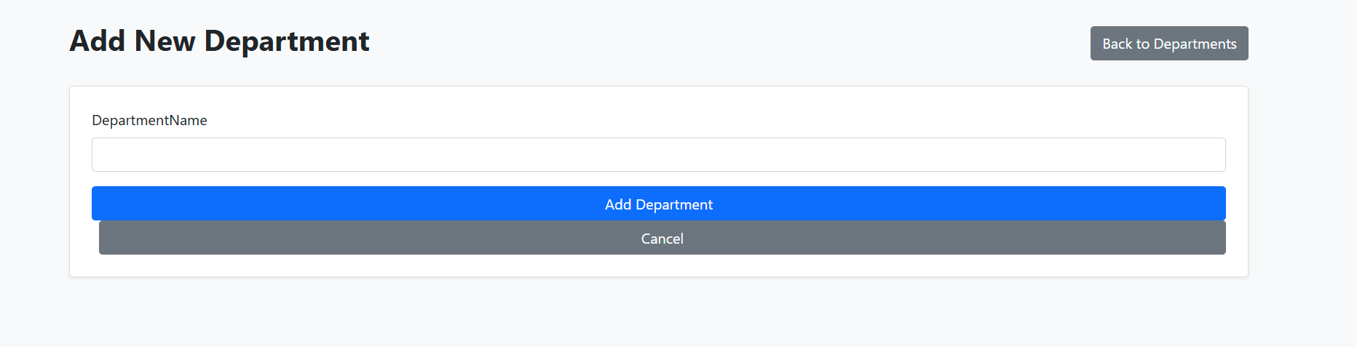

Fill the information for new department.

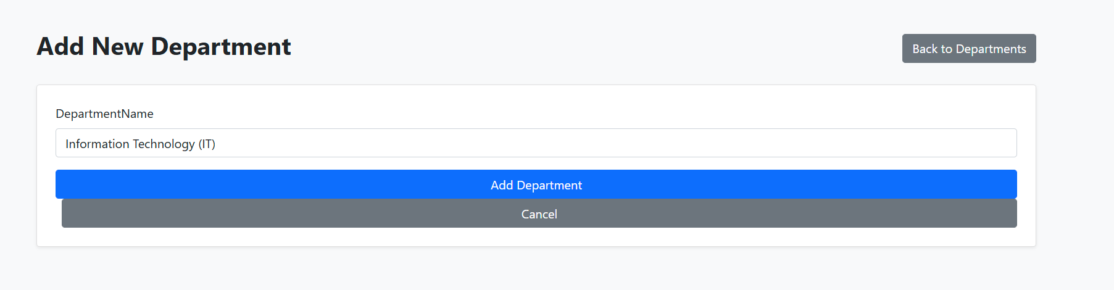

Department is created.

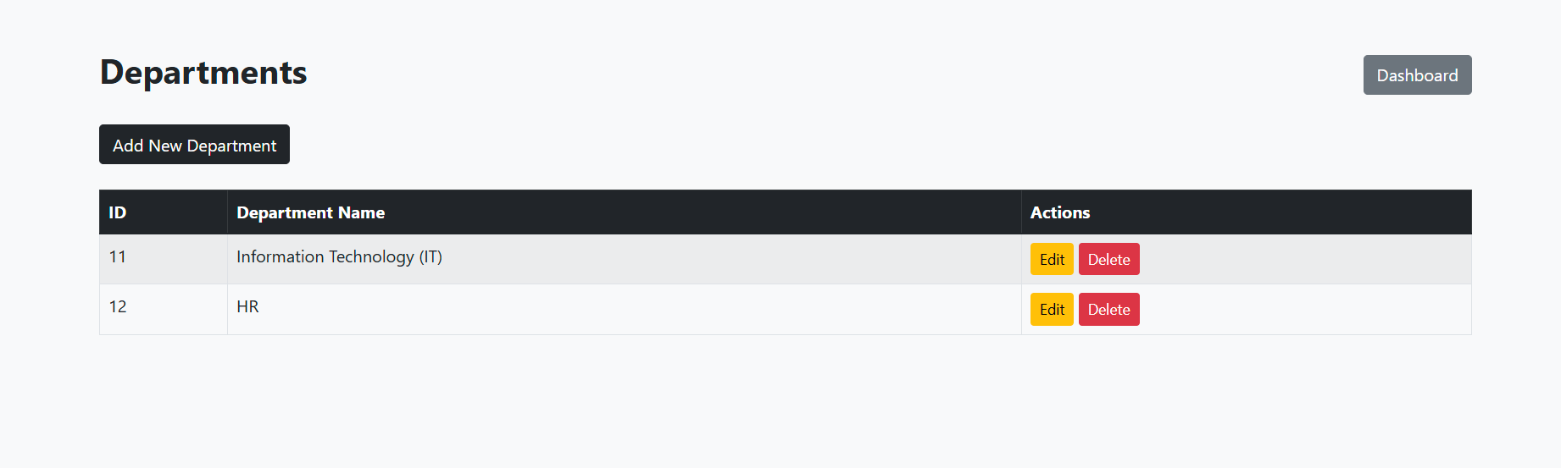

1. To edit department, click on edit button under action.

Enter the updated information. And save changes.

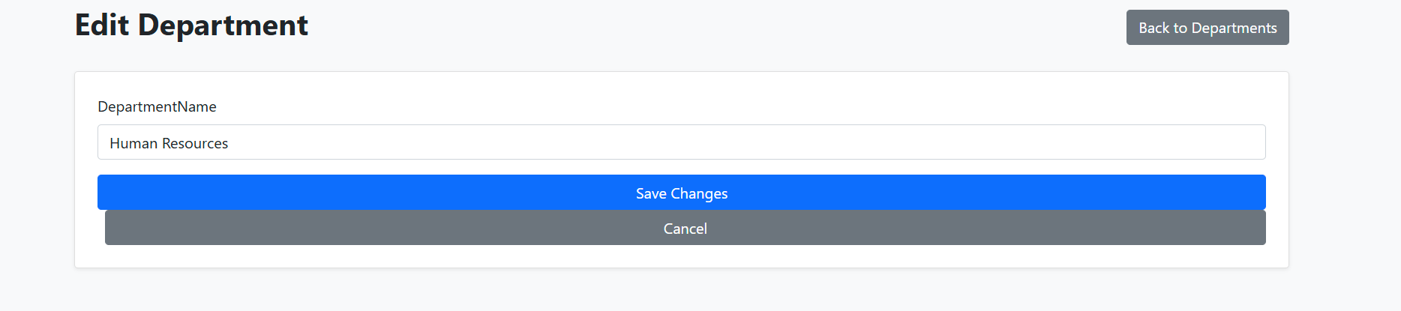

Changes will reflect in index page.

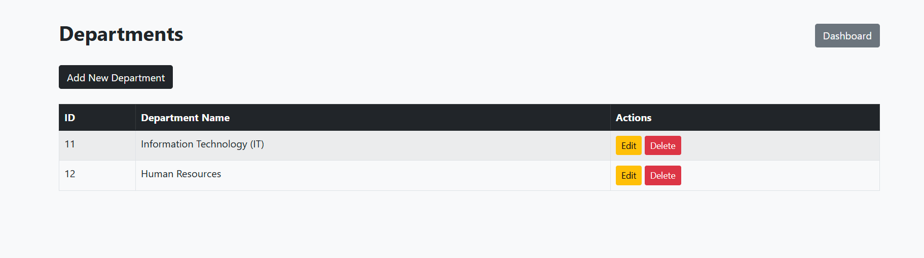

1. To Delete department, click delete under action.

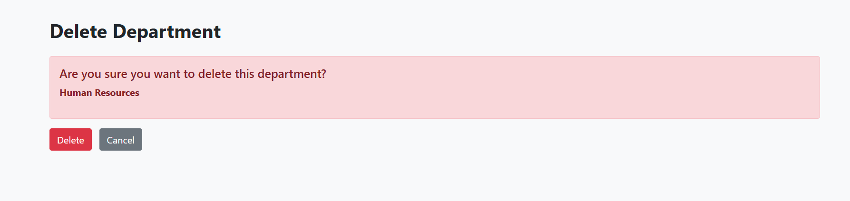

Employee will get deleted.

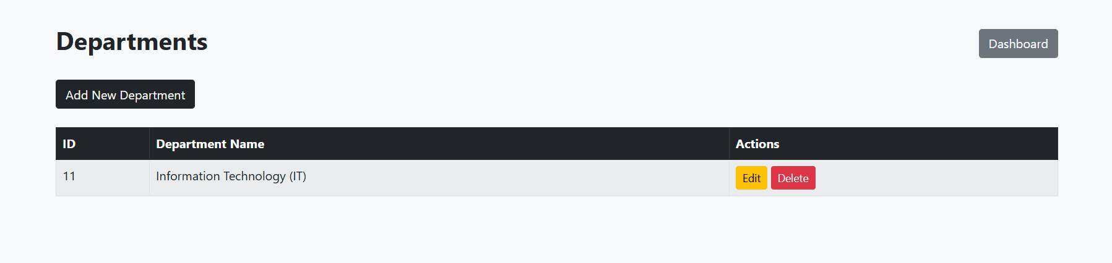

**Manage Project**

1. Landing page of project.

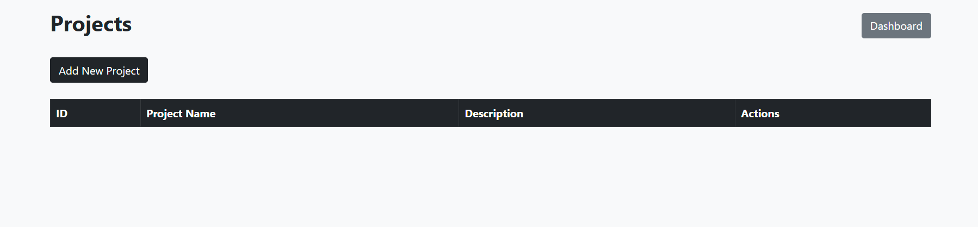

1. Click on “Add New Project”.

Fill the information for new Project.

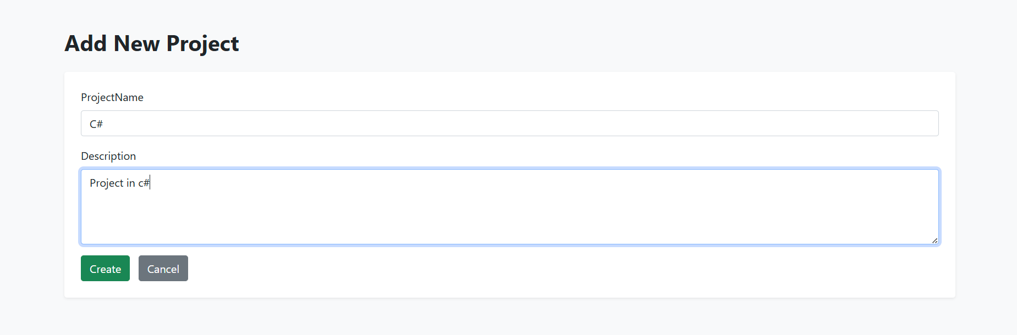

Project is created.

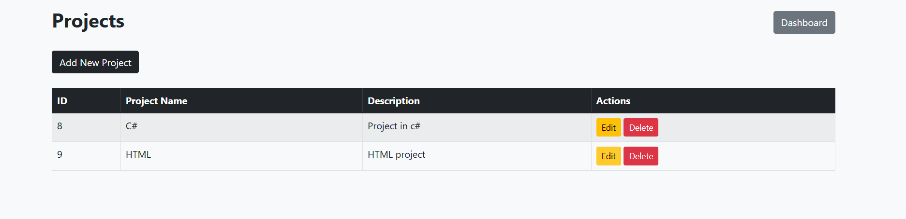

1. To edit Project, click on edit button under action.

Enter the updated information. And save changes.

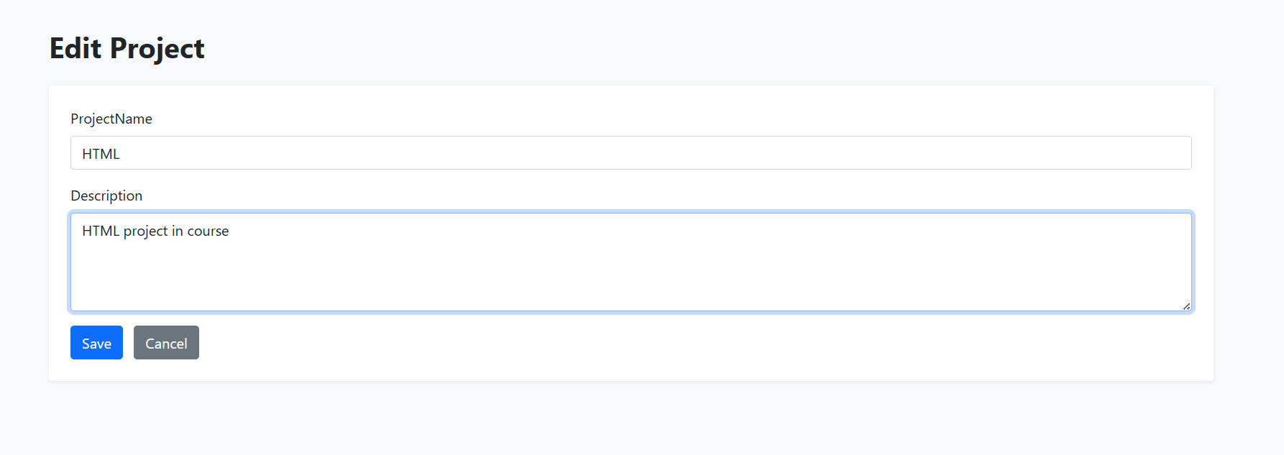

Changes will reflect in index page.

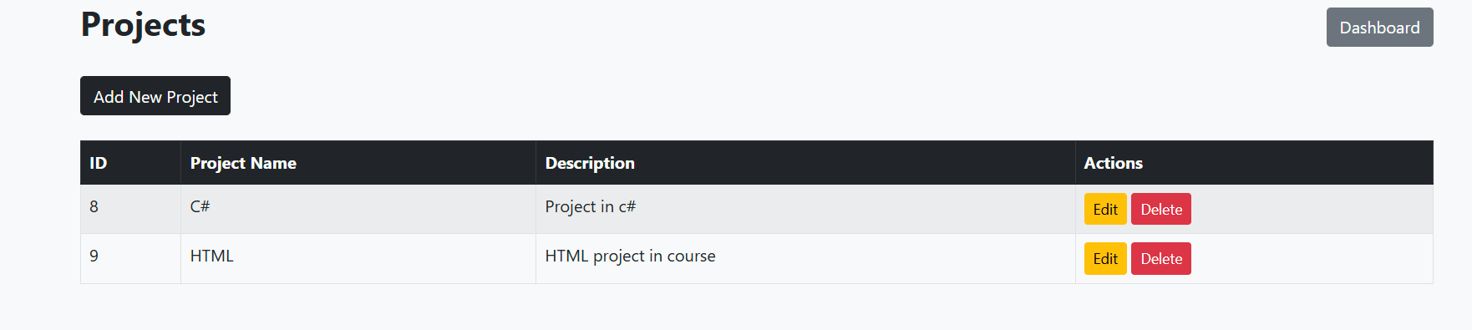

1. To Delete Project, click delete under action.

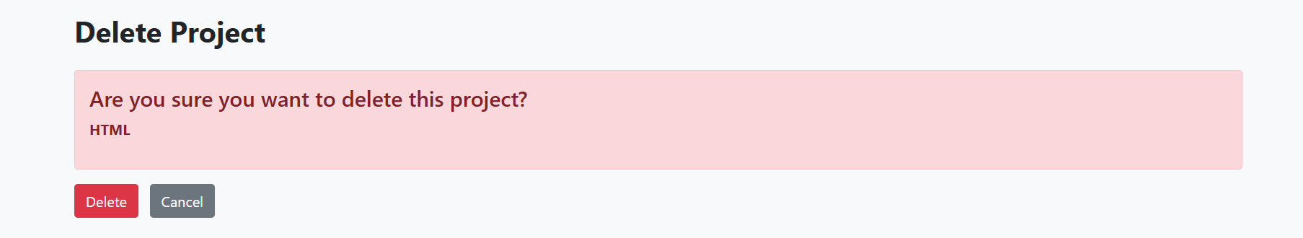

Project will get deleted.

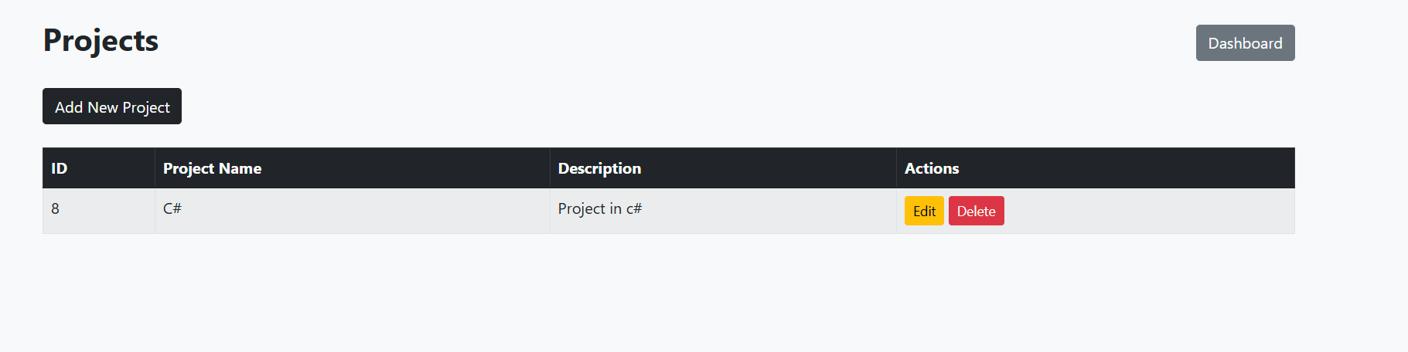

1. Landing page of project allocation.

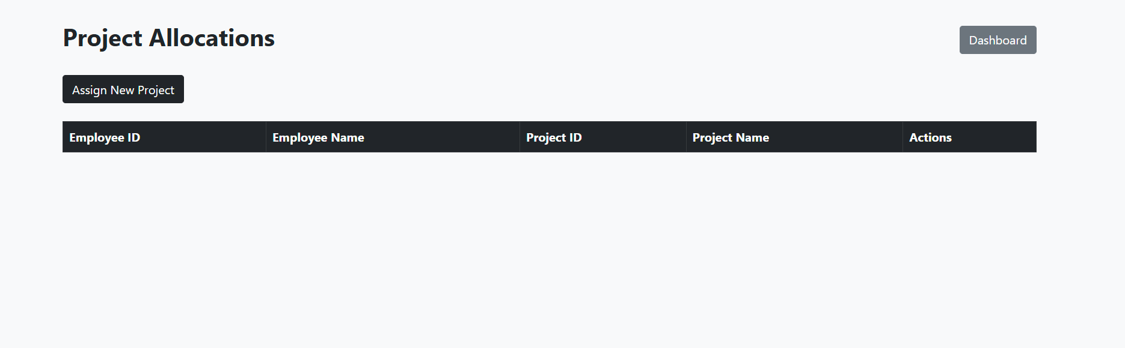

1. Click on “Add New Project allocation”.

Select employee and project for allocation.

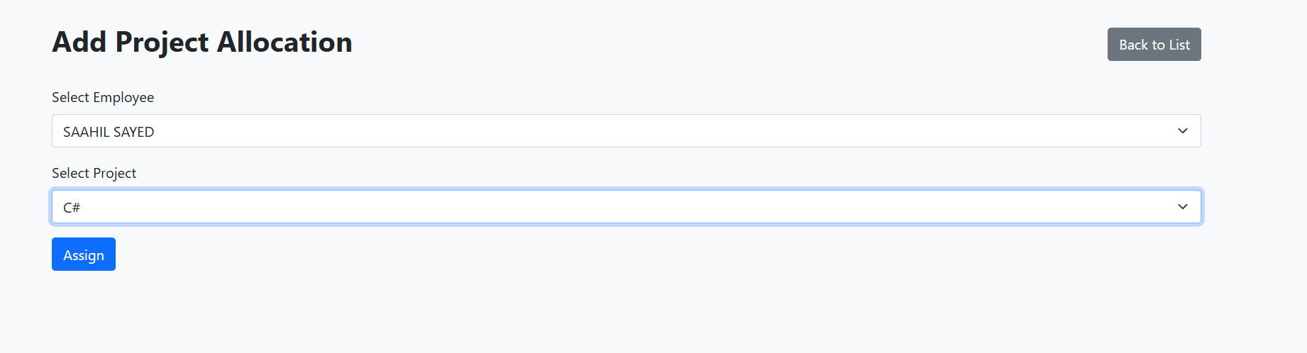

Project Allocation is created.

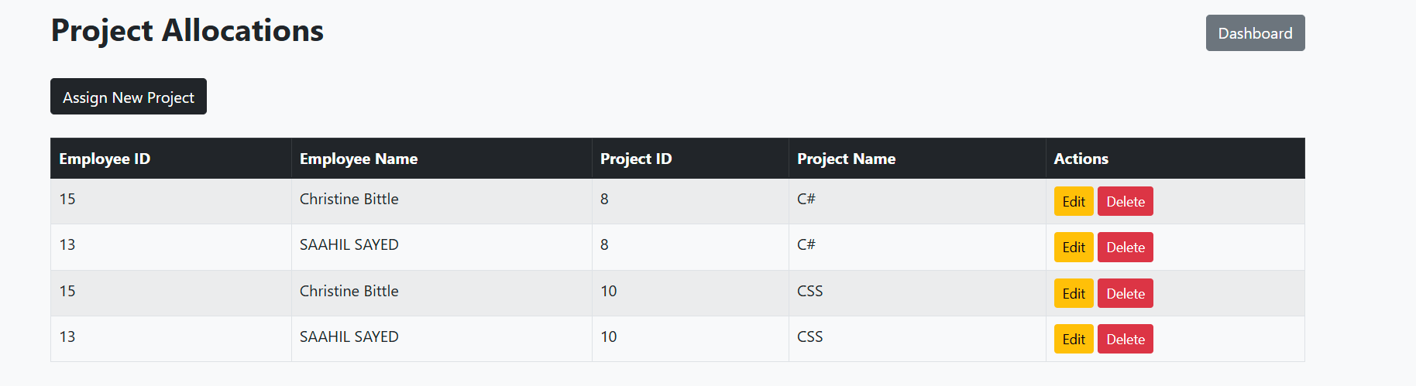

1. To Delete Project allocation, click delete under action.

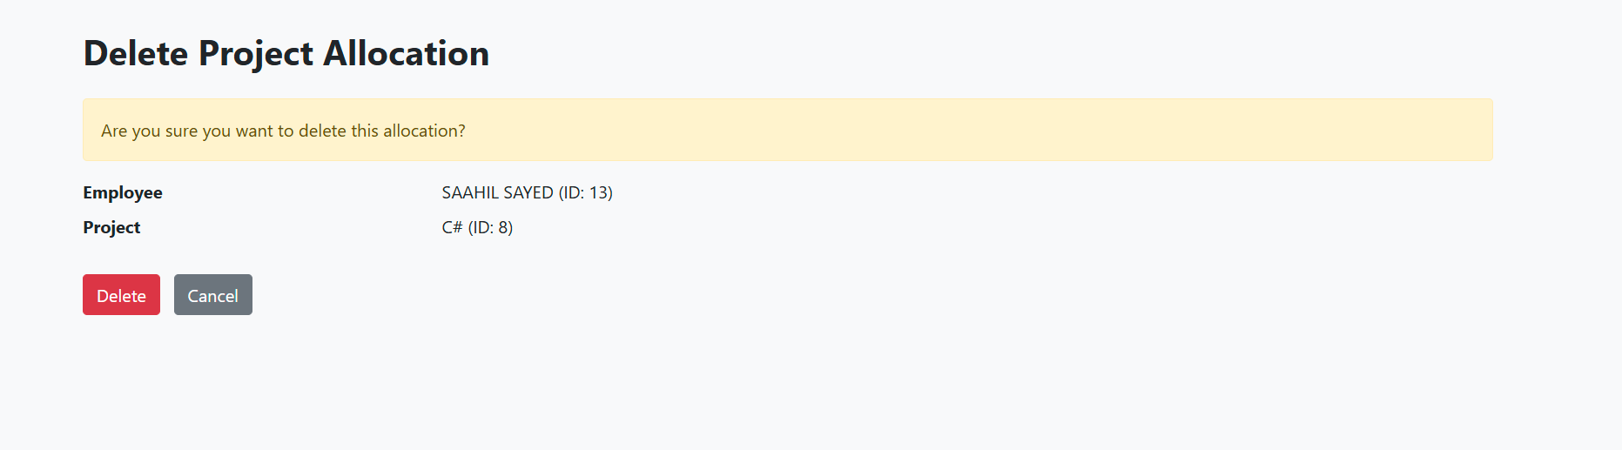

Project allocation is deleted.

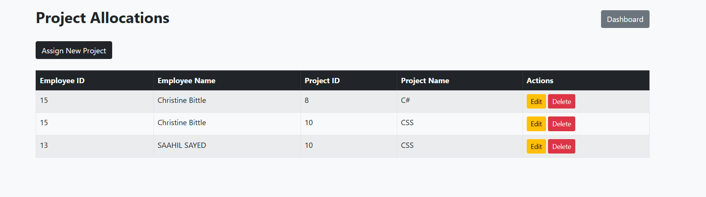

**API TESTING**

**Employee**

1. Get all employees

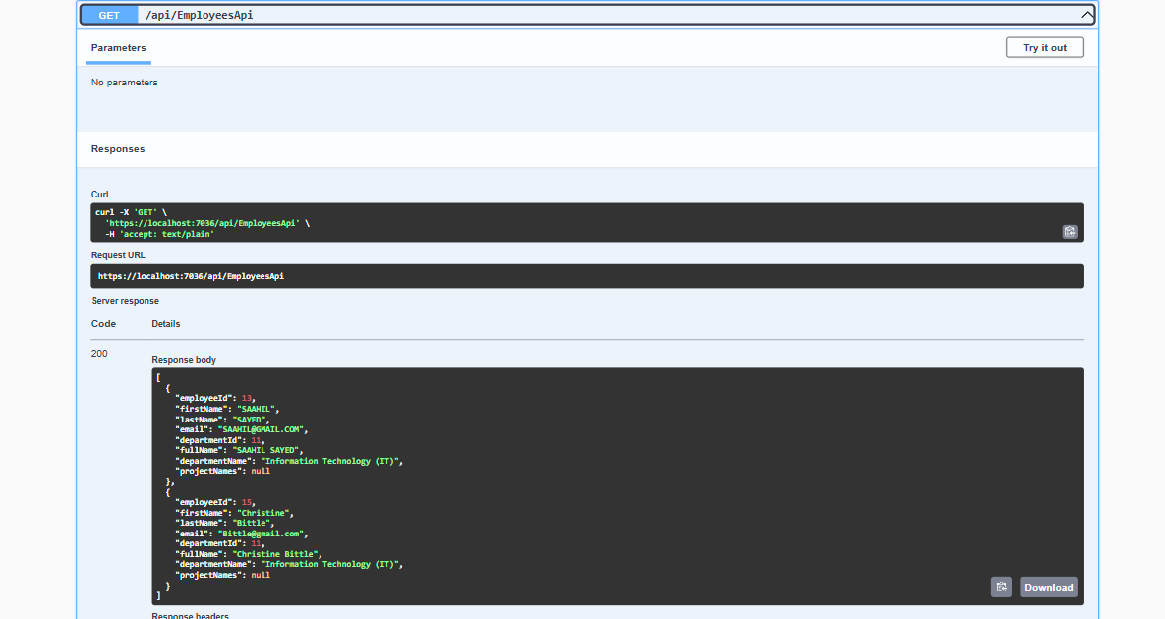

1. Get employee by id

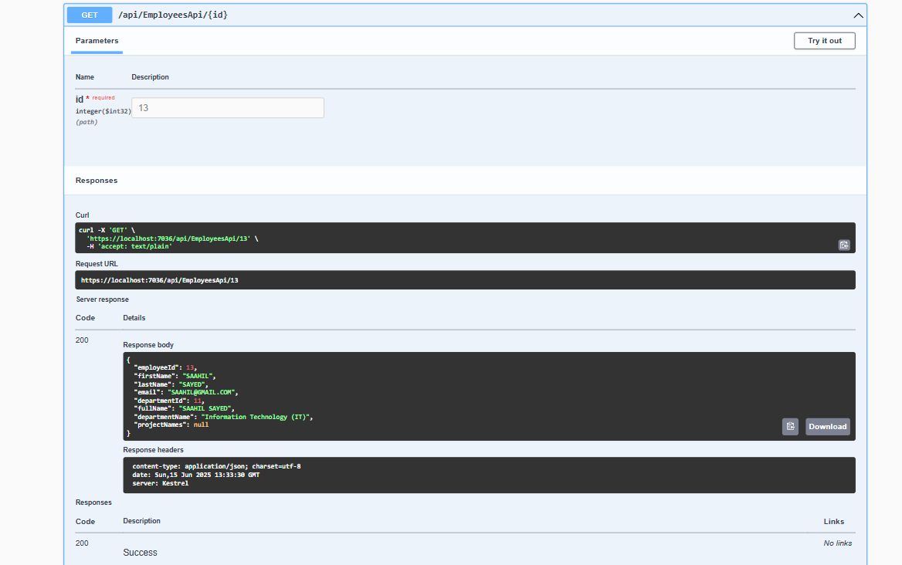

1. Create employee (Post)

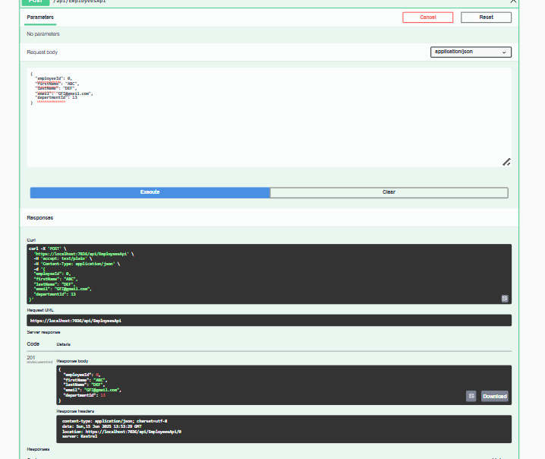

1. Edit employee (Put)

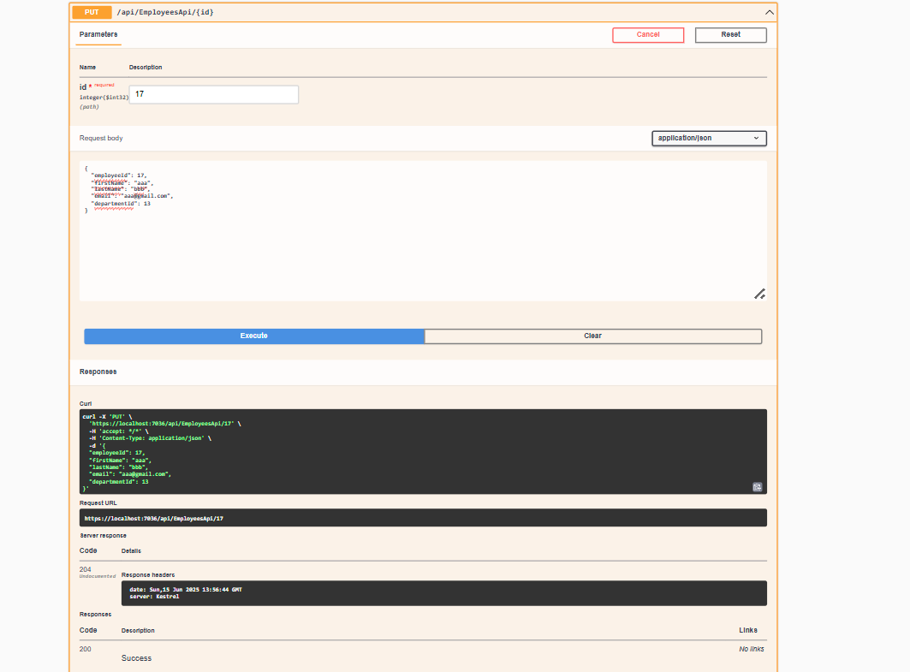

1. Delete employee

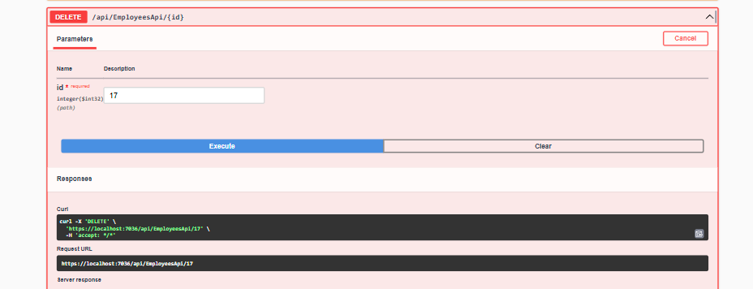

**Department**

1. Get all departments

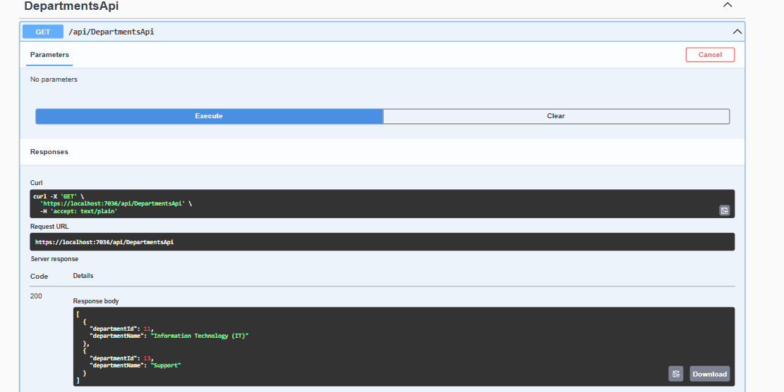

1. Get department by id

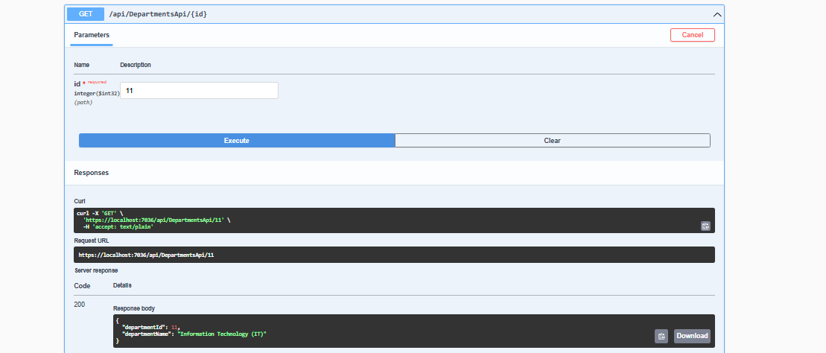

1. Create department (Post)

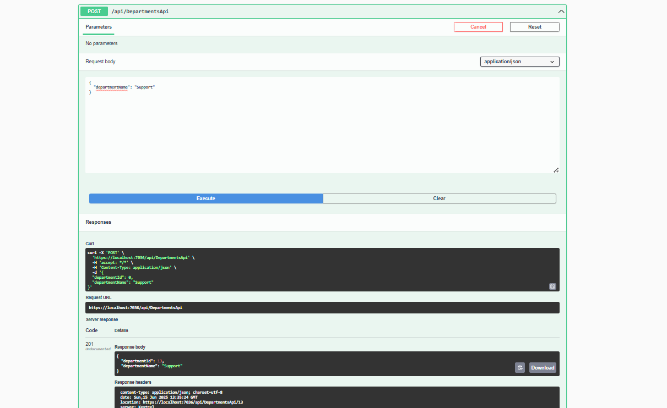

1. Edit department (Put)

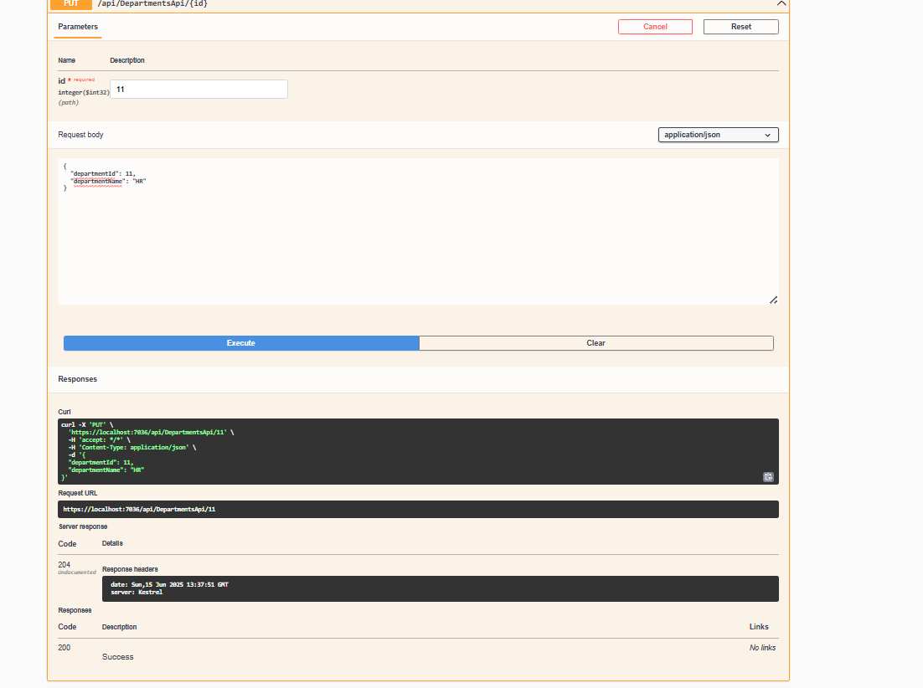

1. Delete

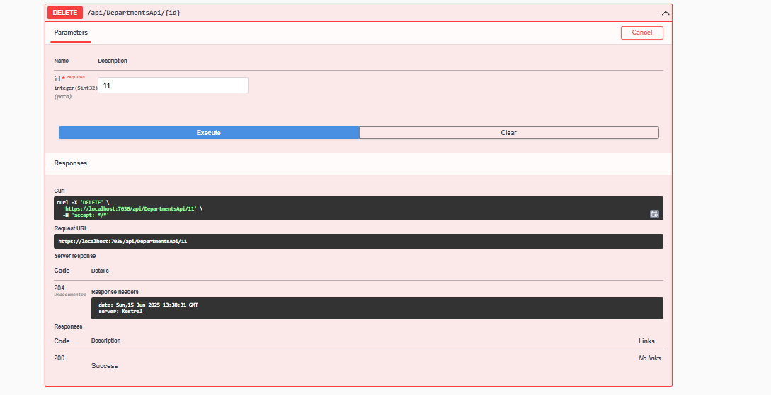

**Projects**

1. Get all Projects

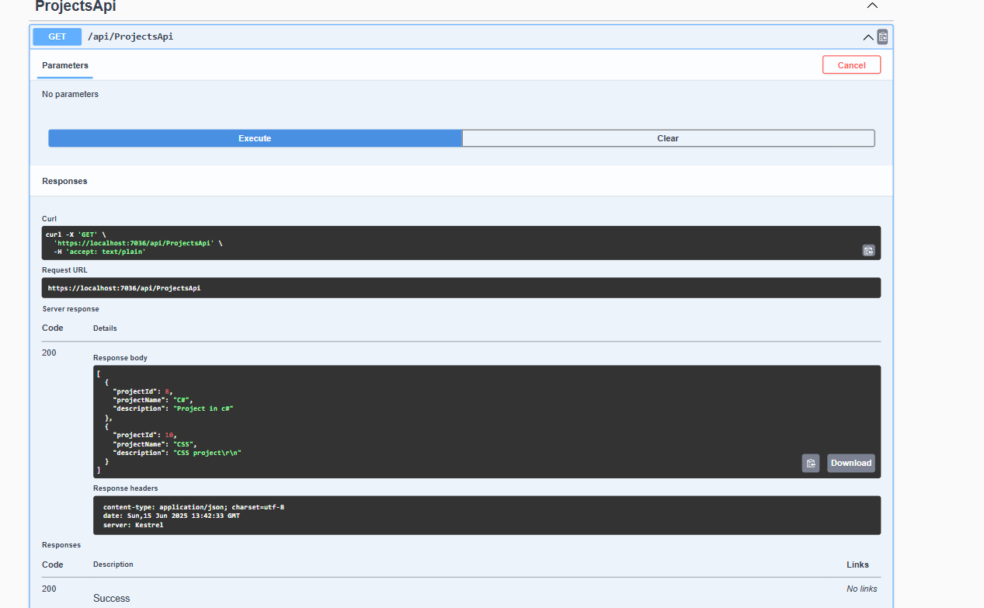

1. Get Project by id

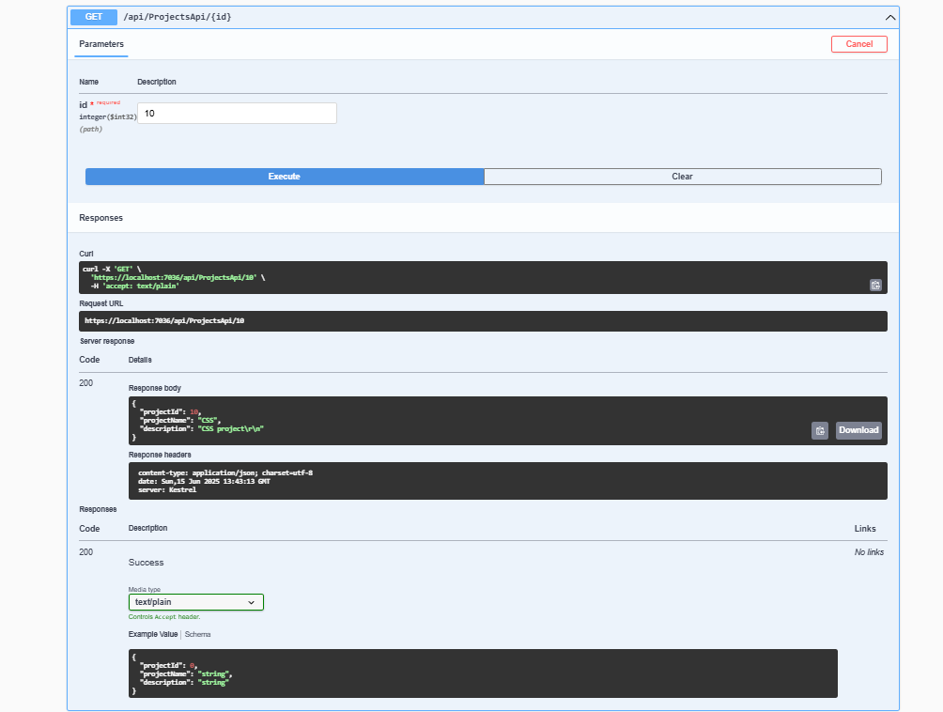

1. Create Project (Post)

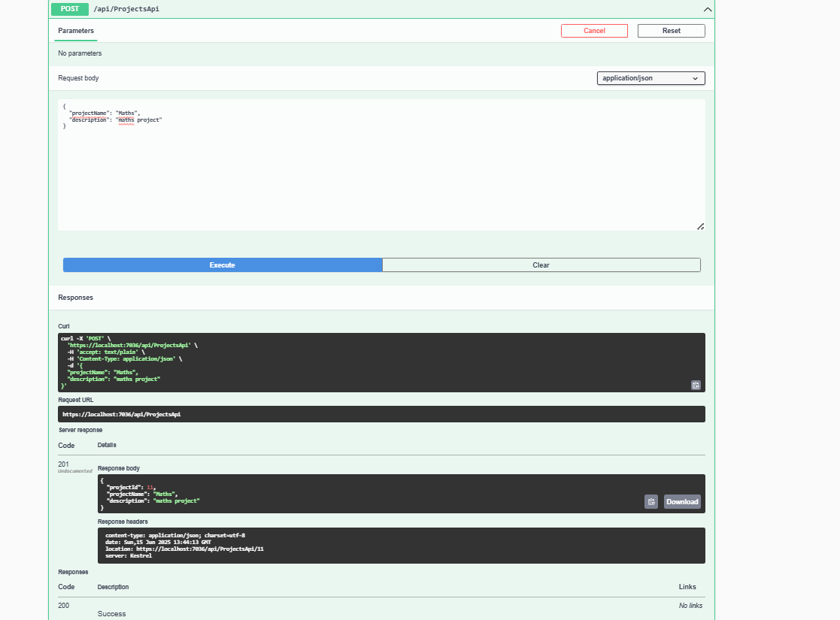

1. Edit Project (Put)

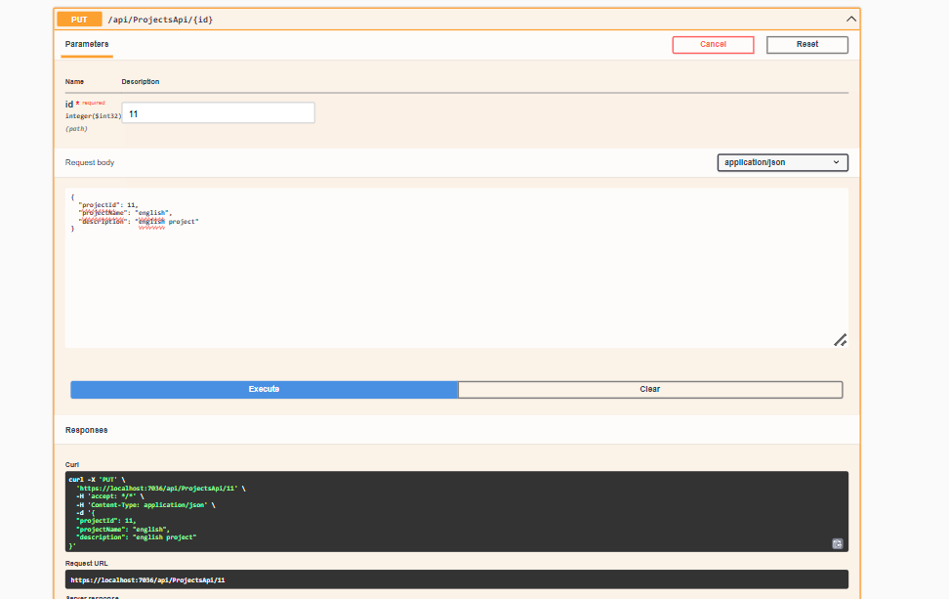

1. Delete Project

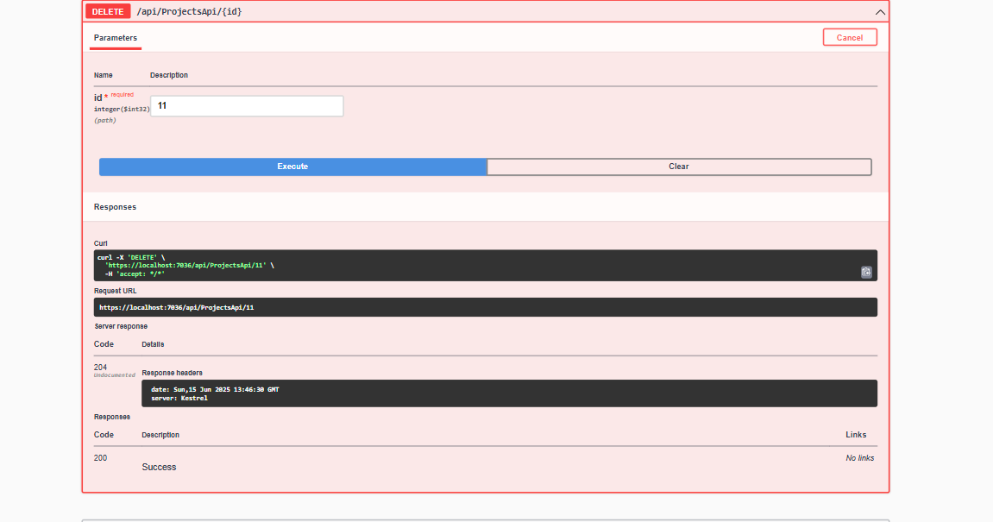

**Project Allocation**

1. Get all Project Allocation

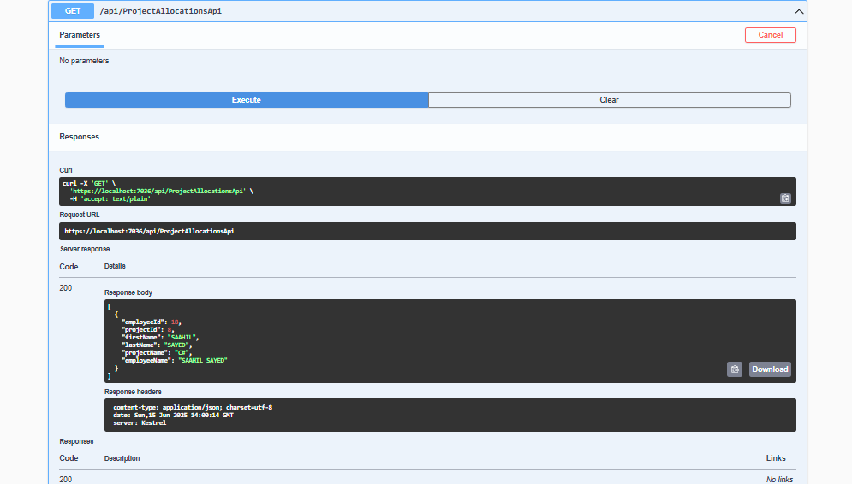

1. Create Project Allocation

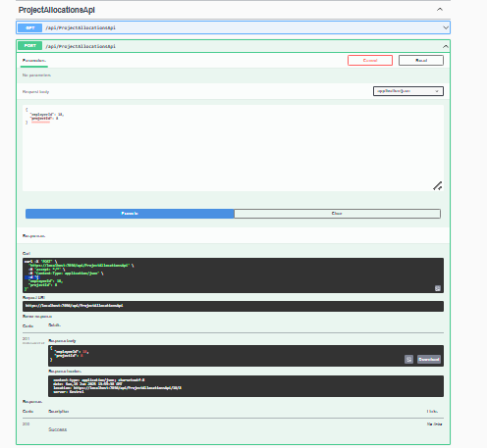

1. Delete Project Allocation

