Aaron Campbell
Problem: Write a program to compute the price of a theater ticket
- Pseudocode
Establish constant values for age group prices
Establish constant values for regular, 3D, and discounted movie ticket price

Initialize 3D Boolean

Print opening statement

Ask user if they are viewing a 3D movie or regular as input

If user input is 'y' or 'Y' set 3D boolean to True, else keep it false

Ask user for their age as input

Check if user is in the discount age group(s) or not
If in the discount age group(s), check if movie is 3D
If not a 3D movie, just calculate discounted ticket price
If not discounted age group, check if movie is 3D
If not discounted age group and not 3D, print regular ticket price

Convert ticket price variable to string for printing

Print final ticket price based on conditions above

- Actual code
#Establish constant values for age group prices
childAgeCutoff = 10
seniorAgeCutoff = 65

#Establish constant values for regular, 3D, and discounted movie ticket price
ticketPrice = 9.50
ticketPriceReduction = 4.00
ticket3dSurcharge = 3.50

#Initialize 3D boolean
movieIs3d = False

#Print opening statement
print("Welcome to Python Cinema!")

#Ask user if they are viewing a 3D movie or regular as input
response3d = input("Are you viewing this movie in 3D? y/n ")

#If user input is 'y' or 'Y' set 3D boolean to True, else keep it false
if (response3d == "y" or response3d == "Y") :
movieIs3d = True
elif (response3d == "n" or response3d == "N") :
movieIs3d = False
else :
print("Invalid entry")

#Ask user for their age as input
patronAge = int(input("What is your age? "))

#Check if user is in the discount age group(s)
if patronAge >= 65 or patronAge <= 10 :
#If in the discount age group(s), check if movie is 3D
if (movieIs3d == True) :
ticketPrice = format((ticketPrice - ticketPriceReduction) + ticket3dSurcharge,',.2f')
#If not a 3D movie, just calculate discounted ticket price
else :
ticketPrice = format((ticketPrice - ticketPriceReduction),',.2f')
else :
if (movieIs3d == True) :
ticketPrice = format(ticketPrice + ticket3dSurcharge,',.2f')
else :
ticketPrice = format(ticketPrice, ',.2f')

#Convert ticketPrice to string for printing
ticketPrice = str(ticketPrice)

#Print final ticket price based on conditions above
print("Thank you! The ticket price will be $" + ticketPrice + "! Enjoy your movie!")

- Test Cases
  - Test Case 1
    - Input: 3D = y, age = 24
    - Expected output: Full price for 3D, 13.00
    - Actual output:
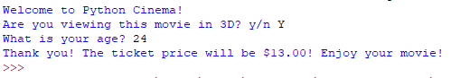
  - Test Case 2
    - Input: 3D = y, age = 65
    - Expected output: Discounted price for 3D, 9.00
    - Actual output:
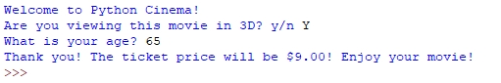
  - Test Case 3
    - Input: 3D = N, age = 11
    - Expected output: Regular price for non-3D, 9.50
    - Actual output:
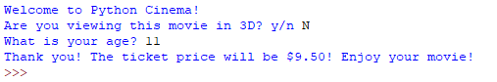
  - Test Case 4
    - Input: 3D = n, age = 72
    - Expected output: Discounted price for non-3D, 5.50
    - Actual output:
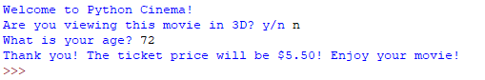
  - Test Case 5
    - Input: 3D = n, age = -2
    - Expected output: Error stating it was not a valid age
    - Actual output:
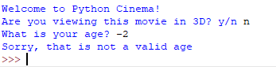
  - Test Case 6
    - Input: 3D = Y, age = “none”
    - Expected output: A console error
    - Actual output:
