Aaron Campbell
Problem: Write a program to compute the price of a theater ticket
- Pseudocode
Establish constant values for prices and tiers
Define the function that calculates carpeting costs
Multiply length times width to get square feet
Multiply square feet by selected quality tier to get cost per square foot
Print the result to the screen and return
Print opening statement and offer quality choices
Prompt user for input of carpet quality
Determine user selection and assign it to a variable
Prompt user for measurements of room in ft
Call the function to calculate the carpeting cost using input values as parameters

- Actual code
#Establish constant values for prices and tiers
budgetQuality = 2.00
standardQuality = 5.50
premiumQuality = 9.50

#Define the function that calculates carpeting costs
def costOfCarpeting (length, width, quality) :
#Multiply length times width to get square feet
sqFt = length * width
#Multiply square feet by selected quality tier to get cost per square foot
costPerRoom = format(sqFt * quality,'.2f')

#Print the result to the screen
print("The cost to carpet your room is $" +
costPerRoom + " at $" + str(format(quality,'.2f')) + " per square foot.")
return

#Print opening statement
print("Welcome to UMGCarpeting! Where we 'lay the groundwork' for your success!\n")
print("Enter the number of your selection:\n" +
"1. Budget Quality Carpeting (our cheapest) -- $2.00\n" +
"2. Standard Quality Carpeting (our most popular) -- $5.50\n" +
"3. Premium Quality Carpeting (our fanciest, with that special padding) --$9.50\n")

#Prompt user for input of carpet quality
selectedQuality = int(input("Which would you prefer? "))

#Determine user selection and assign it to a variable
if (selectedQuality == 1) :
carpetQuality = budgetQuality
elif (selectedQuality == 2) :
carpetQuality = standardQuality
elif (selectedQuality == 3) :
carpetQuality = premiumQuality
else :
print("Sorry, that is not a valid selection. Thank you!")

#Prompt user for measurements of room in ft
print("\nGreat! Now it's time to enter the measurements of your room!")
roomWidth = float(input("Please enter the width of your room, in feet: "))
roomLength = float(input("Please enter the length of your room, in feet: "))

#Call the function to calculate the carpeting cost
costOfCarpeting(roomLength, roomWidth, carpetQuality)

- Test Cases
  - Test Case 1
    - Input: width = 16, length = 21, choice = 2
    - Expected output: $1848
    - Actual output:
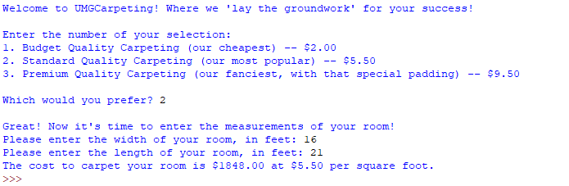
  - Test Case 2
    - Input: width = 10, length = 11.5, choice = 3
    - Expected output: $1092
    - Actual output:
