Aaron Campbell
Problem: Create a program to validate a password based on conditions
- Pseudocode
Initialize list of five students
Initialize variables for student grades to compute
Print opening statement
Iterate through list of students
Prompt user to input grade for each student as it loops
Add each grade to a new list
Take the student grade total and divide by the number of students for the average
Convert average to string and print the result to the screen

- Actual code
#Initialize list of five students
studentsList = ["Sandra Dee",
"Johnny Appleseed",
"James Kirk",
"Quentin Florentino",
"Ronald Weasley"]

#Initialize variables for student grades to compute
gradeList = []
studentGradeTotal = 0
studentGradeAvg = 0

#Print opening statement
print("Please input the grades for the following students")

#Iterate through list of students
for student in studentsList:
print("Enter the grade for",student)
#Prompt user to input grade for each student as it loops
studentGrade = float(input())
#Add each grade to a new list
gradeList.append(studentGrade)
studentGradeTotal += studentGrade

#Take the student grade total and divide by the number of students for the average
studentGradeAvg = round((studentGradeTotal / 5),1)

#Convert average to string and print the result to the screen
print("The average grade for all five students is " +
str(studentGradeAvg) + "%, and the \n" +
"highest grade was " + str(max(gradeList)) + "%.")

- Test Cases
  - Test Case 1
    - Input: Grades = 85.5, 98, 79.4, 94, 88
    - Expected output: 88.98
    - Actual output: (rounded to nearest tenth)
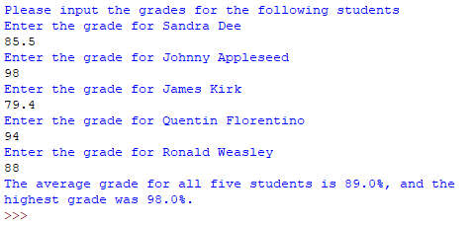

  - Test Case 2
    - Input: Grades = 77.6, 83.7, 95, 100, 68
    - Expected output: 84.86
    - Actual output: (rounded to nearest tenth)
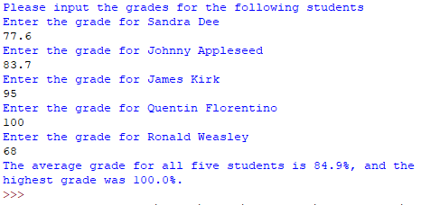
  - Test Case 3
    - Input: Grades = 79, 85, 98, 97, 94
    - Expected output: 90.6
    - Actual output: (rounded to nearest tenth)
