Aaron Campbell
Problem: Create a program that takes ten consecutive days of Celsius temperatures and displays them as Fahrenheit
- Pseudocode
Initialize the array variables for Celsius and Fahrenheit
Initialize variables for warm, hot, and cold day counters
Display opening message to user
Prompt user to enter temperatures until limit has reached while loop condition
Print all ten temperatures to screen
Loop through Celsius temps and convert to Fahrenheit
81 degrees or higher is a hot day
Between 62 and 80 degrees is a warm day
Less than 62 would be a cold day
Print the Fahrenheit temperatures to screen
Display the number of hot, warm, and cold days

- Actual code
c_temps = []
f_temps = []

warmDays = 0
hotDays = 0
coldDays = 0

print("You will be entering the temperatures for the next 10 days in Celsius.")

while len(c_temps) < 10 :
print("Please enter a temperature in Celsius:")
c = int(input())
c_temps.append(c)

print("The temperatures in Celsius are:\n",c_temps)

for c in c_temps:
f = int((c * 1.8) + 32)
f_temps.append(f)
if f >= 81 :
hotDays += 1
elif f >= 62 and f <= 80 :
warmDays += 1
elif f < 62 :
coldDays += 1

print("The temperatures in Fahrenheit are:\n",f_temps)

print("Based on these temperatures, there will be:\n",hotDays,"hot days\n",warmDays,"warm days\n",coldDays,"cold days.")

- Test Cases
  - Test Case 1
    - Input: Celsius Temps = 33, 40, 31, 27, 24, 19, 12, 18, 24, 23
    - Expected output: 3 hot days, 6 warm days, 1 cold day
    - Actual output: (converted to integer)
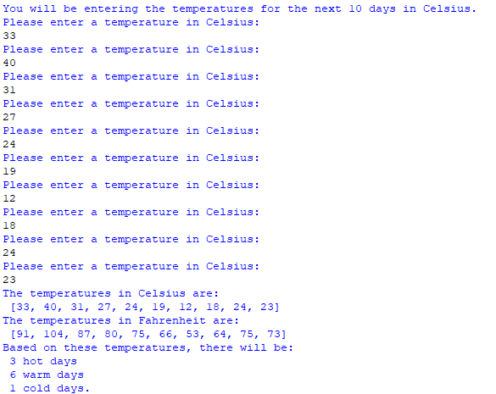

  - Test Case 2
    - Input: Celsius Temps = 15, 16, 24, 23, 12, 9, 19, 21, 26, 20
    - Expected output: 0 hot days, 6 warm days, 4 cold days
    - Actual output: (converted to integer)
