Aaron Campbell
Problem: Determine the body-mass index of a collection of 6 individuals
- Pseudocode
Initialize list of names
Initialize array lists for BMI and number of people in each category
Define function to determine body mass index using formula
Define function with BMI as parameter to determine if underweight, normal, or overweight
if BMI under 20.5
underweight
else if BMI between 20.5 and 25.0
normal weight
else if BMI is greater than or equal to 25.0
overweight
Prompt user to input BMI in inches and pounds for each individual using FOR loop
If BMI is underweight/overweight/normal, add it to the
number of individuals in that category
Add the individuals BMI to a separate list and print name and BMI to screen
Loop through the list of BMI and call function if overweight or underweight or normal
Print the number of individuals for each category to the screen

- Actual code
#Initialize list of names
individuals = ["JayJay","Andre","Chantel","Eugene","Ysenia","Clawdeen"]

#Initialize array lists for bmi and number of people in each category
bmiList = []
underweightBMI = 0
normalWeightBMI = 0
overweightBMI = 0

#Define function to determine body mass index
def bodyMassIndex(height, weight):
bmi = (weight * 703) / height**2
return bmi

#Define function with BMI as parameter to determine if underweight, normal, or overweight
def weightCategory(userBMI):
#if BMI under 20.5
if userBMI < 20.5 :
category = "underweight"
#else if BMI between 20.5 and 25.0
elif userBMI >= 20.5 and userBMI < 25.0:
category = "normal weight"
#else if BMI greater than or equal to 25.0
elif userBMI >= 25.0:
category = "overweight"
return category

#Prompt user to input BMI in inches and pounds for each individual
for individual in individuals:
print("Please enter the height in inches and weight in pounds for",individual)
personHeight = float(input("Height: "))
personWeight = float(input("Weight: "))
bmi = round(bodyMassIndex(personHeight, personWeight),2)
#If BMI is within a certain range, add it to the number of individuals in that category
if bmi < 20.5:
underweightBMI += 1
elif bmi >= 20.5 and bmi < 25.0:
normalWeightBMI += 1
elif bmi >= 25.0:
overweightBMI += 1
#Add the individuals BMI to a separate list and print to screen
bmiList.append(bmi)
print("The BMI of",individual,"is",bmi)

#Loop through the list of BMI and call function if overweight or underweight or normal
for bodymass in bmiList:
print("A BMI of",bodymass,"is considered to be",weightCategory(bodymass))

#Print the number of individuals for each category to the screen
print("\n")
print("Number of individuals that are underweight:",underweightBMI)
print("Number of individuals that are in the normal range:",normalWeightBMI)
print("Number of individuals that are overweight:",overweightBMI)

- Test Cases
  - Test Case 1
    - Input: Height/Weight: = [79/195, 78/256, 64/105, 68/175, 67/136, 65/127]
    - Expected output: Normal, overweight, underweight, overweight, normal, normal
    - Actual output:
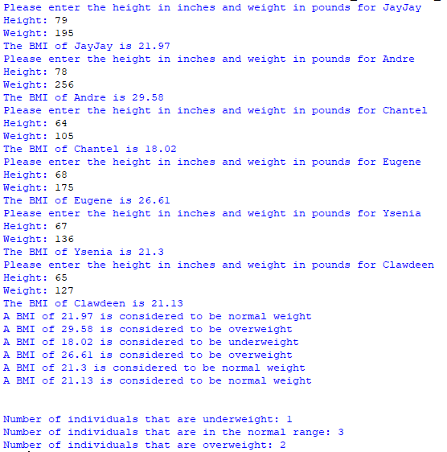

  - Test Case 2
    - Input: Height/Weight: = [70/341, 72/155, 62/148, 69/180, 58/108, 66/127]
    - Expected output: Overweight, normal, overweight, overweight, normal, normal
    - Actual output:
