Machine Learning

Programming Assignment 1

Behnam Heydarshahi

3.1 Sensitivity to Irrelevant Features

It appears IBk initially performs better than J48. But as we increase the number of features from 14 IBk performs drastically worse.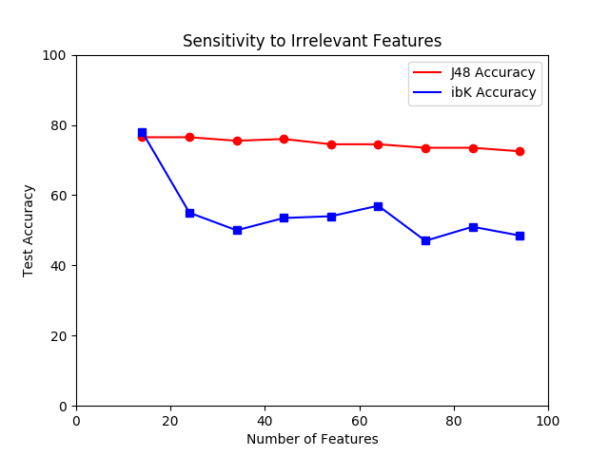

3.2 Learning Curves

The effect of growth of training size on J48 is evidently larger than iBK. The larger the training set size gets, the better accuracy of J48 gets. The same cannot be said about iBK.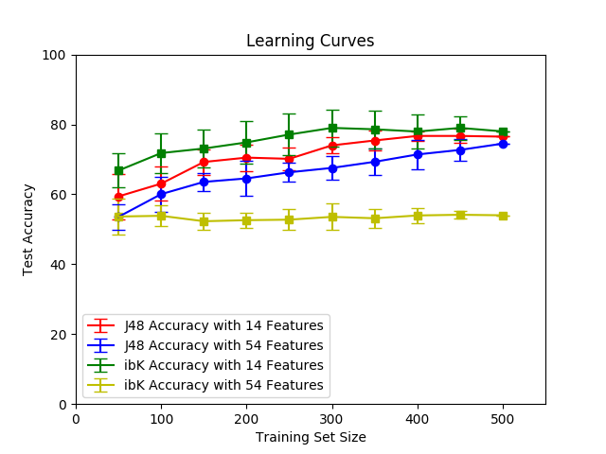

It is interesting that among the four experiments, iBK performs best of the four with 14 features and worst of the four when run with 54 features.

It is worth noting that generally the standard deviation gets smaller as training size increases.

J48 also performs better with 14 feature than 54 features, which confirms the results from the previous section.