COMP135

Empirical/Programming Assignment 3

Behnam Heydarshahi

**1. Investigating the Effect of Initialization on k-means: Random vs Smart**

First off, here's an overview off all the 8 datasets:

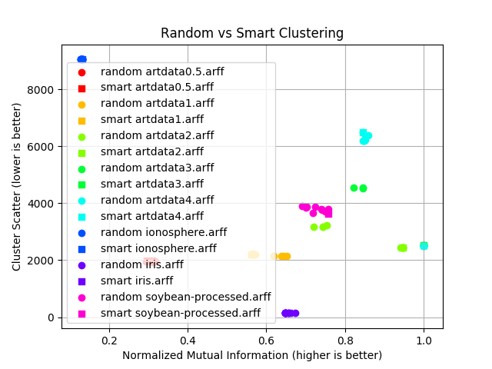

In the next picture, I remove the legends so the clusters are more visible.

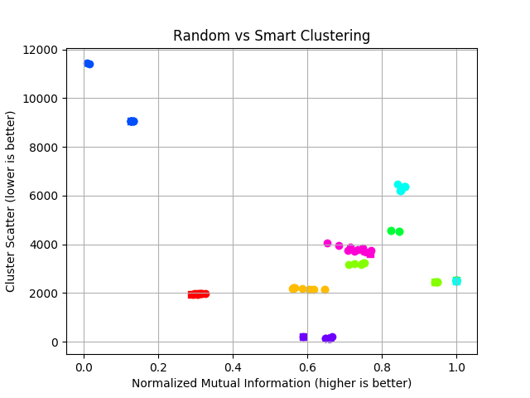

From above figures, I can see that ionosphere is the hardest dataset to cluster.

Are CS and NMI stable multiple random initializations?

There above picture of 10 random initializations looks like each dataset's results are in a certain proximity, but when you look at the individual graphs below there is definitely big changes in both NMI and CS values across random initializations.

Another interesting point is that their quality judgments are not always in agreement. But it is not hard to see there is a vague pattern (for example in artdata1) where smart initializations most of the times give answers with low lowest CS and highest NMI.

Smart initialization fares betters with respect to NMI, than CS.

Now for a better view, let's go through the results of all 8 datasets.

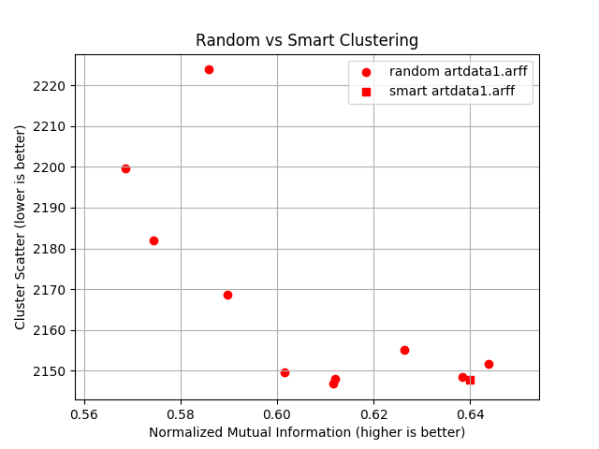

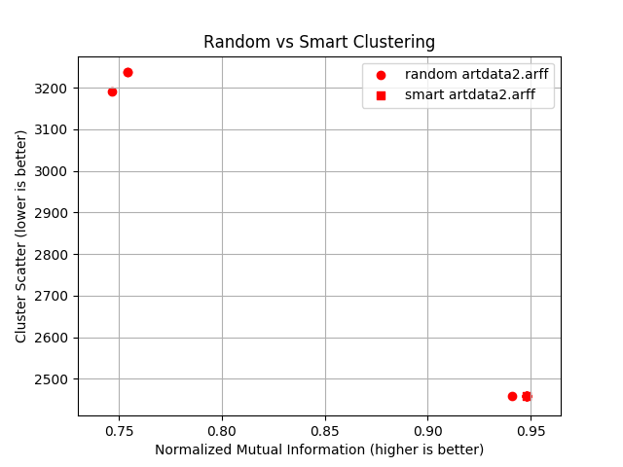

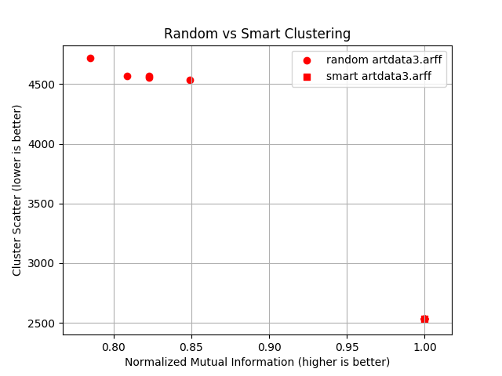

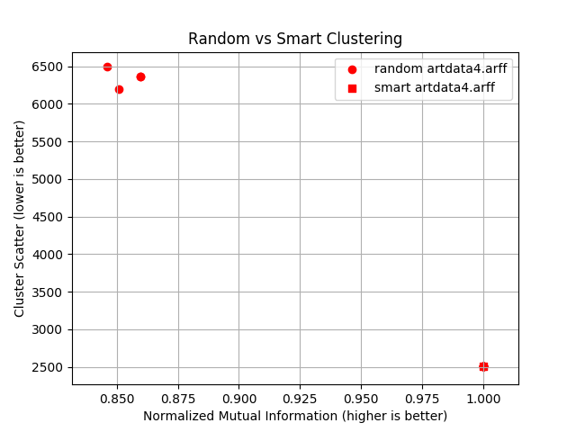

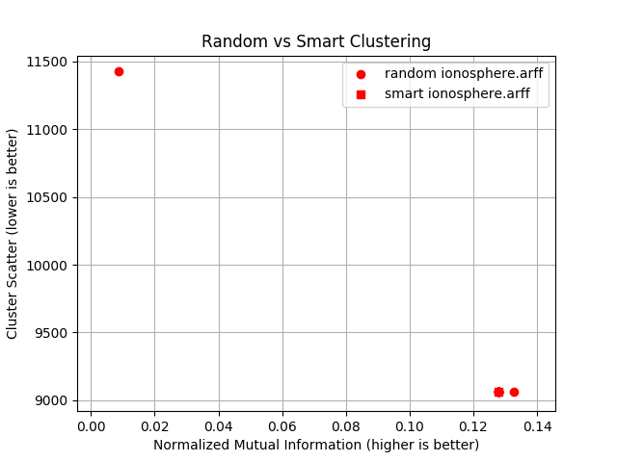

Note that the total number of nodes is still 11, but the values are too close for the chart, so multiple nodes look like one.

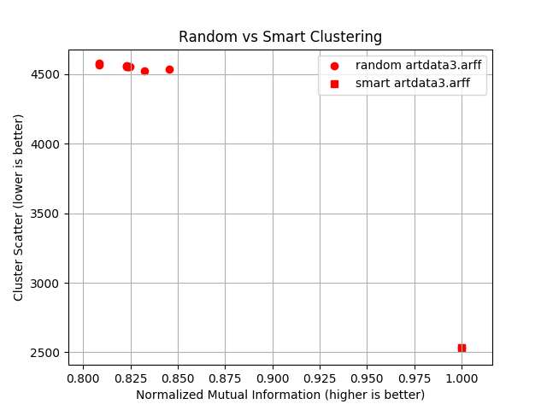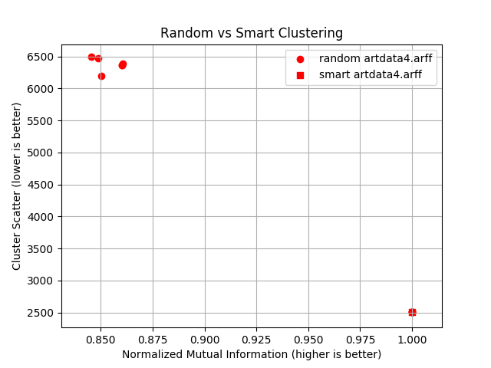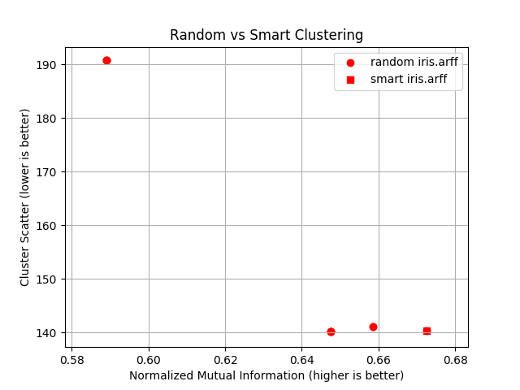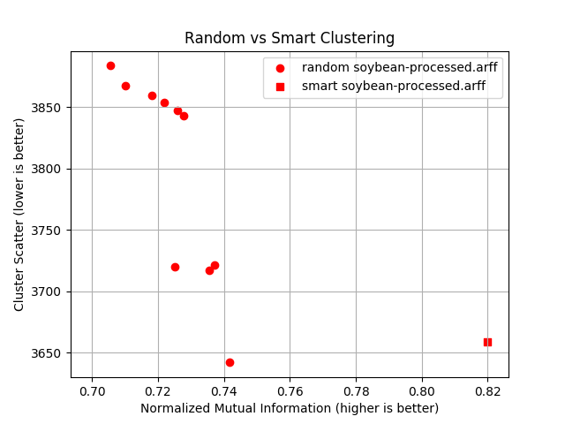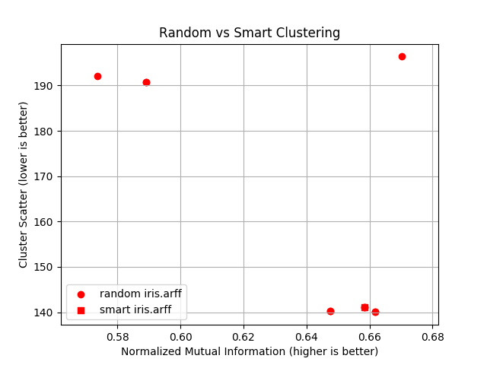



**2. Selecting k**

Is there visual evidence suggesting CS can be used as a criterion for selecting k?

Yes! The derivative of the plots drastically becomes less steep at certain k values. Usually the largest derivative change happens on k = number of different class labels.

What can we conclude from the relative performance on the artificial databases?

Two things:

(1) For the five artificial datasets, 'argdata 0.4' through 'artdata 0.5' performance relatively improves. Therefore we conclude that relative to the spheres' width, the spheres are closer in the 'argdata 4' than 'argdata 3' and so on and so forth.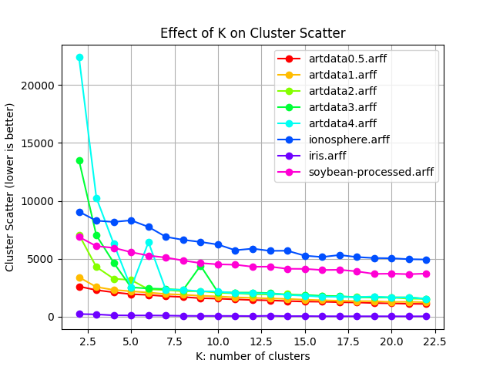

(2) The variability in performance is much much higher, and datasets with close spheres perform much worse, when the cluster number is smaller than the knee value, which is 5.

Are the results consistent across datasets? What can you observe?

Generally yes. That said, I made these observations:

There are two irregularities in Artdata 4 and Artdata3 graphs, where performance suddenly bumps up for k=6 and k = 9, respectively.

The variability of results on real data is much much smaller, especially when cluster number is small.