COMP135

Empirical/Programming Assignment 4

Behnam Heydarshahi

Neural Networks

**Part 1: 838 dataset**

Below figure contains the trend of neural network's training error rate with increase of iteration.

General trend is, the more iterations, the more accurate the predictions. Additionally I made the following three observations:

(1) Error increase from .825 to 1 in when the iteration is smaller than 20. That is perhaps addressable to the fact that the network learns anything, it is guessing the same number, rather randomly, and chances of guessing one of the 8 output nodes randomly is 1/8. As the network tries to learn after 20 iterations or so, it looses the benefit of randomness, but soon after 200 iterations, the benefits of making a learned guess start to show.

(2) The error rate changes in steps. That is because we have a limited number (8) of input data. Therefore, when a new value is learned, the error rate drops by 1/8.

(3) There is a surge in error near 1750 iterations. One theory is that the network starts to learn a better compression rule at that point, where it drops the current rule, which hurts the accuracy at first, but gains it later on. At 2500+ iterations the predictions are always correct.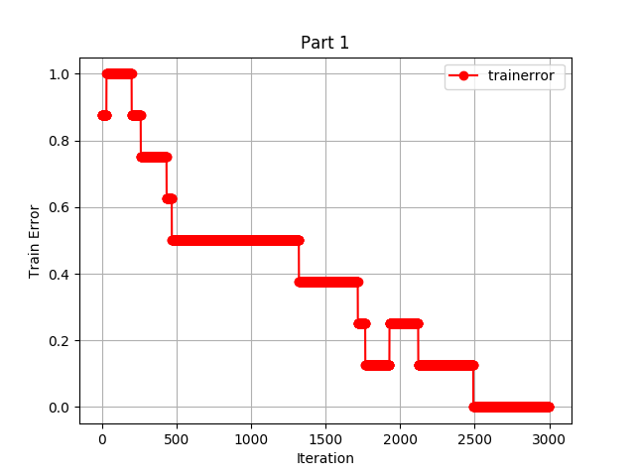

**Hidden Units Representation:**

Below is the representation my code prints.

[1.0, 0.0, 0.0, 0.0, 0.0, 0.0, 0.0, 0.0] --> 0.183218139209 0.256381555915 0.975508515699 --> 1

(0x1)

[0.0, 1.0, 0.0, 0.0, 0.0, 0.0, 0.0, 0.0] --> 0.977969925039 0.424915809918 0.0691604695012 --> 2 (1x0)

[0.0, 0.0, 1.0, 0.0, 0.0, 0.0, 0.0, 0.0] --> 0.529877611108 0.975555069763 0.0505748912021 --> 3

(x10)

[0.0, 0.0, 0.0, 1.0, 0.0, 0.0, 0.0, 0.0] --> 0.378697489384 0.361981334259 0.336551316341 --> 4

(xxx)

[0.0, 0.0, 0.0, 0.0, 1.0, 0.0, 0.0, 0.0] --> 0.031148699745 0.969650075395 0.83674947487 --> 5

(011)

[0.0, 0.0, 0.0, 0.0, 0.0, 1.0, 0.0, 0.0] --> 0.329056011223 0.356633608434 0.410168341984 --> 6

(xxx)

[0.0, 0.0, 0.0, 0.0, 0.0, 0.0, 1.0, 0.0] --> 0.957579040378 0.0268982899954 0.92707061013 --> 7

(101)

[0.0, 0.0, 0.0, 0.0, 0.0, 0.0, 0.0, 1.0] --> 0.392479560595 0.332274864132 0.359044383485 --> 8

(xxx)

Even though my code reaches 100% accuracy, and while some encodings are clear, such as 101 for 7 and 011 for 5, my code does not reflect the binary representation the way the example from class does. I marked anything between 0.25 and 0.75 as unknown (x), below 0.25 as 0, and above .075 as 1. That said, if we want to force ourselves to find a correlation with binary representation, one way would be to normalize the values to a different base and roof other than 0 and 1.

**Part 2:** OPT Digits datasets

**2.1.1 Train/test error of six width over 200 iterations**

I first simulated 200 iterations, with depth of 3, and width of 5, 10, 15, 20, 30, and 40. For each of the six configurations I documented the changes of training and test errors over number of iterations. Here too, I observed that with more iterations the test results become more accurate. That said, it is worth noting that the gains in test error reduction become very small (below one percent) after a width of 20 nodes per layer. So given a fixed depth, if we want to have a faster algorithm, we might want to stick with w=30 which would also give us a fairly accurate test rate. Otherwise, if we do not care about run time and resources, we can use the largest width possible.

Among all the configurations d3w30 performed best.

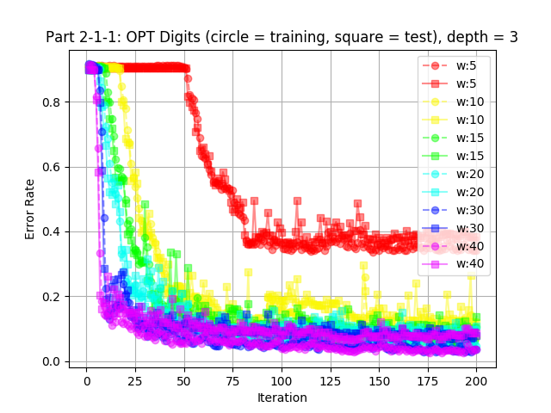

**2.1.2 Test error of six networks with different widths**

Then I plotted the error of last iteration, as a function of width. The results where in line with my expectations. More width results in better accuracy.

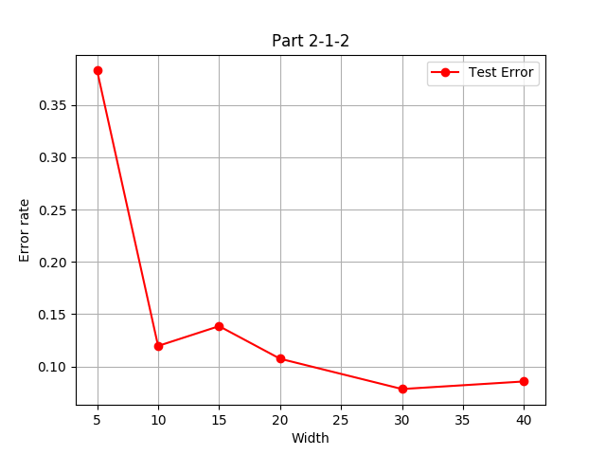

**2.2.1 Train/test error of six depths over 200 iterations**

I first simulated 200 iterations, with width of 10, and depth of 0, 1, 2, 3, 4, and 5. For each of the six configurations I documented the changes of training and test errors over number of iterations. Here too, I observed that the depth of 0 was too small and 4, and 5 were too large. 2 was the best. Almost as good as the previous experiment, the best in this experiment was d1w10.

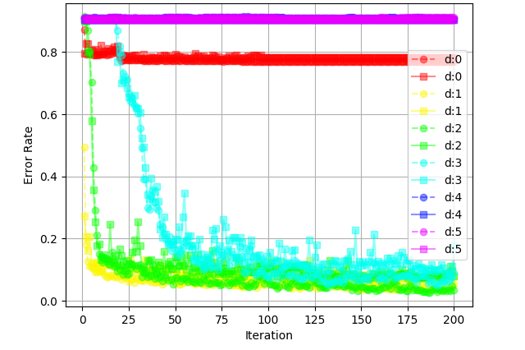

**2.2.2 Test error of six networks with different depths**

Then I plotted the error of last iteration, as a function of depth. It appears that neural network works best with non zero but small depths, such as 1 and 2. Too many or too few hidden layers decrease accuracy of neural network.

