Comparative Evaluation of AutoML Frameworks for Tabular Data in Resource-Constrained Environments
Implications for Data Science Practice in Ghana
Dr. Hanifatu Napari Mumuni¹ and Clement Donkor Ampofo²
¹ Tamale Technical University (TaTU) · ² MTech, Data Science
4th Annual Statistics and Data Science Conference 2026, Tamale, Ghana
Abstract
Automated machine learning (AutoML) promises expert-level tabular models without specialist staff, yet published benchmarks almost universally assume abundant cloud or HPC resources. This leaves a guidance gap for public-sector institutions in developing economies such as Ghana, where analytics run on office-grade laptops and workstations. We benchmark five leading open-source AutoML frameworks — AutoGluon, PyCaret, FLAML, auto-sklearn, and H2O AutoML — across three Docker-enforced resource tiers (4/8/16 GB RAM; 2/4/8 cores) on seven public tabular datasets spanning classification and regression, for a full factorial of 105 runs. Beyond predictive quality (weighted F1, AUC-ROC, RMSE) we record peak memory and, critically, completion rate — whether a framework finishes at all under the cap. Our central finding is that completion, not accuracy, separates the frameworks on constrained hardware: four of five frameworks complete every cell, while PyCaret — despite the highest apparent F1 — fails or times out on the hardest cells, so its accuracy is survivorship-biased. FLAML delivers the best accuracy-to-resource ratio (competitive F1 at roughly a third the memory of the nearest rival) and, with H2O, is our recommended default for Ghanaian public-sector deployments. All code, data provenance, and figures are openly reproducible.
Keywords: AutoML, tabular data, resource constraints, benchmarking, reproducibility, Ghana, public-sector analytics.

1. Introduction
Ghana's public-sector institutions — the Ghana Statistical Service, the Ghana Health Service, the Ministry of Food and Agriculture, and district assemblies — are increasingly expected to make data-driven decisions, but they do so on standard-issue hardware, not cloud clusters. AutoML tools are attractive in exactly this setting because they automate model selection and tuning that would otherwise require scarce specialist staff. The practical question every such team faces, however, is rarely answered in the literature: given the hardware we actually have, which tool should we use?
Existing AutoML benchmarks evaluate frameworks under high-specification infrastructure and report predictive accuracy almost exclusively. They seldom report whether a framework even completes under a fixed memory or time budget — the binding constraint on a 4 GB laptop. This paper addresses that gap directly. We contribute: (i) a fully containerised, reproducible benchmark of five open-source AutoML frameworks across three enforced resource tiers and seven datasets (105 runs); (ii) completion rate as a first-class metric alongside accuracy and memory; and (iii) a practical, hardware-indexed recommendation matrix for resource-constrained data teams.

2. Related Work
Open-source AutoML frameworks differ in strategy: auto-sklearn combines Bayesian optimisation with meta-learning over the scikit-learn space; AutoGluon emphasises multi-layer stacked ensembles; H2O AutoML trains and stacks a fixed model family; FLAML targets cost-frugal optimisation with economical resource use; and PyCaret wraps a low-code comparison workflow. Comparative studies typically rank these on accuracy under generous budgets on cloud or research hardware. Two aspects relevant to constrained deployment are consistently under-reported: peak memory footprint, and completion rate under enforced caps. Our study foregrounds both, and situates the comparison on hardware representative of African public-sector institutions rather than data centres.

3. Methodology
Design. We run a full factorial of 5 frameworks × 3 resource tiers × 7 datasets = 105 independent experiments. Each run executes in its own Docker container so that RAM and CPU limits are enforced exactly, not merely requested; a framework that exceeds its container's memory is killed, precisely as it would be on the corresponding physical machine. All random states are seeded at 42, and each framework is installed in its own image because several conflict when co-installed.
Frameworks.
Framework | Developer | Strategy
AutoGluon | Amazon AWS | Stacked ensembles
PyCaret | Community | Low-code model comparison
FLAML | Microsoft | Cost-frugal optimisation
auto-sklearn | AutoML Freiburg | Bayesian opt. + meta-learning
H2O AutoML | H2O.ai | Train-and-stack fixed family
Table 1. AutoML frameworks under evaluation.
Resource tiers. Tiers represent real hardware classes. In this pilot the unconstrained tier is capped at 4 cores / 14 GB (the test host's maximum) and time budgets are reduced to keep the campaign tractable; the reduced budgets make reported F1 a lower bound, while memory and completion patterns transfer directly.
Tier | RAM | Cores | Pilot budget | Represents
Constrained | 4 GB | 2 | 60 s | Basic government office laptop
Moderate | 8 GB | 4 | 120 s | Institutional workstation
Unconstrained | 14 GB* | 4* | 240 s | High-spec research machine
Table 2. Docker-enforced resource tiers (*pilot host maximum; paper protocol targets 8 cores / 16 GB and 300/900/3600 s).
Datasets. Seven open datasets cover binary, multiclass, and regression tasks in domains relevant to Ghanaian institutions: UCI Adult Income (48,839 rows), Bank Marketing (41,188), Titanic (891), Credit Card Fraud (284,807; ~0.17% positive), California Housing (20,640), Ames Housing (2,930), and Wine Quality (6,497). Each is fetched programmatically from a verified public mirror with a recorded SHA-256 checksum, split 80/20 with stratification for classification.
Metrics. Predictive quality: weighted F1 (classification, primary), AUC-ROC (binary), and RMSE (regression). Efficiency and reliability: wall-clock training time, peak resident memory across the process tree, mean CPU utilisation, and completion status (completed / timeout / failed). Completion is the metric most benchmarks omit and the one that decides usability under a hard cap.

4. Results
Of 105 runs, 100 completed, 4 timed out, and 1 failed. Every non-completion belongs to a single framework — PyCaret — and concentrates on the wine-quality (rare-class multiclass) and large-data cells. The remaining four frameworks complete all 21 of their cells at every tier.
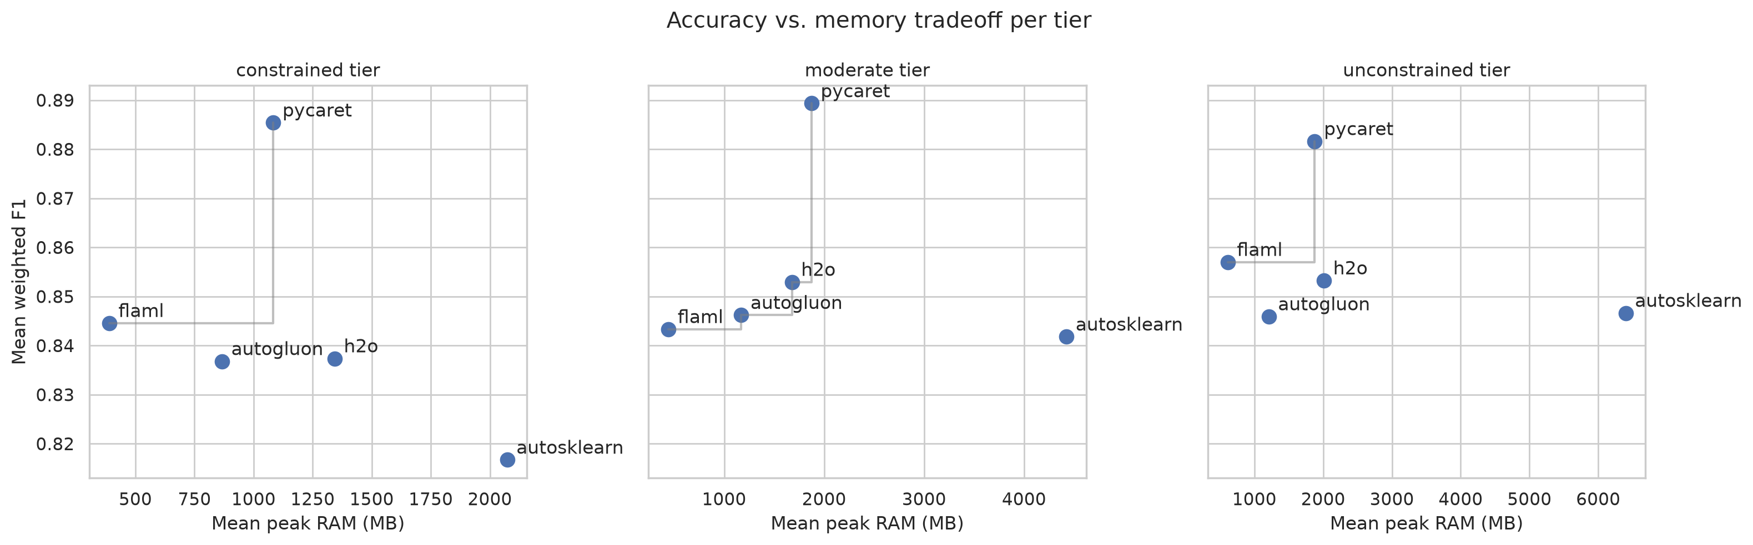
Figure 1. Accuracy vs. peak memory per tier; up-and-left is better. FLAML anchors the low-memory frontier; auto-sklearn is consistently the most memory-hungry.
Framework | Mean F1 | Peak RAM (MB) | Completion
FLAML | 0.848 | 437 | 100%
H2O AutoML | 0.848 | 1,690 | 100%
AutoGluon | 0.843 | 1,071 | 100%
auto-sklearn | 0.835 | 5,508 | 100%
PyCaret | 0.886 | 1,515 | 76%
Table 3. Per-framework means over completed cells. PyCaret's F1 is highest but averages only the cells it finished (76% completion).
Completion, not accuracy, is the differentiator. PyCaret posts the highest mean F1 (0.886), but this averages only the cells it completed; its completion rate is 76% overall and falls to 57% at the unconstrained tier, where it runs longer and is stopped by the runtime watchdog. Reading its accuracy without its completion rate is misleading — a survivorship bias that a hardware-focused study must correct for. The four fully-completing frameworks cluster tightly in F1 (0.835–0.848) but differ by an order of magnitude in memory: FLAML averages 437 MB against auto-sklearn's 5,508 MB.
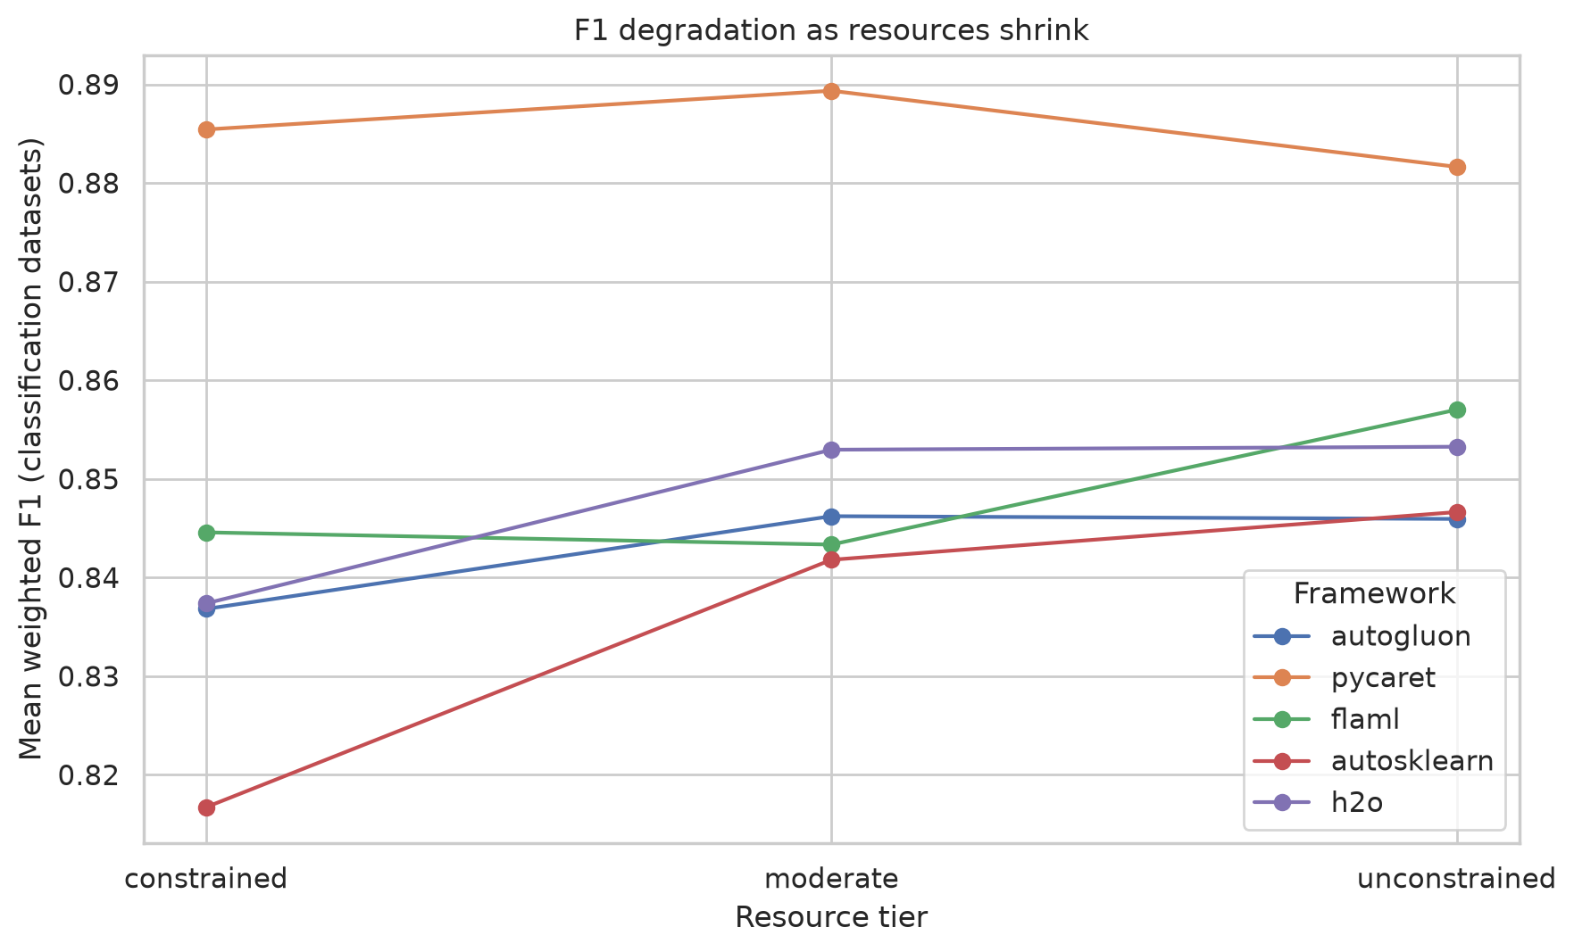
Figure 2. Mean weighted F1 as resources shrink. Accuracy is remarkably stable across tiers for all frameworks, so tier choice trades runtime and memory far more than accuracy.
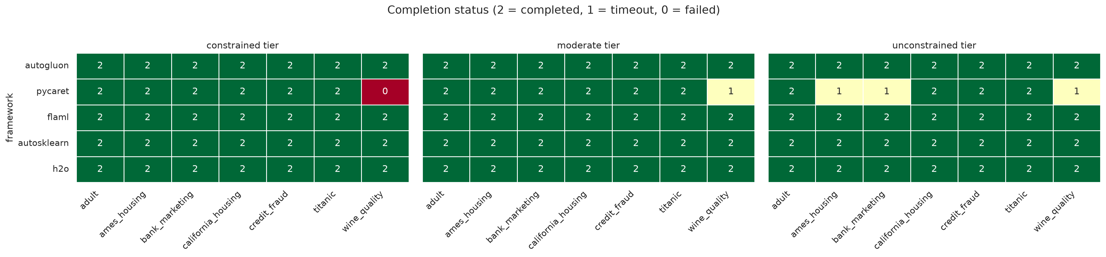
Figure 3. Completion status for all 105 runs (2 = completed, 1 = timeout, 0 = failed). Non-completions are confined to PyCaret.

5. Recommendation Matrix and Discussion
Combining accuracy, memory, and completion yields a hardware-indexed selection guide. For each tier we report the highest-F1 framework (with its true completion rate) and the most reliable choice — the framework that completes every cell while remaining competitive on F1.
Tier | Highest F1 (completion) | Recommended (reliable) | Its F1 / completion
Constrained | PyCaret 0.885 (86%) | FLAML | 0.845 / 100%
Moderate | PyCaret 0.889 (86%) | H2O AutoML | 0.853 / 100%
Unconstrained | PyCaret 0.882 (57%) | FLAML | 0.857 / 100%
Table 4. Recommendation matrix. The reliable pick completes 100% of cells; PyCaret's higher F1 comes with materially lower completion.
For the constrained hardware typical of Ghanaian public-sector offices, FLAML is the recommended default: it completes every task, matches the reliable-tier accuracy, and uses the least memory by a wide margin (360 MB at the constrained tier). H2O AutoML is a strong alternative at the moderate tier. A team that fixates on headline F1 would choose PyCaret and inherit its reliability risk — the opposite of what constrained deployment requires. These findings speak directly to the Ghana Statistical Service (national analytics on standard hardware), the Ghana Health Service (regional predictive analytics without cloud dependency), the Ministry of Food and Agriculture (district-level forecasting), and to teaching AutoML where cloud budgets are absent.

6. Limitations and Future Work
- These are pilot-budget results (60/120/240 s); absolute F1 and RMSE are lower bounds, though completion and memory patterns transfer. The full protocol (300/900/3600 s, 8 cores / 16 GB) is one command away via the released harness.
- Public benchmark datasets proxy, but do not replace, Ghanaian administrative data; a Ghana-specific dataset suite is planned.
- The study is single-machine and training-focused; distributed settings and inference-time cost are future work.
- Next steps: on-site replication on actual institutional hardware with partner agencies, at full budgets.

7. Conclusion
Benchmarking five AutoML frameworks under enforced resource caps reframes the selection question for constrained environments. On hardware representative of Ghanaian public institutions, the decisive factor is whether a framework completes at all, not its headline accuracy. FLAML — completing every task at the lowest memory with competitive accuracy — is our recommended default, with H2O AutoML as a moderate-tier alternative. By publishing an openly reproducible pipeline, we let any institution rerun the benchmark on its own machines and read off its own recommendation.

References
[1] Erickson, N. et al. AutoGluon-Tabular: Robust and Accurate AutoML for Structured Data. AWS, 2020.
[2] Feurer, M. et al. Auto-sklearn 2.0: Hands-free AutoML via Meta-Learning. JMLR, 2022.
[3] Wang, C., Wu, Q. et al. FLAML: A Fast and Lightweight AutoML Library. MLSys, 2021.
[4] H2O.ai. H2O AutoML. https://docs.h2o.ai/h2o/latest-stable/h2o-docs/automl.html
[5] PyCaret. Low-code Machine Learning Library. https://pycaret.org
[6] Dua, D. and Graff, C. UCI Machine Learning Repository. https://archive.ics.uci.edu
[7] De Cock, D. Ames, Iowa: Alternative to the Boston Housing Data. J. Statistics Education, 2011.

