Yoan Marvic J. Lagan BSIT 4-1

Screenshots of Output:
- Click button
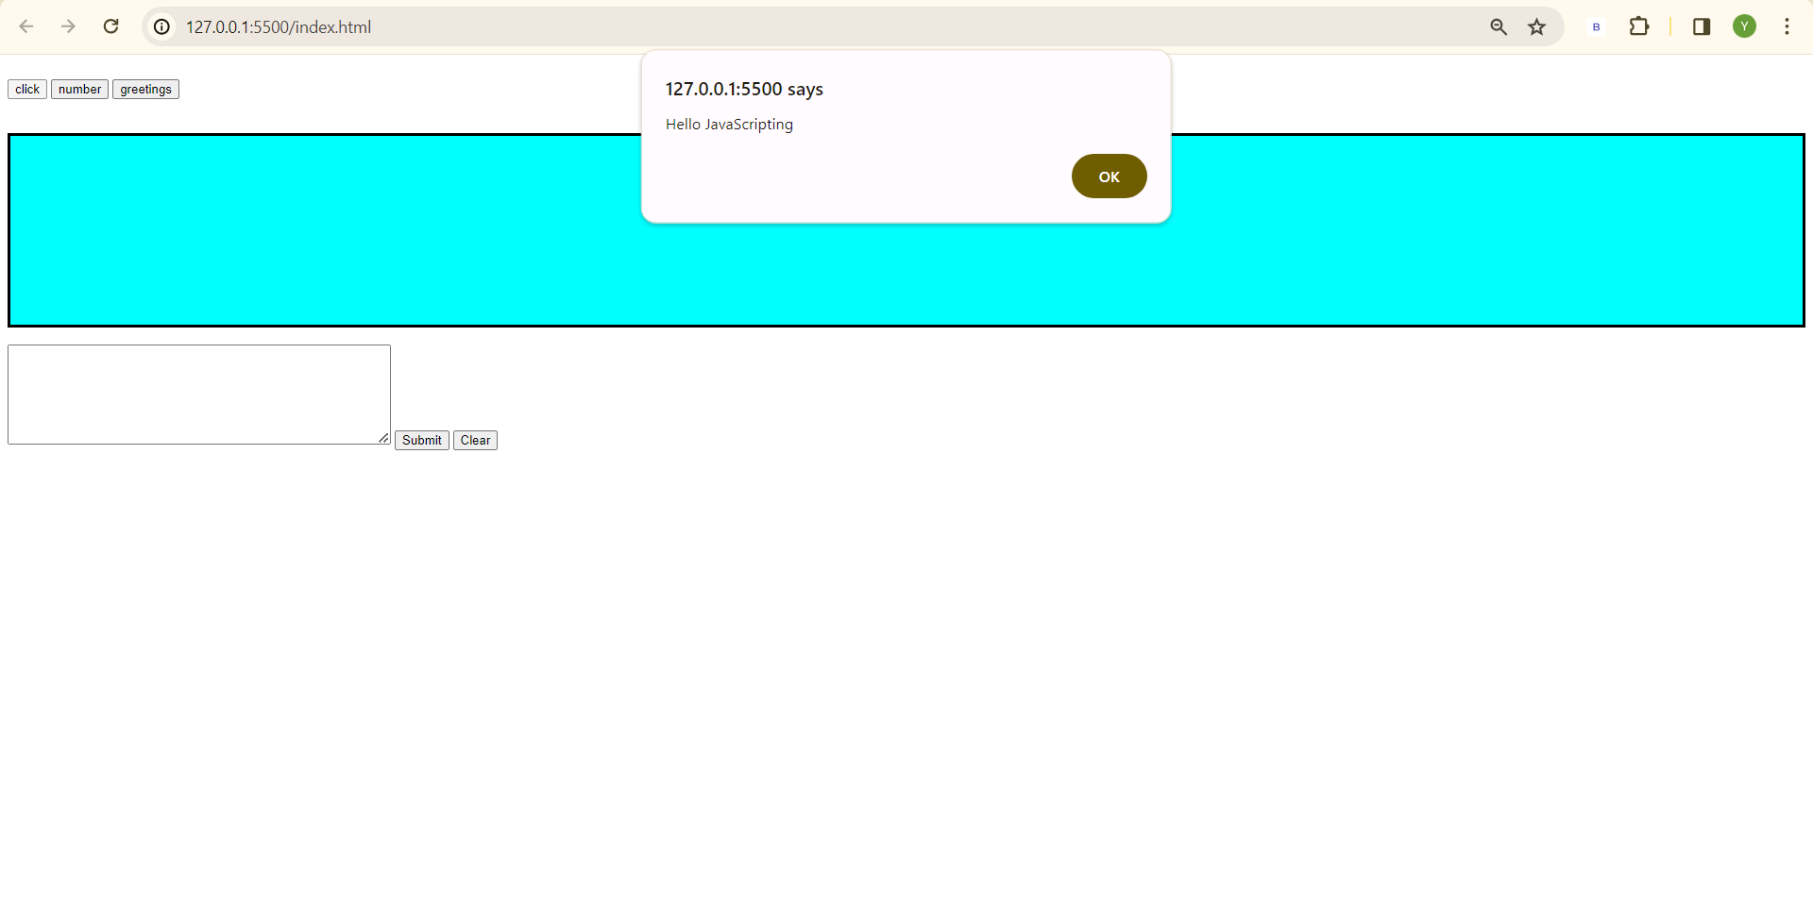
- Number button
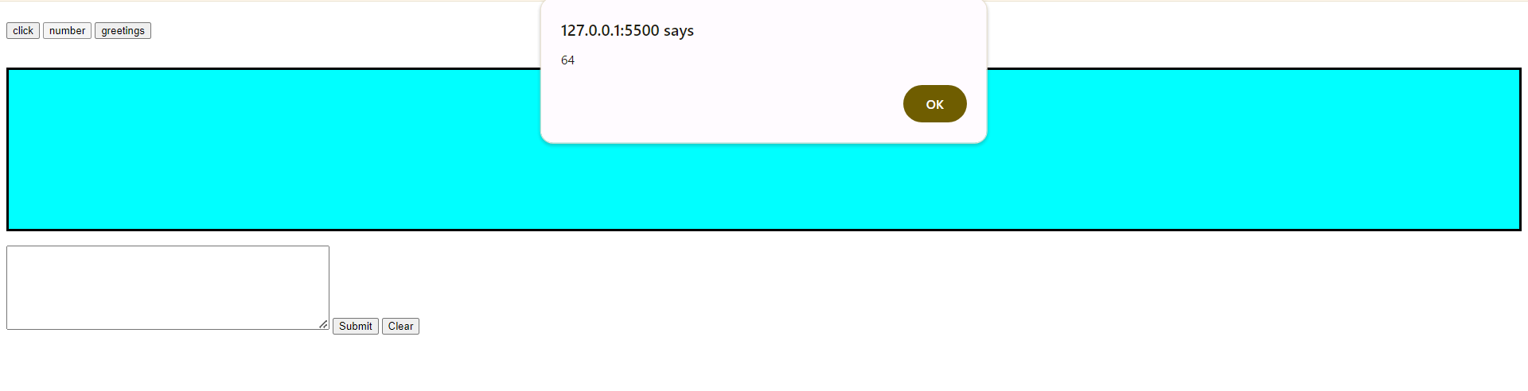
- Greetings button
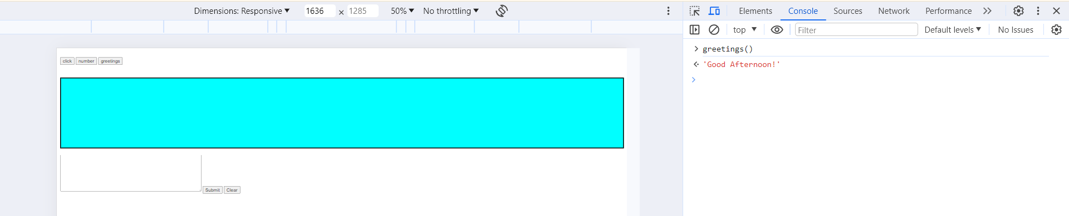
- Submit button
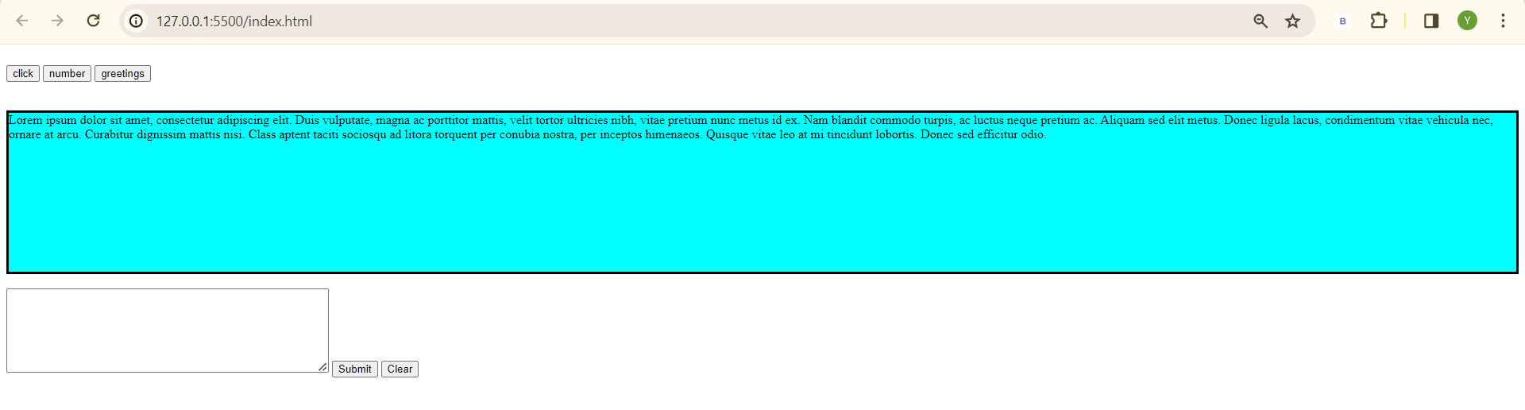

- Clear button
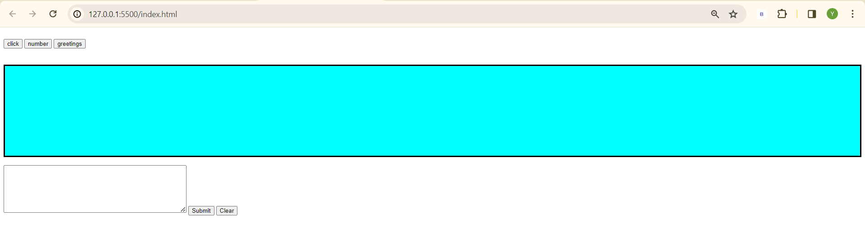
- Count meter
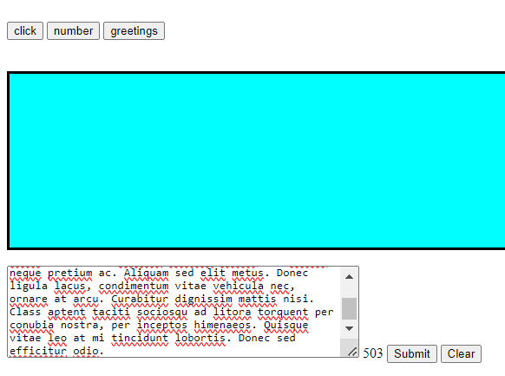

Source code:
- Index.html
<!DOCTYPE html>
<html lang="en">
<head>
<meta charset="UTF-8">
<meta name="viewport" content="width=device-width, initial-scale=1.0">
<title>ITE3:02032024</title>
<script type="text/javascript" src="js/jquery-3.6.1.min.js"></script>
<script type="text/javascript" src="js/common.js"></script>
</head>
<body>
<!-- <script type="text/javascript">
// alert("Hello JavaScripting");
// console.log("Hello JavaScripting"); inline javascript
</script> -->

<br>

<form>
<input type="button" value="click" onclick="msg()"/>

<input type="button" value="number" onclick="getcube(4)"/>

<input type="button" value="greetings" onclick="greetings()"/>

<input type="button" value="query disappear" id="query" />
</form>

<br>
<br>

<div id="message" style="background-color:aqua; border: solid black; height: 200px;"></div>

<br>

<textarea id="comment" style="height: 100px; width: 400px;"></textarea>
<span id="count"></span>
<!-- var a = 1 + 1 + "string" = 2string
var a = "string" + 1 + 1 = string11 -->

<input type="button" value="Submit" id="submit" />
<input type="button" value="Clear" id="clear" />

</body>
</html>

<!-- <script type="text/javascript" src="../common.js"></script> case to case baseis if the script needs to load the html/css code first-->

- Common.js
$(document).ready(function() {
//jQuery methods go here...

$("#query").hide();

$("#submit").click(function() {
var msg=$("#comment").val();
var html = "<div>" + msg + "<div>"
// console.log(msg);

$("#message").append(html);
$("#comment").val("");
});

$("#clear").click(function() {
$("#message").text("");
});

// $("#count").click(function() {
$("#comment").keyup(function() { //onchange
var count = $(this).val().length;
$("#count").text(count);
});
// });
});

function msg(){
alert("Hello JavaScripting");
}

function getcube(number){
alert(number*number*number);
}

function greetings(){
return "Good Afternoon!";
// alert("Good Afternoon!");
}

function ajax1 (){
$.ajax({
type: "GET",
url: "https://dummyjson.com/users",
success: function(result){
console.log(result);
}, error: function(error){

}
});
}

