Brother Inspection Post – Calibration Data and
Commissioning Mode

Brother Inspection Post Processor

The Brother post will need calibration macro numbers filled in before use. These values are entered in the Post properties fields when post processing from Fusion. Below is a brief explanation of the properties which should be set or confirmed.
There are 3 macro variables that define calibration data. Using Renishaw as an example, look for these 3 values, normally around macro variable #500.
- The calibrated radius will be just less than the actual radius (Renishaw default #500 and #501)
- The eccentricity (run-out in X) will be close to 0 (default #502)
- The eccentricity (run-out in X) will also be close to 0 (default #503)

If the controller does not have values in macro variable #500, check for values as described above: two values just below the calibrated probe radius and two values very close to 0. If macro variables #500, #501, #502, and #503 are all 0 then the user should check for values matching the described pattern. The expected values are found in #600, #601, #602, and #603, or else contact the Renishaw team to know the exact variables.
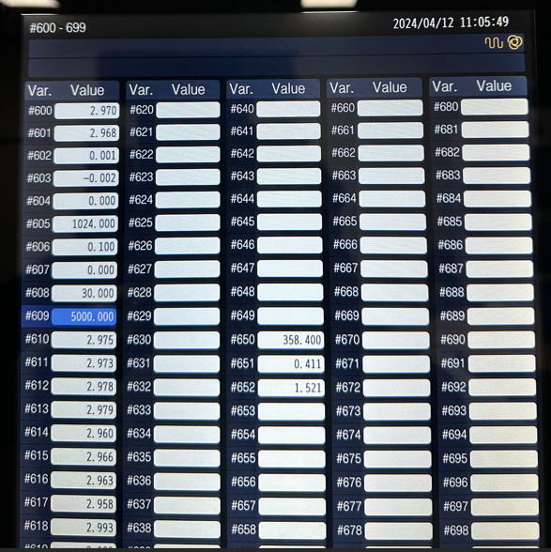
A screenshot of these items highlighted in Fusion's post properties is shown in the Post Processor Settings section with some sample values. Once they are filled in with the correct macro variable values and commands, commissioning mode can be set to false, and then inspection programs can be posted.
To double check if you are looking at the proper variables, run the probe calibration process and see if the values are slightly changed.

Post Processor Settings
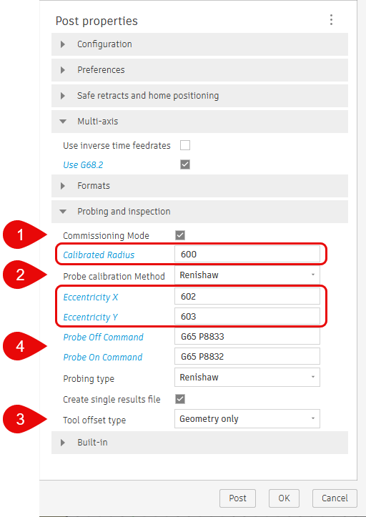
Here are some of the more common post-processor settings that you will need to pay attention to when post-processing your Inspection toolpath
- Commissioning Mode: Enables M0 and messages at key points in the program. You can disable Commissioning Mode after a successful run.
- Probe calibration Method: The probe tip radius can be calibrated as a single value or two values (in X&Y direction).
If Renishaw is selected as a calibration method, then the probe tip radius will be calculated as an average value of two numbers. Calibrated Radius #600 variable will be taken as the first value and the next variable #601 will be taken as the second.
- Tool offset type: Depends on your tool table type:
  - Memory A – single column to store geometry and wear. You should choose Geometry only
(GEOMETRY ONLY)
#8=#[11000 + #4111]
  - Memory B or C – two columns or more. You should choose Geometry and Wear
(GEOMETRY AND WEAR)
#8=#[11000 + #4111] + #[10000 + #4111]
- Probe On/Off Command: It can be an M-code or a subprogram call. Check that the probe flashes green after the probe on command has been executed.
Renishaw Inspection+ cycles probe On and probe Off commands will typically be G65 P8832 and G65 P8833. Check with the Machine documentation if needed.
Commissioning Mode
Inspection posts for Fusion defaults to Commissioning Mode. When Commissioning Mode is enabled, it will print messages on the controller screen at certain places throughout the inspection process for safety purpose.

The following checks are common while running in commissioning mode.
- Ensure the probe is enabled.
  - The probe should move to the first point.
  - Verify the probe is enabled, and if so, press Cycle Start to continue.
- Probe is about to contact part. Move should stop on contact.
  - Probe will position to the measuring point.
  - Make sure the probe is at the correct location and is about to make contact with the surface.
  - If it is positioned correctly press Cycle Start to continue.
  - Probe will touch the measuring surface and retract to a safe point.
- Ensure the probe has been disabled.
  - The probe should move to a safe Z position.
  - Make sure the probe is disabled and press Cycle Start to continue.
- The Results file can now be found in the same location as your NC code file or the folder specified in the Results file location property.
  - The Results file will be saved in the specified file folder.
  - Press Cycle Start to continue.
  - The Z-axis will now move to the machine's maximum Z location.

It is always recommended to enable Commissioning Mode the first time you run an inspection program.
After the first run, if everything works as expected, Commissioning Mode can be disabled when post processing.

Settings for Multi-axis Probing
For 3+2 probing operations the Brother post processors use G68.2 (Workplane Transformation) by default. To output the machine angles for the 3+2 probing operation, the machine kinematics need to be defined in the post processor or a corresponding Machine Definition must be selected while post processing. Refer to the following forum link for instructions on how to set the post as multi-axis.
How to set up a 4/5 axis machine configuration
Reach out to us via HSM Post Processor Forum - Autodesk Community if you have any issues.

