

Fusion Post Processor and Tooling Information

- Introduction
Brother Speedio M series machine is a 5-axis vertical spindle machining center with turning capabilities. It can perform continuous 5-axis operations using G43.4 and tilted work plane operations using G68.2.

It is possible to perform turning operations in four directions (±XY) and lathe turning can be indexed at A-axis angles of 0 to 90 degrees.

- G&M Codes
- M444/M445 C-axis Unclamp/Clamp
- M141 selects the milling spindle. M142 selects the lathe spindle.
- M494/M495 Coolant through center ON/OFF
- M303/M304 Lathe Spindle Control
- M305 Lathe Spindle Stop
- G100 Canned Cycle for Tool Change (Non-stop ATC)
- G143 Tool position offset.
- G141/G142 Nose Radius compensation Right / Left
- G376 Thread angle in complex thread cutting cycle.
- G100 Canned Cycle for Tool Change (Non-stop ATC)
- G77 Tapping Cycle (Synchro Mode)

- General
- To use the Brother Multi-Tasking post processor a multi-axis Machine Definition needs to be selected when post processing.
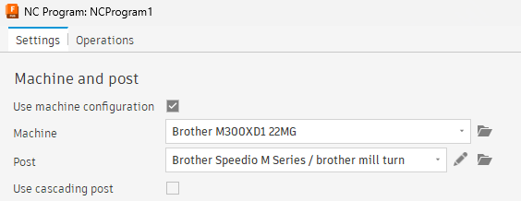

- You can find the Machine Definition files in the Fusion Machine Library.

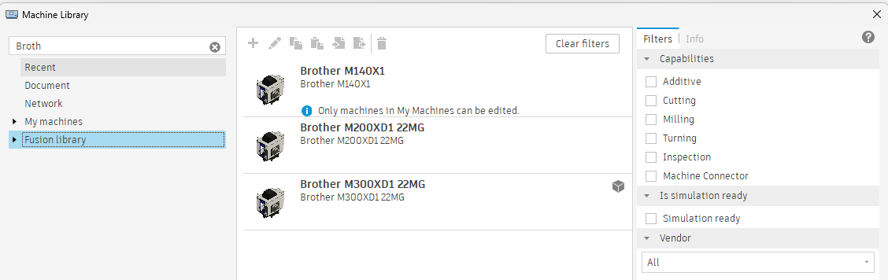

- Tooling
Since the machine can perform turning in different directions defining the tools in Fusion is important. The Fusion post processor is configured to process the tool turret value in the tool library and output the NC program accordingly. The Brother Multi-Tasking post supports the following turning combinations based on the turret value set in the tool library.

A0, X+ axis Turning = Turret number = 1 or 0.
A0, Y+ axis Turning = Turret number = 202.
A0, X- axis Turning = Turret number = 203.
A0, Y- axis Turning = Turret number = 204.
A90, Y+ axis Turning = Turret number = 205.

- A0 Along X axis. (Turret = 0 or 1)
The following image shows a left-hand turning tool mounted along the X+ direction in the machine. To configure this tool in Fusion, create a left-hand turning with the orientation set as 90 degrees.

The direction of the table will be decided based on the mounted (left hand/ right hand) tool in the machine.
The turret number must be set to 0 or 1 in the Post processor tab of the tool form.

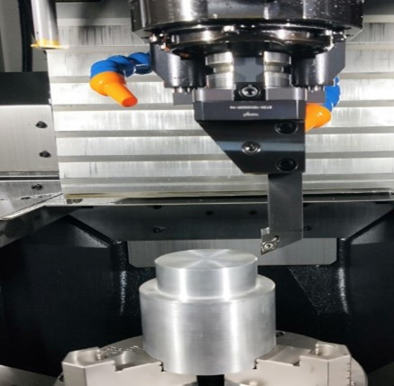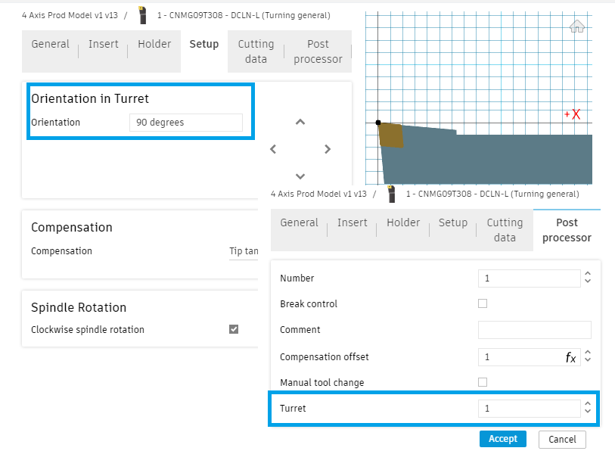

- A0 Along Y axis. (Turret =202)
The following image shows a right-hand turning tool mounted along the Y+ direction in the machine. To configure this tool in Fusion, create a right-hand turning tool with the orientation set as 90 degrees.

The direction of the table will be decided based on the mounted (left hand/ right hand) tool in the machine.
The turret number must be set to 202 in the Post processor tab of the tool form.

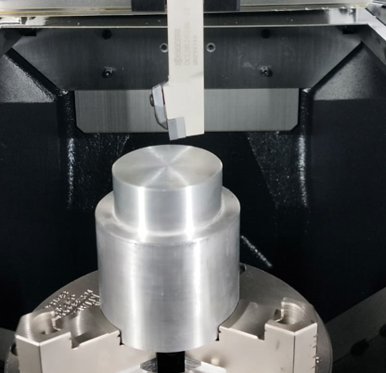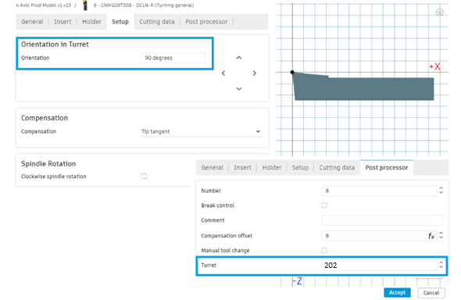

- A0 Along -X axis. (Turret =203)
The following image shows a right-hand turning tool mounted along X- direction in the machine. To configure this tool in Fusion, create a right-hand turning tool with the orientation set as 90 degrees.

The direction of the table will be decided based on the mounted (left hand/ right hand) tool in the machine.
The turret number must be set to 203 in the Post processor tab of the tool form.

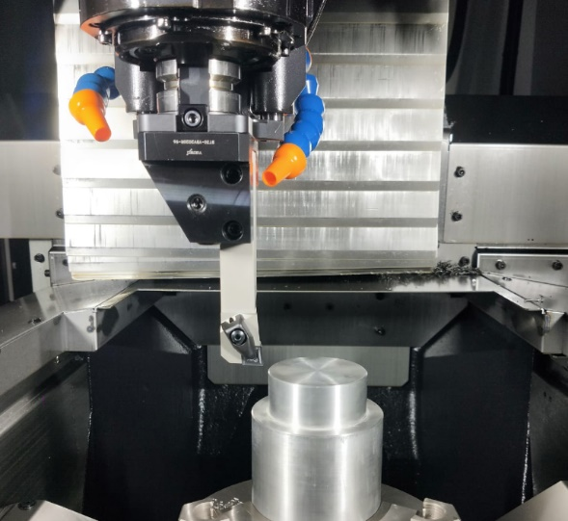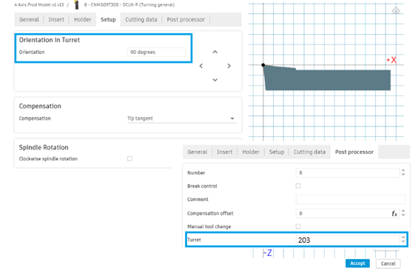

- A0 Along -Y axis. (Turret =204)
To configure the tool in Fusion for -Y direction, create a right-hand/left hand turning tool with the orientation set as 90 degrees.

The direction of the table will be decided based on the mounted (left hand/ right hand) tool in the machine.
The turret number must be set to 204 in the Post processor tab of the tool form.
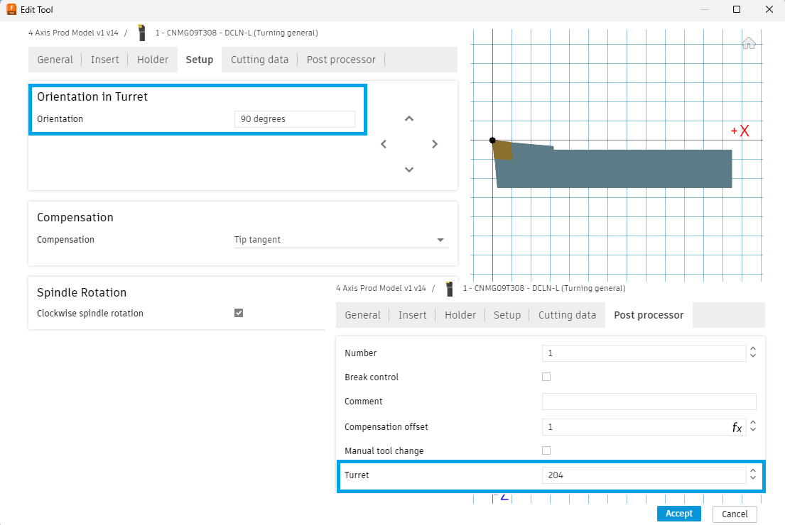

- A90 Along Y axis. (Turret = 205)
The following image shows a left-hand turning tool mounted along the X+ direction in the machine. To configure this tool in Fusion, create a left-hand turning with the orientation set as 90 degrees.

The direction of the table will be decided based on the mounted (left hand/ right hand) tool in the machine.

The turret number must be set to 205 in the Post processor tab of the tool form.
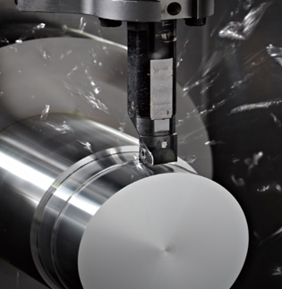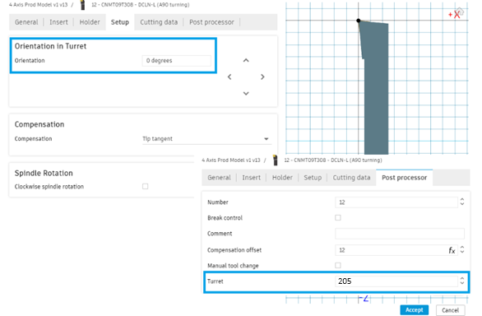

- When using an A90 rotation for turning a unique coordinate system for the workpiece must be established based on its position, since TCP (43.4) and Feature Coordinate setting (G68.2) cannot be activated in turning mode.
- In Fusion a new coordinate system can be set using the Override WCS Offset feature by creating a folder.

Toolpaths using A90 turning can be placed in the folder and the Override WCS Offset can be used to set the desired WCS offset number.
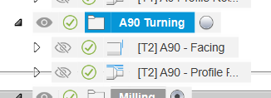
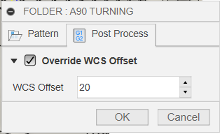
The output will look like:
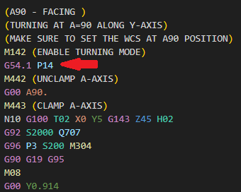

You can define the same work coordinate offsets in the standard coordinate and the rotary fixture offset settings on the control.

Machine setting

Setting screen (workpiece coordinate zero) Setting screen (reference rotary fixture offset)

- Sample files.

- You can find a sample Fusion program to test on the machine in the CAM samples project.
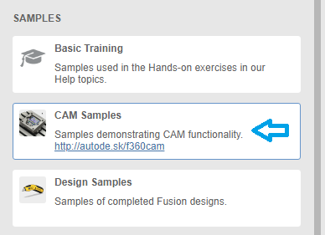

CAM Samples > Partnerships > Brother > Demos > M200_M300_PostProcessor_Benchmark

Reach out to us via HSM Post Processor Forum - Autodesk Community if you have any issues.

