Heidenhain Inspection Post – Calibration Data and
Commissioning Mode

Heidenhain Inspection Post Processor

In order to use the Inspection capabilities of the post the Touch Probe Cycle 4 is required on the control. Verify that your control has this cycle.
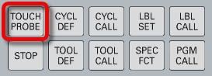
Create new program on the controller or edit the existing one.
Insert special cycle selecting “Touch Probe” hard key, then “Special Cycles” softkey and look if cycle 4 is available. If not, your machine is not ready for Fusion Inspection operations.
The inspection programs require a mask file stored on the controller to create the inspection result files.
This mask file is automatically created by the post processor when the Commissioning Mode property is enabled. The file will be written to your NC programs folder and will be called MSR_MASK.a.
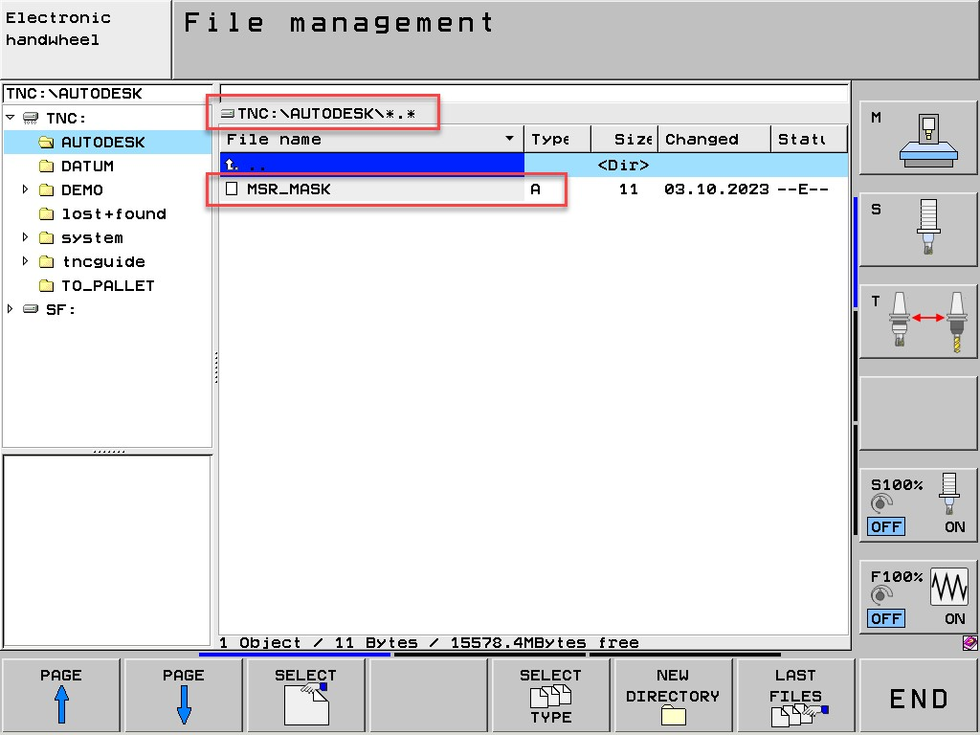

You must now copy this file to your machine. To do this, create a folder called AUTODESK on the TNC and copy the MSR_MASK.a file into that folder.

Post Processor Settings
Here are some of the more common post-processor settings that you will need to pay attention to when post-processing your Inspection toolpath.
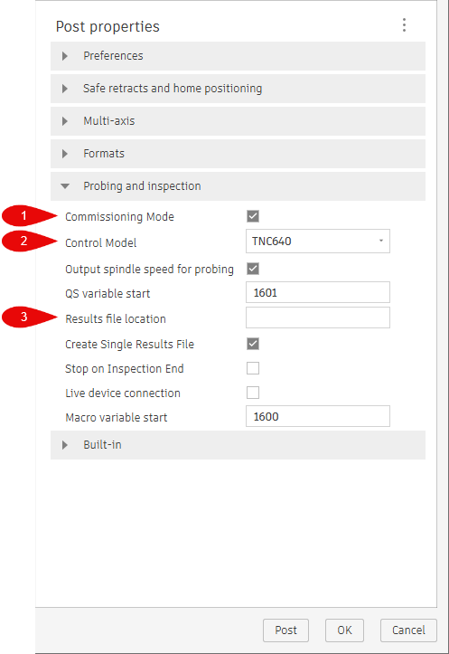
- Commissioning Mode: Enables M0 and messages at key points in the program. You can disable Commissioning Mode after a successful run.
- Control Model: Controller model, Choose the TNC model (iTNC530 or iTNC640).
- Result File Location: Folder location where the result files should be written. If you leave it blank, you will find your results (*.MSR) file in the same location where the NC code file is located. You can enter a different folder if needed, for example TNC:\Fusion\. Note that folders will not be created automatically during this process. The desired folder must be created beforehand.

Commissioning Mode
Inspection posts for Fusion default to Commissioning Mode, as does the Heidenhain post, to allow safe initial inspection operations. The controller stores calibration data and the probe will turn on and off from appropriate tool calls.
When Commissioning Mode is enabled, it will print messages on the TNC screen at certain places throughout the inspection process for safety purpose.

The following checks are common while running in commissioning mode.
- Has the directory 'TNC:\AUTODESK' been created and is the file MSR_MASK.a in this folder? If both are true, press Cycle Start to continue.
- Ensure the probe is enabled.
  - The probe should move to the first point.
  - Verify the probe is enabled, and if so, press Cycle Start to continue.
- Probe is about to contact part. Move should stop on contact.
  - Probe will position to the measuring point.
  - Make sure the probe is at the correct location and is about to make contact with the surface.
  - If it is positioned correctly press Cycle Start to continue.
  - Probe will touch the measuring surface and retract to a safe point.
- Ensure the probe has been disabled.
  - The probe should move to a safe Z position.
  - Make sure the probe is disabled and press Cycle Start to continue.
- The Results file can now be found in the same location as your NC code file or the folder specified in the Results file location property.
  - The Results file will be saved in the specified file folder.
  - Press Cycle Start to continue.
  - The Z-axis will now move to the machine's maximum Z location.

It is always recommended to enable Commissioning Mode the first time you run an inspection program. After the first run, if everything works as expected, Commissioning Mode can be disabled when post processing.
If the Results file is not visible after successfully probing, check that the controller is set to show more than
*.H files.

Settings for Multi-axis Probing
3+2 probing uses Plane Spatial for tilting the work plane as shown below. Change the Tilted workplane method if needed.
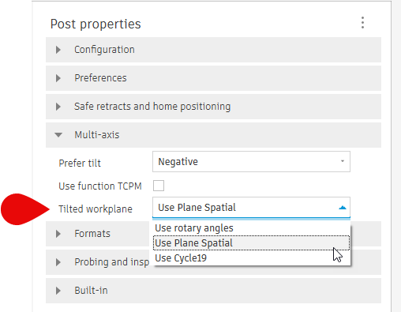
For other work plane methods, the machine kinematics need to be defined in the post processor or an associated Machine Definition must be assigned when post processing. Refer to the following forum link for instructions on how to set the post as multi-axis.
How to set up a 4/5 axis machine configuration
Reach out to us via HSM Post Processor Forum - Autodesk Community if you have any issues.

