Siemens Inspection Post – Calibration Data and
Commissioning Mode

Siemens Inspection Post Processor
The post will need probe on and probe off commands filled in before use. Fusion will use the probe on and probe off commands as defined int the Post properties interface.
- Probe on command. As an example, the picture below shows an on command of M64.
- Probe off command. As an example, the picture below shows an off command of M65.
It can be an M-code or a subprogram call. Check that the probe flashes green after the probe on command has been executed.
Post Processor Settings
Here are some of the more common post-processor settings that you will need to pay attention to when post-processing your Inspection toolpath.
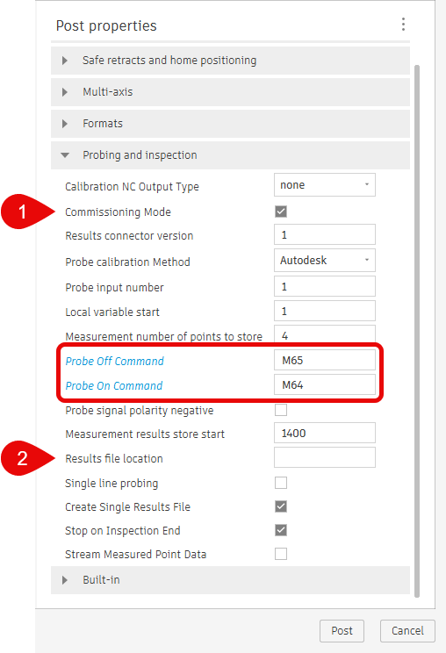
- Commissioning mode: Enables M0 and messages at key points in the program. You can disable Commissioning Mode after a successful run.
- Result File Location: Folder location where the result files should be written. If you leave it blank, you will find your results (*.MPF) file in the same location where the NC code file is located. You can enter a different folder if needed, for example: /_N_WKS_DIR/Fusion/
Note that folders will not be created automatically during this process. The desired folder must be created beforehand.
Commissioning Mode
Inspection posts for Fusion default to Commissioning Mode, to allow safe initial inspection operations. When Commissioning Mode is enabled, it will print messages on the Siemens screen at certain places throughout the inspection process for safety purpose.

The following checks are common while running in commissioning mode.
- Ensure the probe is enabled.
  - The probe should move to the first point.
  - Verify the probe is enabled, and if so, press Cycle Start to continue.
- Probe is about to contact part. Move should stop on contact.
  - Probe will position to the measuring point.
  - Make sure the probe is at the correct location and is about to make contact with the surface.
  - If it is positioned correctly press Cycle Start to continue.
  - Probe will touch the measuring surface and retract to a safe point.
- Ensure the probe has been disabled.
  - The probe should move to a safe Z position.
  - Make sure the probe is disabled and press Cycle Start to continue.
- The Results file can now be found in the same location as your NC code file or the folder specified in the Results file location property.
  - The Results file will be saved in the specified file folder.
  - Press Cycle Start to continue.
  - The Z-axis will now move to the machine's maximum Z location.

It is always recommended to enable Commissioning Mode the first time you run an inspection program. After the first run, if everything works as expected, Commissioning Mode can be disabled when post processing.

Settings for Multi-axis Probing
For 3+2 probing Siemens uses Cycle800 for tilting the work plane as shown. Select the appropriate CYCLE800 mode and enter the corresponding CYCLE800 Swivel Data record in the post properties field.
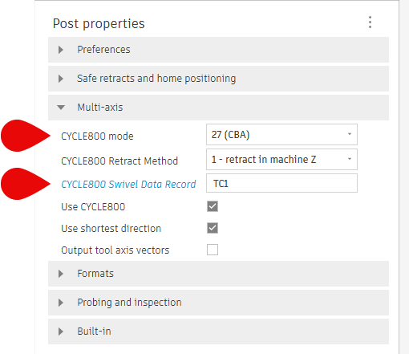
To use the Rotary angles method (192), the machine kinematics need to be defined in the post processor or an associated Machine Definition must be assigned when post processing.
Refer to the following forum link for instructions on how to set the post as multi-axis.
How to set up a 4/5 axis machine configuration
Reach out to us via HSM Post Processor Forum - Autodesk Community if you have any issues.

