Geodetic Acoustic Rays in the Time Domain

Analytic Ray Solutions – Catenary Test Case

September 2006

Prepared for:
Sean M. Reilly
Alion Science and Technology
Newport, RI

Prepared by
Michael S. Goodrich
Alion Science and Technology
Norfolk, VA

Document Control Information

Revision | Revision History | Date
Ver. 1.0 | First version of document | August 2006

Table of Contents
1 Introduction 1
1.1 Scope 1
1.2 Applicable Documents 1
2 Derivation of Catenary Analytic Ray Path 2
2.1 General Analytic Solution 2
3 Particular Test Case 4
3.1 Analytic Formulation 4
3.2 Test Results 6
3.2.1 Test Conditions 6
3.2.2 Analytic vs. Computed Ray Path – 3 deg Take off Angle 6

List of Figures

Figure 1 Analytic Solution vs. Computed Solution (3 deg.) 6
Figure 2 Analytic Solution vs. Computed Solution (3 deg.) - Detail 7
Figure 3 Differences between Analytic Solution vs. Computed Solution 7
Figure 4 Differences between Analytic Solution vs. Computed Solution 3 deg. (AB/3) 8

- Introduction
  - Scope
This report presents major findings concerning testing activities for the Geodetic Acoustic Ray Solutions in the Time Domain effort against the analytic ray path resulting from an analytic specification of sound velocity profile which is a catenary curve figure resulting in a long range refractive scenario in a deep sound channel.

This test case is particularly important since this tests the accuracy of the numerically integrated ray trace against an analytic solution at very long range (approx. 100km). As such, it is a direct test of numerical accuracy as compared to the computer calculated analytic ray path formula.

  - Applicable Documents
Following is a list of documents that should prove useful as references.
- "Computational Ocean Acoustics”, Jensen, Kuperman, et al..
- "Geodetic Acoustic Ray Solutions in the Time Domain", June 30, 2006.
- "Geodetic Acoustic Ray Solutions in the Time Domain – Technical Note on Geodetic to Flat Earth Adjustment", August, 2006.

- Derivation of Catenary Analytic Ray Path
  - General Analytic Solution

The starting place for this solution is an analytic specification of a catenary shaped sound velocity profile:

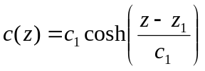 (1)
Where c₁ is a reference sound speed, and z₁ a reference depth. For c₁ =1500m/s and c₁ = 1000m, this equation gives the following curve as depicted below:

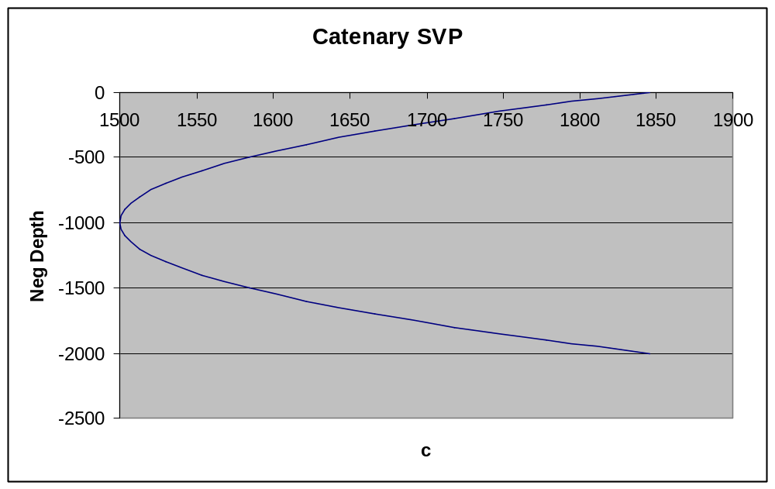

Curves of this type form sound channels where a ray with suitable initial conditions can propagate in a purely refractive mode over large distances. Equation (1) may be used in equation (3.97) in reference 1, which is:

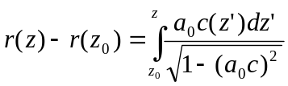 (2)

Let us define
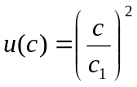 (3)
Then from (3):
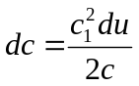 (4)
Also from (1):
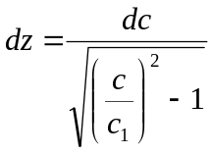 (5)
Where use has been made of the basic identity:
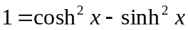 (6)
Combining (3), (4) and (5) we have:
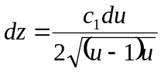 (7)
With 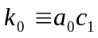 then (2) can be transformed as:
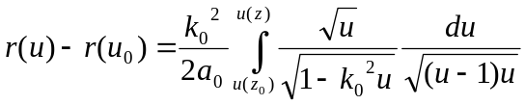 (8)
or
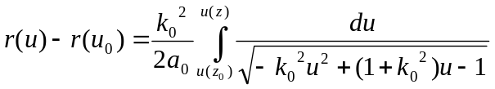 (9)
yielding
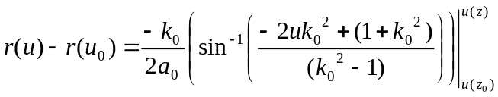 (10)

Equation (10) is the general solution for the ray trajectory for this sound velocity profile.
- Particular Test Case
  - Analytic Formulation

Let us consider the scenario of a ray starting at the sound channel axis (i.e., z₀ = z₁ ) for an arbitrary takeoff angle 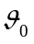. For this scenario then we have:

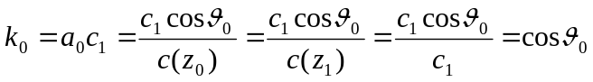 (11)
We also have
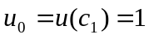 (12)
Thus (10) can be written here as:
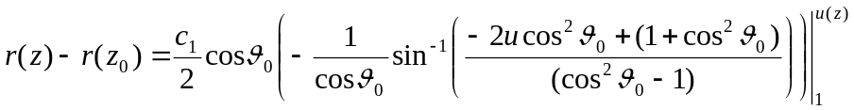 (13)

Evaluating these limits and simplifying gives:
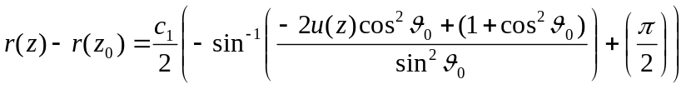 (14)
Rearranging (14) with 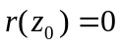 gives:
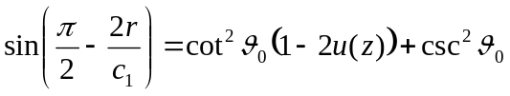 (15)
Equation (15) may be solved for z to yield:
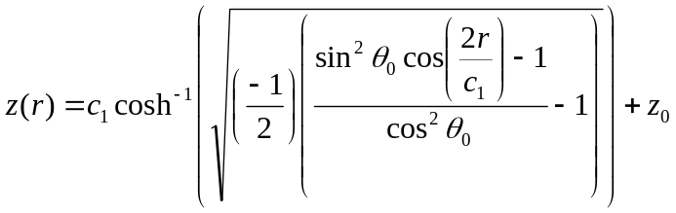 (16)

Equation (16) is the general solution for the ray trajectory for this sound velocity profile good for any 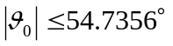 for a ray starting at the sound channel axis depth. The restriction on the takeoff angle follows from the requirement that the argument to the square root in (16) be 0 or positive.

  - Test Results
    - Test Conditions

For the test comparisons the prototype Geodetic Acoustic Ray Engine was used with the analytic sound velocity profile define by equation (1) with z₁ = 1000 and c₁ = 1500, and the Geodetic to Flat Earth adjustment to provide for direct comparison of ray traces.

The analytic ray path (equation (16)) was computed using Gnumeric for the same range values produced by the geodetic ray numerical integration.

    - Analytic vs. Computed Ray Path for +3 deg Take off Angle

Figure 1 Analytic Solution vs. Computed Solution (3 deg.)

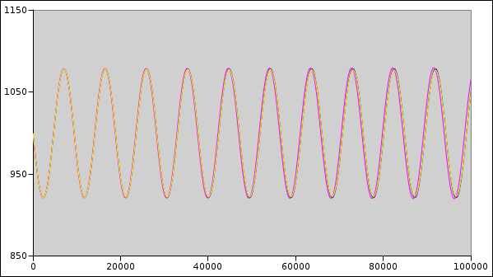

Figure 1 shows the analytic ray curve and the numerically integrated curves superimposed.

Figure 2 Analytic Solution vs. Computed Solution (+3 deg.) - Detail

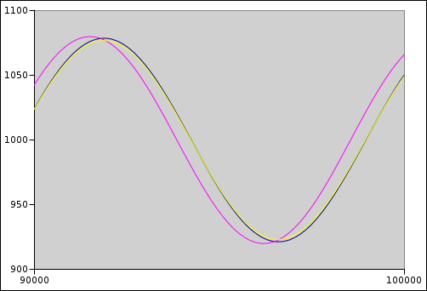

Figure 2 is a blow up of the end of the curves at 100km range. The yellow curve is analytic, the black is numerical for Adams-Bashforth 3rd order, and the purple is for Adams-Bashforth 2nd order.

Figure 3 Differences between Analytic Solution vs. Computed Solution

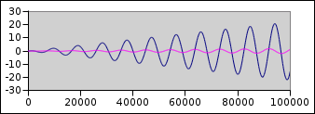

Figure 3 shows the difference between numerical solutions to the analytic curve out to 100km range. The purple curve is for Adams-Bashforth 3rd order, and the blue is for Adams-Bashforth 2nd order. The vertical axis is in meters.

Figure 4 Differences between Analytic Solution vs. Computed Solution 3 deg. (AB/3)

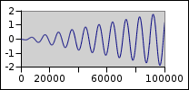

Figure 3 is a blow up for Adams-Bashforth 3rd order. The vertical axis is in meters.

