Geodetic Acoustic Rays in the Time Domain

Comprehensive Test Results

September 2006

Prepared for:
Sean M. Reilly
Alion Science and Technology
Newport, RI

Prepared by
Michael S. Goodrich
Alion Science and Technology
Norfolk, VA

Document Control Information

Revision | Revision History | Date
Ver. 1.0 | First version of document | July 2006

Table of Contents
1 Introduction 1
1.1 Scope 1
1.2 Applicable Documents 1
2 Theory 1
2.1 Isovelocity Analytic Ray Path 1
2.1.1 Derivation of Analytic Ray Path 1
2.1.2 Range Independent Isotropic Analytic Solutions 2
2.1.3 Range Independent Isotropic Isovelocity Analytic Solutions 2
2.2 General Procedure for Flat Earth Analytic Solutions 5
2.3 Geodetic Effect 5
2.4 Linear SVP Analytic Ray Path 6
2.5 N^2 Linear Analytic Solution 7
2.5.1 Physical Considerations 9
2.5.2 Comments on Jensen& Kupperman Solution 10
2.5.3 Particular Analytic Formulation 10
2.6 Catenary Analytic Solution 11
2.6.1 Particular Catenary Analytic Formulation 13
3 Computing the Path of Propagation 14
3.1 Isovelocity Analytic Ray Path 14
3.1.1 Analytic vs. Computed Ray Path 14
3.1.2 Error Performance of Computed vs. Analytic Ray Path 15
3.1.3 Analytic Path Independent of Sound Speed 15
3.2 Linear SVP Analytic Ray Path vs. Numerically Computed Ray Path 15
3.2.1 Linear SVP Analytic vs. Computed Ray Path for 0 deg Take off Angle 16
3.3 N^2 Linear 17
3.3.1 Analytic vs. Computed Ray Path – +2 deg Take off Angle 17
3.4 Catenary 19
3.4.1 Analytic vs. Computed Ray Path for +3 deg Take off Angle 19
4 Appendix – coordinate transforms 22

List of Figures

Figure 1 Isovelocity Analytic Solution vs. Computed Solution 14
Figure 2 Isovelocity Error Performance - Analytic Solution vs. Computed Solution 15
Figure 3 Linear SVP Analytic Solution vs. Computed Solution (0 deg.) 16
Figure 4 Linear SVP: Differences between Analytic Solution vs. Computed Solution 0 deg. (AB/2) 17
Figure 5 N^2 Linear Analytic Solution vs. Computed Solution (+2 deg. Take-off) 17
Figure 6 N^2 Linear Differences between Analytic Solution vs. Computed Solution 18
Figure 7 Catenary Analytic Solution vs. Computed Solution (3 deg.) 19
Figure 8 Catenary Analytic Solution vs. Computed Solution (+3 deg.) - Detail 20
Figure 9 Catenary Differences between Analytic Solution vs. Computed Solution 20
Figure 10 Catenary Differences between Analytic Solution vs. Computed Solution 3 deg. (AB/3) 21

- Introduction
  - Scope
This report presents major findings concerning testing activities for the Geodetic Acoustic Ray Solutions in the Time Domain effort against specific analytic test cases which ensue from the general mathematical model developed in Applicable Document #1.

  - Applicable Documents
Following is a list of documents that should prove useful as references.
- " Geodetic Acoustic Ray Solutions in the Time Domain", June 30, 2006.
- “Isovelocity_a_ab2_005_t0_1.gnumeric”, July 28, 2006

- Theory
  - Isovelocity Analytic Ray Path

This test case is particularly important because it is an analytic solution in the native geodetic geometry without the need for correction factors for adaptation to alien geometries. As such, it is a direct test of numerical accuracy as compared to the computer calculated analytic ray path formula.

    - Derivation of Analytic Ray Path

In general the geodetic ray equations developed in section 2.2 of Applicable Document 1, constitute a set of coupled non-linear differential equations which must be numerically integrated. In some cases however, it is possible to develop analytic solutions which will serve as a vital check on the theoretical model as well as the accuracy of the numerical integration. Henceforth all equation numbers reference Applicable document 1. The general model may be stated in vector form from eqns (13), and (14) as:

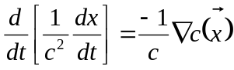 (1)
where is the location vector of the ray. Equation (1) unfolds to:

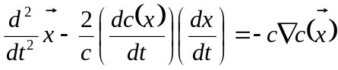 (2)
as the general time domain problem to be solved.

    - Range Independent Isotropic Analytic Solutions

For range independent and isotropic media, 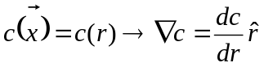 and thus 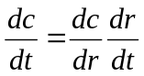 which gives

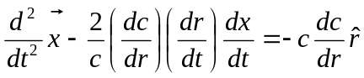 (3)

Equation (3) is to be solved for the general range independent, isotropic, time domain ray propagation problem.

    - Range Independent Isotropic Isovelocity Analytic Solutions

For the simplest case of an isovelocity scenario, we have 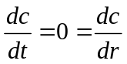 which gives:

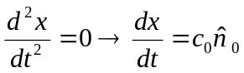 (4)

where 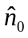 is a constant unit vector giving the direction of the ray.

If we consider a Cartesian coordinate system co-resident with the geodetic (spherical polar) system and oriented such that the prime-meridian intersects the equator where the x axis intersects the Earth’s sphere, then for the general isovelocity scenario we can write the constant direction vector as:
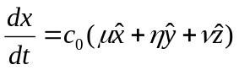 (5)
such that 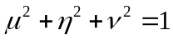. For the case of a ray with a zero takeoff angle headed due east around the equator starting from lat=0, lon=0, we have 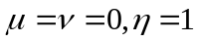 and we can write the direction vector as:

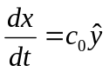 or 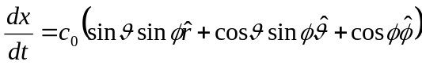 (6)
using the transformations in Section 7. In component form we have:

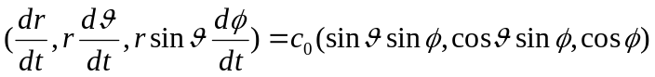 (7)

This yields the following system of three equations:

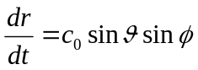 (8)
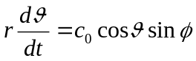 (9)
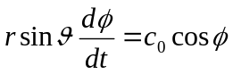 (10)

The initial conditions also require 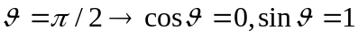 or

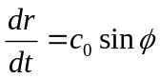 (11)
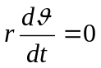 (12)
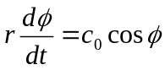 (13)

Equation (12) confirms the motion is confined to the equatorial plane (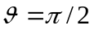), and equations (11) and (13) constitute a set of separable equations such that dividing (11) by (13) gives:

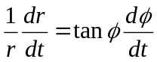 (14)
This equation may be directly integrated to give:

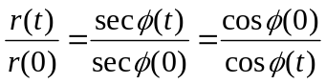 (15)

Letting 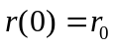 and 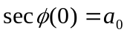 we can write

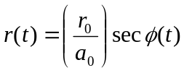 (16)

Equation (16) constitutes an analytic ray path solution to the stated problem in the sense of 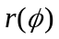. While the solution given by equation (16) is geometrically independent of the sound speed value in terms of the relation , the dependence of the ray solution on the sound speed may be elucidated by substituting equation (16) for 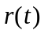 into equation (13) to yield a second integration for as:

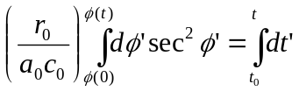 (17)

Which gives:

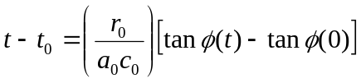 (18)
or inverting

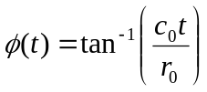 (19)

Substituting (19) into (16) then gives:

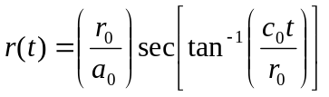 (20)

Where the initial conditions require 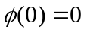 and 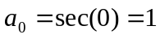.

Equations (19) and (20) are a parametric solution to a ray curve for 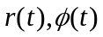, and equation (16) is direct relation .

  - General Procedure for Flat Earth Analytic Solutions
The general procedure for deriving analytic solutions in the flat earth 2-D range-depth geometry will be to integrate equation (3.97) in Jensen and Kupperman, which is:

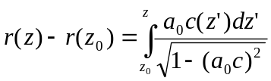 (21)
where
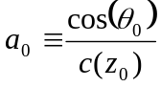 (22)
and 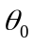 is the elevation/declination take-off angle, for suitable analytic sound velocity depth profiles. These analytic solutions will subsequently be compared to the numerically integrated solutions based on Reference X, also using the same analytic sound velocity depth profile, after an adjustment is made to account for the earth’s curvature (next section).

  - Geodetic Effect
In order to compare numerically computed solutions which are calculated in a native 3-D geodetic earth geometry to analytic solutions which are worked out in 2-D flat earth geometries, it is necessary to modify the native calculation with terms and factors which account for the earth’s curvature. It is known that a modification to the sound velocity profile giving it a slight downward refracting character is sufficient and expedient for doing so. Since a linear term in the sound velocity profile gives rise to circular arc contribution to the ray path, the sound velocity profile adjustment is necessarily a (negative) linear correction term accounting for an effective downward circular refraction of the ray path to keep it parallel to the sea surface which follows the arc of the earth’s curvature, such that:
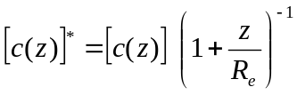 (23)

where the * superscript refers to the “uncorrected” variable to be used in the geodetic-earth system to effectively achieve a flat-earth geometry, and R_{e} is the earth’s radius. Expanding the term in brackets in a Binomial expansion gives:
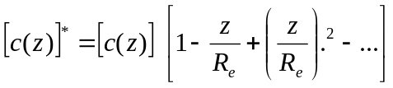 (24)
verifying that the first order correction to the sound velocity is indeed a linear downward refracting term.
Equation (21) gives rise to the following correction to the sound speed derivative:
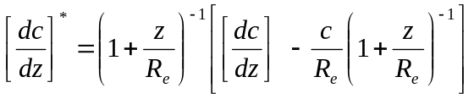 (25)
or
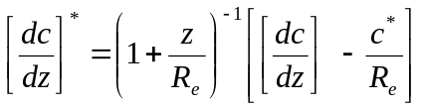 (26)

  - Linear SVP Analytic Ray Path

The starting place for this solution is an analytic specification of a linear sound velocity profile:

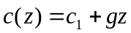 (27)
Where c₁ is a reference sound speed at depth 0. Equation (27) is to be substituted into equation (21). Let us define

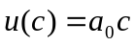 (28)
Then from (29):
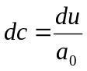 (29)

Also from (27):
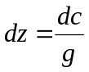 (30)
Combining (29), (30) and (31) we have:
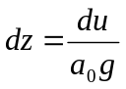 (31)
Then (21) can be transformed as:
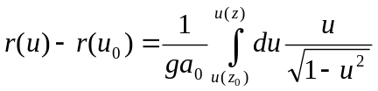 (32)
yielding
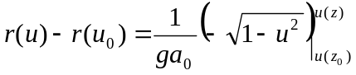 (33)
Evaluating these limits, making substitutions, and solving for the ray trajectory gives:
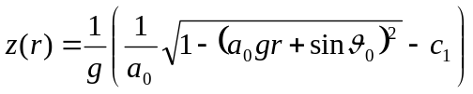 (34)

  - N^2 Linear Analytic Solution

The starting place for this solution is equation (3.122) in reference 1, giving the most general formulation of the 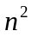 linear sound velocity profile:

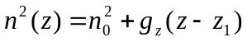 (35)
Where 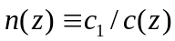 is the index of refraction, and c₁ is a reference sound speed. Equation (1) leads to the sound velocity profile:

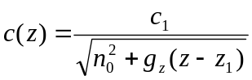 (36)
Equation (37) may be used in equation (21) and the integral may be performed by noting that from (37):
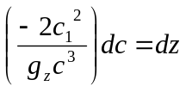 (37)
and with
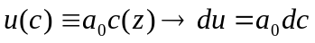 (38)
we have
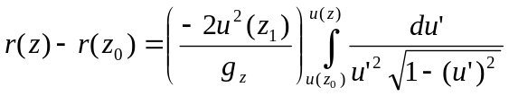 (39)
yielding
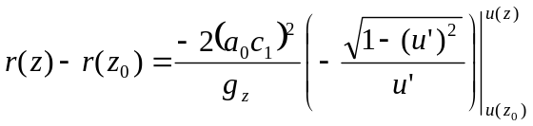 (40)
or
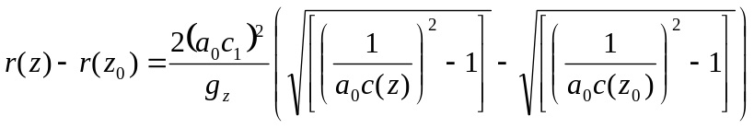 (41)
The second term in equation (43) inside the parentheses reduces to:
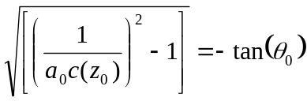 (42)
where the negative branch of the square root is chosen for physical reasons.
Note that equation (44) implies the constraint:
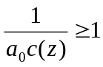 (43)
Also 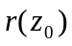 may be taken as zero, then equation (43) implies:
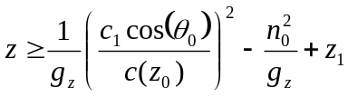 (44)
Setting z=0 in (12) gives the surface grazing takeoff angle of:
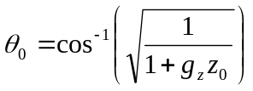 (45)
Equation (43) may be simplified and inverted to yield:
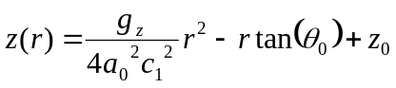 (46)

    - Physical Considerations

In considering equation (2), it should be clear that 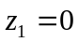 is the most general equation for c(z) possible for all physical scenarios. This further implies that 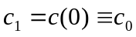 and that 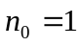. These considerations give the following simplified analytic model:

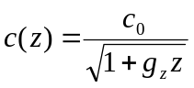 (47)
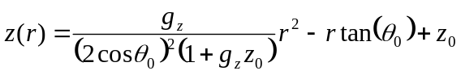 (48)
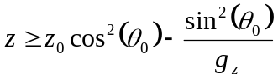 (49)
Setting z=0 in (52) gives the surface grazing takeoff angle of:
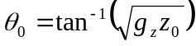 (50)

    - Comments on Jensen& Kupperman Solution
There is evidently an error in equation (3.128) as it should be clear that the “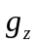” in (3.128) is not the same as that in equation (37) since (3.128) predicts the same parabolic path for rays starting at various depths even though the sound speed gradient itself varies with depth. This is simply not a realistic physical result. A true physical result would necessarily include a coefficient to the 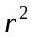 term in the analytic ray path that is not just strictly related to the sound velocity profile but is also a function of the initial conditions. This is reasonable on physical grounds since differing initial conditions imply different parabolic curves as ray paths.

    - Particular Analytic Formulation
Jensen and Kupperman mention that a particular problem for this class has been extensively studied. This is for the sound velocity profile:
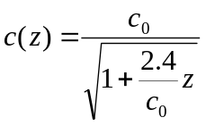 (51)
with 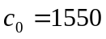 (52)
This implies that
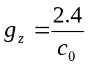 (53)
For the scenario where the initial depth is 1000m, we can set z=0 in (18) to get the surface grazing takeoff angle of:
(54)
We also have from (17):
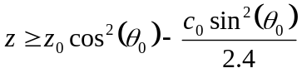 (55)
setting the lower bound on the ray depth for these initial conditions. Finally, the analytic ray path is now given from (16) as:

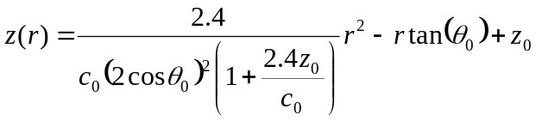 (56)
  - Catenary Analytic Solution

This test case is particularly important since this tests the accuracy of the numerically integrated ray trace against an analytic solution at very long range (approx. 100km). As such, it is a direct test of numerical accuracy as compared to the computer calculated analytic ray path formula.

The starting place for this solution is an analytic specification of a catenary shaped sound velocity profile:

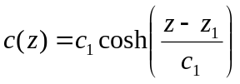 (57)
Where c₁ is a reference sound speed, and z₁ a reference depth. For c₁ =1500m/s and c₁ = 1000m, this equation gives the following curve as depicted below:

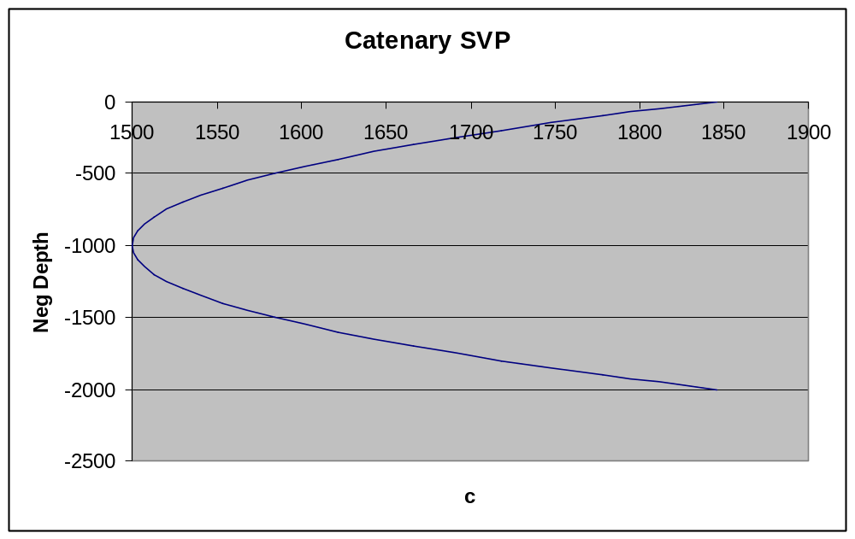

Curves of this type form sound channels where a ray with suitable initial conditions can propagate in a purely refractive mode over large distances. Equation (1) may be used in equation (3.97) in reference 1, which is:

(58)

Let us define
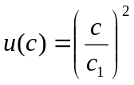 (59)
Then from (3):
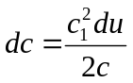 (60)
Also from (1):
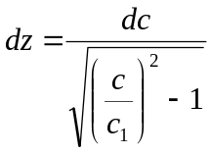 (61)
Where use has been made of the basic identity:
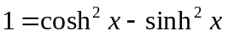 (62)
Combining (3), (4) and (5) we have:
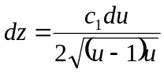 (63)
With 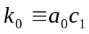 then (2) can be transformed as:
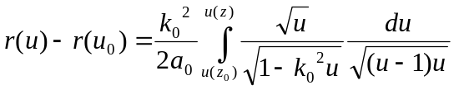 (64)
or
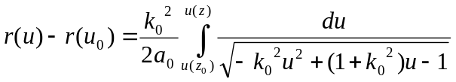 (65)
yielding
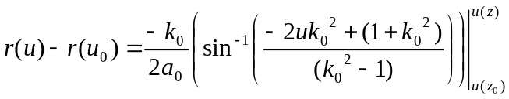 (66)
Equation (66) is the general solution for the ray trajectory for this sound velocity profile.
    - Particular Catenary Analytic Formulation
Let us consider the scenario of a ray starting at the sound channel axis (i.e., z₀ = z₁ ) for an arbitrary takeoff angle 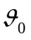. For this scenario then we have:

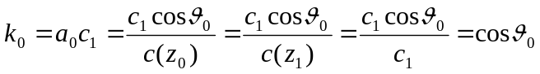 (67)
We also have
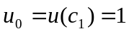 (68)
Thus (66) can be written here as:
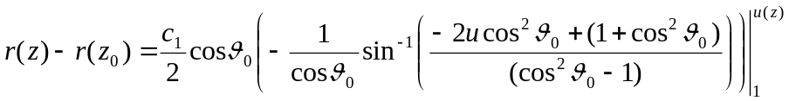 (69)

Evaluating these limits and simplifying gives:
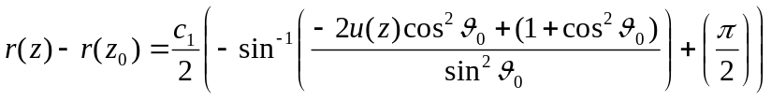 (70)
Rearranging (70) with 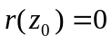 gives:
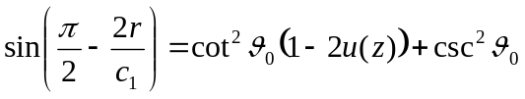 (71)
Equation (71) may be solved for z to yield:
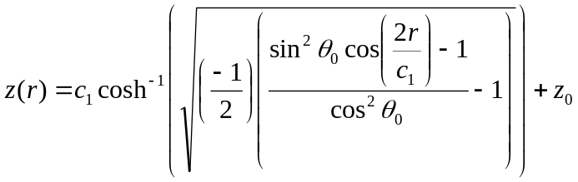 (72)

Equation (72) is the general solution for the ray trajectory for this sound velocity profile good for any 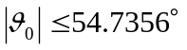 for a ray starting at the sound channel axis depth. The restriction on the takeoff angle follows from the requirement that the argument to the square root in (16) be 0 or positive.

- Computing the Path of Propagation
  - Isovelocity Analytic Ray Path
    - Analytic vs. Computed Ray Path

The detailed ray path of computed versus analytic solution is compared in Figure 1. The computed solution is for sound speed values of 1500 and 1600 m/s at time steps of 0.05 and 0.046875 seconds respectively. The analytic path is for equation (16) using the computed value of the angle as input to (16).

Figure 1 Isovelocity Analytic Solution vs. Computed Solution
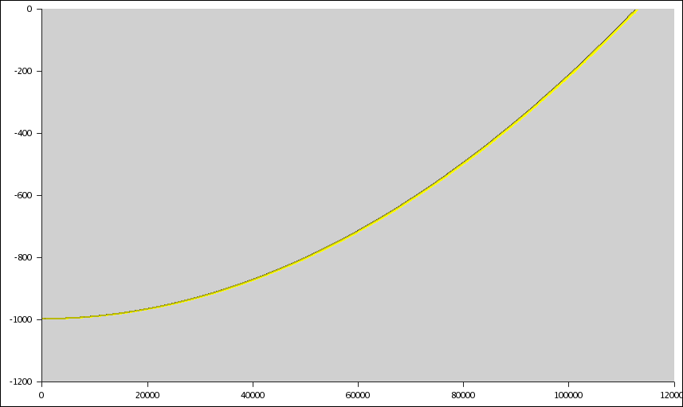
Figure 1 shows the analytic ray curve and the numerically integrated curves superimposed.

    - Error Performance of Computed vs. Analytic Ray Path

The detailed error performance of computed versus analytic ray path solution is compared in Figure 2.

Figure 2 Isovelocity Error Performance - Analytic Solution vs. Computed Solution

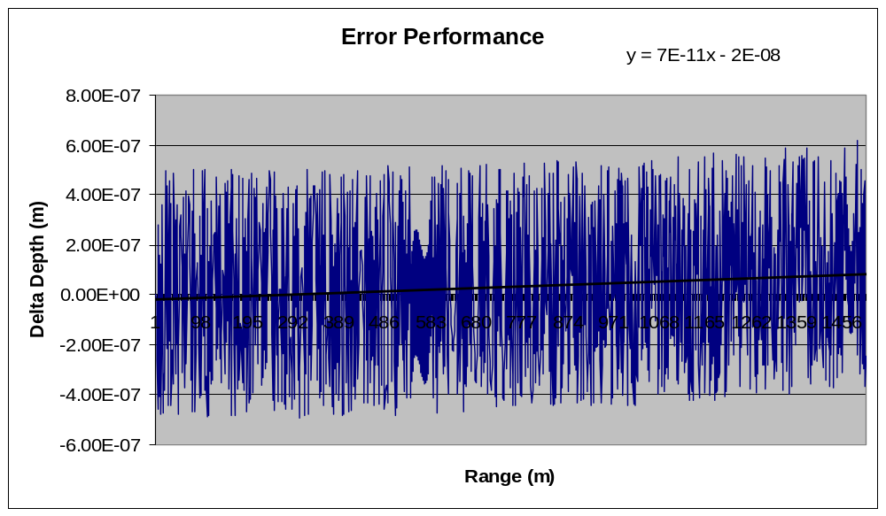
Figure 2 is the error performance for the Adams-Bashforth 2nd order integrator out to a range of 100 km. Here the error starts off at 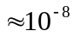 and increases at a rate of 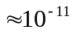 m/m, which increases it to 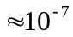 at 100km range.

    - Analytic Path Independent of Sound Speed

Another important prediction of (16) is that the ray path is independent of the sound speed. This was verified by comparing the numerically computed depth values for sound speeds of 1500 and 1600 m/s for the same angle (achieved by using different time steps). Differences between these depth values calculate as < machine zero.

  - Linear SVP Analytic Ray Path vs. Numerically Computed Ray Path

For the test comparisons the prototype Geodetic Acoustic Ray Engine was used with the analytic sound velocity profile defined by equation (27) with z₀ = 1000 and c₁ = 1500, and the Geodetic to Flat Earth adjustment (ie., adjusting (27) according to equations (24, 25) ) to provide for direct comparison of ray traces.

The analytic ray path (equation (35)) was computed using Gnumeric for the same range values produced by the geodetic ray numerical integration.

    - Linear SVP Analytic vs. Computed Ray Path for 0 deg Take off Angle

Figure 3 Linear SVP Analytic Solution vs. Computed Solution (0 deg.)

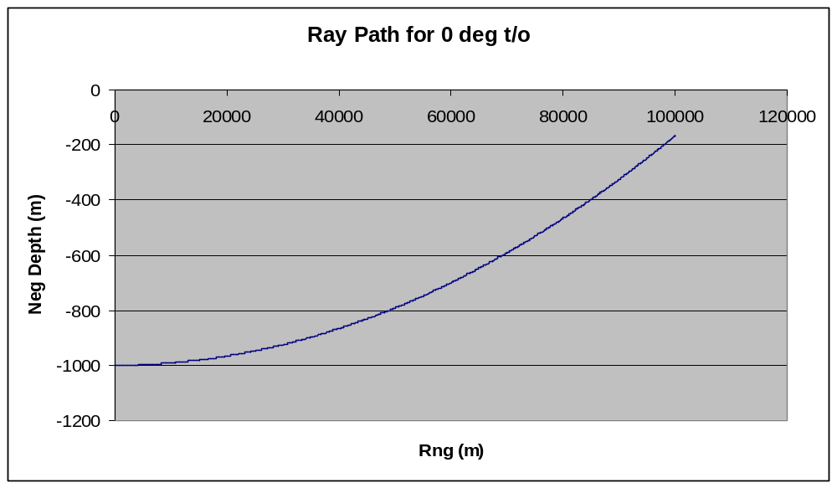

Figure 3 shows the analytic ray curve and the numerically integrated curves superimposed.

Figure 4 Linear SVP: Differences between Analytic Solution vs. Computed Solution 0 deg. (AB/2)

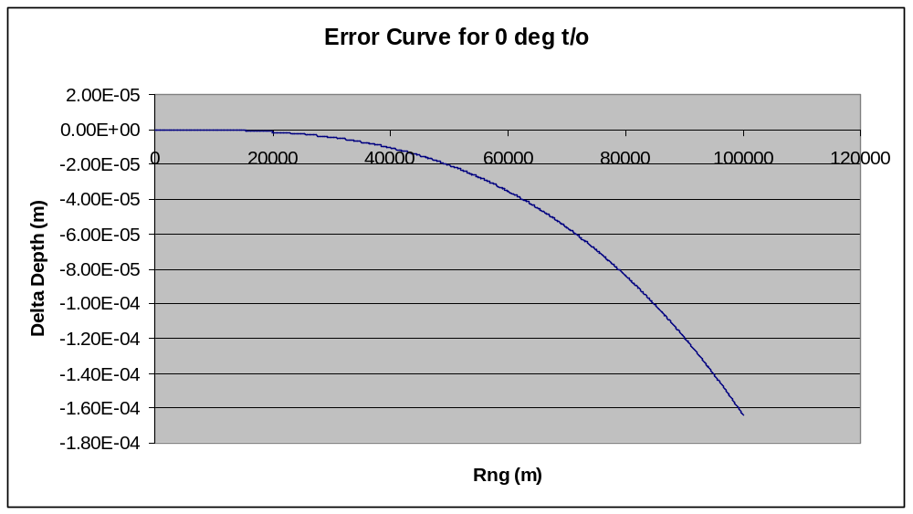

Figure 4 is the error performance for the Adams-Bashforth 2nd order integrator out to a range of 100 km.

  - N^2 Linear

For the test comparisons the prototype Geodetic Acoustic Ray Engine was used with the analytic sound velocity profile define by equation (50) and the Geodetic to Flat Earth adjustment to provide for direct comparison of ray traces. Recall that this means adjusting

The analytic ray path (equation (51)) was computed using Octave, Gnumeric, and a C program in the Linux environment; all analytic results were in agreement.

    - Analytic vs. Computed Ray Path – +2 deg Take off Angle

Figure 5 N^2 Linear Analytic Solution vs. Computed Solution (+2 deg. Take-off)

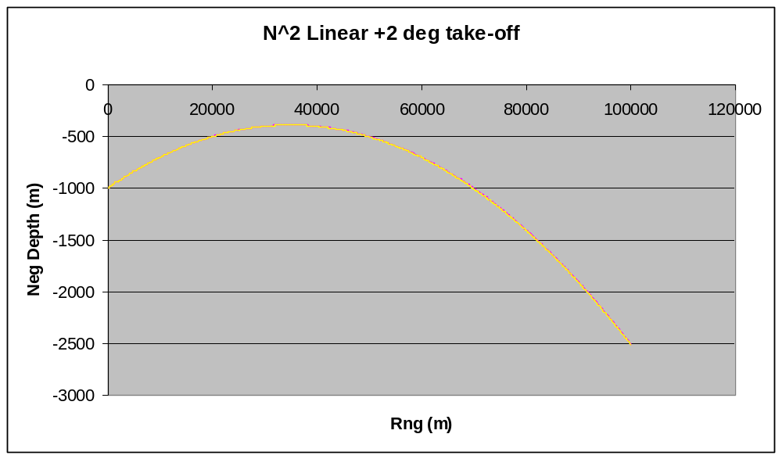
Figure 5 shows the analytic ray curve and the numerically integrated curves superimposed.

Figure 6 N^2 Linear Differences between Analytic Solution vs. Computed Solution
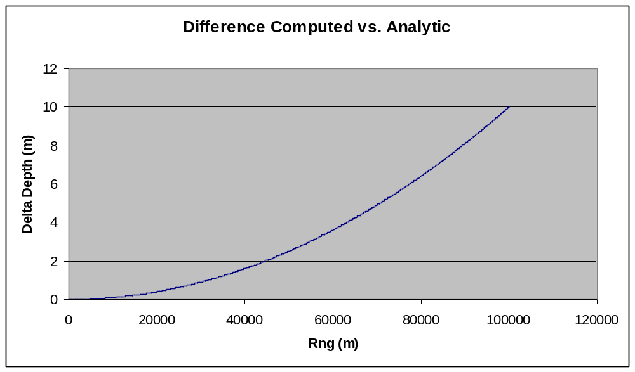
Figure 6 is the error performance for the Adams-Bashforth 2nd order integrator out to a range of 100 km.

  - Catenary

For the test comparisons the prototype Geodetic Acoustic Ray Engine was used with the analytic sound velocity profile define by equation (1) with z₁ = 1000 and c₁ = 1500, and the Geodetic to Flat Earth adjustment to provide for direct comparison of ray traces.

The analytic ray path (equation (16)) was computed using Gnumeric for the same range values produced by the geodetic ray numerical integration.

    - Analytic vs. Computed Ray Path for +3 deg Take off Angle

Figure 7 Catenary Analytic Solution vs. Computed Solution (3 deg.)

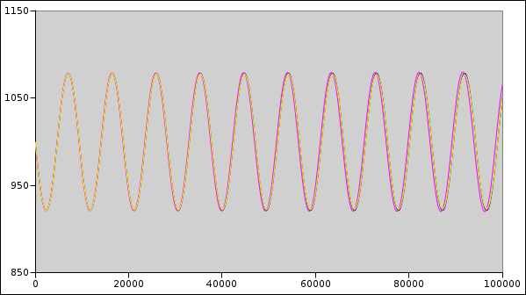

Figure 7 shows the analytic ray curve and the numerically integrated curves superimposed.
Figure 8 Catenary Analytic Solution vs. Computed Solution (+3 deg.) - Detail
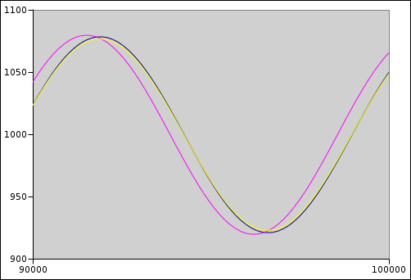

Figure 8 is a blow up of the end of the curves at 100km range. The yellow curve is analytic, the black is numerical for Adams-Bashforth 3rd order, and the purple is for Adams-Bashforth 2nd order.
Figure 9 Catenary Differences between Analytic Solution vs. Computed Solution

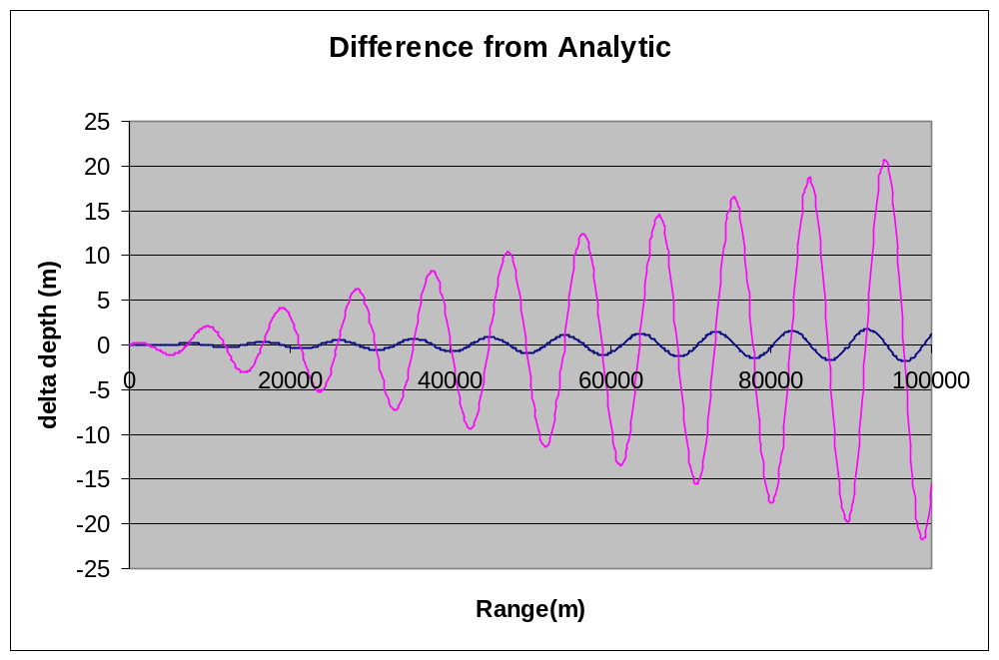
Figure 9 shows the difference between numerical solutions to the analytic curve out to 100km range. The blue curve is for Adams-Bashforth 3rd order, and the purple is for Adams-Bashforth 2nd order. The vertical axis is in meters.

Figure 10 Catenary Differences between Analytic Solution vs. Computed Solution 3 deg. (AB/3)

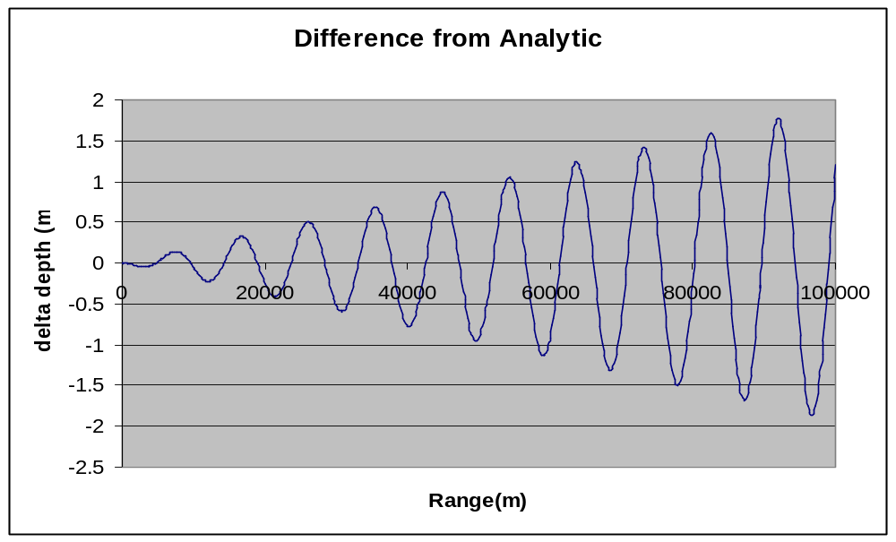
Figure 10 is a blow up for Adams-Bashforth 3rd order. The vertical axis is in meters.

- Appendix – coordinate transforms

Transformations back and forth between geodetic (spherical-polar) and Cartesians frames of reference may be accomplished by using the following relations:
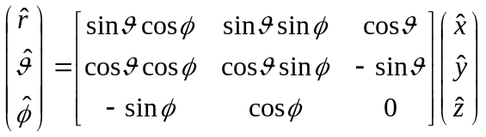
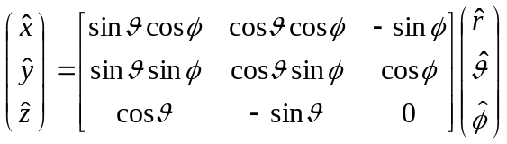

So that for example:

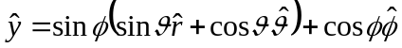

Jensen, Kupperman, et. al., Computational Ocean Acoustics, American Institute of Physics, pg 185.
Etter, Underwater Acoustic Modeling and Simulation, 3rd Edition, Spon Press, 2003, pp 179-80.

