Geodetic Acoustic Rays in the Time Domain

Analytic Ray Solutions – Isovelocity Test Case

July 2006

Prepared for:
Sean M. Reilly
Alion Science and Technology
Newport, RI

Prepared by
Michael S. Goodrich
Alion Science and Technology
Norfolk, VA

Document Control Information

Revision | Revision History | Date
Ver. 1.0 | First version of document | July 2006

Table of Contents
1 Introduction 1
1.1 Scope 1
1.2 Applicable Documents 1
2 Derivation of Isovelocity Analytic Ray Path 1
2.1 Range Independent Isotropic Analytic Solutions 2
2.2 Range Independent Isotropic Isovelocity Analytic Solutions 2
3 Test Results 5
3.1 Analytic vs. Computed Ray Path 5
3.2 Error Performance of Computed vs. Analytic Ray Path 6
3.3 Analytic Path Independent of Sound Speed 6

List of Figures

Figure 1 Analytic Solution vs. Computed Solution 5
Figure 1 Error Performance - Analytic Solution vs. Computed Solution 6

- Introduction
  - Scope
This report presents major findings concerning testing activities for the Geodetic Acoustic Ray Solutions in the Time Domain effort against the isovelocity geodetic analytic solution derived herein.

This test case is particularly important because it is an analytic solution in the native geodetic geometry without the need for correction factors for adaptation to alien geometries. As such, it is a direct test of numerical accuracy as compared to the computer calculated analytic ray path formula.

  - Applicable Documents
Following is a list of documents that should prove useful as references.
- " Geodetic Acoustic Ray Solutions in the Time Domain", June 30, 2006.
- “Isovelocity_a_ab2_005_t0_1.gnumeric”, July 28, 2006

- Derivation of Isovelocity Analytic Ray Path

In general the geodetic ray equations developed in section 2.2 of Applicable document 1, constitute a set of coupled non-linear differential equations which must be numerically integrated. In some cases however, it is possible to develop analytic solutions which will serve as a vital check on the theoretical model as well as the accuracy of the numerical integration. Henceforth all equation numbers reference Applicable document 1. The general model may be stated in vector form from eqns (13), and (14) as:

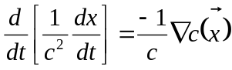 (1)
where is the location vector of the ray. Equation (1) unfolds to:

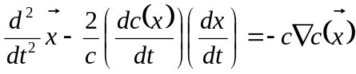 (2)
as the general time domain problem to be solved.

  - Range Independent Isotropic Analytic Solutions

For range independent and isotropic media, 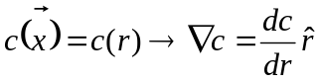 and thus 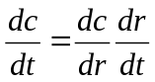 which gives

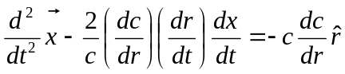 (3)

Equation (3) is to be solved for the general range independent, isotropic, time domain ray propagation problem.

  - Range Independent Isotropic Isovelocity Analytic Solutions

For the simplest case of an isovelocity scenario, we have 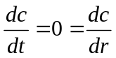 which gives:

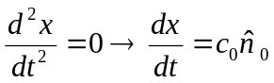 (4)

where 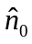 is a constant unit vector giving the direction of the ray.

If we consider a Cartesian coordinate system co-resident with the geodetic (spherical polar) system and oriented such that the prime-meridian intersects the equator where the x axis intersects the Earth’s sphere, then for the general isovelocity scenario we can write the constant direction vector as:

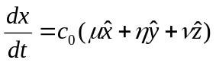 (5)

such that 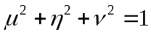. For the case of a ray with a zero takeoff angle headed due east around the equator starting from lat=0, lon=0, we have 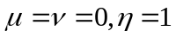 and we can write the direction vector as:

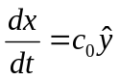 or 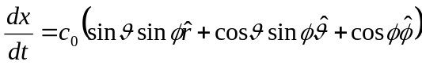 (6)
using the transformations in Section 7. In component form we have:

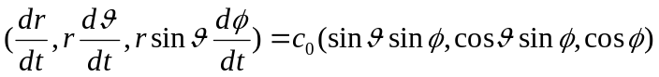 (7)

This yields the following system of three equations:

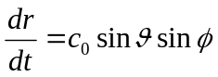 (8)
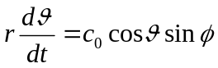 (9)
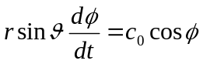 (10)

The initial conditions also require 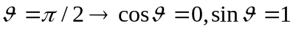 or

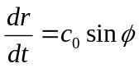 (11)
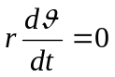 (12)
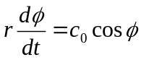 (13)

Equation (12) confirms the motion is confined to the equatorial plane (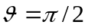), and equations (11) and (13) constitute a set of separable equations such that dividing (11) by (13) gives:

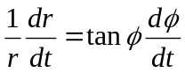 (14)
This equation may be directly integrated to give:

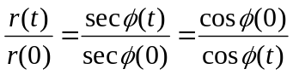 (15)

Letting 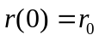 and 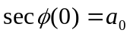 we can write

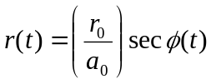 (16)

Equation (16) constitutes an analytic ray path solution to the stated problem in the sense of 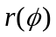. While the solution given by equation (16) is geometrically independent of the sound speed value in terms of the relation , the dependence of the ray solution on the sound speed may be elucidated by substituting equation (16) for 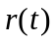 into equation (13) to yield a second integration for as:

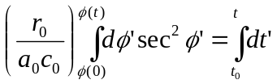 (17)

Which gives:

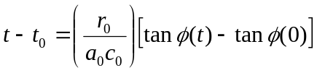 (18)
or inverting

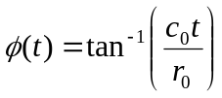 (19)

Substituting (19) into (16) then gives:

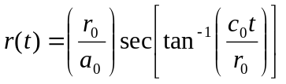 (20)

Where the initial conditions require 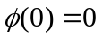 and 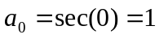.

Equations (19) and (20) are a parametric solution to a ray curve for 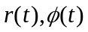, and equation (16) is direct relation .

- Test Results
  - Analytic vs. Computed Ray Path

The detailed ray path of computed versus analytic solution is compared in Figure 1. The computed solution is for sound speed values of 1500 and 1600 m/s at time steps of 0.05 and 0.046875 seconds respectively. The analytic path is for equation (16) using the computed value of the angle as input to (16).

Figure 1 Analytic Solution vs. Computed Solution
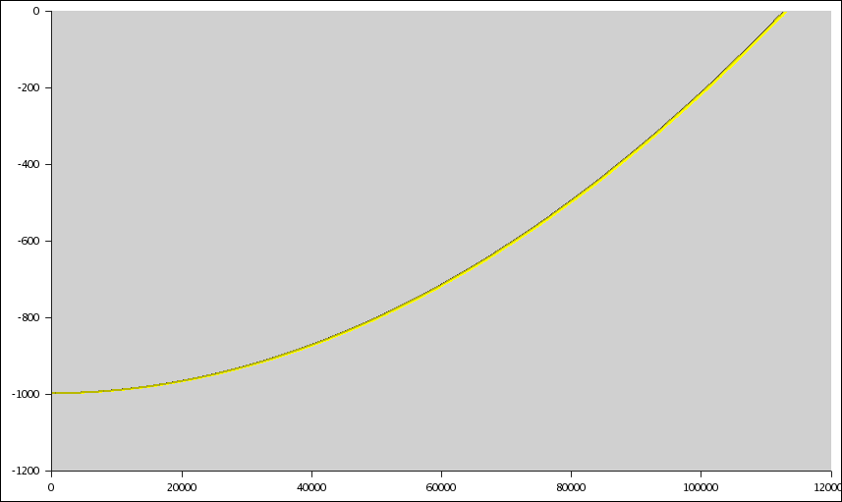

  - Error Performance of Computed vs. Analytic Ray Path

The detailed error performance of computed versus analytic ray path solution is compared in Figure 2.

Figure 2 Error Performance - Analytic Solution vs. Computed Solution

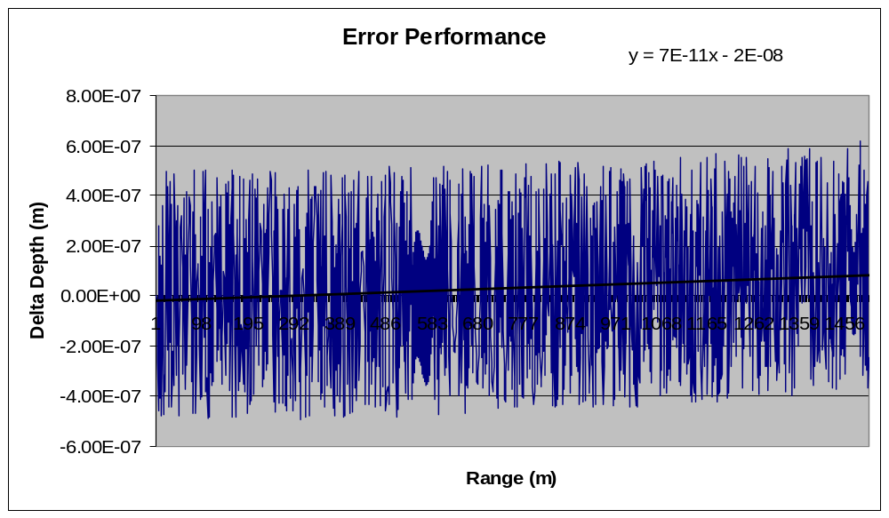

  - Analytic Path Independent of Sound Speed

Another important prediction of (16) is that the ray path is independent of the sound speed. This was verified by comparing the numerically computed depth values for sound speeds of 1500 and 1600 m/s for the same angle (achieved by using different time steps). Differences between these depth values calculate as < machine zero.

