Geodetic Acoustic Rays in the Time Domain

Analytic Ray Solutions – 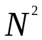 Linear Test Case

August 2006

Prepared for:
Sean M. Reilly
Alion Science and Technology
Newport, RI

Prepared by
Michael S. Goodrich
Alion Science and Technology
Norfolk, VA

Document Control Information

Revision | Revision History | Date
Ver. 1.0 | First version of document | August 2006

Table of Contents
1 Introduction 1
1.1 Scope 1
1.2 Applicable Documents 1
2 Derivation of Linear Analytic Ray Path 2
2.1 General Analytic Solution 2
2.2 Physical Considerations 4
2.3 General Comments on Jensen& Kupperman Solution 4
3 Particular Test Case 4
3.1 Analytic Formulation 4
3.2 Test Conditions 6
3.3 Analytic vs. Computed Ray Path – 30 deg Take off Angle 6
3.4 Analytic vs. Computed Ray Path – 50 deg Take off Angle 8

List of Figures

Figure 1 Analytic Solution vs. Computed Solution (30 deg.) 6
Figure 2 Differences between Analytic Solution vs. Computed Solution 7
Figure 3 Differences between Analytic Solution vs. Computed Solution 30 deg. (AB/3) 7
Figure 4 Analytic Solution vs. Computed Solution (50 deg.) 8
Figure 5 Differences between Analytic Solution vs. Computed Solution 9
Figure 6 Differences between Analytic Solution vs. Computed Solution 50 deg. (AB/3) 9

- Introduction
  - Scope
This report presents major findings concerning testing activities for the Geodetic Acoustic Ray Solutions in the Time Domain effort against the analytic ray path resulting from an analytic specification of sound velocity profile which is linear in the square of the index of refraction.

This test case is particularly important since this is a standard profile used in analytical ocean acoustics. As such, it is a direct test of numerical accuracy as compared to the computer calculated analytic ray path formula.

  - Applicable Documents
Following is a list of documents that should prove useful as references.
- "Computational Ocean Acoustics”, Jensen, Kuperman, et al..
- "Geodetic Acoustic Ray Solutions in the Time Domain", June 30, 2006.
- "Geodetic Acoustic Ray Solutions in the Time Domain – Technical Note on Geodetic to Flat Earth Adjustment", August, 2006.

- Derivation of Linear Analytic Ray Path
  - General Analytic Solution

The starting place for this solution is equation (3.122) in reference 1, giving the most general formulation of the 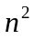 linear sound velocity profile:

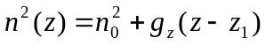 (1)
Where 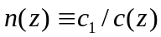 is the index of refraction, and c₁ is a reference sound speed. Equation (1) leads to the sound velocity profile:

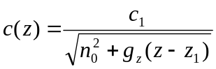 (2)

Equation (2) may be used in equation (3.97) in reference 1, to give:

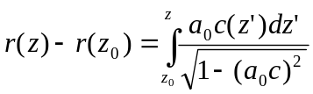 (3)

This integral may be performed by noting that from (2):
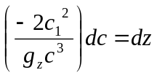 (4)
and with
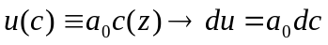 (5)
we have
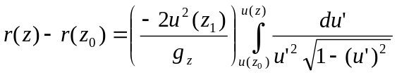 (6)
yielding
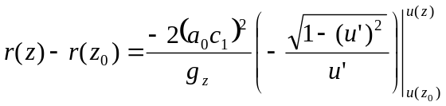 (7)
or
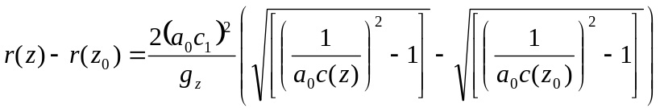 (8)
The second term in equation (8) inside the parentheses reduces to:
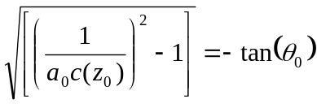 (9)
where the negative branch of the square root is chosen for physical reasons.
Also 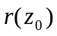 may be taken as zero and the constant 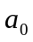 may be evaluated from equation (3.106) reference 1 as:
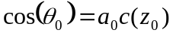 (10)
Note that equation (8) implies the constraint:
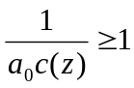 (11)
Equation (11) then implies:
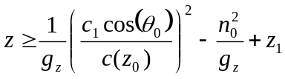 (12)
Setting z=0 in (12) gives the surface grazing takeoff angle of:
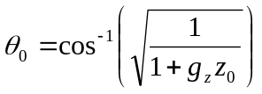 (13)
Equation (8) may be simplified and inverted to yield:
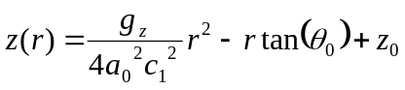 (14)
  - Physical Considerations

In considering equation (2), it should be clear that 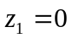 is the most general equation for c(z) possible for all physical scenarios. This further implies that 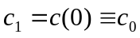 and that 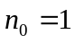. These considerations give the following simplified analytic model:

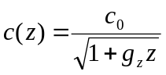 (15)
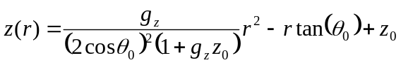 (16)
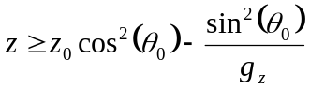 (17)
Setting z=0 in (17) gives the surface grazing takeoff angle of:
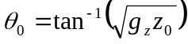 (18)

  - Comments on Jensen& Kupperman Solution

There is evidently an error in equation (3.128) as it should be clear that the “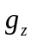” in (3.128) is not the same as that in equation (2) since (3.128) predicts the same parabolic path for rays starting at various depths even though the sound speed gradient itself varies with depth. This is simply not a realistic physical result. A true physical result would necessarily include a coefficient to the 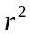 term in the analytic ray path that is not just strictly related to the sound velocity profile but is also a function of the initial conditions. This is reasonable on physical grounds since differing initial conditions imply different parabolic curves as ray paths.

- Particular Test Case
  - Analytic Formulation

Jensen and Kupperman mention that a particular problem for this class has been extensively studied. This is for the sound velocity profile:
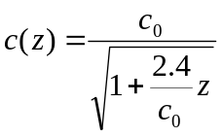 (19)
with 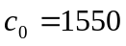 (20)
This implies that
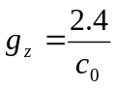 (21)
For the scenario where the initial depth is 1000m, we can set z=0 in (18) to get the surface grazing takeoff angle of:
(22)
We also have from (17):
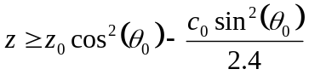 (23)
setting the lower bound on the ray depth for these initial conditions. Finally, the analytic ray path is now given from (16) as:

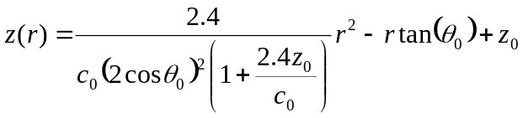 (24)
  - Test Results
    - Test Conditions

For the test comparisons the prototype Geodetic Acoustic Ray Engine was used with the analytic sound velocity profile define by equations (19), (20) and the Geodetic to Flat Earth adjustment to provide for direct comparison of ray traces.

The analytic ray path (equation (24)) was computed using Octave, Gnumeric, and a C program in the Linux environment; all analytic results were in agreement.

    - Analytic vs. Computed Ray Path – 30 deg Take off Angle

Figure 1 Analytic Solution vs. Computed Solution (30 deg.)
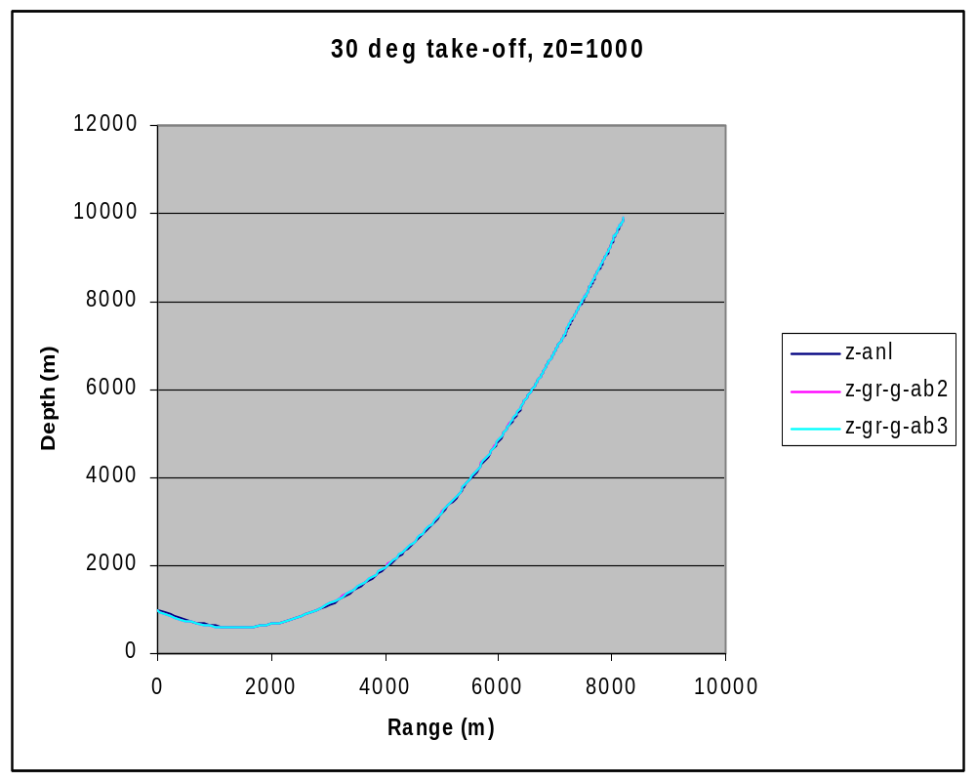
Figure 2 Differences between Analytic Solution vs. Computed Solution
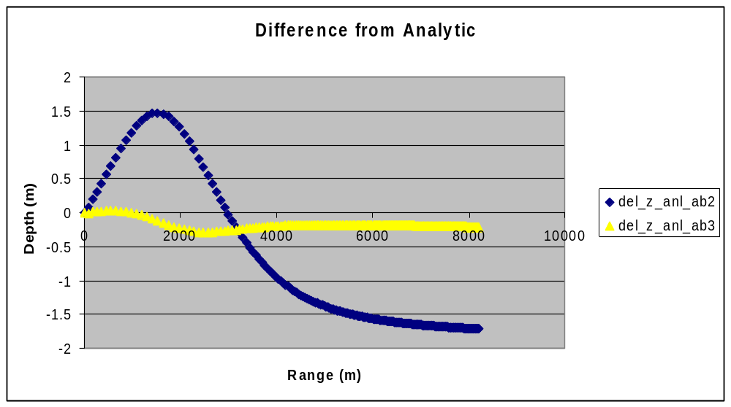
Figure 3 Differences between Analytic Solution vs. Computed Solution 30 deg. (AB/3)
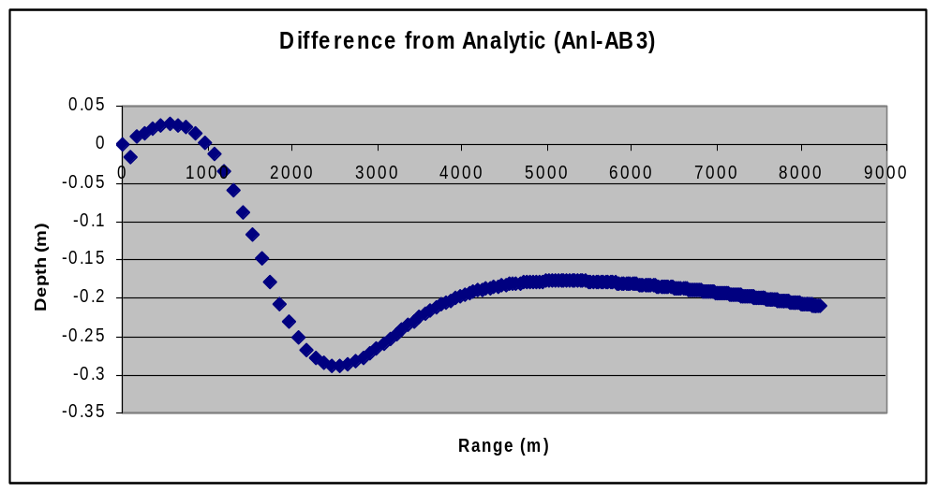
    - Analytic vs. Computed Ray Path – 50 deg Take off Angle
Figure 4 Analytic Solution vs. Computed Solution (50 deg.)
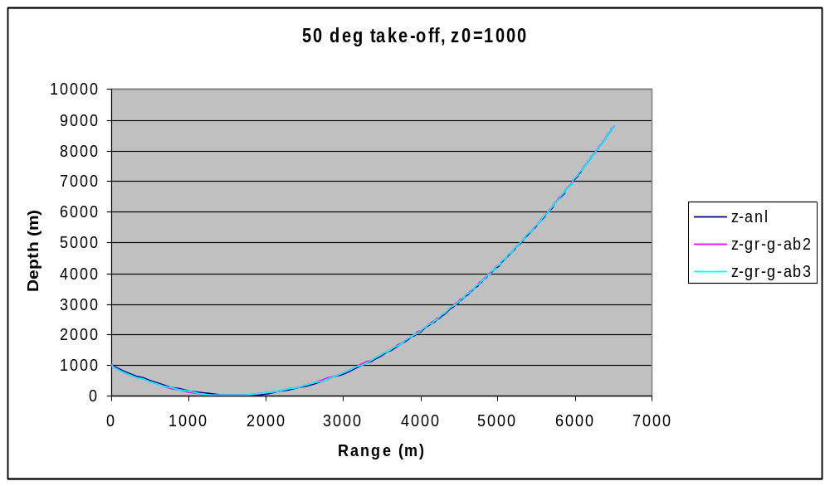

Figure 5 Differences between Analytic Solution vs. Computed Solution

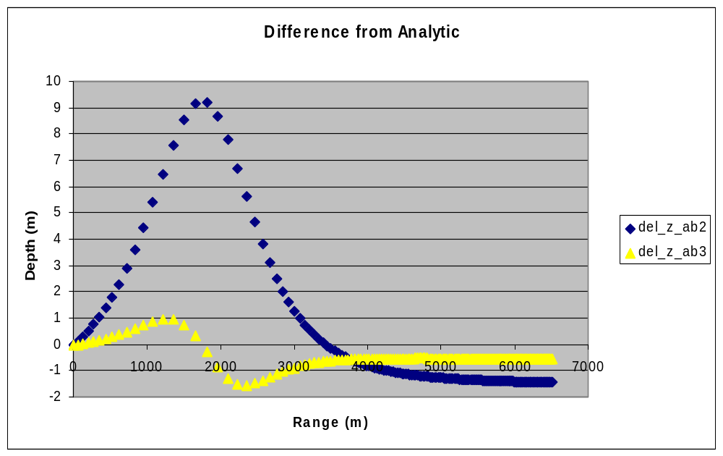
Figure 6 Differences between Analytic Solution vs. Computed Solution 50 deg. (AB/3)
