Docusign steps to follow
===============================================

1.https://admindemo.docusign.com/logout

2. Signup here

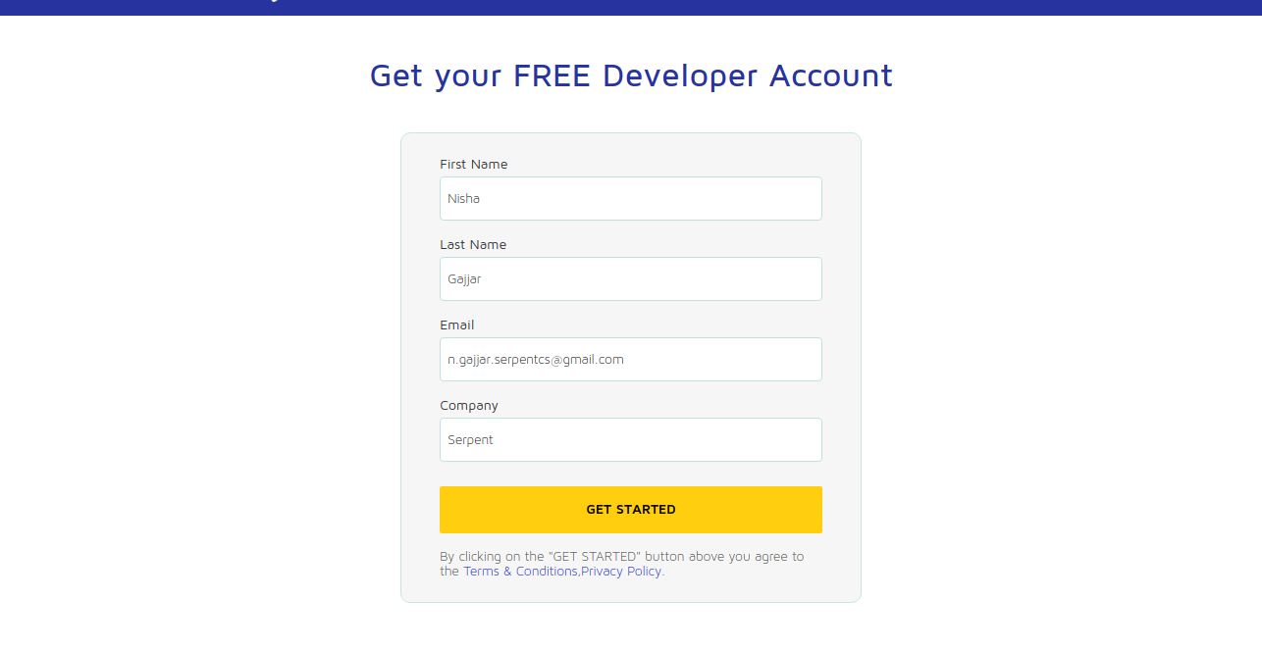

3. Activate Account from email

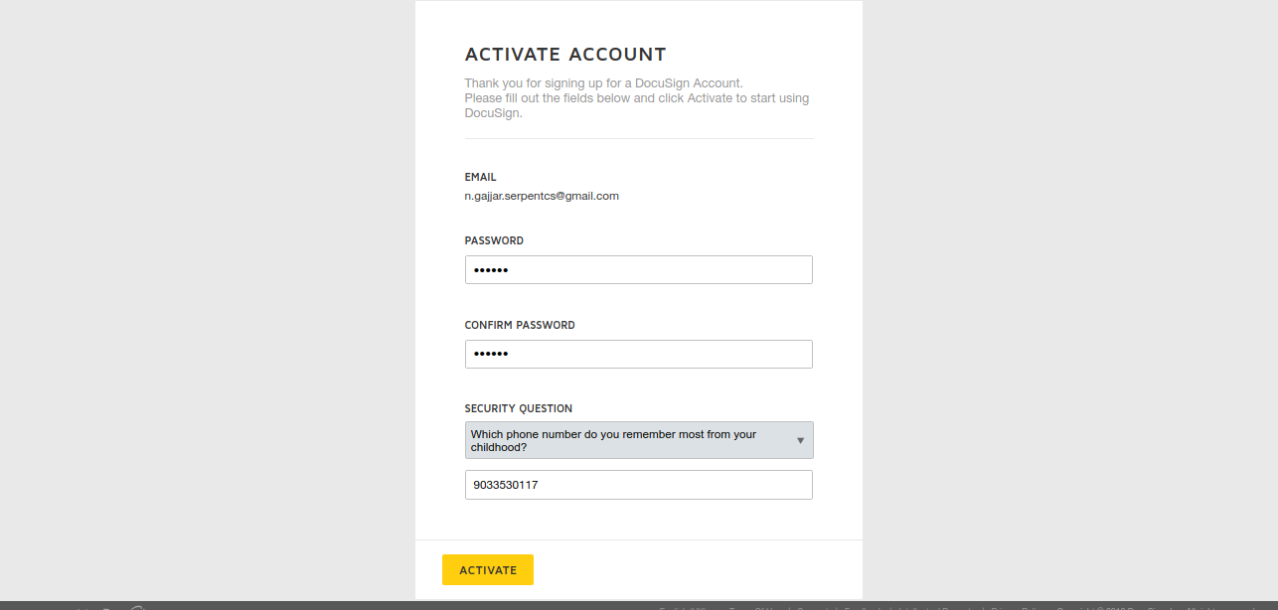

4.SignIn again and go to admin account

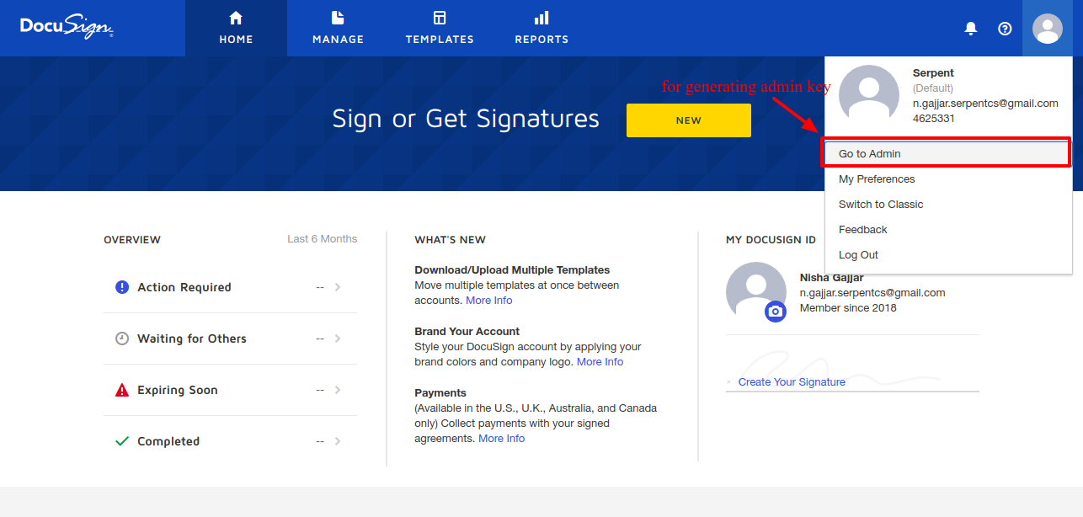

5.Now go to API and Keys

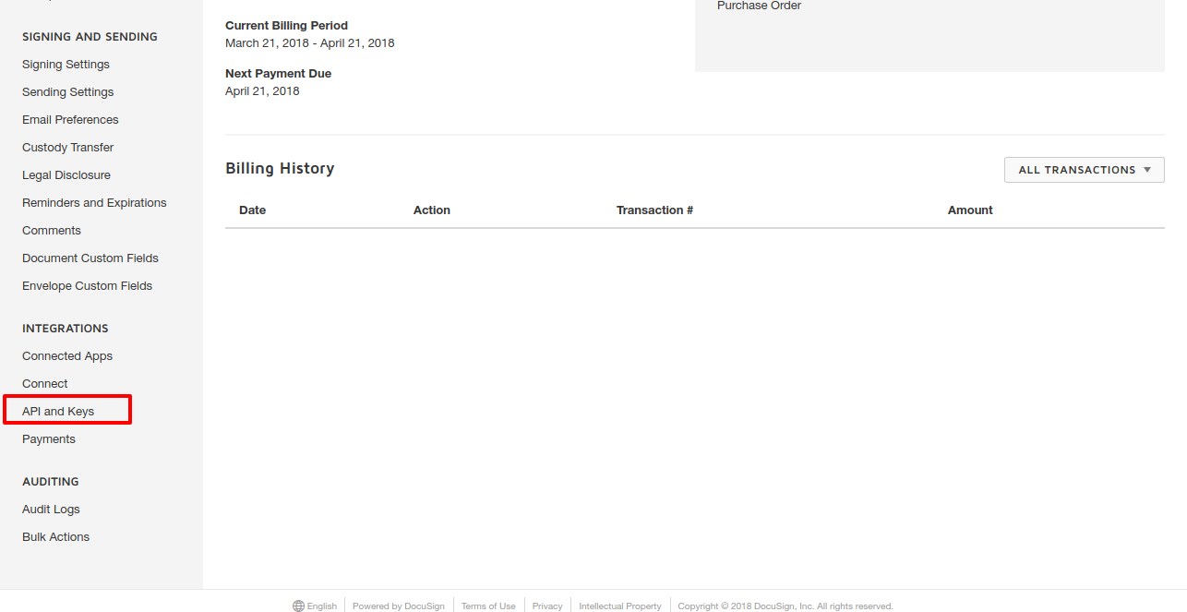

6.Using this key configure docusign

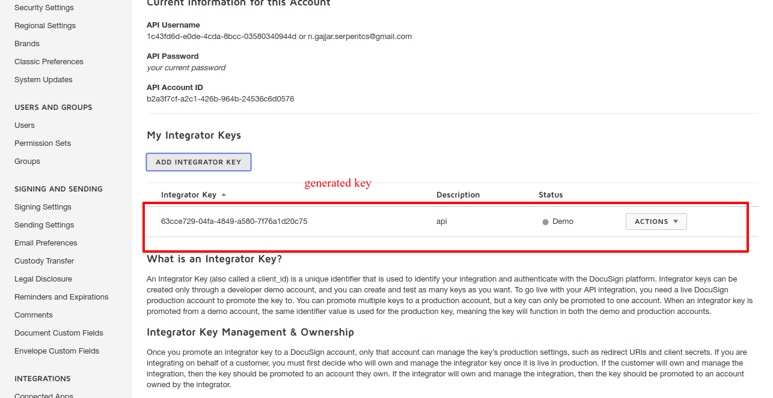

7.Test and confirmed it

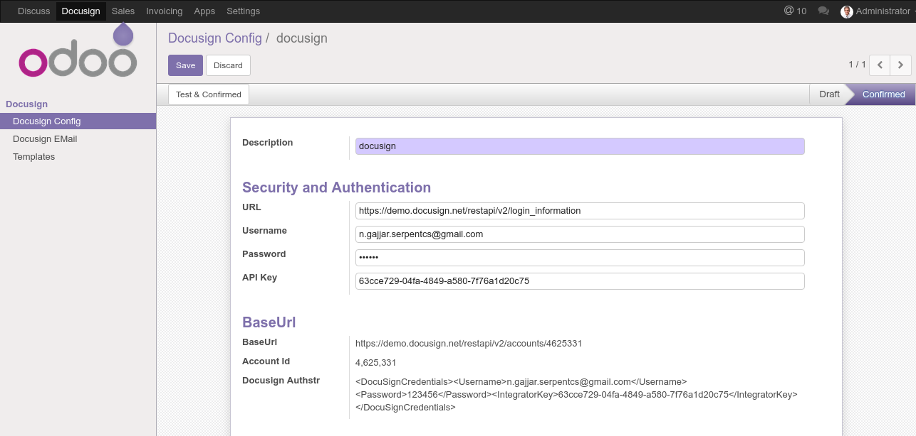

8.Configure Docusign Template

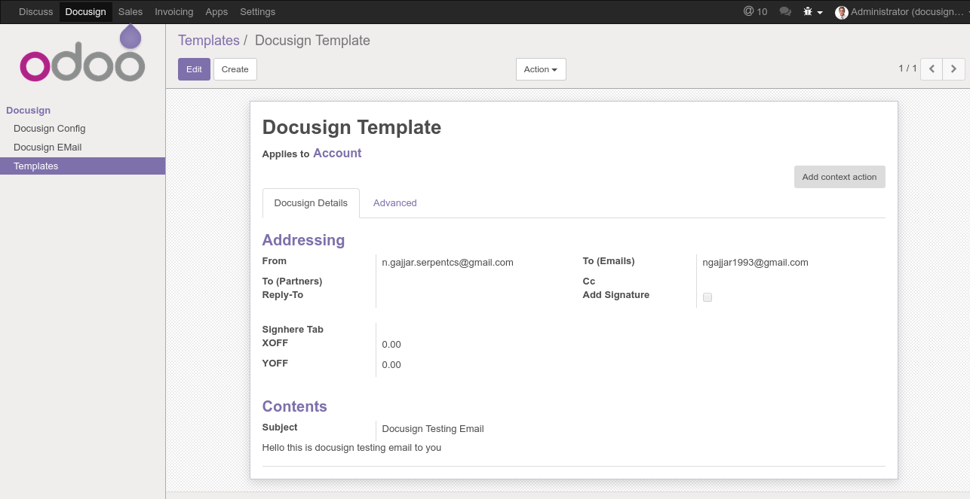

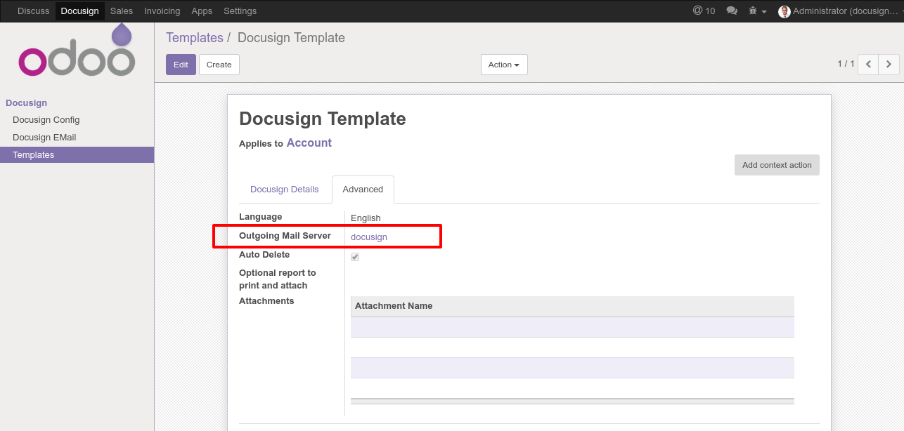

9. Docusign Email Configuration.Then after that send an email

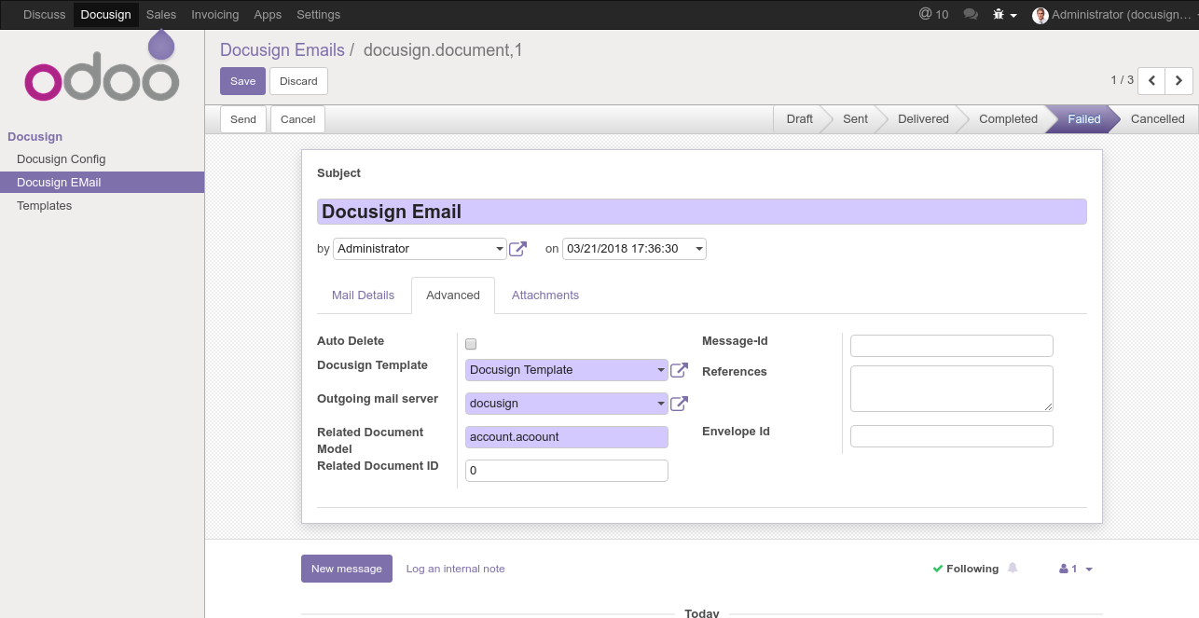

click on review Decoumnet it will redirect to attached image or file to add signature

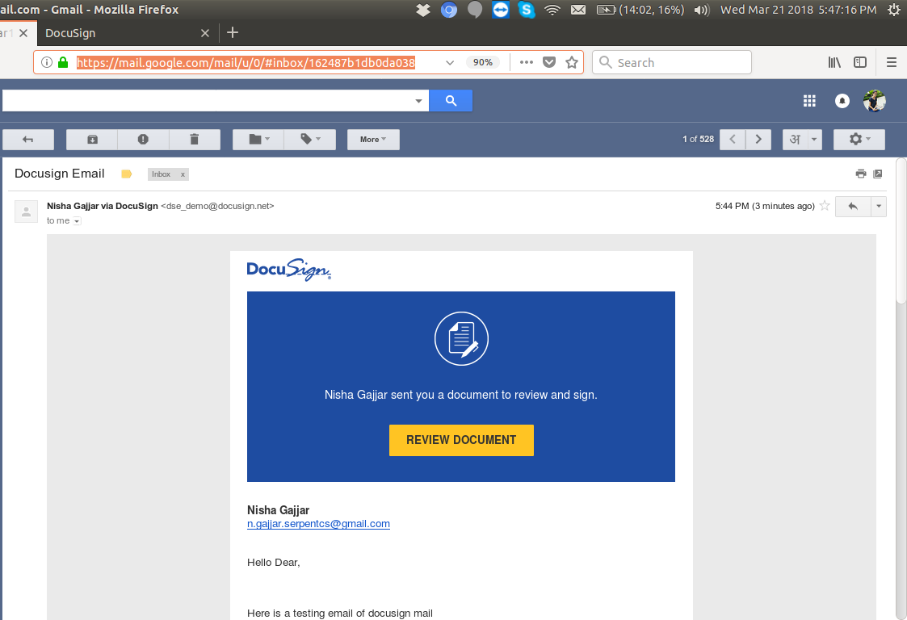

10. Add signature in image and fininshed it after that user get an fininshed email

