ESP8266

ESP8266 is a low cost SoC WIFI enabled with a micro controller unit (MCU) and a full TCP/IP stack.
It allows the MCU to connect to the WIFI.
AI-Thinker: integrated circuit disign
Expressif: manufacturer.

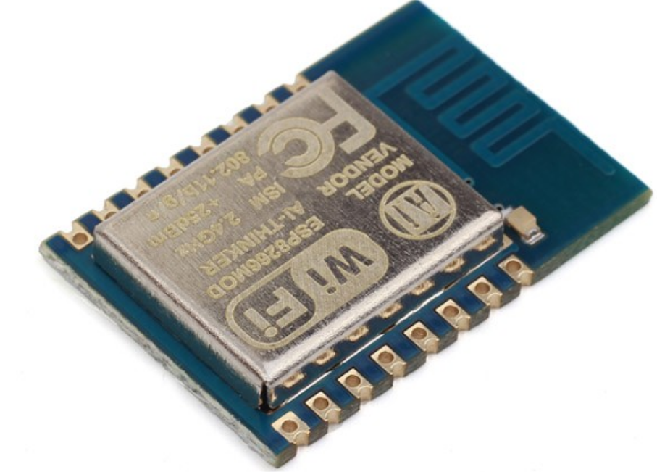

Fig 1: ESP-12E

Features

- MCU Tensilica Xtensa LX106
    - 32 bits RISC
    - clock: 80 Mhz (can be doubled to 160 Mhz)

- RAM
    - Data: 96 KB
    - Instructions: 64 KB

- Flash:
    - 512KB to 4KB up to 16KB (40 Mhz can be doubled to 80Mhz)

- BUS:
    - SPI (communicate with the falsh memory)
    - I2C
    - I2S: interface with DMA

- I/O
    - 16 pins GPIO
    - 1 bits ADC(Analog to Digital Converter 10 bits precision (0 – 1023 values)) 0 up to 1V.

- WIFI IEEE 802.11 b/g/n
    - Authentication: WEP, WPA/WEPA2
    - Opened networks
- Built-in temperature sensor
- Electrical features
  - Input voltage: 3.3v
  - Input current
      - total suhtdow: 0.5 uA
      - Transmit 802.11b, CCK 1Mbps, POUT=+19.5dBm: 215 mA
  - Max output current: 12 mA
SDK
ESP8266 Arduino core allows the ESP8266 WIFI chip and the CPU to be programmed like any others Arduino device.
Comes with the libaries to support:
- TCP
- UDP
- HTTP
- DNS
- SD card
- I2C
- SPI
- …

PIN description

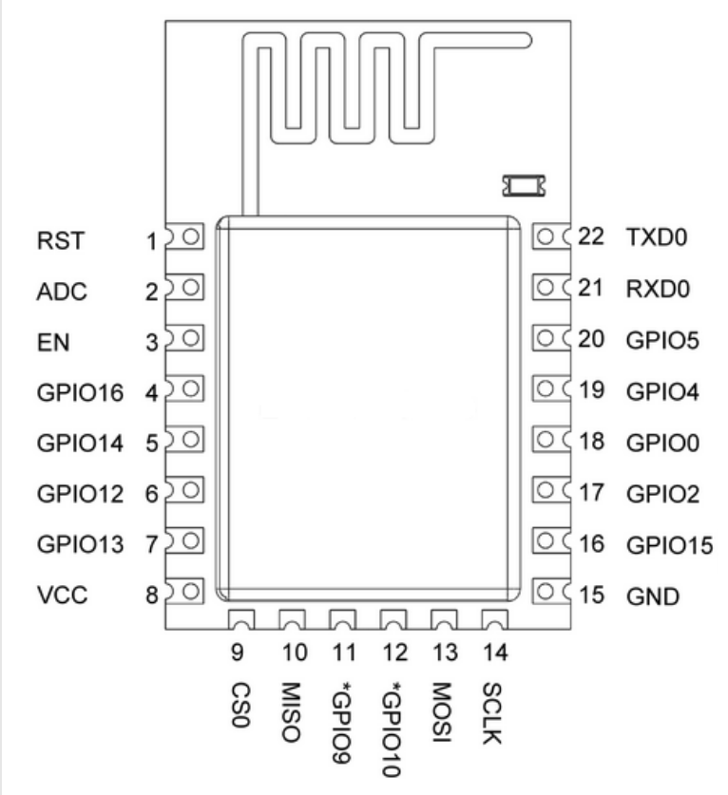

Fig 2: pin description

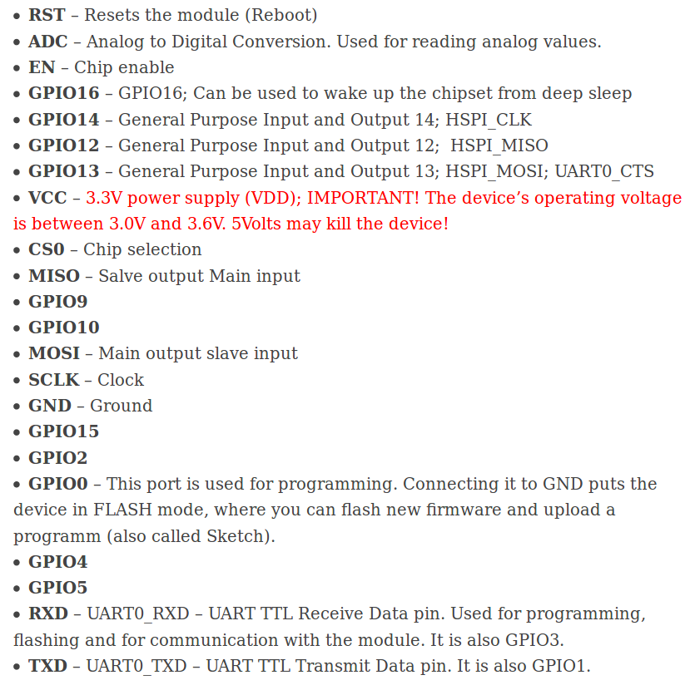
Worklog
This part concerns all the commands we have found during the project, to fix some issue.
- To know the device flash size
esptool.py --port /dev/ttyUSB0 --baud 115200 flash_id

esptool.py v1.3
Connecting....
Manufacturer: e0
Device: 4016
0x4016: denotes a 4MB device

esptool.py is a software used to communicate with the device ROM bootloader and to flash the device.
We can see all the available commands by typing esptool.py -h

