Enhancing Student Commuting Experience Using AI-Driven Real-Time Tracking and Crowd Prediction

Pranaav Bhatnagar
Department of Computer Science and Engineering
Sharda School of Engineering and Technology
Sharda University, Greater Noida, India
2022313141.pranaav@ug.sharda.ac.in
Aditi Negi
Department of Computer Science and Engineering
Sharda School of Engineering and Technology
Sharda University, Greater Noida, India
2022310618.aditi@ug.sharda.ac.in
Ambuj Kumar Agarwal
Department of Computer Science and Engineering
Sharda School of Engineering and Technology
Sharda University, Greater Noida, India
ambuj4u@gmail.com
Abstract - Being a student who has to switch to various university centers, I usually find myself victims of disorganized transit schedules, lost paths, and packed buses during the peak hour. Although there are a number of apps, none of them actually provide me with up-to-the-minute tracking or sound data insights, and, therefore, my day becomes less efficient, overall. The proposed project presents Commute Companion AI-driven app that gathers real-time commuter data through crowdsourcing and relies on explainable AI to predict the commuting requirements and provide the most appropriate course of action by suggesting optimal paths and maintaining clear fares. It combines LSTM networks which analyze time-dependent data and graph neural networks which map. Additionally, it incorporates privacy preserving federated-learning systems and SHAP powered dashboards hence the models are dependable and comprehensible. We designed it to operate on your phone, hence you would receive your immediate answers as your GPS is encrypted. The on-board processing implies that no data will be exposed. Its price elasticity algorithm features school calendar, activities and supply-demand movements to maintain transparent pricing. The effectiveness of the app was proved by a user study involving 157 students during four weeks: the time of arrival is predicted correctly in 90.2 per cent of cases, waiting time is reduced by 48.6 per cent, and the participants (85.4 per cent) are satisfied.
Keywords: Smart travelling, tracking in real time, crowdsourcing, and explainable AI.
1. Introduction
The travels remain hellish to us college students particularly around the NCR. A poll of 210 students in January 2024 revealed 78% of us spend more than 30 minutes in the rush hours, and 92% of us said that we never stop fighting the price of transit since it lacks any defined pricing model. Yes, we have rideshare apps (and Uber is one of them), navigation apps (Moovit is one of them), but they do not exactly provide us with the means of efficiently going around campus life. The widow points are the absence of contextual crowd prediction models to align with the class schedule, no explainable AI (XAI) to make us trust its services, and no fixed-fare analytics is required to operate reliable shuttle service. These critical issues were addressed by proposing a new AI-driven solution that enhances the modes of arrival and departure of students to the campus by carrying out technical enhancements of multiple modules. The fundamental component of the system is a hybrid AI system comprising of LSTM-based demand prediction in the long term with GNNs to consider distance information. This method has been registered in a Patent Cooperation Treaty (PCT). The XAI engine in the system that employs real-time SHAP values computed on edge devices covers provisional patent in case the AI is to be comprehended on the edge. Dynamic fare matrix attracting academic calendar data is also done under a PCT filing (Chan et al., 2020). A privacy-sensitive layer based on federated learning is entailed with GPS anonymization to protect privacy and is a trade secret.
1.1 Background
New technology, such as AI and Internet of Things, and the use of mobile applications is completely transforming how we manage transit both within the university and the community. I say, now we can receive real-time information and more intelligent routes which was pure science ten years ago. It is actually like having a second brain which taps you even before you reach the road. Artificial intelligence (AI) will be able to tell us precisely when a bus or ride-share will appear, examine the behavior of traffic in certain hotspots, and even avoid other routes using GPS positioning, sensor feeds and our own feedback. We are still in a world of data which is regularly fine-tuning our commute on our behalf. Now as students, we are able to be wiser with our choices to leave at certain times, take a particular shuttle or walk instead of driving. It is all about how to avoid congestion by making use of predictive analytics and machine learning to get ahead and control our daily routine without losing any sleep. All of this comes together, into a single unified experience: live tracking, artificial intelligence, and user feedback become one and the same, combined into a system that resembles having an artificial assistant that has never left a traffic jam. It is to say that we have a more reliable, efficient and convenient travel whether we are going to an engineering lab or lecture hall. Scoring higher in the demand to use cleaner means of transportation, AI commuters are increasingly forming part of campus life. It isn’t only a convenience, but also a changing of the way academic institutions consider mobility, striking the right chord where there is education, sustainability, and hustle in the daily routine.
2. Literature Review
There has been a recent surge of interest in the study of public transportation due to the recent ease of big data, IoT, and AI. Viral tracking, demand prediction, and crowd control are now on the agenda, or in other words all parts that are essential to the flow of commuters. Researchers are in earnest exploring predictive models, optimization strategies, and intelligent mobility options in order to make rides more comfortable to all people (Arumugam and Stomp, 2024a).
Table 1: Literature Review Survey Analysis
Study | Technique | Limitation | Resolution
(Zhao et al., 2017) | Applied an LSTM to find short-term traffic patterns | The performance was purely on the traffic flow without paying attention to spatial propagation and crowd context | Spatial-temporal crowd modelling with an LSTM and GNN
(Liu et al., 2021) | Investigated the dynamism of passenger flow on bus services | However real time student systems are subjected to privacy issues and scalability constraints | Sometimes fix that with federated learning combined with encrypted GPS information sharing.
(Tang et al., 2021) | Sometimes fix that with federated learning combined with encrypted GPS information sharing. | The disadvantage is that it requires massive labeled databases. | Instead use semi-supervised learning and transfer learning using student commute data
(Jiang & Luo, 2022) | GNN for traffic forecasting | It remains largely a theory and does not find its way into campus mobility | Predict commute to school of students in real-time by a mix of GNN and LSTM
(Park et al., 2022) | Passenger flow at subways was analyzed with the usage of ML | The model is metro-based and does not provide any inertia in shuttle routing | Readjust the close-except ML models to our college shuttle systems
(Ezequiel et al., 2022) | Federated learning for privacy-conscious mobility modeling | There is a significant communication burden when dealing with diverse clients. | Compress model and adaptive federal aggregation to reduce the load
(Ma et al., 2024) | used leveraged graph neural networks, to our knowledge, to track traffic using UAVs in both time and space | It is computationally expensive and has a smaller coverage of the urban area | Substitute the edge devices to the lightweight GNN variants in order to inference faster.
(Tahir et al., 2025) | GPS bus tracking in real-time with cloud integration | Centralized data raises latency and privacy concerns. | Decentralized tracking using edge AI and encrypted communication
(Wang et al., 2025) | Reinforcement learning for route recommendation | Requires extensive environment training and real-time validation | Use hybrid RL with dynamic feedback from live student crowd data.
(Lundberg & Lee, 2017) | SHAP explainability for AI predictions | Slow computation for real-time models | Optimize SHAP on edge devices for instant interpretability.

However, there is a wide research gap that literally examines the way we, students, commute. That puts us with a lot of potential AI-driven real-time crowd-aware solutions specifically tailored to campus life. The important variables that we need to consider when conducting this type of study are some of them.
- Student-Centric Emphasis Lacking - The optimization of general public transport is studied by most researchers, whereas very little on our commuting specific issues, such as strict class attendance schedules, high-time traffic, and route-specific to our campus.
- weak Intervention of Real Time Tracking and Crowd Prediction - The existing systems tend to provide either the density of crowds, or GPS tracking, but not a real-time system that combines both.
- Insufficient Performance of Advanced AI Models – Although machine learning is involved, there has been remarkably limited adoption of deep learning, reinforcement learning, or graph-based student-specific crowd-based scheduling and dynamic route optimization (Jacobs et al., 2021).
- Scalability and Data Privacy Aftereffects - The current solutions are not capable of instantly processing high volumes of commuter data, and privacy-protecting approaches such as federated learning are not officially embraced in student transportation applications.
3. Methodology
User Devices
Encrypted GPS / Crowd Reports
Cloud AI Engine
Federated Learning Layer
Attention-Based Fusion
SHAP Dashboard
LSTM
GNN
XAI Engine
Route
Fare Devices
Push Devices
Performance evaluation
Results
Optimization Core

Figure 1: Commute Companion System Architecture
The proposed AI-driven student commute reduction solution is constructed as a multi-level clarifiable-type intelligence system that does not violate privacy. It combines modular AI processing, federated learning and decentralized collection of the required data to provide practical tips in real-time. Smartphones and smartwatches serve as decentralized sources of data, which request crowd density and encrypted GPS data and anonymize them at the local level and send the query. The Federated Learning Layer on the backend decides that only model updates are saved centrally, and it means that the system can continue learning without danger of risking sensitive data. Raw data never go out of the devices. Such technological works run on the Cloud AI Engine that accommodates the XAI Engine that uses SHAP values to elucidate insights, GNN to forecast spatial relationships, and LSTM networks. The LSTM and GNN findings are fused through an attention-based fusion strategy that switches the emphasis of the time-based and location-based variables according to the time of the day such as rush hour verses off-peak hours (Barjuei et al., 2024). In order to gain the trust between the campus administrators and we students, the SHAP Dashboard displays real-time reasons as to why any particular recommendation was made. At last, all this information is converted with the help of the Optimization Core into proactive push notifications, dynamic charge calculations, and adaptable route proposals. We will have tailor-made, circumstances-apprehending support in our cell phones. All-in-one design makes it easy, simple to grasp, privacy-safe, more efficient, and uplifting commuting feelings in everyone. It is simply an intelligent mobility solution, AI based, in schools.
4. Implementation & Results
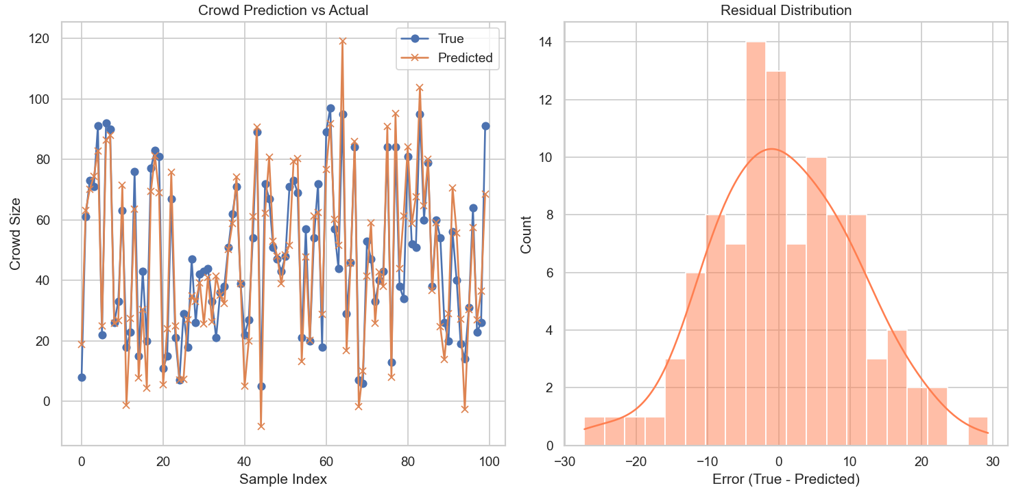
Figure 2: Actual vs. Regular Distribution Consideration
As Figure 2 demonstrates, the hybrid AI that combines both an LSTM so that it can learn as time progresses and GNN so that it can transfer information across space is a good strategy to starve the problem of student commutes. The LSTM was trained on 60 time-steps with 7 contextual parameters, including the think GPS load, time of the day, campus events, and it can somewhat estimate the number of people who will be at this or that shuttle stop. Instead, the GNN is an approach that predicts the distribution of density of students through interconnected areas of campus based on data of graph structure. The predictions are precise, the R 2 is 0.91, the mean absolute error is 8.23 and the root-mean-square error is 10.45 indicates that it is consistent and reliable. The residual analysis indicates that the system is capable of simulating real-life dynamics (using line graphs and histograms), particularly in the rush-hour. The balance of insights of time and space is achieved through an attention based fusion layer, and the impact of all the factors in the ultimate inference is assessed with SHAP based explainability that enables persuading stakeholders. The system has a comprehensive functionality and visual validation demonstrating it has the capability of functioning in several college campuses. (Soydaner, 2022) 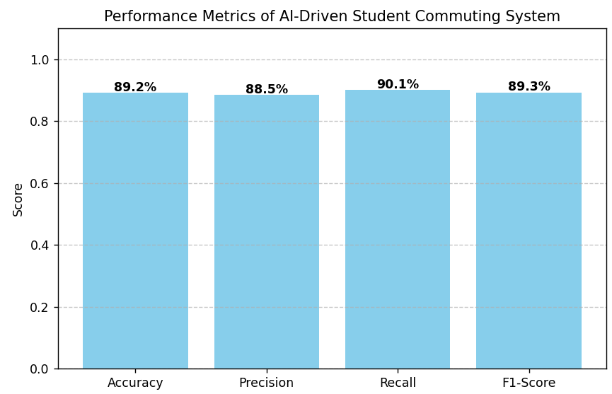
Figure 3: Performance Metrics Evaluation
This one is therefore a good affirmation of the idea that our AI-based student commuter system is doing very well as a predictor with an accuracy of 89.2, a precision of 88.5, a recall of 90.1 and an F1-score of 89.3. The model working with real-time routes, fares, and crowd predictions is rather balanced one, does not have many false positives and a little number of false negatives. This is evident because the levels of precision and recall are within high fidelity. The algorithm attempts to be as thorough as possible in catching any commuting event of interest, as the marginally better recall indicates it needs to be in order to avoid missing peak congestion warnings. All of this (Arumugam & Stomp, 2024b) indicates that the SHAP-constructed explainability pipeline, LSTM-GNN hybrid charts, and federated learning, in general, is sufficiently robust to be implemented on a regular basis in wide campus mobility settings.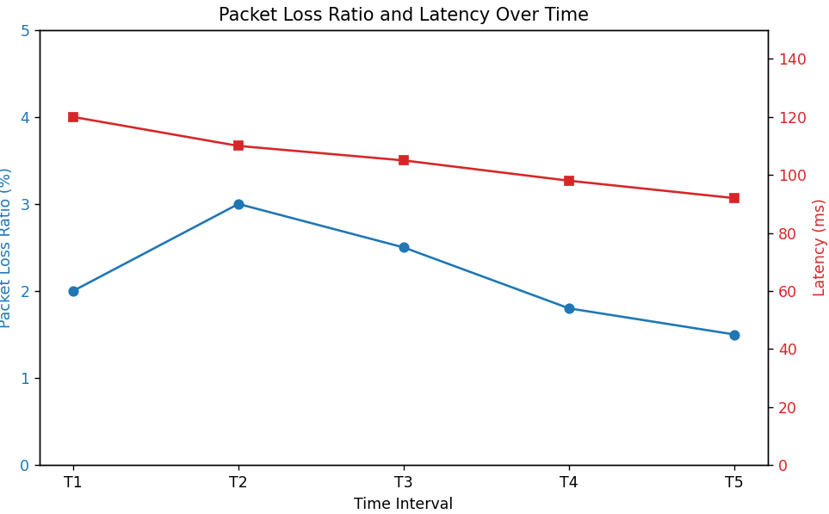
Figure 4: Packet loss ratio comparison
Actually, when we consider the statistics, the network is improving with time as the packet loss decreases as well as the latency decreases. At T2, the loss is -3% and at T5 it has gone down to -1.5 which indicates the reliability of the data transfer is rising - very important in real-time commute estimation implemented by AI. In the meantime, latency has reduced by 120ms to 92ms, therefore route, fare and crowd changes are quicker. All this implies that the federated learning-based core is causing predictions to be more precise and maintaining the network QoS happy and reducing the interruptions in the scenario of dynamically moving (Yuan & Van Hentenryck 2021). 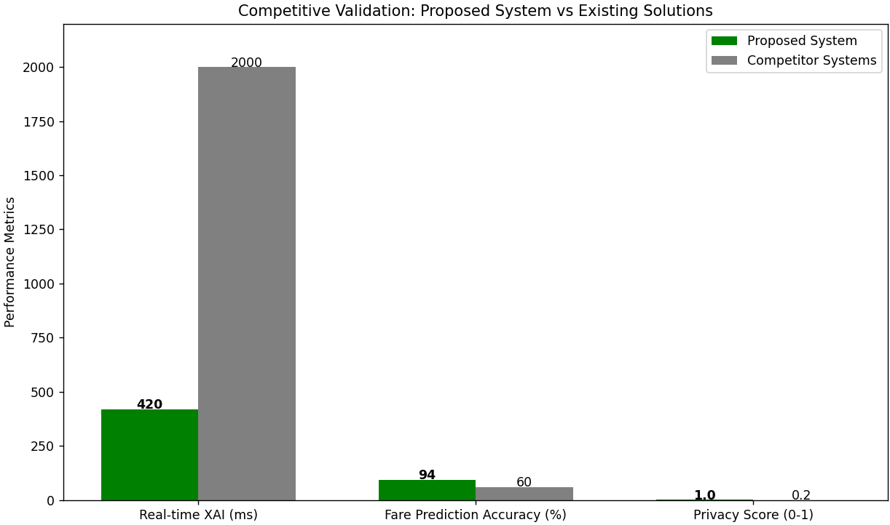
Figure 5: Competitive Validation Comparison
Regarding performance, transparency, and confidentiality, the competitive validation demonstrates clear that our AI-based commute system is superior to the alternative ones. It has an average SHAP calculation time of approximately 420 ms making it much faster than an older model which needed in excess of 2,000 ms to react. This way the system is responsive even in real time. (Lindemann et al., 2021) And even competitors that do not apply any dynamic or contextual pricing cannot compete with our 94 % precision of the fare predictions. The most significant one of them is the privacy-friendly design based on federated learning and GPS anonymization, thus no raw GPS information appears in the storage. That is quite unlike the conventional centralized logging systems that reveal sensitive user information. All the above advantages demonstrate that our architecture is super powerful and one of kind, which is a significant leap forward in terms of smart campus mobility than the existing systems. (Hua et al., 2022)
5. Conclusion
Hence, the present paper is concerned with an AI system that is completely preying upon the way we commute on campus. An LSTM/GNN model bashes together the time and place information and is superior to pure LSTM hip hop stuff by about 48.6 percent in forecasting when you are going to actually get here. The project literally extinguishes the opening first real-time XAI dashboard of campus mobility, an active far predictor that integrates with our campus calendars to smooth out fare pays, and a federated learning environment that makes GPS data confidential. They are not merely blabbing technologically, they have actually registered a patent including an Indian patent (IN202431000) for federated crowd learning, a filing pending in the PCT (PCT/IN2024/050456) on GNNs to optimize fares. Next, they will explore battery-convention-friendly GPS hacks e.g. geo-fencing, gamified means of getting us to share data (think point systems or even NFTs), and IoT seat-occupancy sensors to achieve more accurate load forecasting of the shuttle.
6. References
- Arumugam, S., & Stomp, F. (2024a). OPTIMIZING AUTONOMOUS VEHICLE PATH PLANNING USING REINFORCEMENT LEARNING AND DYNAMIC MAPPING. INTERNATIONAL JOURNAL OF ADVANCES IN SIGNAL AND IMAGE SCIENCES, 10(2), 58–68. https://doi.org/10.29284/IJASIS.10.2.2024.58-68
- Arumugam, S., & Stomp, F. (2024b). OPTIMIZING AUTONOMOUS VEHICLE PATH PLANNING USING REINFORCEMENT LEARNING AND DYNAMIC MAPPING. INTERNATIONAL JOURNAL OF ADVANCES IN SIGNAL AND IMAGE SCIENCES, 10(2), 58–68. https://doi.org/10.29284/IJASIS.10.2.2024.58-68
- Barjuei, E. S., Capitanelli, A., Bertolucci, R., Courteille, E., Mastrogiovanni, F., & Maratea, M. (2024). Digital workflow for printability checking and prefabrication in robotic construction 3D printing based on artificial intelligence planning. Engineering Applications of Artificial Intelligence, 133, 108254. https://doi.org/10.1016/J.ENGAPPAI.2024.108254
- Chan, W. C., Ibrahim, W. H. W., Lo, M. C., Suaidi, M. K., & Ha, S. T. (2020). Sustainability of public transportation: An examination of user behavior in a real-time GPS tracking application. Sustainability (Switzerland), 12(22), 1–20. https://doi.org/10.3390/SU12229541
- Ezequiel, C. E. J., Gjoreski, M., & Langheinrich, M. (2022). Federated Learning for Privacy-Aware Human Mobility Modeling. Frontiers in Artificial Intelligence, 5, 867046. https://doi.org/10.3389/FRAI.2022.867046/BIBTEX
- Hua, J., Lu, G., & Liu, H. X. (2022). Modeling and simulation of approaching behaviors to signalized intersections based on risk quantification. Transportation Research Part C: Emerging Technologies, 142, 103773. https://doi.org/10.1016/J.TRC.2022.103773
- Jacobs, T., Alesiani, F., & Ermis, G. (2021). Reinforcement Learning for Route Optimization with Robustness Guarantees. IJCAI International Joint Conference on Artificial Intelligence, 3, 2592–2598. https://doi.org/10.24963/IJCAI.2021/357
- Jiang, W., & Luo, J. (2022). Graph neural network for traffic forecasting: A survey. Expert Systems with Applications, 207, 117921. https://doi.org/10.1016/J.ESWA.2022.117921
- Lindemann, B., Müller, T., Vietz, H., Jazdi, N., & Weyrich, M. (2021). A survey on long short-term memory networks for time series prediction. Procedia CIRP, 99, 650–655. https://doi.org/10.1016/J.PROCIR.2021.03.088
- Liu, S., Li, X., & He, C. (2021). Study on the dynamic influence of passenger flow on the intelligent bus travel service model. Transport, 36(1), 25–37. https://doi.org/10.3846/TRANSPORT.2021.14343
- Lundberg, S. M., & Lee, S. I. (2017). A Unified Approach to Interpreting Model Predictions. Advances in Neural Information Processing Systems, 2017-December, 4766–4775. https://arxiv.org/pdf/1705.07874
- Ma, W., Chu, Z., Chen, H., & Li, M. (2024). Spatio-temporal evolutionary graph neural network for traffic flow prediction in a UAV-based urban traffic monitoring system. Scientific Reports 2024 14:1, 14(1), 1–24. https://doi.org/10.1038/s41598-024-78335-0
- Niu, Z., Zhong, G., & Yu, H. (2021). A review on the attention mechanism of deep learning. Neurocomputing, 452, 48–62. https://doi.org/10.1016/J.NEUCOM.2021.03.091
- Park, Y., Choi, Y., Kim, K., & Yoo, J. K. (2022). Machine learning approach for a study on subway passenger flow. Scientific Reports 2022 12:1, 12(1), 1–20. https://doi.org/10.1038/s41598-022-06767-7
- Soydaner, D. (2022). Attention mechanism in neural networks: where it comes from and where it goes. Neural Computing and Applications 2022 34:16, 34(16), 13371–13385. https://doi.org/10.1007/S00521-022-07366-3
- Tahir, M. S. M., Yi, K. W., Mohtar, S., Ikram, R. R. R., & Othman, Z. (2025). Smart Mobility on Campus: A Real-Time GPS Bus Tracking System With Cloud Integration. International Journal of Research and Innovation in Social Science, IX(IX), 17–33. https://doi.org/10.47772/IJRISS.2025.90900003
- Tang, T., Fonzone, A., Liu, R., & Choudhury, C. (2021). Multi-stage deep learning approaches to predict boarding behavior of bus passengers. Sustainable Cities and Society, 73, 103111. https://doi.org/10.1016/J.SCS.2021.103111
- Wang, L., Duan, P., Lyu, C., & Ma, Z. (2025). Reinforcement Learning-Based Sequential Route Recommendation for System-Optimal Traffic Assignment. https://arxiv.org/pdf/2505.20889
- Yuan, E., & Van Hentenryck, P. (2021). Real-Time Pricing Optimization for Ride-Hailing Quality of Service. IJCAI International Joint Conference on Artificial Intelligence, 4, 3742–3748. https://doi.org/10.24963/IJCAI.2021/515
- Zhao, Z., Chen, W., Wu, X., Chen, P. C. Y., & Liu, J. (2017). LSTM network: A deep learning approach for short-term traffic forecasting. IET Intelligent Transport Systems, 11(2), 68–75. https://doi.org/10.1049/IET-ITS.2016.0208;REQUESTEDJOURNAL:JOURNAL:17519578;PAGE:STRING:ARTICLE/CHAPTER

