CAMPSYNC
Remember · Understand · Act · Evolve
MONGODB DATA ARCHITECTURE
Detailed Design Document — Core Data Store
Document Version 2.0
All 13 Core Platform Modules Fully Detailed

1. Introduction & Purpose
This document defines the MongoDB data architecture for the CampSync platform's Core Data Store, as shown in the Core Components Architecture diagram. MongoDB is the Primary Operational Database of record for all 13 core platform modules — Academic Management, Examination Management, Learning Management (LMS), Finance & Accounts, Human Resource Management, Library Management, Hostel Management, Placement Management, Transport Management, Facilities Management, Alumni Management, Admin Manager, and Communication & Announcement.
MongoDB sits alongside — not instead of — Redis (cache/session), Elasticsearch (search & indexing), a Vector Database (AI/embeddings), and S3-compatible Object Storage (documents/media), each of which is fed from MongoDB via change streams and the platform Event Bus (Kafka), consistent with the Shared Services & Intelligence Layer and Data & Integration Layer shown in the source architecture.

1.1 Scope
- Full field-level schema detail (collections, indexes, embedding/referencing decisions, design rationale) for all 13 core platform modules — extended in this v2.0 revision from the four priority modules covered in v1.0 (Academic Management, Examination Management, Finance & Accounts, Admin Manager) to the remaining nine (LMS, HR, Library, Hostel, Placement, Transport, Facilities, Alumni, Communication & Announcement).
- Cluster-wide cross-cutting concerns — sharding, replication, transactions, integration with Redis/Elasticsearch/Vector DB/Object Storage, backup & security — documented once and applied uniformly across all modules rather than repeated per module.
- Cluster topology, sharding & replication strategy, indexing conventions, multi-tenancy model, transaction patterns, and integration with Redis / Elasticsearch / Vector DB / Object Storage / Event Bus.

1.2 Design Principles
- Module-aligned collections — each of the 13 modules owns a bounded set of collections; no module reaches directly into another module's collection (cross-module reads go through the module's service API or the Shared Services layer).
- Reference over duplication for high-churn entities (e.g. a student's fee balance is looked up, not copied), embedding for data that is always read/written together and rarely grows unbounded (e.g. an exam result's marks breakdown).
- Multi-tenant by design — every collection carries an institution_id (tenant) as the leading field of its primary compound index and, where sharded, as part of the shard key.
- Schema-on-write validation using MongoDB $jsonSchema validators per collection, versioned alongside the application's migration scripts.
- Event-sourced side effects — cross-module consequences (notifications, audit, analytics, search sync) are never written inline by the originating module; they are published to Kafka via change streams and consumed asynchronously.
- Soft-delete & audit-first — operational collections use status/is_deleted flags rather than hard deletes; the Admin Manager's audit_logs collection is append-only and immutable.

2. Multi-Tenancy & Database Topology
CampSync serves multiple institutions (colleges/universities) from a shared platform. A hybrid tenancy model is used:

2.1 Tenancy Model
Tenant Tier | Isolation Approach | Rationale
Standard institutions | Shared cluster, shared database, institution_id field on every document + tenant-aware compound indexes | Cost-efficient; majority of institutions are small/mid-size
Large / Enterprise institutions | Dedicated database within the same cluster (mongodb://.../inst_<id>), still sharded on the same key strategy | Predictable performance isolation, easier per-tenant backup/restore, satisfies data-residency clauses in some contracts
Government / regulated institutions | Dedicated replica set or shard zone, geo-pinned | Data residency & compliance (UGC/AICTE audit, state data-localization requirements)

2.2 Cluster Topology
The Core Data Store runs as a sharded MongoDB cluster (MongoDB 7.x, Atlas or self-managed):
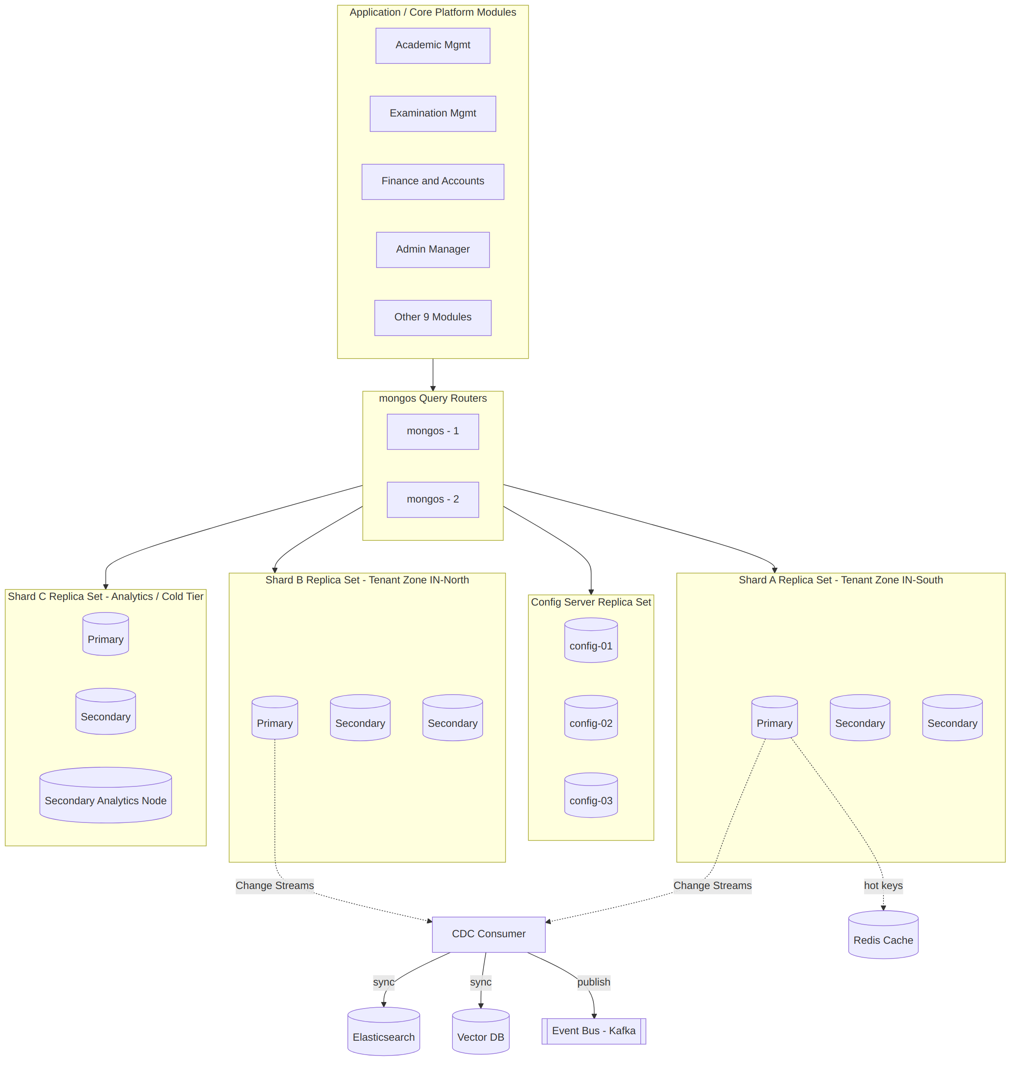
- Config Server Replica Set (3 nodes) — holds cluster metadata and chunk distribution.
- mongos Query Routers (2+, stateless, behind the API Gateway's Load Balancer) — every module connects only to mongos, never directly to a shard.
- Shard Replica Sets (3-node minimum: 1 Primary + 2 Secondaries per shard) — zoned by tenant geography (e.g. IN-South, IN-North) using zone sharding, so a tenant's data stays within its assigned zone for latency and residency reasons.
- A dedicated Analytics/Cold-Tier shard with a Secondary configured as an Analytics Node (hidden, priority 0) serves the Insight Engine and reporting workloads without impacting OLTP latency on the primary shards.
Assumption: institutions below a configurable document-count/QPS threshold are co-located in shared shards; larger institutions are pinned to a dedicated shard zone via the Tenant Resolver in the API Gateway layer. Actual thresholds are an operational tuning decision outside this document's scope.

3. Platform-Wide Collection Map
The table below lists the primary collections owned by each of the 13 core modules. Every module listed here is detailed in full in Sections 4-23 of this document: field-level schemas for its most complex collections, embedding-vs-referencing decisions, and design rationale. All modules follow the same platform-wide conventions established in Sections 2, 9-13 (tenant-scoped documents, module-owned collections, reference IDs to other modules' documents rather than embedded copies, common indexing and security patterns).
Module | Primary Collections (illustrative, not exhaustive) | Detail
1. Academic Management | programs, courses, course_sections, class_schedules, enrollments, academic_calendars, learning_pathways | §4
2. Examination Management | exam_registrations, exam_timetables, hall_tickets, question_banks, exam_results, revaluation_requests, certificates | §5
3. Learning Management (LMS) | course_content, assignments, submissions, discussion_threads, virtual_classrooms, progress_tracking, badges | §15
4. Finance & Accounts | fee_structures, fee_invoices, fee_receipts, scholarships, expenses, budgets, financial_reports | §6
5. Human Resource Management | employees, onboarding_cases, leave_requests, attendance_timesheets, performance_reviews, training_records, payroll_runs | §16
6. Library Management | catalog_items, book_circulations, digital_library_assets, memberships, fines | §17
7. Hostel Management | rooms, room_allocations, hostel_checkins, mess_plans, visitor_logs, maintenance_requests | §18
8. Placement Management | companies, job_postings, placement_drives, student_applications, interview_schedules, offers | §19
9. Transport Management | routes, vehicles, vehicle_assignments, gps_pings (time-series), driver_profiles | §20
10. Facilities Management | assets, work_orders, inventory_items, vendors, utility_readings, preventive_maintenance_schedules | §21
11. Alumni Management | alumni_profiles, alumni_events, mentorship_pairs, donations, engagement_scores | §22
12. Admin Manager | users, roles, permissions, role_assignments, system_configs, audit_logs | §7
13. Communication & Announcement | announcements, campaigns, notification_logs, survey_responses, emergency_alerts | §23
"Detail" column references the section of this document with full field-level schemas for that module.

4. Academic Management — Detailed Schema Design
Academic Management is the system of record for programs, courses, sections, schedules, and enrollments. Its collections are read heavily by Examination, Finance (fee-linked enrollment), LMS, and the Analytics Engine, so read-optimized denormalization is used deliberately in a few places (noted below).

4.1 Collections Overview
Collection | Purpose | Approx. Growth
programs | Degree/diploma programs (e.g. B.Tech CSE) | Low — tens per institution
courses | Course catalog & curriculum/syllabus | Low-Medium — hundreds per institution
course_sections | A course offered in a given term/semester with a faculty & capacity | Medium — recreated every term
class_schedules | Timetable slots for a section | Medium — 1:N per section
enrollments | Student ↔ section registration record | High — largest collection in the module
academic_calendars | Term dates, holidays, exam windows | Low
learning_pathways | Recommended/elective sequencing per student | Medium — AI/Insight Engine writes here

4.2 Core Schema — enrollments
The busiest collection in the module; the shard key and indexes here matter most.
Field | Type | Notes
_id | ObjectId | Primary key
institution_id | ObjectId | Tenant scope — leading field of shard key
student_id | ObjectId | Ref → students (owned by Admin Manager's users collection, role=student)
course_section_id | ObjectId | Ref → course_sections
term_id | ObjectId | Ref → academic_calendars
status | String (enum) | pending_fee | active | dropped | completed
enrolled_at | Date
fee_invoice_id | ObjectId, nullable | Ref → Finance.fee_invoices; set inside the enrollment transaction
grade | Object, nullable | { letter, gpa_points, published_at } — embedded, written once by Examination module via event
attendance_summary | Object | { present, absent, percentage } — denormalized rollup, recomputed nightly, NOT the source of truth
created_at / updated_at | Date | Standard audit timestamps
Design note: attendance_summary is intentionally denormalized for fast dashboard reads. The authoritative attendance ledger lives in its own append-only collection (attendance_events) fed by the Attendance Service; the summary is a materialized view refreshed via a scheduled aggregation, not written synchronously on every check-in.

4.3 Core Schema — course_sections
Field | Type | Notes
_id | ObjectId
institution_id | ObjectId | Shard key leading field
course_id | ObjectId | Ref → courses
term_id | ObjectId | Ref → academic_calendars
faculty_id | ObjectId | Ref → Admin Manager users (role=faculty)
capacity / seats_filled | Int | seats_filled incremented via findOneAndUpdate with a capacity guard, not read-then-write
schedule_ids | Array<ObjectId> | Ref → class_schedules
status | String (enum) | draft | open | closed | archived

4.4 Embedding vs. Referencing Decisions
Relationship | Approach | Reason
course_sections.schedule_ids | Reference (array of IDs) | Schedules can be edited independently and queried on their own for room-clash checks
enrollments.grade | Embed | Written once, read always with the enrollment, no independent lifecycle
courses.curriculum / syllabus | Embed (sub-document array of units) | Bounded size, always read together with the course
programs → courses | Reference | Many-to-many via a program_courses join-array; avoids duplicating course data per program

5. Examination Management — Detailed Schema Design
Examination Management handles registration, timetabling, hall-ticket generation, question banks, result processing, and revaluation. Results are write-once/append-heavy and are the system-of-record consumed by Academic Management, Alumni (transcripts), and Placement (eligibility).

5.1 Collections Overview
Collection | Purpose | Approx. Growth
exam_registrations | Student's registration for a specific exam | High — per student per exam
exam_timetables | Date/time/venue grid per term | Low
hall_tickets | Generated admit-card documents | High, mostly-immutable
question_banks | Question repository tagged by course/topic/difficulty | Medium, curated over time
exam_results | Marks, grade, publication status | High — append-heavy, never overwritten
revaluation_requests | Re-check/re-eval workflow state | Low-Medium
certificates | Issued certificates/marksheets metadata (file lives in Object Storage) | Medium

5.2 Core Schema — exam_results
Field | Type | Notes
_id | ObjectId
institution_id | ObjectId | Shard key leading field
exam_registration_id | ObjectId | Ref → exam_registrations
student_id | ObjectId | Ref → Admin Manager users
course_id | ObjectId | Ref → Academic.courses
marks_breakdown | Array<Object> | Embedded: [{component: 'internal'|'external'|'practical', max, obtained}] — bounded, always read together
total_obtained / total_max | Number | Derived, stored for query performance
grade_letter / grade_points | String / Number
status | String (enum) | draft | moderation | published | under_revaluation | finalized
published_at | Date, nullable | Set on transition to published; triggers EnrollmentGradeUpdated event
revision_of | ObjectId, nullable | Points to the prior result document when a revaluation changes marks — original is never mutated in place
Design note: exam_results is treated as an append-only ledger. A revaluation does not UPDATE the published document — it inserts a new result document with revision_of pointing at the original and status=finalized, and marks the original status=superseded. This preserves a full, auditable history of every mark change, which academic-integrity audits (NAAC/NBA) frequently require.

5.3 Core Schema — hall_tickets
Field | Type | Notes
_id | ObjectId
institution_id | ObjectId
exam_registration_id | ObjectId | Ref → exam_registrations
seat_number / venue / session_slot | String
document_ref | Object | { bucket, key, checksum } — pointer into Object Storage (S3-compatible), never store the PDF binary in MongoDB
eligibility_check | Object | { fee_cleared: bool, attendance_cleared: bool, checked_at } — snapshotted at generation time
- eligibility_check is a point-in-time snapshot, deliberately denormalized from Finance and Academic Attendance data, so a hall ticket already issued remains valid even if downstream records later change (audit trail integrity).

6. Finance & Accounts — Detailed Schema Design
Finance & Accounts owns fee structures, invoicing, receipts, scholarships, expenses, budgeting, and payroll integration. This module has the platform's strictest consistency requirements — money must never be lost or double-counted — so it makes the heaviest use of multi-document ACID transactions of any module.

6.1 Collections Overview
Collection | Purpose | Approx. Growth
fee_structures | Program/term fee templates & heads (tuition, hostel, exam, etc.) | Low
fee_invoices | A billed amount owed by a student for a term/head | High
fee_receipts | Immutable payment records against an invoice | High, append-only
scholarships | Awarded scholarship/waiver records | Medium
expenses | Institutional expenditure entries | Medium
budgets | Departmental/annual budget allocations & utilization | Low
financial_reports | Generated report metadata (file in Object Storage) | Low-Medium

6.2 Core Schema — fee_invoices
Field | Type | Notes
_id | ObjectId
institution_id | ObjectId | Shard key leading field
student_id | ObjectId | Ref → Admin Manager users
enrollment_id | ObjectId, nullable | Ref → Academic.enrollments — set when the invoice originates from a course enrollment
fee_structure_id | ObjectId | Ref → fee_structures
line_items | Array<Object> | Embedded: [{head, amount, waived_amount}] — bounded, always read/written with the invoice
total_amount / amount_paid / balance | Decimal128 | Decimal128 mandatory for currency — never Number/float
status | String (enum) | issued | partially_paid | paid | overdue | waived | cancelled
due_date | Date
version | Int | Optimistic-concurrency counter, incremented on every update

6.3 Core Schema — fee_receipts
Field | Type | Notes
_id | ObjectId
institution_id | ObjectId
fee_invoice_id | ObjectId | Ref → fee_invoices
amount | Decimal128
payment_method | String (enum) | card | upi | netbanking | dd | cash
gateway_reference | Object | { provider, transaction_id, status } — from the Payment Gateway external system
receipt_number | String | Unique per institution, sequence-generated (see 6.4)
idempotency_key | String, unique index | Prevents duplicate receipt creation on gateway webhook retries
created_at | Date | Immutable — receipts are never edited or deleted, only reversed via a new adjustment record

6.4 Transactional Write Pattern
A fee payment is a two-collection, invariant-critical write: it must update fee_invoices.amount_paid/status AND insert a fee_receipts document atomically, or neither happens. This is implemented as a MongoDB multi-document ACID transaction:
- startSession() → withTransaction(): (1) findOneAndUpdate on fee_invoices with a filter on {_id, version} and $inc on amount_paid/version (optimistic lock), (2) insertOne on fee_receipts with the idempotency_key unique constraint as a duplicate-webhook guard.
- Receipt numbering uses a dedicated counters collection ({_id: 'inst_<id>_receipt'}, seq: Int) incremented via findOneAndUpdate with $inc inside the same transaction, avoiding auto-increment race conditions.
- On commit, the module publishes FeePaid to the Event Bus; Academic Management consumes it to flip the linked enrollment from pending_fee to active (see Section 8 sequence diagram); Notification Engine sends the receipt; Audit & Compliance logs the event.
Design note: Decimal128 is mandatory for every monetary field platform-wide, not just in this module, to avoid floating-point rounding drift across fee/payroll/budget calculations.

7. Admin Manager — Detailed Schema Design
Admin Manager is the central administration module: it owns the platform's identity, role, and permission model (users, roles, RBAC assignments), system configuration, and the immutable audit ledger that every other module writes to. Because every module's students/faculty/staff records are actually role-typed profiles on top of this module's users collection, its schema choices ripple across the whole platform.

7.1 Collections Overview
Collection | Purpose | Approx. Growth
users | Single identity record per person, with a role-typed profile sub-document | High
roles | Named role definitions (student, faculty, hod, registrar, warden, ...) | Low
permissions | Granular permission catalog (resource:action pairs) | Low
role_assignments | Many-to-many: user ↔ role, scoped optionally to a department/hostel/etc. | Medium
system_configs | Per-tenant feature flags, branding, integration keys | Low
audit_logs | Immutable, append-only event ledger for every write across the platform | Very High — largest collection platform-wide

7.2 Core Schema — users
Field | Type | Notes
_id | ObjectId
institution_id | ObjectId | Shard key leading field
auth | Object | { email, phone, password_hash, sso_provider, mfa_enabled } — password_hash never returned by any projection used outside the auth service
profile_type | String (enum) | student | faculty | staff | parent | alumni | admin
profile | Object | Type-specific embedded sub-document, e.g. student: {enrollment_number, program_id, batch_year}; faculty: {employee_code, department_id, designation}
status | String (enum) | active | suspended | deactivated
created_at / updated_at | Date
Design note: a single users collection with a discriminated profile sub-document (rather than one collection per role) keeps identity, auth, and RBAC in one place and avoids the 'which collection is this person in' ambiguity when a person holds two roles (e.g. an alumnus who is also adjunct faculty). Modules reference users._id and read only the profile fields they need via a projection.

7.3 Core Schema — role_assignments (RBAC)
Field | Type | Notes
_id | ObjectId
institution_id | ObjectId
user_id | ObjectId | Ref → users
role_id | ObjectId | Ref → roles
scope | Object, nullable | { scope_type: 'department'|'hostel'|'program', scope_id } — e.g. 'HOD scoped to CSE department'
granted_by / granted_at | ObjectId / Date
expires_at | Date, nullable | For time-bound roles (e.g. exam invigilator for one term)
- Effective permission resolution (role → permissions, plus scope check) is computed at the application/API-Gateway Authorization layer and cached in Redis per session — MongoDB is the source of truth, not the per-request lookup path.

7.4 Core Schema — audit_logs
Field | Type | Notes
_id | ObjectId
institution_id | ObjectId | Shard key leading field
event_type | String | e.g. EnrollmentCreated, FeePaid, RoleGranted, ExamResultPublished
actor | Object | { user_id, role, ip_address }
target | Object | { collection, document_id, module }
before / after | Object, nullable | Diff snapshot for update events; omitted for high-volume read events
occurred_at | Date | Indexed with a TTL-free retention — see Section 9
source | String | Which module/service published the event
Design note: audit_logs is populated exclusively by Kafka consumers reading the change-stream-derived event bus — no module writes to it directly and synchronously. This keeps every module's own write latency independent of audit-log write volume, and guarantees no module can accidentally corrupt the audit trail.

8. Cross-Collection Relationships
The diagram below shows the relationship structure across the platform's core transactional modules (Academic, Examination, Finance, Admin Manager). The same referencing conventions extend to the nine additional modules detailed in Sections 15-23 — each references Admin Manager's users collection for identity and links to other modules by ID rather than duplicating data, consistent with the platform's overall preference for referencing across module boundaries and embedding only within a single document's natural lifecycle.
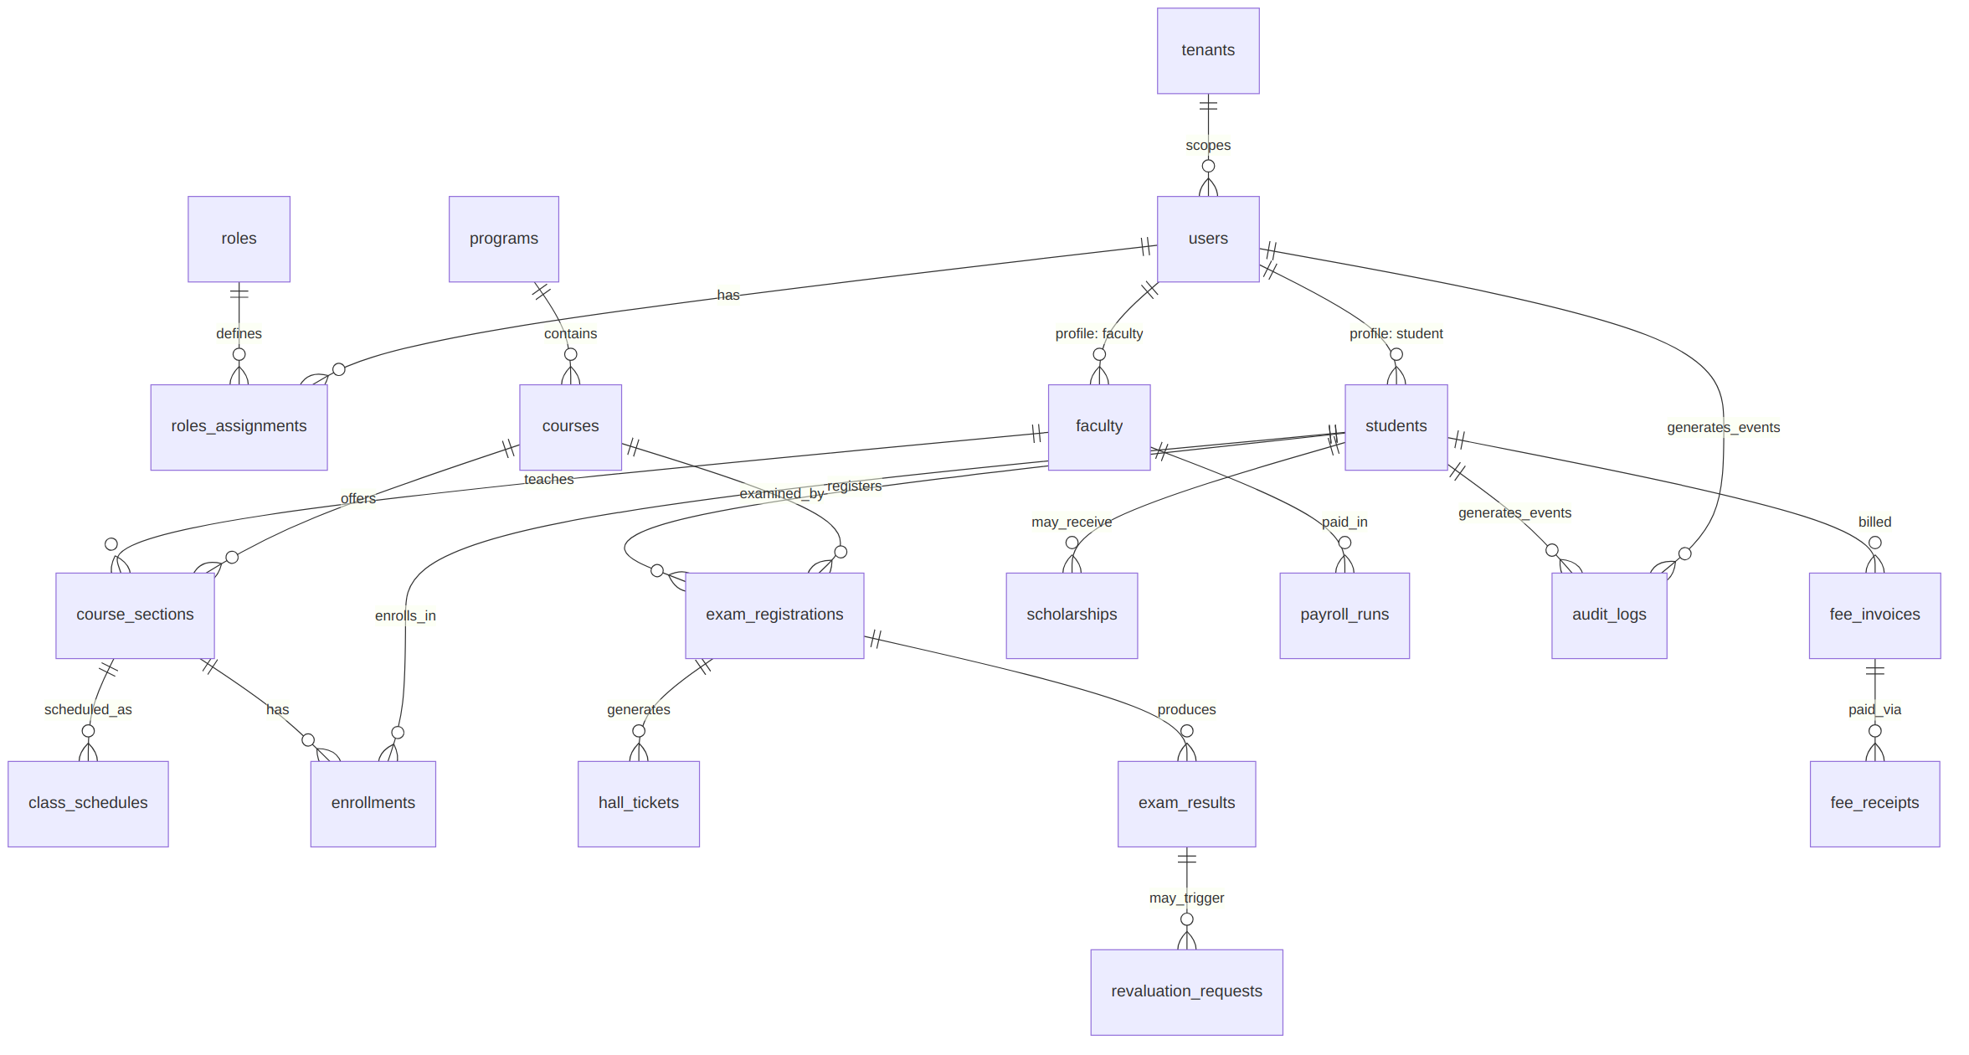

8.1 Cross-Module Write Sequence — Enrollment → Fee → Confirmation
The most representative end-to-end write path (mirroring the source architecture's 'Student Enrolls in a Course' scenario) touches Academic, Finance, the Event Bus, Notification Engine, and Audit & Compliance:
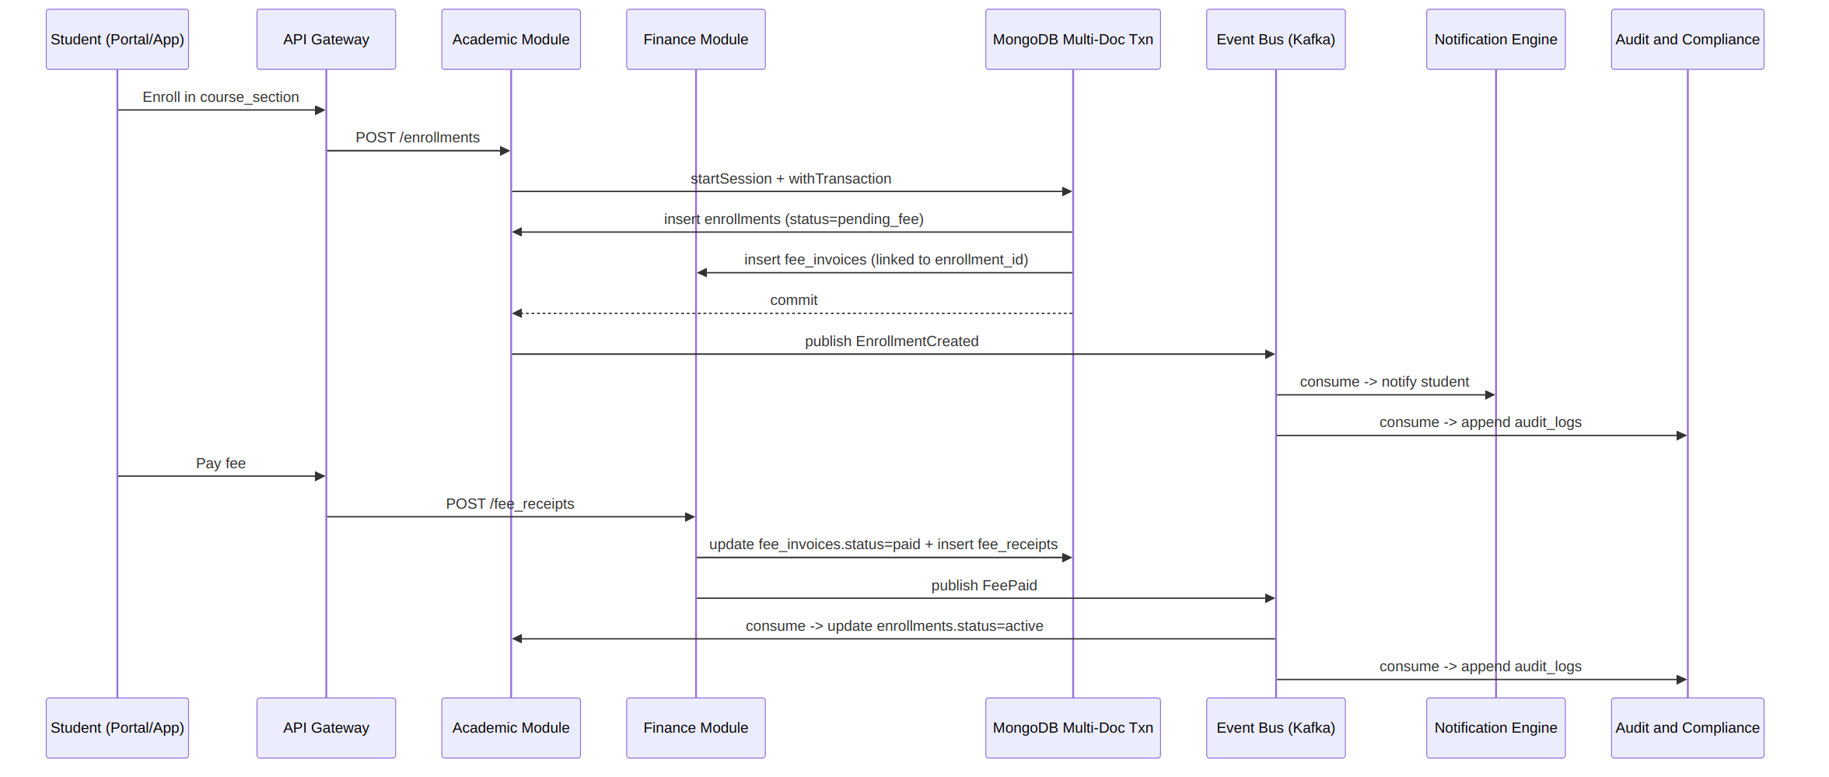
- Steps 1-2 (enrollment insert + invoice insert) execute inside a single MongoDB transaction because they must succeed or fail together.
- Steps 4+ (notification, audit) are deliberately outside that transaction — they are eventually-consistent side effects delivered via Kafka, so a slow notification provider can never block or fail an enrollment.

9. Indexing Strategy
Every collection follows a common indexing convention, with collection-specific compound indexes layered on top.

9.1 Platform-Wide Conventions
- Every tenant-scoped collection has institution_id as the leading key of its most-used compound index (and of the shard key, where sharded) — this keeps every common query and every chunk migration tenant-local.
- Every collection has a unique compound index enforcing its natural key, e.g. { institution_id: 1, enrollment_number: 1 } on users, { institution_id: 1, idempotency_key: 1 } on fee_receipts.
- Foreign-key-style reference fields (student_id, course_section_id, fee_invoice_id, etc.) are indexed wherever they are used in a lookup or a $lookup-equivalent application-side join.
- Partial indexes are used for enum-filtered hot queries, e.g. an index on fee_invoices filtered to {status: {$in: ['issued','partially_paid','overdue']}} for the collections dashboard, so the index stays small as paid invoices accumulate.

9.2 Core-Module Index Definitions
Collection | Key Indexes | Type
enrollments | {institution_id,student_id,term_id} unique; {institution_id,course_section_id,status} | Compound
course_sections | {institution_id,term_id,faculty_id}; {institution_id,course_id,term_id} unique | Compound
exam_results | {institution_id,student_id,course_id,status}; {institution_id,exam_registration_id} unique (current revision only, partial) | Compound / Partial
hall_tickets | {institution_id,exam_registration_id} unique | Compound unique
fee_invoices | {institution_id,student_id,status,due_date}; {institution_id,enrollment_id} | Compound
fee_receipts | {institution_id,idempotency_key} unique; {institution_id,fee_invoice_id} | Compound unique
users | {institution_id,'auth.email'} unique; {institution_id,profile_type,status} | Compound unique
role_assignments | {institution_id,user_id}; {institution_id,role_id,'scope.scope_id'} | Compound
audit_logs | {institution_id,occurred_at} desc; {institution_id,'target.document_id'}; {institution_id,event_type,occurred_at} | Compound
All indexes above are illustrative starting points. Actual index selection should be finalized against real query patterns using MongoDB's Query Profiler / Atlas Performance Advisor once production traffic is available — over-indexing write-heavy collections like enrollments and fee_receipts has a real write-latency cost.

10. Sharding & Replication Strategy

10.1 Shard Key Selection
Collection | Shard Key | Rationale
enrollments | {institution_id, student_id} | High cardinality, tenant-local, matches the dominant query pattern (a student's own enrollments)
exam_results | {institution_id, student_id} | Same rationale; keeps a student's full result history on one shard
fee_invoices / fee_receipts | {institution_id, student_id} | Co-locates a student's financial ledger for transaction locality
audit_logs | {institution_id, occurred_at} | Time-ordered, hashed on institution_id to avoid a monotonically-increasing single-shard hotspot; occurred_at supports range scans for retention/archival jobs
users | {institution_id, _id} | Lower volume; institution_id alone would still be too coarse at platform scale, hashed _id suffix avoids hotspotting on large-institution onboarding bursts

10.2 Zone Sharding for Multi-Institution Isolation
- Shards are grouped into zones (e.g. zone: 'IN-South', zone: 'IN-North', zone: 'dedicated-<large-tenant>'); each institution_id range is tagged to a zone via sh.updateZoneKeyRange().
- This gives large or regulated tenants dedicated shard capacity without a separate cluster, and lets the Tenant Resolver route by geography for latency.

10.3 Replication
- Every shard is itself a 3-node (minimum) replica set: 1 Primary + 2 Secondaries, with writeConcern: majority for all financial and audit writes, and readConcern: majority for any read feeding a financial decision (fee balance checks, payroll).
- A dedicated hidden Secondary (priority: 0, votes: 0) on the primary transactional shards serves as the Analytics Node, absorbing Insight Engine / reporting queries so they never contend with OLTP traffic on the Primary.
- Read preference defaults to primaryPreferred for module APIs and secondary/secondaryPreferred for the Insight Engine, Analytics dashboards, and the Elasticsearch/Vector DB sync consumers.

11. Data Consistency & Transaction Patterns

11.1 When to Use a Multi-Document Transaction
Transactions are used only for writes within a single module's collections where an invariant would otherwise be violatable (money, seat capacity, published results). Cross-module consequences are handled via the event-driven saga pattern instead, matching the platform's Event Bus / Workflow Engine layer.
Scenario | Consistency Pattern
Fee payment (invoice update + receipt insert) | ACID transaction, single module (Finance)
Enrollment + auto-generated invoice | ACID transaction spanning enrollments + fee_invoices (both owned conceptually by the same write path; see Section 8.1)
Fee paid → enrollment activated | Saga via Kafka event (FeePaid consumed by Academic Management) — eventual consistency, retried with an outbox-pattern guarantee
Exam result published → transcript/eligibility update | Saga via Kafka event, consumed by Placement (eligibility) and Alumni (transcript) modules
Role granted → permission cache invalidation | Saga via Kafka event, consumed by the Authorization layer to bust the Redis permission cache

11.2 Outbox Pattern for Reliable Event Publication
- Rather than publishing to Kafka directly inside application code (which can fail silently after a DB commit), each module writes a small outbox_events collection entry inside the same transaction as its business write.
- A change-stream-driven relay process tails outbox_events and publishes to Kafka, then marks the entry published — guaranteeing at-least-once delivery without losing events on a mid-write crash.

12. Integration with Redis, Elasticsearch, Vector DB & Object Storage
MongoDB remains the single source of truth; every other data-layer component is a derived, resyncable view fed by MongoDB Change Streams, matching the Data & Integration Layer in the source architecture.
Component | What Syncs From MongoDB | Sync Mechanism
Redis | Session data, resolved RBAC permissions, hot-path caches (fee balance, seat availability), rate-limit counters | Write-through on the API layer + cache-invalidation events consumed from Kafka on relevant changes
Elasticsearch | Full-text/faceted search indexes: course catalog, question banks, library catalog, announcements, alumni directory | Change Streams → CDC consumer → bulk index API; near-real-time (seconds)
Vector Database | Embeddings for AI Agents / Insight Engine: course descriptions, LMS content, placement job descriptions, knowledge-graph entities | Change Streams → embedding pipeline → upsert; batched, minutes-level latency is acceptable
Object Storage (S3-compatible) | Actual binary files — hall tickets, certificates, receipts PDFs, LMS content assets | MongoDB never stores binaries; it stores {bucket, key, checksum} pointers only, per Section 5.3
Design note: because search and vector indexes are fully derived, they are treated as disposable — a full reindex-from-MongoDB job is a supported, tested operational runbook, not an emergency procedure.

13. Backup, Security & Compliance

13.1 Backup & Archival
- Continuous, oplog-based backups (Atlas continuous backup or equivalent) with point-in-time restore granularity of under 60 seconds for the transactional shards.
- audit_logs and exam_results (superseded revisions) are moved to the Cold-Tier/Analytics shard and ultimately to the Backup & Archive object-storage tier after a configurable active-retention window, rather than being deleted — matching regulatory retention expectations for academic records.
- Quarterly restore drills into an isolated cluster validate that backups are actually restorable, not just captured.

13.2 Security
- Encryption in transit (TLS) for all client↔mongos and mongos↔shard traffic; encryption at rest via the storage engine's native encryption or the underlying cloud volume encryption.
- Field-level (client-side) encryption for the highest-sensitivity fields — auth.password_hash is already a one-way hash; government-ID-type fields, where an institution stores them, use MongoDB Queryable Encryption so even a database-level breach does not expose plaintext.
- RBAC at the database layer (MongoDB's own users/roles) is scoped to service accounts per module, so a compromised Finance service credential cannot read/write Examination or HR collections — this is defense-in-depth underneath the application-level RBAC described in Section 7.3.
- All schema validators ($jsonSchema) reject documents missing institution_id, preventing an entire class of cross-tenant data leakage bugs at the database layer, not just the application layer.

13.3 Compliance Alignment
- The append-only exam_results/audit_logs pattern directly supports NAAC/NBA academic-integrity audit trails and UGC-mandated result-record retention.
- Zone sharding supports state-level data-localization requirements where an institution's regulator requires it.

14. Representative Aggregation Pipelines
Two examples of the analytics-style queries the Insight Engine and module dashboards run directly against the Analytics Secondary/Cold-Tier shard.

14.1 Fee Collection Dashboard — Outstanding Balance by Program
Aggregation Pipeline (fee_invoices)
db.fee_invoices.aggregate([
{ $match: { institution_id: tenantId, status: { $in: ["issued","partially_paid","overdue"] } } },
{ $lookup: { from: "enrollments", localField: "enrollment_id", foreignField: "_id", as: "enr" } },
{ $unwind: "$enr" },
{ $lookup: { from: "course_sections", localField: "enr.course_section_id", foreignField: "_id", as: "sec" } },
{ $unwind: "$sec" },
{ $lookup: { from: "courses", localField: "sec.course_id", foreignField: "_id", as: "course" } },
{ $unwind: "$course" },
{ $group: {
_id: "$course.program_id",
total_outstanding: { $sum: { $subtract: ["$total_amount", "$amount_paid"] } },
invoice_count: { $sum: 1 }
} },
{ $sort: { total_outstanding: -1 } }
])

14.2 Placement Eligibility Feed — Students Meeting Result Criteria
Aggregation Pipeline (exam_results)
db.exam_results.aggregate([
{ $match: { institution_id: tenantId, status: "published" } },
{ $group: {
_id: "$student_id",
avg_gpa: { $avg: "$grade_points" },
backlog_count: { $sum: { $cond: [{ $lt: ["$grade_points", 4] }, 1, 0] } }
} },
{ $match: { avg_gpa: { $gte: 6.5 }, backlog_count: 0 } }
])
These pipelines run on the hidden Analytics Secondary (readPreference: secondary) so they never compete with OLTP writes on the Primary, consistent with the replication design in Section 10.3.

15. Learning Management (LMS) — Detailed Schema Design
LMS holds course content, assignments and submissions, discussions, virtual classroom sessions, and per-student progress tracking. It is read/write heavy on submissions and progress_tracking, and read-mostly on course_content, which is large-payload (video/document references) and therefore stored as pointers into Object Storage, not embedded binary.

15.1 Collections Overview
Collection | Purpose | Approx. Growth
course_content | Modules/units/lessons within a course_section, with content pointers | Medium
assignments | Assignment definitions per course_section | Medium
submissions | Student submissions against an assignment | High
discussion_threads | Forum threads/replies scoped to a course_section | Medium-High
virtual_classrooms | Scheduled/recorded live-session metadata | Medium
progress_tracking | Per-student completion state across course_content | High
badges | Earned achievement/badge records | Low-Medium

15.2 Core Schema — submissions
Field | Type | Notes
_id | ObjectId
institution_id | ObjectId | Shard key leading field
assignment_id | ObjectId | Ref → assignments
student_id | ObjectId | Ref → Admin Manager users
content_ref | Object | { bucket, key, checksum } — pointer into Object Storage, same convention as hall_tickets/certificates
submitted_at | Date
attempt_number | Int | Supports multi-attempt assignments; combined with assignment_id+student_id forms the natural key
grading | Object, nullable | { score, max_score, feedback, graded_by, graded_at } — embedded, single lifecycle with the submission
status | String (enum) | submitted | late | graded | resubmission_requested

15.3 Core Schema — progress_tracking
Field | Type | Notes
_id | ObjectId
institution_id | ObjectId
student_id | ObjectId | Ref → Admin Manager users
course_section_id | ObjectId | Ref → Academic.course_sections
completed_content_ids | Array<ObjectId> | Ref → course_content; append-only set, grows monotonically
completion_percentage | Number | Denormalized rollup, recomputed on each content-completion event
last_activity_at | Date

15.4 Embedding vs. Referencing Decisions
Relationship | Approach | Reason
submissions.grading | Embed | Written once by a grader, always read with the submission, no independent lifecycle
course_content binary/video | Reference (content_ref pointer) | Large payloads belong in Object Storage, not MongoDB documents
discussion_threads replies | Reference (separate documents, thread_id foreign key), not embedded array | Threads can grow unbounded; embedding would breach the 16MB document limit on popular threads
progress_tracking.completed_content_ids | Embed (array of IDs, not full content docs) | Bounded by course size, avoids an extra lookup for the common 'is this done' check
Design note: discussion_threads is deliberately NOT modeled as one document per thread with an embedded replies array, unlike the bounded embeds used elsewhere in this document — a popular thread's reply count is unbounded, so replies are their own documents referencing thread_id, mirroring the same reasoning applied to audit_logs and exam_results being separate append-only collections rather than embedded arrays.

16. Human Resource Management — Detailed Schema Design
HR Management covers the employee lifecycle — onboarding, leave, attendance/timesheets, performance, training, and payroll. Its payroll_runs collection shares the Finance module's strict monetary conventions (Decimal128, ACID transactions), since a payroll run ultimately produces Finance expense entries.

16.1 Collections Overview
Collection | Purpose | Approx. Growth
employees | Employment record layered on top of the Admin Manager users profile | Low-Medium
onboarding_cases | New-hire onboarding checklist/workflow state | Low
leave_requests | Leave application and approval workflow | Medium
attendance_timesheets | Daily/period attendance and hours | High
performance_reviews | Periodic review records | Low-Medium
training_records | Completed/enrolled training programs | Medium
payroll_runs | Per-cycle payroll computation and disbursement record | Medium, strict consistency

16.2 Core Schema — employees
Field | Type | Notes
_id | ObjectId
institution_id | ObjectId | Shard key leading field
user_id | ObjectId | Ref → Admin Manager users (profile_type=faculty|staff)
employee_code | String | Unique per institution
department_id | ObjectId
designation | String
employment_type | String (enum) | permanent | contract | visiting | probation
date_of_joining | Date
reporting_to | ObjectId, nullable | Ref → employees (self-reference for org hierarchy)
status | String (enum) | active | on_leave | separated
Design note: employees is a separate collection from users (Admin Manager) rather than folding employment fields into users.profile, because HR-specific fields (department, designation, reporting line) change on a different cadence and under different write-permissions than identity/auth fields — keeping them separate limits the blast radius of an HR data-correction to the HR module's own collection.

16.3 Core Schema — payroll_runs
Field | Type | Notes
_id | ObjectId
institution_id | ObjectId
employee_id | ObjectId | Ref → employees
period | String | e.g. '2026-08'
line_items | Array<Object> | Embedded: [{component: 'basic'|'hra'|'deduction', amount}] — bounded, single payslip lifecycle
gross_amount / net_amount | Decimal128 | Currency fields — Decimal128 mandatory, same convention as Finance
status | String (enum) | draft | approved | disbursed | reversed
disbursed_at | Date, nullable
idempotency_key | String, unique index | Same duplicate-disbursement guard pattern as Finance.fee_receipts
- On status → disbursed, the module publishes a PayrollDisbursed event; Finance & Accounts consumes it to create the corresponding expenses entry — an eventually-consistent saga, not a cross-module transaction, following the same pattern as the Fee Payment → Enrollment Activated flow in Section 8.1/11.1.

16.4 Embedding vs. Referencing Decisions
Relationship | Approach | Reason
payroll_runs.line_items | Embed | Bounded payslip components, always read/written together
employees.reporting_to | Reference (self-referencing) | Org hierarchy changes independently of the employee's own record
attendance_timesheets | Separate collection, referencing employee_id | High write volume — kept out of the employees document to avoid unbounded growth and write contention

17. Library Management — Detailed Schema Design
Library Management is a catalog-and-circulation system: a searchable catalog (synced to Elasticsearch per Section 12), circulation transactions, digital assets, memberships, and fines. Circulation is the module's transactional core — checking out a book must atomically decrement available copies.

17.1 Collections Overview
Collection | Purpose | Approx. Growth
catalog_items | Books/journals/media catalog with copy counts | Medium
book_circulations | Issue/return/renewal transaction records | High
digital_library_assets | E-book/e-resource metadata with access pointers | Medium
memberships | Per-user library membership status and limits | Medium
fines | Overdue/damage fine records, linked to Finance for collection | Low-Medium

17.2 Core Schema — catalog_items
Field | Type | Notes
_id | ObjectId
institution_id | ObjectId | Shard key leading field
isbn | String, nullable
title / authors / subject_tags | String / Array<String> | Synced to Elasticsearch for full-text/faceted search per Section 12
total_copies / available_copies | Int | available_copies updated via findOneAndUpdate with a $gt:0 guard on checkout — never read-then-write
location | String | Shelf/section reference

17.3 Core Schema — book_circulations
Field | Type | Notes
_id | ObjectId
institution_id | ObjectId
catalog_item_id | ObjectId | Ref → catalog_items
member_id | ObjectId | Ref → Admin Manager users
issued_at / due_at / returned_at | Date | returned_at null while the item is out
renewal_count | Int
status | String (enum) | issued | returned | overdue | lost
fine_id | ObjectId, nullable | Ref → fines, set if the return is late/damaged
- Checkout is a single-collection transaction: findOneAndUpdate on catalog_items (decrement available_copies with a >0 guard) followed by insertOne on book_circulations, wrapped in a session — the same optimistic-guard pattern used for course_sections.seats_filled in Section 4.3.

17.4 Embedding vs. Referencing Decisions
Relationship | Approach | Reason
book_circulations ↔ catalog_items | Reference | Circulation history must outlive and be queryable independently of the catalog item's current state
fines ↔ book_circulations | Reference | Fine collection/waiver workflow has its own lifecycle beyond the return event

18. Hostel Management — Detailed Schema Design
Hostel Management tracks room inventory, allocations, daily check-ins, mess plans, visitor logs, and maintenance requests. Room allocation shares the same capacity-guard write pattern used in Academic (course_sections) and Library (catalog_items).

18.1 Collections Overview
Collection | Purpose | Approx. Growth
rooms | Room inventory with capacity and occupancy | Low
room_allocations | Student ↔ room assignment for a term/year | Medium
hostel_checkins | Daily in/out check-in ledger | High
mess_plans | Meal plan subscriptions | Medium
visitor_logs | Visitor entry records | Medium
maintenance_requests | Room/facility maintenance tickets | Low-Medium

18.2 Core Schema — room_allocations
Field | Type | Notes
_id | ObjectId
institution_id | ObjectId | Shard key leading field
student_id | ObjectId | Ref → Admin Manager users
room_id | ObjectId | Ref → rooms
academic_year | String
status | String (enum) | active | vacated | transferred
allocated_at / vacated_at | Date
- Allocation is a transaction: findOneAndUpdate on rooms (increment occupied_beds with a capacity guard) + insertOne on room_allocations, mirroring the seat/copy-guard pattern established in Academic and Library.

18.3 Core Schema — hostel_checkins
Field | Type | Notes
_id | ObjectId
institution_id | ObjectId
student_id | ObjectId | Ref → Admin Manager users
direction | String (enum) | in | out
recorded_at | Date
method | String | biometric | manual | qr
Design note: hostel_checkins follows the same append-only ledger pattern as attendance_events (referenced in Section 4.2) rather than a mutable 'current status' field — this makes the daily in/out history auditable and lets the current status be derived (most recent record) rather than stored as a separate source of truth that could drift.

18.4 Core Schema — mess_plans
Field | Type | Notes
_id | ObjectId
institution_id | ObjectId
student_id | ObjectId | Ref → Admin Manager users
plan_type | String (enum) | veg | non_veg | jain | custom
term_id | ObjectId | Ref → Academic.academic_calendars — mess subscription is term-scoped, same as room_allocations.academic_year
fee_invoice_id | ObjectId, nullable | Ref → Finance.fee_invoices; mess fees are billed the same way as tuition/hostel fees
status | String (enum) | active | paused | cancelled
start_date / end_date | Date
- Like enrollments.fee_invoice_id and room_allocations, a mess_plans subscription can be created inside the same billing-linked write path — a student's subscription and its invoice are written together, consistent with the enrollment→invoice pattern in Section 8.1.

18.5 Embedding vs. Referencing Decisions
Relationship | Approach | Reason
room_allocations ↔ rooms | Reference | A room's occupancy history spans many students/years; embedding allocations into the room document would grow it unboundedly, the same reasoning as course_sections vs. enrollments
mess_plans ↔ fee_invoices | Reference | Billing lifecycle (payment, refund, waiver) is owned by Finance and must stay queryable independently of the subscription
hostel_checkins ↔ students | Reference, separate append-only collection | High write volume, unbounded growth — same rationale as attendance_events and audit_logs

19. Placement Management — Detailed Schema Design
Placement Management runs company/job-posting management, placement drives, student applications, interview scheduling, and offers. Its student eligibility checks read directly from Examination's exam_results (aggregation shown in Section 14.2), making it a heavy consumer of another module's data via reference rather than duplication.

19.1 Collections Overview
Collection | Purpose | Approx. Growth
companies | Recruiting company/partner directory | Low
job_postings | Open roles per company/drive | Medium
placement_drives | A recruitment cycle/event grouping postings | Low
student_applications | Student ↔ job_posting application record | Medium-High
interview_schedules | Interview rounds/slots per application | Medium
offers | Extended offer records and acceptance status | Low-Medium

19.2 Core Schema — student_applications
Field | Type | Notes
_id | ObjectId
institution_id | ObjectId | Shard key leading field
student_id | ObjectId | Ref → Admin Manager users
job_posting_id | ObjectId | Ref → job_postings
eligibility_snapshot | Object | { avg_gpa, backlog_count, checked_at } — point-in-time snapshot, same design pattern as Examination.hall_tickets.eligibility_check (Section 5.3)
status | String (enum) | applied | shortlisted | interviewing | offered | rejected | withdrawn
applied_at | Date
- eligibility_snapshot is computed at apply-time using the same aggregation shape shown in Section 14.2, then frozen — a student's later result change does not retroactively alter an already-submitted application, preserving process fairness/auditability.

19.3 Core Schema — offers
Field | Type | Notes
_id | ObjectId
institution_id | ObjectId
student_application_id | ObjectId | Ref → student_applications
compensation | Object | { ctc, currency, breakup } — Decimal128 for amounts, same currency convention as Finance/HR
status | String (enum) | extended | accepted | declined | expired
responded_at | Date, nullable

19.4 Embedding vs. Referencing Decisions
Relationship | Approach | Reason
student_applications.eligibility_snapshot | Embed | Point-in-time, immutable once written, no independent lifecycle
interview_schedules | Separate collection, referencing student_application_id | Multiple rounds per application, each independently reschedulable
placement_drives → job_postings | Reference | A drive groups many postings; postings can also exist standalone (off-cycle hiring)

20. Transport Management — Detailed Schema Design
Transport Management is unique among the 13 modules in that its highest-volume data — live GPS telemetry — is not a general operational document at all but high-frequency time-series data, modeled using MongoDB's native time-series collection type rather than the standard document pattern used elsewhere in this document.

20.1 Collections Overview
Collection | Purpose | Approx. Growth
routes | Defined transport routes and stops | Low
vehicles | Vehicle registry and assignment status | Low
vehicle_assignments | Vehicle ↔ route ↔ driver assignment for a period | Low-Medium
driver_profiles | Driver records (license, contact) | Low
gps_pings | Live location telemetry — time-series collection | Very High — highest-frequency writes platform-wide

20.2 Core Schema — gps_pings (Time-Series Collection)
Field | Type | Notes
ts | Date | timeField — required by MongoDB time-series collections
meta | Object | metaField: { institution_id, vehicle_id } — grouping key for the underlying bucketed storage
location | Object (GeoJSON Point) | { type: 'Point', coordinates: [lng, lat] }
speed_kmph | Number
heading | Number | Degrees
- Created with granularity: 'seconds' and a metaField of {institution_id, vehicle_id} — MongoDB automatically buckets pings sharing the same meta value into compressed internal storage, giving far better write throughput and disk efficiency than a standard collection would for this access pattern.
- A short TTL-backed retention (e.g. 30-90 days) is typically applied to raw pings via a time-series collection's expireAfterSeconds; the Insight Engine periodically aggregates raw pings into route-level analytics (on-time %, distance covered) stored in a small standard collection for long-term reporting, rather than retaining every raw ping indefinitely.

20.3 Core Schema — vehicle_assignments
Field | Type | Notes
_id | ObjectId
institution_id | ObjectId
vehicle_id | ObjectId | Ref → vehicles
route_id | ObjectId | Ref → routes
driver_id | ObjectId | Ref → driver_profiles
effective_from / effective_to | Date

20.4 Core Schema — vehicles
Field | Type | Notes
_id | ObjectId
institution_id | ObjectId | Shard key leading field
registration_number | String | Unique per institution
type | String (enum) | bus | van | car
capacity | Int
current_assignment_id | ObjectId, nullable | Ref → vehicle_assignments; denormalized pointer to the active assignment for a fast 'where is bus #12 assigned today' lookup
status | String (enum) | active | maintenance | retired
last_serviced_at | Date
- current_assignment_id is a denormalized convenience pointer, not the source of truth — the authoritative assignment history lives in vehicle_assignments, following the same 'denormalized rollup, recomputed from the ledger' pattern used for enrollments.attendance_summary in Section 4.2.

20.5 Embedding vs. Referencing Decisions
Relationship | Approach | Reason
vehicles.current_assignment_id | Reference (denormalized pointer) | Fast-read convenience field; full assignment history stays in its own collection
gps_pings ↔ vehicles | Reference via metaField, not embedded | Unbounded high-frequency telemetry — modeled as a time-series collection rather than any document-embedding approach
routes.stops | Embed (bounded sub-document array) | A route's stop list is small, ordered, and always read together with the route
Design note: gps_pings is intentionally excluded from the standard sharding/indexing conventions in Sections 9-10 — time-series collections use MongoDB's own internal bucketing and shard automatically on the metaField, so the {institution_id, student_id}-style shard-key guidance elsewhere in this document does not apply here.

21. Facilities Management — Detailed Schema Design
Facilities Management covers asset tracking, maintenance work orders, inventory, vendors, utility monitoring, and preventive maintenance scheduling — structurally similar to Hostel's maintenance_requests but generalized across the whole campus rather than hostel rooms specifically.

21.1 Collections Overview
Collection | Purpose | Approx. Growth
assets | Physical asset registry (equipment, furniture, systems) | Medium
work_orders | Maintenance/repair tickets against an asset or location | Medium-High
inventory_items | Consumable/spare-part stock levels | Medium
vendors | Vendor/contractor directory | Low
utility_readings | Periodic utility meter readings (power/water) | Medium-High
preventive_maintenance_schedules | Recurring maintenance plans per asset | Low

21.2 Core Schema — work_orders
Field | Type | Notes
_id | ObjectId
institution_id | ObjectId | Shard key leading field
asset_id | ObjectId, nullable | Ref → assets — nullable because some work orders are location-based, not asset-specific
reported_by | ObjectId | Ref → Admin Manager users
vendor_id | ObjectId, nullable | Ref → vendors, set once assigned
priority | String (enum) | low | medium | high | critical
status | String (enum) | open | assigned | in_progress | resolved | closed
cost | Decimal128, nullable | Feeds Finance.expenses on closure, same saga pattern as payroll_runs → expenses

21.3 Core Schema — inventory_items
Field | Type | Notes
_id | ObjectId
institution_id | ObjectId
name / sku | String
quantity_on_hand | Int | Updated via $inc, never read-then-write, same guard pattern as available_copies/seats_filled
reorder_threshold | Int | Drives an automated low-stock alert via the Notification Engine

21.4 Embedding vs. Referencing Decisions
Relationship | Approach | Reason
work_orders ↔ assets | Reference | An asset accumulates many work orders over its lifetime; embedding would grow the asset document unboundedly
preventive_maintenance_schedules ↔ assets | Reference | Schedule can be edited/paused independently of the asset record

22. Alumni Management — Detailed Schema Design
Alumni Management maintains the alumni directory, events, mentorship pairing, donations, and engagement scoring. An alumni_profile is created from a users document at the point a student's status transitions to alumni, following the same discriminated-profile approach as Admin Manager's users collection.

22.1 Collections Overview
Collection | Purpose | Approx. Growth
alumni_profiles | Extended alumni-specific profile data | Low-Medium
alumni_events | Reunions/meetups and RSVPs | Low
mentorship_pairs | Alumni ↔ current-student mentorship matches | Low-Medium
donations | Donation/pledge records | Low-Medium, strict consistency
engagement_scores | Computed engagement metric per alumnus | Low, recomputed periodically

22.2 Core Schema — alumni_profiles
Field | Type | Notes
_id | ObjectId
institution_id | ObjectId | Shard key leading field
user_id | ObjectId | Ref → Admin Manager users (profile_type=alumni)
graduation_year | Int
program_id | ObjectId | Ref → Academic.programs, retained even after the term/program record ages out
current_employer | String, nullable | Self-reported, not synced from Placement
contact_visibility | String (enum) | public | alumni_only | private

22.3 Core Schema — donations
Field | Type | Notes
_id | ObjectId
institution_id | ObjectId
alumni_profile_id | ObjectId | Ref → alumni_profiles
amount | Decimal128 | Currency convention consistent with Finance/HR/Placement
campaign | String, nullable
payment_reference | Object | { provider, transaction_id } — mirrors Finance.fee_receipts.gateway_reference
idempotency_key | String, unique index | Same duplicate-webhook guard as fee_receipts/payroll_runs
received_at | Date
- A confirmed donation publishes a DonationReceived event; Finance & Accounts consumes it for institutional financial reporting — the same eventually-consistent saga pattern used for PayrollDisbursed.

22.4 Embedding vs. Referencing Decisions
Relationship | Approach | Reason
alumni_profiles ↔ users | Reference | Identity/auth stays in Admin Manager; alumni-specific fields evolve independently
engagement_scores | Separate collection, referencing alumni_profile_id | Recomputed on a schedule by the Insight Engine — kept out of alumni_profiles so a batch recompute job never contends with profile edits

23. Communication & Announcement — Detailed Schema Design
This module is the platform's outbound-communication layer, sitting downstream of the Notification Engine (Shared Services layer) referenced throughout this document. Its collections are largely write-once/read-many, except notification_logs which is the delivery ledger for every notification any module triggers.

23.1 Collections Overview
Collection | Purpose | Approx. Growth
announcements | Institution-wide or group-targeted announcements | Low-Medium
campaigns | Multi-step/scheduled communication campaigns | Low
notification_logs | Delivery ledger for every notification sent platform-wide | Very High
survey_responses | Feedback/survey submission records | Medium
emergency_alerts | High-priority emergency broadcast records | Low, but latency-critical

23.2 Core Schema — notification_logs
Field | Type | Notes
_id | ObjectId
institution_id | ObjectId | Shard key leading field
recipient_id | ObjectId | Ref → Admin Manager users
channel | String (enum) | push | email | sms | whatsapp | in_app
source_event | String | The originating platform event, e.g. FeePaid, EnrollmentCreated — traces back to Section 11's outbox events
status | String (enum) | queued | sent | delivered | failed
sent_at | Date
- notification_logs is populated exclusively by the Notification Engine consuming Kafka events, never written directly by another module — the same 'only a consumer writes here' discipline used for audit_logs in Section 7.4.
- Given its very high volume, notification_logs uses a shorter active-retention window than audit_logs (see Section 13.1) and is a lower-priority candidate for capped/TTL-based aging, since it is a delivery record rather than a compliance record.

23.3 Core Schema — emergency_alerts
Field | Type | Notes
_id | ObjectId
institution_id | ObjectId
message | String
severity | String (enum) | advisory | warning | critical
target_scope | Object | { scope_type: 'institution'|'hostel'|'department', scope_id }
broadcast_at | Date
acknowledgement_count | Int | Denormalized counter, incremented via $inc as recipients acknowledge
Design note: emergency_alerts writes with writeConcern: majority and is read with readPreference: primary despite its low volume — unlike most read paths in this document, latency and staleness tolerance are deliberately traded away here because correctness during an active emergency matters more than read scalability.

23.4 Core Schema — campaigns
Field | Type | Notes
_id | ObjectId
institution_id | ObjectId | Shard key leading field
name | String
steps | Array<Object> | Embedded: [{offset_days, channel, template_id}] — bounded sequence, always read/edited as a whole campaign
target_segment | Object | { segment_type: 'all'|'program'|'batch'|'custom', filter } — resolved to a recipient list at run time, not stored per-recipient
status | String (enum) | draft | scheduled | running | completed | paused
scheduled_start | Date
- A running campaign does not pre-materialize one document per recipient — a scheduler resolves target_segment against Admin Manager's users collection at each step's send time and emits individual events for the Notification Engine to log in notification_logs, keeping campaigns itself small regardless of audience size.

23.5 Embedding vs. Referencing Decisions
Relationship | Approach | Reason
campaigns.steps | Embed | Small, ordered, bounded sequence with a single edit lifecycle tied to the campaign
campaigns ↔ recipients | Reference (resolved at send-time, not stored) | Avoids an unbounded per-recipient array and keeps campaigns cheap to read/edit regardless of audience size
notification_logs ↔ announcements/campaigns | Reference via source_event | Delivery history must remain queryable even after the originating announcement/campaign is edited or archived

24. Assumptions & Open Items
This v2.0 revision extends full field-level schema design from the four v1.0 priority modules to all 13 core platform modules (Sections 4-23). The cross-cutting architecture — tenancy, sharding, replication, transactions, integration, and security (Sections 2, 9-13) — was designed to already generalize across every module and required no structural changes.

24.1 Assumptions Made in This Document
- MongoDB 7.x feature set is assumed available (Queryable Encryption, time-series collections used for Transport's gps_pings in Section 20.2, $jsonSchema validators).
- Every module is assumed to publish domain events to the shared Event Bus via the outbox pattern (Section 11.2) — the module-specific sections (15-23) name the specific events each module produces/consumes, but the delivery mechanism itself is not re-explained per module.
- Exact shared-vs-dedicated cluster thresholds, node sizing, and zone-to-institution mapping remain operational/capacity-planning decisions, not fixed in this document.
- Fields shown as "illustrative" in each module's schema tables cover the collection's primary/most-referenced fields, not an exhaustive field list — supplementary metadata fields (created_by, notes, tags, etc.) are expected during implementation and do not require a document revision to add.

24.2 Open Items for Follow-Up
- Confirmation of which fields (if any) require MongoDB Queryable Encryption vs. standard encryption-at-rest, pending each institution's specific regulatory obligations (e.g. government ID numbers collected by some institutions but not others).
- Formal capacity planning (shard count, node sizing, IOPS) once real institution counts and per-institution document-volume estimates are available.
- The provisioning script (campsync_provision.js) currently applies full validators for the four v1.0 priority modules and light baseline validators for the nine modules added in this revision — updating it to match the full schemas in Sections 15-23 is a direct follow-up.
- Per-module read/write volume estimates, once available, should be used to revisit the shard-key choices in Section 10.1 for the newly detailed high-volume collections (submissions, attendance_timesheets, book_circulations, notification_logs).

