CAMPXSYNC

Login Performance Investigation
Reported timings, likely causes, and an evidence-driven fix plan
Prepared from the Antigravity performance report summarized in the conversation • 18 October 2026

1. Executive summary
The reported login-to-dashboard delay is too high for a smooth college-management system. Antigravity reported median timings of approximately 9.1 seconds for Platform Admin, 12.5 seconds for College Admin, and 10.8 seconds for Faculty before its local optimization. After a targeted local change, the reported medians fell to approximately 2.1–2.9 seconds. That is a substantial improvement, but it is not yet proof that the deployed Vercel Preview is fixed or that the full user experience is consistently fast.
The reported likely cause was repeated failed PostgREST requests to private Supabase schemas, combined with role resolution occurring once at the root route and again at the destination dashboard. The right next step is not another broad audit: verify the exact change, measure each stage, and test it on a deployed non-production Preview before accepting the fix.

2. Baseline versus optimized timing
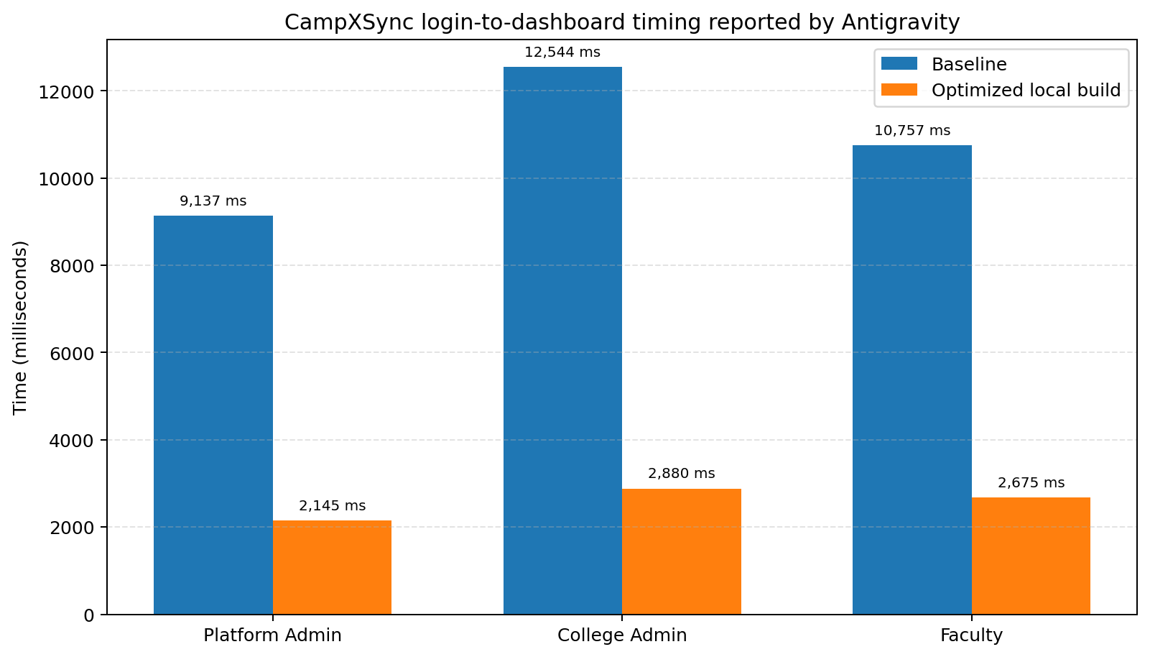
Figure 1. Reported median timings. Lower is better. Optimized values were measured on a local compiled production build, not a newly deployed Preview.
Role | Baseline median | Optimized median | Reported reduction
Platform Admin | 9,137 ms (9.14 s) | 2,145 ms (2.15 s) | 76.5%
College Admin | 12,544 ms (12.54 s) | 2,880 ms (2.88 s) | 77.0%
Faculty | 10,757 ms (10.76 s) | 2,675 ms (2.67 s) | 75.1%
Interpretation: the reported reduction is about 75–77% across all three roles. Even after the improvement, a 2–3 second delay may still feel sluggish, especially if the page appears blank or unresponsive. Measure login submission, authentication response, role resolution, navigation, and dashboard data readiness separately.

3. Additional measurements reported
Antigravity also recorded cold-run and repeat measurements. These figures show that the measured times varied between runs, so a single timing should not be treated as definitive.
Role | Cold baseline → optimized | Repeat 2 baseline → optimized | Repeat 3 baseline → optimized
Platform Admin | 9,583 → 2,262 ms | 6,215 → 2,145 ms | 9,137 → 2,092 ms
College Admin | 17,037 → 5,371 ms | 12,544 → 2,880 ms | 12,305 → 2,867 ms
Faculty | 11,284 → 2,380 ms | 10,757 → 2,675 ms | 9,409 → 2,913 ms

4. Reported root cause and local change
The Antigravity report identified the following likely sequence:
- Role resolution attempted Supabase PostgREST calls against private schemas such as plat, iam, and core.
- Those requests reportedly failed with PGRST106 (invalid schema), creating repeated network/error overhead.
- The report estimated five failed calls added roughly 1.5–2.5 seconds.
- The login flow also resolved the role at the root route, redirected with a 307, and resolved the role again at the destination dashboard.
- The reported local fix removed the failing PostgREST schema calls and used the existing server-side database query helper, with profile and role-assignment queries run concurrently.
The report says the change retained fail-closed authorization behavior for missing roles, inactive memberships, and suspended tenants; avoided cross-user/tenant caching; and did not use user-editable metadata for authorization. These are important claims to re-verify in code and tests.

5. Evidence status: what is and is not proven
- Reported by Antigravity: local production build passed across 34 routes with no TypeScript errors.
- Reported by Antigravity: login-hardening checks passed 58/58; independent-account checks passed 7/7; faculty authentication/routing verification passed.
- Not yet established by those local timings: the optimized code is deployed to Vercel Preview and performs similarly there.
- Not yet established: the cause accounts for every part of the perceived delay; dashboard queries, network latency, cold starts, and client rendering may still contribute.
- Not yet established: the performance result is repeatable across fresh sessions, roles, and mobile/network conditions.

6. Recommended acceptance criteria
Use these as proposed targets for a trial-ready MVP, not as universal laws. Record both the user-perceived time and stage timings.
- Role resolution on the server: target p50 ≤ 500 ms and p95 ≤ 1,000 ms under normal staging conditions.
- Login submit to usable dashboard: target p50 ≤ 2.0 seconds and p95 ≤ 3.0 seconds on a warm session; investigate any repeatable result above 3 seconds.
- No repeated role-resolution request across root redirect and dashboard when the result can be safely carried forward or the flow can be simplified.
- No PGRST106/private-schema errors in the browser network log or server logs.
- Authorization remains fail-closed; role/tenant results are never cached across users or tenants.
- Measure at least five runs per role, include one cold run and warm runs, and report median plus p95 rather than selecting the best result.

7. Action plan for Antigravity
Step 1 — Inspect the existing change, do not restart the investigation.
Review the current diff for frontend/src/lib/auth/resolve-role.ts, the timing scripts, and the Step 17 execution log. Confirm the measured code is the exact code currently in ReviewBranch. Do not overwrite unrelated work.
Step 2 — Reproduce the slow path with stage-level timings.
Instrument login submit, Supabase authentication completion, profile lookup, role lookup, redirect, dashboard first render, and dashboard data-ready. Capture request count and duration. Use browser Network timings and server logs; avoid logging credentials, tokens, or sensitive student data.
Step 3 — Confirm or falsify the proposed cause.
Check for PGRST106 and calls to private schemas through PostgREST. Confirm whether role resolution runs twice. If the errors are gone but login remains slow, identify the next largest measured component rather than guessing.
Step 4 — Verify the fix and security invariants.
Run the existing build and targeted hardening/account/faculty tests. Add a regression check that role resolution does not invoke the failing private-schema REST calls and does not resolve twice unnecessarily. Keep inactive memberships and suspended tenants denied.
Step 5 — Request explicit approval before any deployment.
First report the exact diff, tests, and target. Do not commit, push, deploy, or write to any database without the user's separate explicit approval. If approved, deploy only to Vercel Preview wired to the verified staging project.
Step 6 — Measure the deployed Preview manually.
Test Platform Admin, College Admin, and Faculty in a fresh browser session. Record at least five runs per role with p50/p95, plus a phone run. Verify the URL and staging target before testing; never access or modify the production Supabase project.
Step 7 — Decide based on evidence.
If Preview meets targets, document the evidence and move to the planned independent gap analysis. If it does not, fix the single largest measured bottleneck and repeat only the relevant tests.

8. Copy-ready instruction for Antigravity
Continue from the current ReviewBranch and existing performance investigation. Do not restart completed phases or repeat broad audits. First inspect the current diff and the Step 17 execution log, then reproduce login timing with stage-level instrumentation for Platform Admin, College Admin, and Faculty. Verify whether PGRST106 errors from private-schema PostgREST calls and duplicate role resolution actually occur. Report evidence (request counts, timings, logs, code locations) before changing anything. If the reported fix is incomplete, make the smallest targeted local change and preserve fail-closed authorization, tenant isolation, and no cross-user/tenant caching. Run the existing targeted tests and build. Do not connect to or modify production Supabase project ref ekspahbsbwdpraaqfqui. Do not perform database writes, run seed scripts, commit, push, or deploy without my separate explicit approval. Before any Preview deployment, state the exact Vercel target and verify it uses staging project ref kpwdvvcschankgggitnj. Return a concise before/after table with p50 and p95 for each role, separate server role-resolution time from dashboard-ready time, and state clearly what was measured locally versus on deployed Preview.

9. Bottom line
The reported optimization is promising, but the original 9–13 second experience is unacceptable for a smooth MVP, and the local 2–3 second result still needs deployed verification. The way forward is measurable: instrument each stage, prove the cause, verify the targeted fix, and measure on a staging-only Preview. Do not accept a claim of “fixed” based only on a local build or a report.

