# Pre-Lab: Accessing your VM

### How will it work:

In order to access your machine from home, you will need two pieces of software:

1. A VPN to the UIS network
2. The vSphere Client to access your virtual machine

Your Windows Server 2008 virtual machine will have all of the software necessary for the course.

### Setting up your VPN:

***If you are on-campus (already on the UIS network), you do not need to run the VPN.***

If you are off campus, you will need a VPN in order to use the vSphere Client. UIS provides a free VPN client: Cisco AnyConnect. It is available from the campus webstore: <https://webstore.illinois.edu/shop/category.aspx?zcid=107>

Log in using your NetID and go to the Springfield Campus Product to get the VPN software (free).

Install the VPN .

Log into UISAD and leave the VPN running.

## Getting the vSphere Client:

With your VPN running, launch your web browser and navigate to:

https://cscvc01

(Continue to the website if you get a certificate error)

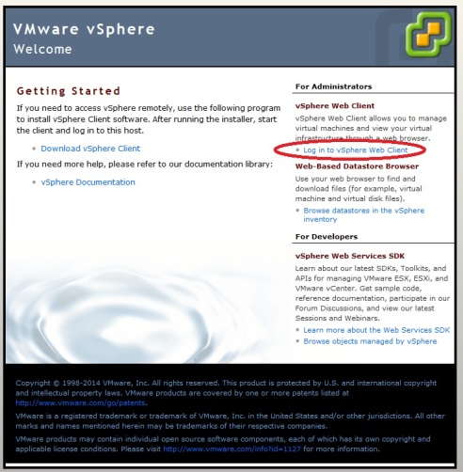Select “Download vSphere Client” and install the software. Or you can run the web client (if you are using a Mac, you will want to use the web client.

If you have downloaded and installed the client, Launch the vSphere Client:

With your VPN running, double-click on the vSphere client Icon and log into the virtual server using your NetID. The IP address/ Name is: cscvc01 (see below)

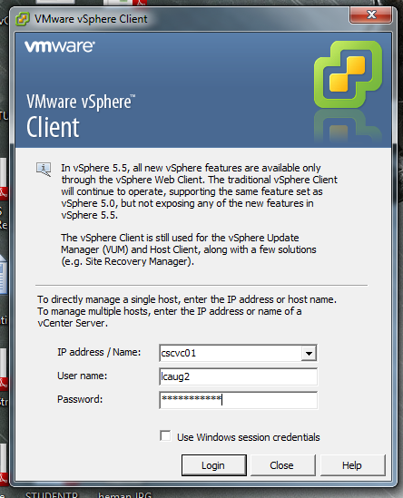

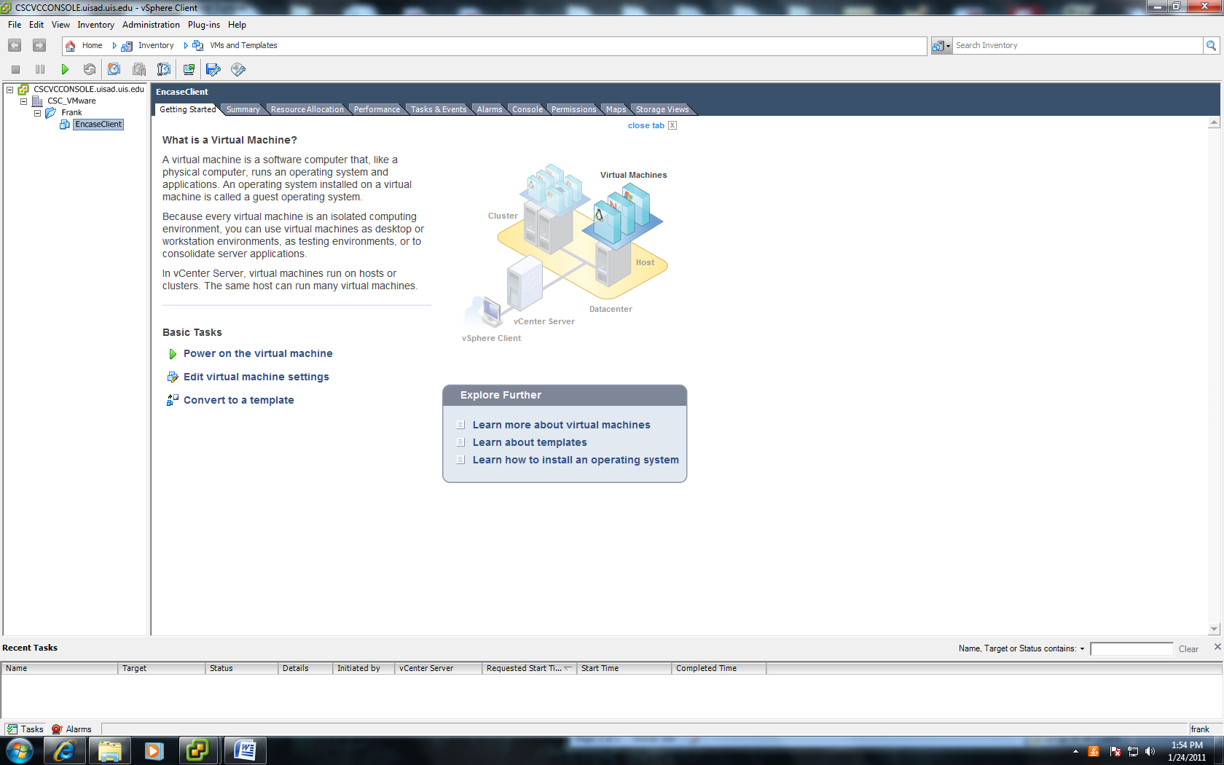If you have logged on successfully, you should be at your virtual machine directory:

On the right-hand side should be a folder with your user name. It contains your virtual machines within the folder.

Select “Power On Virtual Machine” from the main frame “Basic Tasks” list to turn on your virtual machine.

Click on the “Console” tab to view your machine. You may have to click within the console window to take control of the muse on the virtual machine, and it may take a couple of minutes to launch.

The console is now running your virtual machine. There is a full-screen console icon available to you on the button bar (3rd from right) if you prefer to have a full screen console for your session.

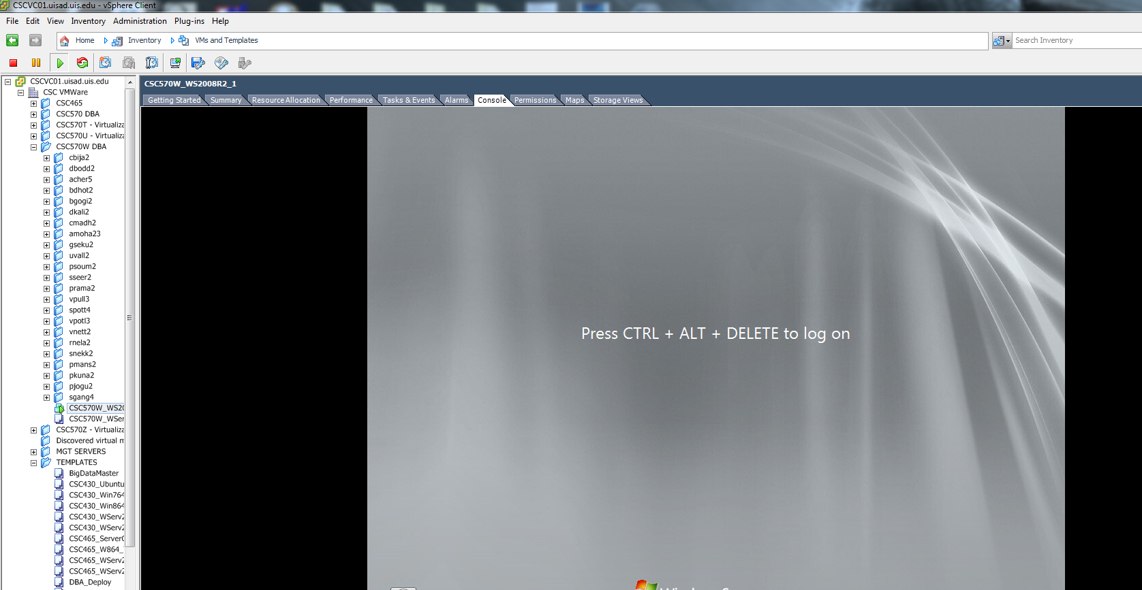

Your virtual machine is ready to use.

To exit your virtual machine:

1. Close any running applications.
2. Shut-down your windows O/S using the Shut-down on the start menu.
3. Exit vSphere.

Please feel free to email Instructor Joshua Smith, [jsmit6@uis.edu](mailto:jsmit6@uis.edu), if you are having any issues with your virtual machines.