**Final Project DBDL**

CSC572 Advanced Database Concepts

Camron Khan

**Time Logs:**

1. 10/3/17
   1. 3 hours
   2. Started and completed the Entities, Attributes, Functional Dependencies, Primary Keys, and Special Restrictions sections
2. 10/5/17
   1. 2 hours
   2. Started and completed the DBDL 3NF and Data Structure Diagram sections

**Entities:**

1. Order
2. OrderLine
3. Customer
4. SalesRep
5. ItemClass
6. Part
7. Warehouse
8. Inventory
9. Manufacturer

**Attributes:**

1. OrderID
2. OrderDate
3. OrdererID
4. OrdererType
5. OrderLineQuantity
6. CustomerID
7. CustomerName
8. CustomerStreet
9. CustomerCity
10. CustomerState
11. CustomerZip
12. CustomerBalance
13. CustomerCreditLimit
14. SalesRepID
15. SalesRepFirstName
16. SalesRepLastName
17. SalesRepStreet
18. SalesRepCity
19. SalesRepState
20. SalesRepZip
21. SalesRepCommissionTotal
22. SalesRepCommissionRate
23. ItemClassID
24. ItemClassDescription
25. PartID
26. PartDescription
27. PartPrice
28. PartCost
29. WarehouseID
30. WarehouseDescription
31. InventoryQuantity
32. ManufacturerID
33. ManufacturerName

**Functional Dependencies:**

1. OrderID 🡪 OrderDate, OrdererID, OrdererType, CustomerID
2. (OrderID, PartID) 🡪 OrderLineQuantity
3. CustomerID 🡪 CustomerName, CustomerStreet, CustomerCity, CustomerState, CustomerZip, CustomerBalance, CustomerCreditLimit, SalesRepID
4. SalesRepID 🡪 SalesRepFirstName, SalesRepLastName, SalesRepStreet, SalesRepCity, SalesRepState, SalesRepZip, SalesRepCommissionTotal, SalesRepCommissionRate
5. ItemClassID 🡪 ItemClassDescription
6. PartID 🡪 PartDescription, PartPrice, PartCost, ManufacturerID
7. WarehouseID 🡪 WarehouseDescription
8. (WarehouseID, PartID) 🡪 InventoryQuantity
9. ManufacturerID 🡪 ManufacturerName

**Primary Keys:**

1. OrderID
2. (OrderID, PartID)
3. CustomerID
4. SalesRepID
5. ItemClassID
6. PartID
7. WarehouseID
8. (WarehouseID, PartID)
9. ManufacturerID

**Special Restrictions:**

1. Legal values for the OrderedByType column in the Order table are ‘customer’ and ‘sales rep’
2. Legal values for the ItemClassDescription column in the ItemClass table are ‘hand tools’, ‘power tools’, ‘safety equipment’, and ‘miscellaneous equipment’

**DBDL 3NF:**

1. Order(OrderID, OrderDate, OrdererID, OrdererType, CustomerID)

FK CustomerID 🡪 Customer

1. OrderLine(OrderID, PartID, OrderLineQuantity)

FK OrderID 🡪 Order

FK PartID 🡪 Part

1. Customer(CustomerID, CustomerName, CustomerStreet, CustomerCity, CustomerState, CustomerZip, CustomerBalance, CustomerCreditLimit, SalesRepID)

FK SalesRepID 🡪 SalesRep

1. SalesRep(SalesRepID, SalesRepFirstName, SalesRepLastName, SalesRepStreet, SalesRepCity, SalesRepState, SalesRepZip, SalesRepCommissionTotal, SalesRepCommissionRate)
2. ItemClass(ItemClassID, ItemClassDescription)
3. Part(PartID, PartDescription, PartPrice, PartCost, ItemClassID, ManufacturerID)

FK ItemClassID 🡪 ItemClass

FK ManufacturerID 🡪 Manufacturer

1. Warehouse(WarehouseID, WarehouseDescription)
2. Inventory(WarehouseID, PartID, InventoryQuantity)
3. FK WarehouseID 🡪 Warehouse

FK PartID 🡪 Part

1. Manufacturer(ManufacturerID, ManufacturerName)

**Data Structure Diagram**

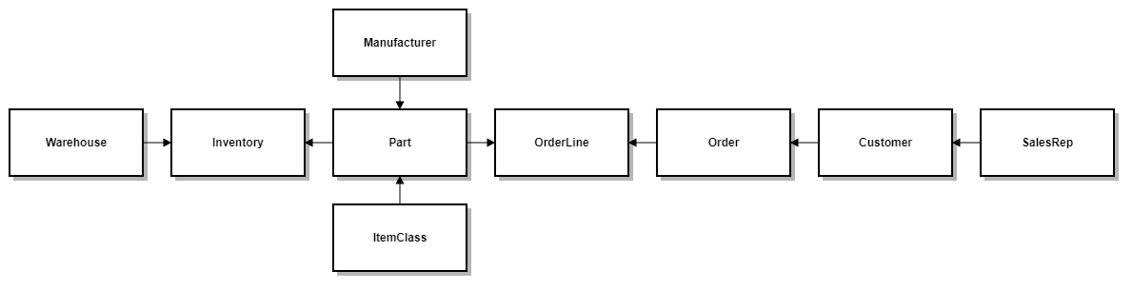

**Questions for the User / Prof. Waggoner:**

1. Are the terms "parts" and "tools" used interchangeably?
2. Is the "quoted price" on an order line the same thing as a part’s "part price"?
3. Can I safely assume that in cases where an ID is required (i.e., ManufacturerID, ItemClassNumber) that I should break those entities into their own tables?
4. Do we want uniqueness constraints on any of the following?
   1. ItemClassDescription
   2. PartDescription
   3. WarehouseDescription
   4. ManufacturerName
5. Are there any quantity minimums or maximums on order lines?
6. Do we need to differentiate between clients and customers? For example, two customers who work for the same organization placing orders for that organization.
7. Should SalesRepCommissionTotal be considered a calculated column, since we could determine this value by multiplying the SalesRepCommissionRate by the sum of all order lines associated with that rep within a given date range?
8. Regarding the OrdererID and OrdererType columns in the Order table:
   1. Can I use the OrdererID column to map to either a CustomerID or a SalesRepID and then use the OrdererType column to specify which former belongs to by a restricted set of values (i.e., ‘customer’, ‘sales rep’)?
   2. If the above is allowable, how should this be modeled in the data structure diagram given that the OrdererID column is not a true foreign key?