**CSC 572 – Homework #4**

Camron Khan

**PART 1**

CREATE TABLE Manufacturers (

ManufacturerID CHAR(3) PRIMARY KEY,

ManufacturerName VARCHAR(25) NOT NULL

);

CREATE TABLE ItemClasses (

ItemClassID CHAR(2) PRIMARY KEY,

ItemClassDescription VARCHAR(25) NOT NULL,

CONSTRAINT CHK_ItemClasses_ItemClassDescription CHECK (ItemClassDescription IN ('hand tools', 'power tools', 'safety equipment', 'miscellaneous'))

);

CREATE TABLE Parts (

PartID CHAR(8) PRIMARY KEY,

PartDescription VARCHAR(15) NOT NULL,

PartPrice DECIMAL(6,2) NOT NULL DEFAULT 0,

PartCost DECIMAL(6,2) NOT NULL DEFAULT 0,

ItemClassID CHAR(2) NOT NULL,

ManufacturerID CHAR(3) NOT NULL,

CONSTRAINT FK_Parts_ItemClasses FOREIGN KEY (ItemClassID) REFERENCES ItemClasses(ItemClassID),

CONSTRAINT FK_Parts_Manufacturers FOREIGN KEY (ManufacturerID) REFERENCES Manufacturers(ManufacturerID)

);

CREATE TABLE Warehouses (

WarehouseID CHAR(3) PRIMARY KEY,

WarehouseDescription VARCHAR(50) NOT NULL

);

CREATE TABLE Inventories (

WarehouseID CHAR(3) NOT NULL,

PartID CHAR(8) NOT NULL,

InventoryQuantity DECIMAL(4) NOT NULL DEFAULT 0,

CONSTRAINT PK_Inventories PRIMARY KEY (WarehouseID,PartID),

CONSTRAINT FK_Inventories_Warehouses FOREIGN KEY (WarehouseID) REFERENCES Warehouses(WarehouseID),

CONSTRAINT FK_Inventories_Parts FOREIGN KEY (PartID) REFERENCES Parts(PartID)

);

CREATE TABLE SalesReps (

SalesRepID CHAR(2) PRIMARY KEY,

SalesRepFirstName VARCHAR(15) NOT NULL,

SalesRepLastName VARCHAR(15) NOT NULL,

SalesRepStreet VARCHAR(100) NOT NULL,

SalesRepCity VARCHAR(30) NOT NULL,

SalesRepState CHAR(2) NOT NULL,

SalesRepZip CHAR(5) NOT NULL,

SalesRepCommissionTotal DECIMAL(7,2) NOT NULL DEFAULT 0,

SalesRepCommissionRate INTEGER NOT NULL DEFAULT 0,

CONSTRAINT CHK_SalesReps_SalesRepCommissionRate CHECK (SalesRepCommissionRate >= 0 AND SalesRepCommissionRate <= 100)

);

CREATE TABLE Customers (

CustomerID CHAR(4) PRIMARY KEY,

CustomerName VARCHAR(15) NOT NULL,

CustomerStreet VARCHAR(100) NOT NULL,

CustomerCity VARCHAR(30) NOT NULL,

CustomerState CHAR(2) NOT NULL,

CustomerZip CHAR(5) NOT NULL,

CustomerBalance DECIMAL(6,2) NOT NULL DEFAULT 0,

CustomerCreditLimit DECIMAL(4) NOT NULL DEFAULT 0,

SalesRepID CHAR(2) NOT NULL,

CONSTRAINT FK_Customers_SalesReps FOREIGN KEY (SalesRepID) REFERENCES SalesReps(SalesRepID)

);

CREATE TABLE Orders (

OrderID CHAR(5) PRIMARY KEY,

OrderDate DATE NOT NULL DEFAULT DATE(),

OrdererType VARCHAR(10) NOT NULL,

CustomerID CHAR(4) NOT NULL,

CONSTRAINT FK_Orders_Customers FOREIGN KEY (CustomerID) REFERENCES Customers(CustomerID),

CONSTRAINT CHK_Orders_OrdererType CHECK (OrdererType IN ('customer', 'sales rep'))

);

CREATE TABLE OrderLines (

OrderID CHAR(5) NOT NULL,

PartID CHAR(8) NOT NULL,

OrderLineQuantity DECIMAL(4) NOT NULL DEFAULT 0,

OrderLineQuotedPrice DECIMAL(6,2) NOT NULL DEFAULT 0,

CONSTRAINT PK_OrderLines PRIMARY KEY (OrderID,PartID),

CONSTRAINT FK_OrderLines_Orders FOREIGN KEY (OrderID) REFERENCES Orders(OrderID),

CONSTRAINT FK_OrderLines_Parts FOREIGN KEY (PartID) REFERENCES Parts(PartID)

);

INSERT INTO Manufacturers (ManufacturerID, ManufacturerName) VALUES ('001', 'Alabama Mfg.');

INSERT INTO Manufacturers (ManufacturerID, ManufacturerName) VALUES ('002', 'Alaska Mfg.');

INSERT INTO Manufacturers (ManufacturerID, ManufacturerName) VALUES ('003', 'Arizona Mfg.');

INSERT INTO Manufacturers (ManufacturerID, ManufacturerName) VALUES ('004', 'Arkansas Mfg.');

INSERT INTO Manufacturers (ManufacturerID, ManufacturerName) VALUES ('005', 'California Mfg.');

INSERT INTO Manufacturers (ManufacturerID, ManufacturerName) VALUES ('006', 'Colorado Mfg.');

INSERT INTO Manufacturers (ManufacturerID, ManufacturerName) VALUES ('007', 'Connecticut Mfg.');

INSERT INTO Manufacturers (ManufacturerID, ManufacturerName) VALUES ('008', 'Delaware Mfg.');

INSERT INTO ItemClasses (ItemClassID, ItemClassDescription) VALUES ('01', 'hand tools');

INSERT INTO ItemClasses (ItemClassID, ItemClassDescription) VALUES ('02', 'power tools');

INSERT INTO ItemClasses (ItemClassID, ItemClassDescription) VALUES ('03', 'safety equipment');

INSERT INTO ItemClasses (ItemClassID, ItemClassDescription) VALUES ('04', 'miscellaneous');

INSERT INTO Parts (PartID, PartDescription, PartPrice, PartCost, ItemClassID, ManufacturerID) VALUES ('00000001', 'Angle Drill', 99.99, 26.33, '02', '001');

INSERT INTO Parts (PartID, PartDescription, PartPrice, PartCost, ItemClassID, ManufacturerID) VALUES ('00000002', 'Circular Saw', 84.49, 18.84, '02', '002');

INSERT INTO Parts (PartID, PartDescription, PartPrice, PartCost, ItemClassID, ManufacturerID) VALUES ('00000003', 'Claw Hammer', 20.49, 4.23, '01', '003');

INSERT INTO Parts (PartID, PartDescription, PartPrice, PartCost, ItemClassID, ManufacturerID) VALUES ('00000004', 'Brace Drill Auger', 15.99, 4.40, '01', '004');

INSERT INTO Parts (PartID, PartDescription, PartPrice, PartCost, ItemClassID, ManufacturerID) VALUES ('00000005', 'Spring Clamp', 3.49, 0.65, '04', '005');

INSERT INTO Parts (PartID, PartDescription, PartPrice, PartCost, ItemClassID, ManufacturerID) VALUES ('00000006', 'Fish Tape', 7.99, 1.35, '04', '006');

INSERT INTO Parts (PartID, PartDescription, PartPrice, PartCost, ItemClassID, ManufacturerID) VALUES ('00000007', 'Safety Goggles', 5.49, 0.47, '03', '007');

INSERT INTO Parts (PartID, PartDescription, PartPrice, PartCost, ItemClassID, ManufacturerID) VALUES ('00000008', 'Gloves', 7.49, 2.33, '03', '008');

INSERT INTO Parts (PartID, PartDescription, PartPrice, PartCost, ItemClassID, ManufacturerID) VALUES ('00000009', 'Pliers', 5.49, 1.87, '01', '001');

INSERT INTO Parts (PartID, PartDescription, PartPrice, PartCost, ItemClassID, ManufacturerID) VALUES ('0000000A', 'Thermometer', 11.49, 3.56, '04', '002');

INSERT INTO Warehouses (WarehouseID, WarehouseDescription) VALUES ('001', 'Northern Warehouse');

INSERT INTO Warehouses (WarehouseID, WarehouseDescription) VALUES ('002', 'Eastern Warehouse');

INSERT INTO Warehouses (WarehouseID, WarehouseDescription) VALUES ('003', 'Southern Warehouse');

INSERT INTO Warehouses (WarehouseID, WarehouseDescription) VALUES ('004', 'Western Warehouse');

INSERT INTO Warehouses (WarehouseID, WarehouseDescription) VALUES ('005', 'Northeastern Warehouse');

INSERT INTO Warehouses (WarehouseID, WarehouseDescription) VALUES ('006', 'Southeastern Warehouse');

INSERT INTO Warehouses (WarehouseID, WarehouseDescription) VALUES ('007', 'Northwestern Warehouse');

INSERT INTO Warehouses (WarehouseID, WarehouseDescription) VALUES ('008', 'Southwestern Warehouse');

INSERT INTO Inventories (WarehouseID, PartID, InventoryQuantity) VALUES ('002', '00000002', 534);

INSERT INTO Inventories (WarehouseID, PartID, InventoryQuantity) VALUES ('003', '00000003', 878);

INSERT INTO Inventories (WarehouseID, PartID, InventoryQuantity) VALUES ('005', '00000005', 122);

INSERT INTO Inventories (WarehouseID, PartID, InventoryQuantity) VALUES ('001', '00000006', 19);

INSERT INTO Inventories (WarehouseID, PartID, InventoryQuantity) VALUES ('004', '0000000A', 4957);

INSERT INTO Inventories (WarehouseID, PartID, InventoryQuantity) VALUES ('008', '00000001', 331);

INSERT INTO Inventories (WarehouseID, PartID, InventoryQuantity) VALUES ('005', '00000003', 1010);

INSERT INTO Inventories (WarehouseID, PartID, InventoryQuantity) VALUES ('006', '00000004', 3);

INSERT INTO Inventories (WarehouseID, PartID, InventoryQuantity) VALUES ('007', '00000008', 333);

INSERT INTO Inventories (WarehouseID, PartID, InventoryQuantity) VALUES ('003', '00000009', 323);

INSERT INTO SalesReps (SalesRepID, SalesRepFirstName, SalesRepLastName, SalesRepStreet, SalesRepCity, SalesRepState, SalesRepZip, SalesRepCommissionTotal, SalesRepCommissionRate) VALUES ('01', 'Camron', 'Khan', '1755 Golf Rd', 'Schaumburg', 'IL', '60173', 10348.33, 33);

INSERT INTO SalesReps (SalesRepID, SalesRepFirstName, SalesRepLastName, SalesRepStreet, SalesRepCity, SalesRepState, SalesRepZip, SalesRepCommissionTotal, SalesRepCommissionRate) VALUES ('02', 'Antoinette', 'Pestillo', '1755 Golf Rd', 'Schaumburg', 'IL', '60173', 23434.44, 50);

INSERT INTO SalesReps (SalesRepID, SalesRepFirstName, SalesRepLastName, SalesRepStreet, SalesRepCity, SalesRepState, SalesRepZip, SalesRepCommissionTotal, SalesRepCommissionRate) VALUES ('03', 'Frank', 'Policht', '1755 Golf Rd', 'Schaumburg', 'IL', '60173', 90044.22, 10);

INSERT INTO SalesReps (SalesRepID, SalesRepFirstName, SalesRepLastName, SalesRepStreet, SalesRepCity, SalesRepState, SalesRepZip, SalesRepCommissionTotal, SalesRepCommissionRate) VALUES ('04', 'Stephanie', 'Hutcheson', '1755 Golf Rd', 'Schaumburg', 'IL', '60173', 12324.33, 40);

INSERT INTO SalesReps (SalesRepID, SalesRepFirstName, SalesRepLastName, SalesRepStreet, SalesRepCity, SalesRepState, SalesRepZip, SalesRepCommissionTotal, SalesRepCommissionRate) VALUES ('05', 'Mike', 'Kravtsov', '1755 Golf Rd', 'Schaumburg', 'IL', '60173', 60433.21, 5);

INSERT INTO SalesReps (SalesRepID, SalesRepFirstName, SalesRepLastName, SalesRepStreet, SalesRepCity, SalesRepState, SalesRepZip, SalesRepCommissionTotal, SalesRepCommissionRate) VALUES ('06', 'Floyd', 'Dexter', '1755 Golf Rd', 'Schaumburg', 'IL', '60173', 9757.57, 10);

INSERT INTO SalesReps (SalesRepID, SalesRepFirstName, SalesRepLastName, SalesRepStreet, SalesRepCity, SalesRepState, SalesRepZip, SalesRepCommissionTotal, SalesRepCommissionRate) VALUES ('07', 'Bob', 'Garcia', '1755 Golf Rd', 'Schaumburg', 'IL', '60173', 23449.98, 5);

INSERT INTO SalesReps (SalesRepID, SalesRepFirstName, SalesRepLastName, SalesRepStreet, SalesRepCity, SalesRepState, SalesRepZip, SalesRepCommissionTotal, SalesRepCommissionRate) VALUES ('08', 'Jenna', 'Mazeikis', '1755 Golf Rd', 'Schaumburg', 'IL', '60173', 75303.22, 25);

INSERT INTO Customers (CustomerID, CustomerName, CustomerStreet, CustomerCity, CustomerState, CustomerZip, CustomerBalance, CustomerCreditLimit, SalesRepID) VALUES ('0001', 'IL Tools', '123 Road Rd', 'Chicago', 'IL', '60657', 8546.44, 9000, '01');

INSERT INTO Customers (CustomerID, CustomerName, CustomerStreet, CustomerCity, CustomerState, CustomerZip, CustomerBalance, CustomerCreditLimit, SalesRepID) VALUES ('0002', 'NY Tools', '123 Street Rd', 'New York', 'NY', '10029', 200.45, 5000, '02');

INSERT INTO Customers (CustomerID, CustomerName, CustomerStreet, CustomerCity, CustomerState, CustomerZip, CustomerBalance, CustomerCreditLimit, SalesRepID) VALUES ('0003', 'TX Tools', '123 Avenue Rd', 'Houston', 'TX', '77001', 1745.04, 3000, '03');

INSERT INTO Customers (CustomerID, CustomerName, CustomerStreet, CustomerCity, CustomerState, CustomerZip, CustomerBalance, CustomerCreditLimit, SalesRepID) VALUES ('0004', 'LA Tools', '123 Boulevard Rd', 'Los Angeles', 'CA', '90016', 3478.21, 8000, '04');

INSERT INTO Customers (CustomerID, CustomerName, CustomerStreet, CustomerCity, CustomerState, CustomerZip, CustomerBalance, CustomerCreditLimit, SalesRepID) VALUES ('0005', 'FL Tools', '123 Highway Rd', 'Miami', 'FL', '33114', 8766.99, 9000, '05');

INSERT INTO Customers (CustomerID, CustomerName, CustomerStreet, CustomerCity, CustomerState, CustomerZip, CustomerBalance, CustomerCreditLimit, SalesRepID) VALUES ('0006', 'SF Tools', '123 Route Rd', 'San Francisco', 'CA', '94114', 234.11, 2000, '06');

INSERT INTO Customers (CustomerID, CustomerName, CustomerStreet, CustomerCity, CustomerState, CustomerZip, CustomerBalance, CustomerCreditLimit, SalesRepID) VALUES ('0007', 'WA Tools', '123 Frontage Rd', 'Seattle', 'WA', '98113', 774.34, 1000, '07');

INSERT INTO Customers (CustomerID, CustomerName, CustomerStreet, CustomerCity, CustomerState, CustomerZip, CustomerBalance, CustomerCreditLimit, SalesRepID) VALUES ('0008', 'CO Tools', '123 Lane Rd', 'Denver', 'CO', '80220', 5578.39, 7000, '08');

INSERT INTO Orders (OrderID, OrderDate, OrdererType, CustomerID) VALUES ('00001', '2017-03-01', 'customer', '0001');

INSERT INTO Orders (OrderID, OrderDate, OrdererType, CustomerID) VALUES ('00002', '2017-04-01', 'sales rep', '0002');

INSERT INTO Orders (OrderID, OrderDate, OrdererType, CustomerID) VALUES ('00003', '2017-05-01', 'customer', '0003');

INSERT INTO Orders (OrderID, OrderDate, OrdererType, CustomerID) VALUES ('00004', '2017-06-01', 'sales rep', '0004');

INSERT INTO Orders (OrderID, OrderDate, OrdererType, CustomerID) VALUES ('00005', '2017-07-01', 'customer', '0005');

INSERT INTO Orders (OrderID, OrderDate, OrdererType, CustomerID) VALUES ('00006', '2017-08-01', 'sales rep', '0006');

INSERT INTO Orders (OrderID, OrderDate, OrdererType, CustomerID) VALUES ('00007', '2017-09-01', 'customer', '0007');

INSERT INTO Orders (OrderID, OrderDate, OrdererType, CustomerID) VALUES ('00008', '2017-10-01', 'sales rep', '0008');

INSERT INTO Orders (OrderID, OrderDate, OrdererType, CustomerID) VALUES ('00009', '2017-11-01', 'customer', '0002');

INSERT INTO Orders (OrderID, OrderDate, OrdererType, CustomerID) VALUES ('0000A', '2017-11-01', 'sales rep', '0007');

INSERT INTO OrderLines (OrderID, PartID, OrderLineQuantity, OrderLineQuotedPrice) VALUES ('00001', '00000001', 10, 90);

INSERT INTO OrderLines (OrderID, PartID, OrderLineQuantity, OrderLineQuotedPrice) VALUES ('00001', '00000002', 40, 80);

INSERT INTO OrderLines (OrderID, PartID, OrderLineQuantity, OrderLineQuotedPrice) VALUES ('00002', '00000003', 50, 19);

INSERT INTO OrderLines (OrderID, PartID, OrderLineQuantity, OrderLineQuotedPrice) VALUES ('00003', '00000004', 60, 15);

INSERT INTO OrderLines (OrderID, PartID, OrderLineQuantity, OrderLineQuotedPrice) VALUES ('00004', '00000005', 70, 3);

INSERT INTO OrderLines (OrderID, PartID, OrderLineQuantity, OrderLineQuotedPrice) VALUES ('00004', '00000006', 80, 7);

INSERT INTO OrderLines (OrderID, PartID, OrderLineQuantity, OrderLineQuotedPrice) VALUES ('00004', '00000007', 90, 5);

INSERT INTO OrderLines (OrderID, PartID, OrderLineQuantity, OrderLineQuotedPrice) VALUES ('00005', '00000008', 20, 7);

INSERT INTO OrderLines (OrderID, PartID, OrderLineQuantity, OrderLineQuotedPrice) VALUES ('00006', '00000009', 10, 5);

INSERT INTO OrderLines (OrderID, PartID, OrderLineQuantity, OrderLineQuotedPrice) VALUES ('00007', '0000000A', 80, 10);

INSERT INTO OrderLines (OrderID, PartID, OrderLineQuantity, OrderLineQuotedPrice) VALUES ('00007', '00000001', 40, 80);

INSERT INTO OrderLines (OrderID, PartID, OrderLineQuantity, OrderLineQuotedPrice) VALUES ('00007', '00000002', 30, 70);

INSERT INTO OrderLines (OrderID, PartID, OrderLineQuantity, OrderLineQuotedPrice) VALUES ('00008', '00000003', 40, 15);

INSERT INTO OrderLines (OrderID, PartID, OrderLineQuantity, OrderLineQuotedPrice) VALUES ('00008', '00000004', 30, 14);

INSERT INTO OrderLines (OrderID, PartID, OrderLineQuantity, OrderLineQuotedPrice) VALUES ('00008', '00000005', 60, 2);

INSERT INTO OrderLines (OrderID, PartID, OrderLineQuantity, OrderLineQuotedPrice) VALUES ('00009', '00000006', 20, 6);

INSERT INTO OrderLines (OrderID, PartID, OrderLineQuantity, OrderLineQuotedPrice) VALUES ('0000A', '00000007', 90, 4);

INSERT INTO OrderLines (OrderID, PartID, OrderLineQuantity, OrderLineQuotedPrice) VALUES ('0000A', '00000008', 20, 6);

INSERT INTO OrderLines (OrderID, PartID, OrderLineQuantity, OrderLineQuotedPrice) VALUES ('0000A', '00000009', 30, 4);

INSERT INTO OrderLines (OrderID, PartID, OrderLineQuantity, OrderLineQuotedPrice) VALUES ('0000A', '0000000A', 10, 9);

/* For a given sales rep, list the number (C2), the name (broken out first name

and last name and each should be C15), the address (broken out into street,

city, state and zip with each being a character variable that you can specify

the valid length), the total commission (D7,2), and the commission rate. */

SELECT SalesRepID,

SalesRepFirstName,

SalesRepLastName,

SalesRepStreet,

SalesRepCity,

SalesRepState,

SalesRepZip,

SalesRepCommissionTotal,

SalesRepCommissionRate

FROM SalesReps;

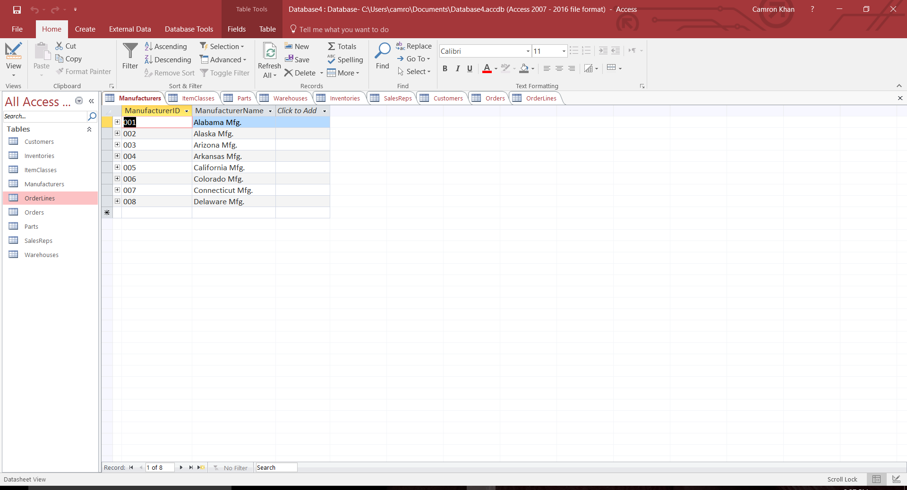

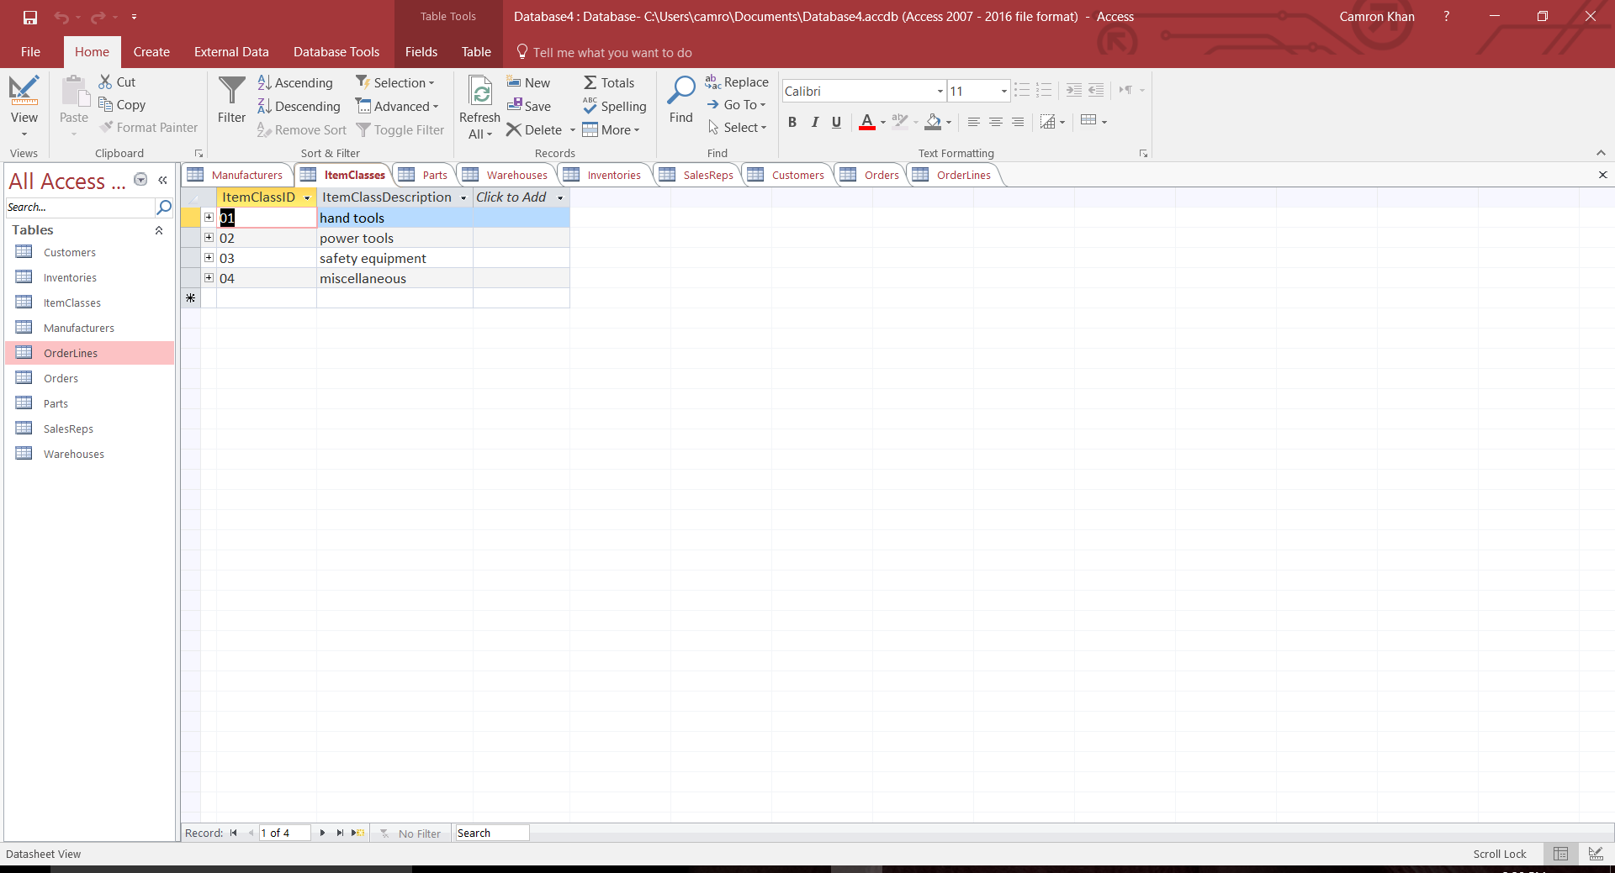

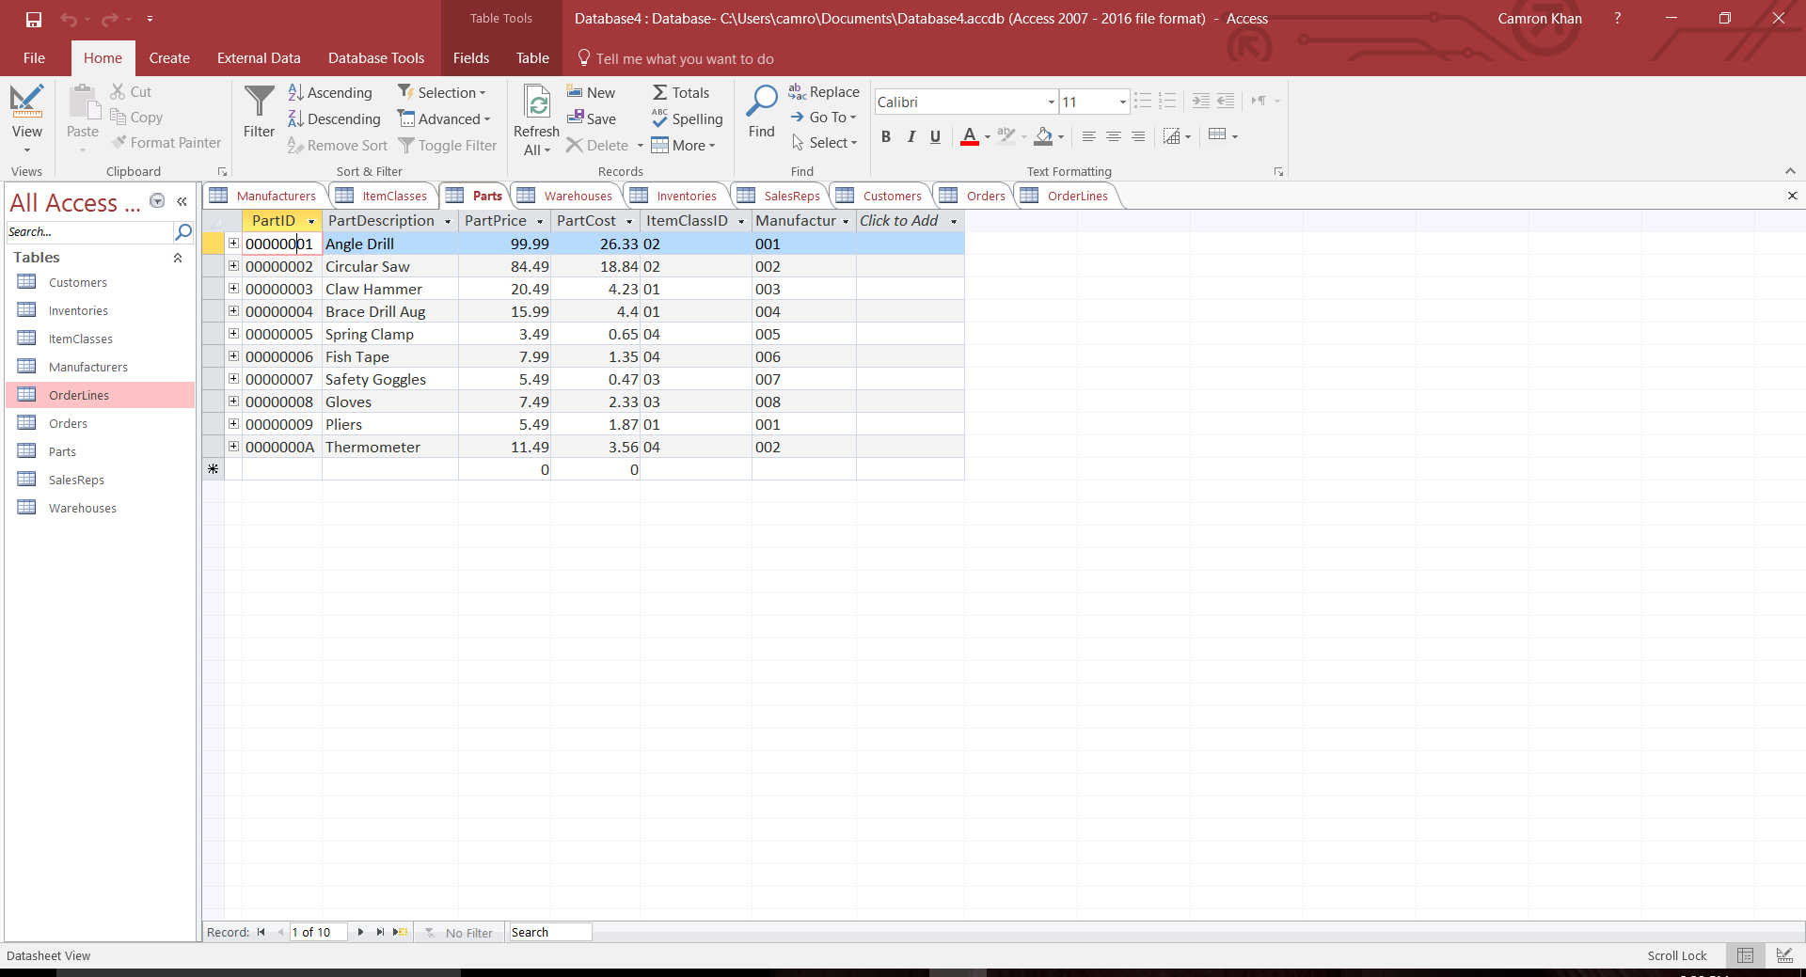

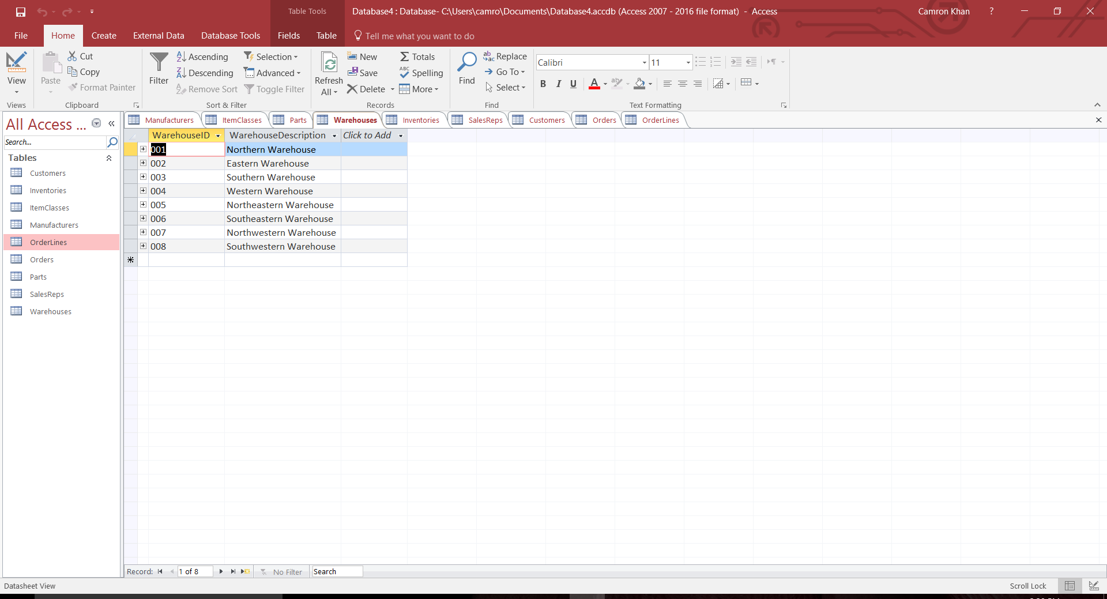

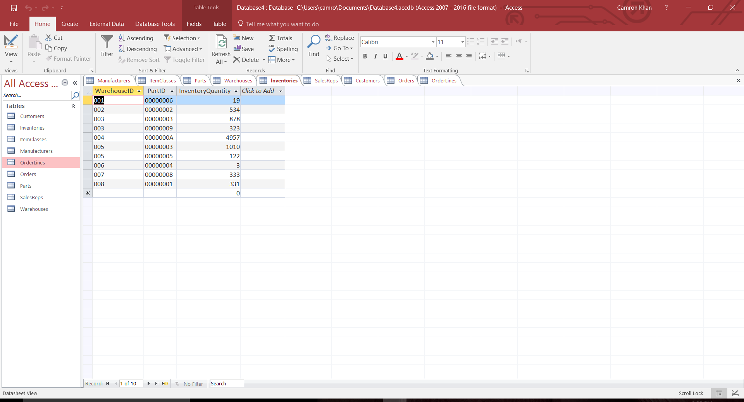

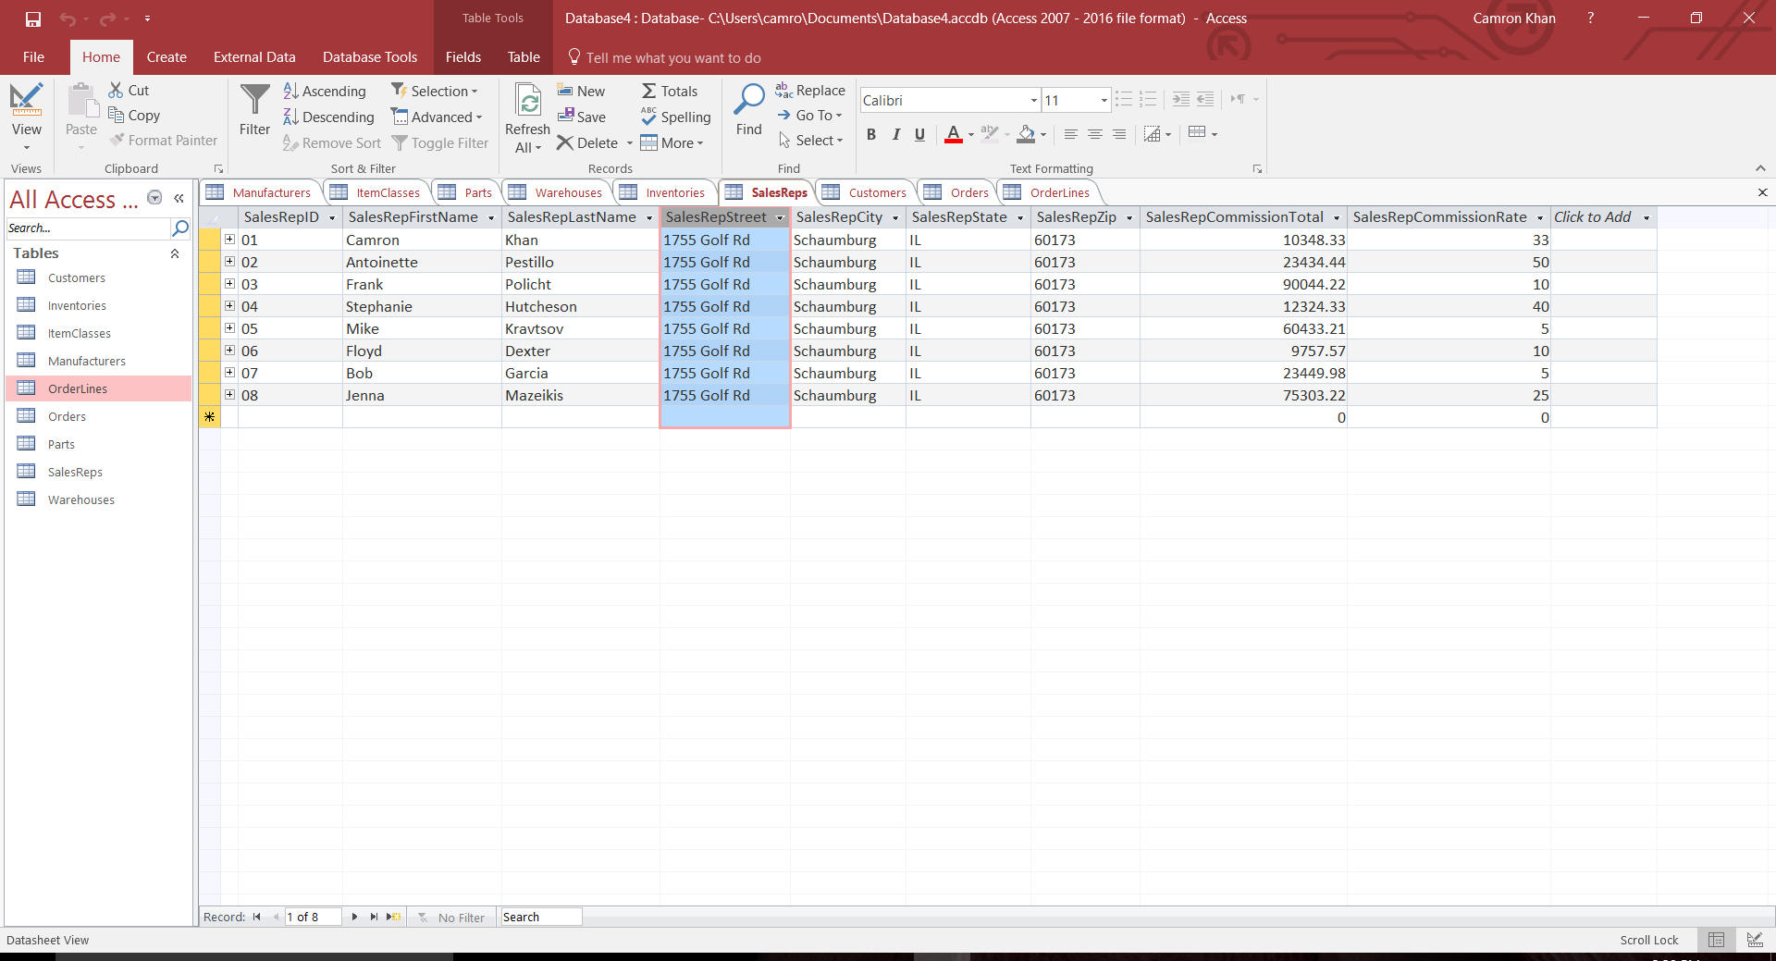

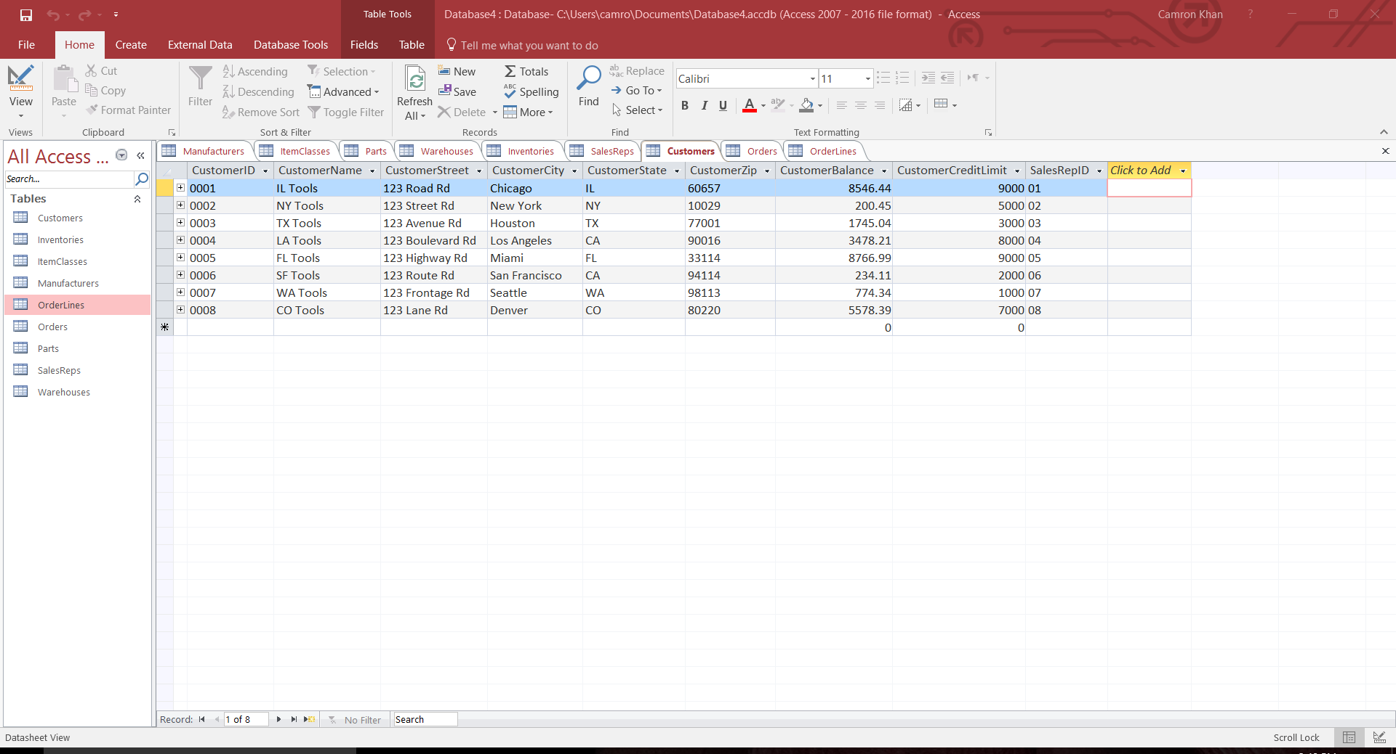

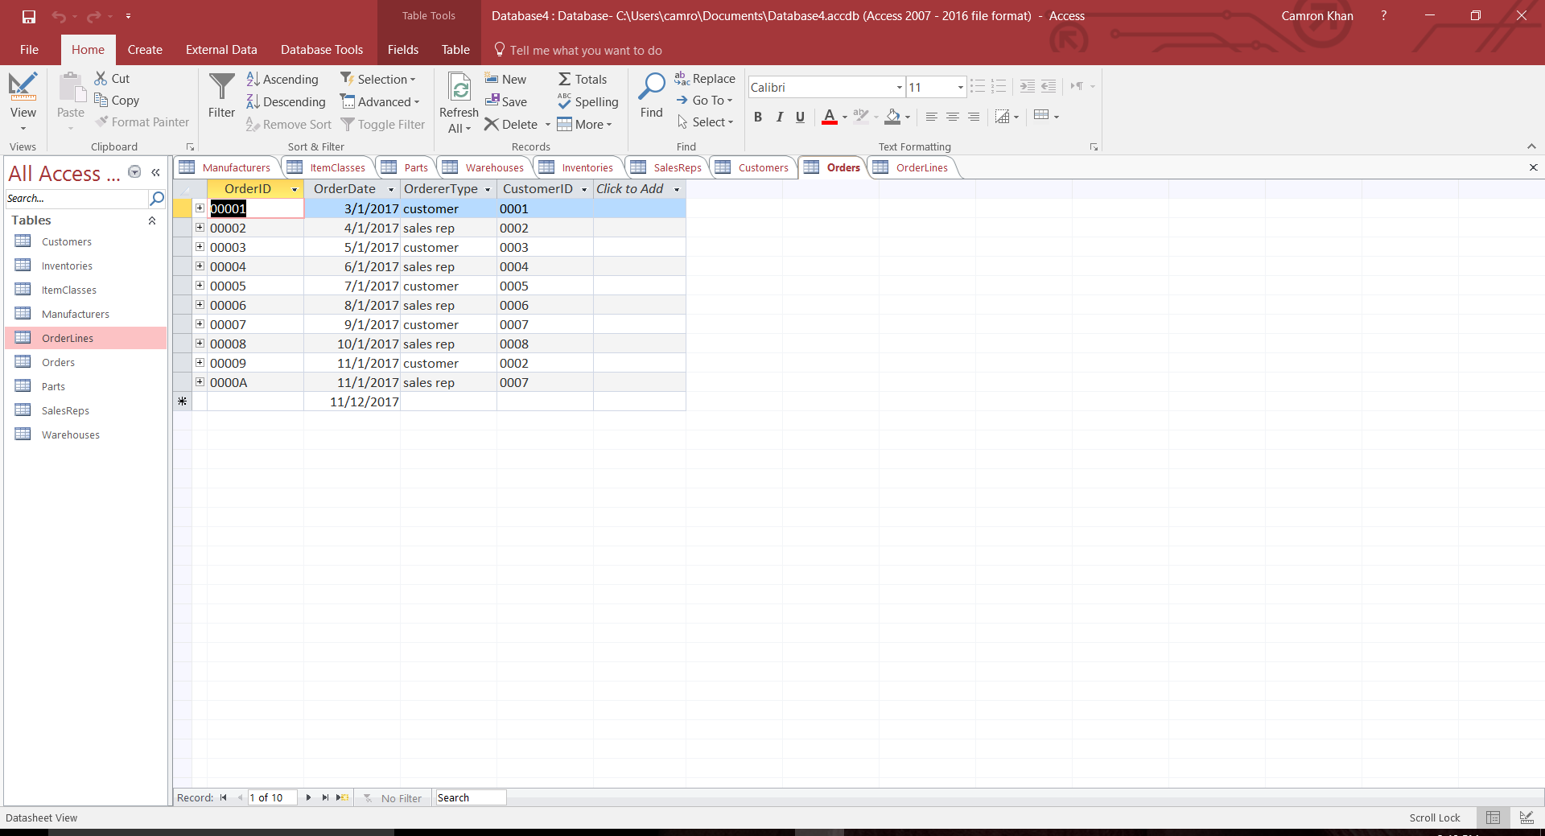

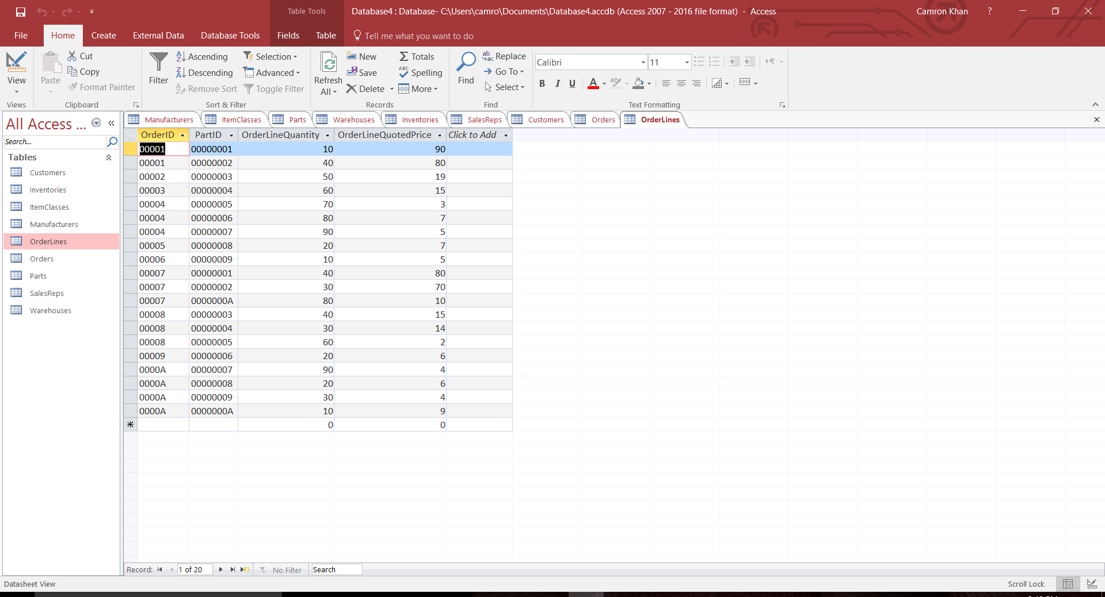

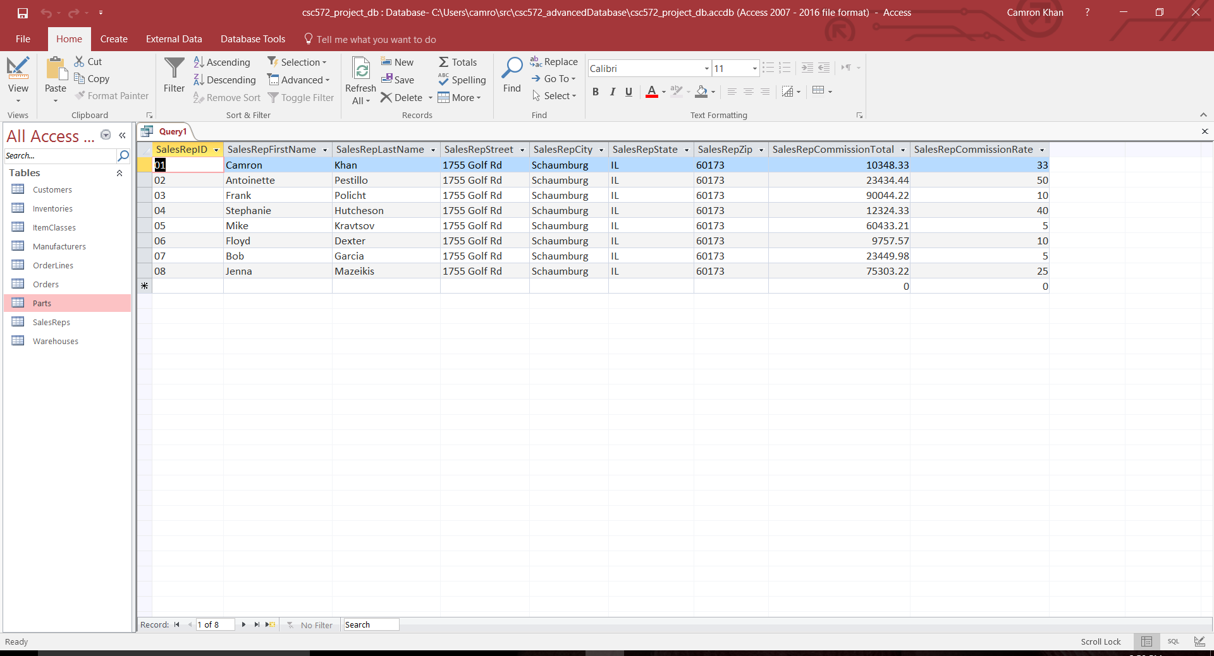

**PART 2**

Entities / Relationships:

* Patient
* Doctor
* AreaOfSpecialization
* PatientDoctor
* Appointment
* MedicalTest
* OrderedMedicalTest
* University

Structural Problems:

* AreaOfSpecialization should be its own entity. Storing this information within the Doctor entity leaves open the potential of an update anomaly.
* DateFirstAppointment and DateLastAppointment do not need to be stored. They can be generated by a parameter query on the Appointment entity.
* PatientName and DoctorName are redundant in the PatientDoctor entity since there are already foreign keys pointing to each, respectively.
* PatientPhone should be stored in the Patient entity, not the Appointment entity. The Appointment entity’s foreign key pointing to Patient will allow the user to access this piece of information.
* MedicalTest should be its own entity.
* University should be its own entity (or the name of the university should simply be stored with the Doctor entity).
* DocGraduatedUniversityID should be moved from OrderedMedicalTest to Doctor.
* DatePatientGivenTest should be part of the primary key for OrderedMedicalTest since the same doctor may give the same patient the same medical test multiple times over the course of their relationship.

DBDL:

* Patient(PatientID, PatientName, PatientAddress, PatientPhone)
* Doctor(DoctorID, DoctorName, DoctorWorkPhone, AreaOfSpecializationCode, UniversityID)

FK AreaOfSpecializationCode 🡪 AreaOfSpecialization(AreaOfSpecializationCode)

FK UniversityID 🡪 University(UniversityID)

* AreaOfSpecialization(AreaOfSpecializationCode, AreaOfSpecializationName)
* PatientDoctor(PatientID, DoctorID)

FK PatientID 🡪 Patient(PatientID)

FK Doctor 🡪 Doctor(DoctorID)

* Appointment(PatientID, DoctorID, AppointmentDate)

FK PatientID 🡪 Patient(PatientID)

FK Doctor 🡪 Doctor(DoctorID)

* MedicalTest(MedicalTestID, MedicalTestDescription)
* OrderedMedicalTest(PatientID, DoctorID, MedicalTestID, DatePatientGivenTest)

FK PatientID 🡪 Patient(PatientID)

FK Doctor 🡪 Doctor(DoctorID)

FK MedicalTest 🡪 MedicalTest(MedicalTestID)

* University(UniversityID, UniversityName)

Data Structure Diagram:

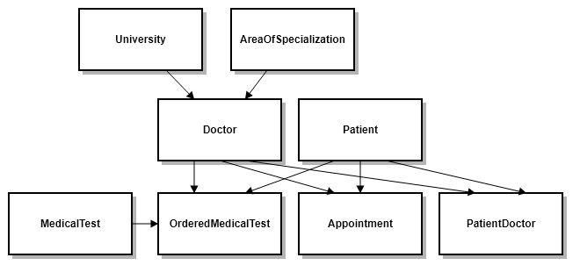

Changes:

* AreaOfSpecialization was made its own entity, and a foreign key reference was added to Doctor.
* DateFirstAppointment and DateLastAppointment were removed from PatientDoctor.
* PatientName and DoctorName were removed from PatientDoctor.
* PatientPhone was moved from Appointment to Patient.
* University was made its own entity, its reference was removed from OrderedMedicalTest, and a foreign key reference was added to Doctor.
* DatePatientGivenTest was made part of the primary key for OrderedMedicalTest.
* MedicalTest was made its own entity, and a foreign key reference was added to OrderedMedicalTest.

Notes on Entities with a Composite Primary Key:

* PatientDoctor:
  + A patient may have many (or no) doctors.
  + A doctor may have many (or no) patients.
* Appointment:
  + A patient may have only one appointment with the same doctor on a particular date.
  + A patient may have multiple appointments with the same doctor on different dates.
  + A patient may have one appointment with each of many doctors on the same date.
  + A doctor may have many appointments with different patients on the same date.
* OrderedMedicalTest
  + A doctor may order a patient multiple different medical tests on the same date.
  + A doctor may not order the same patient multiple of the same medical test on the same date.
  + A doctor may order the same patient the same medical test on different dates.
  + A doctor may order the same medical test for different patients on the same date.