**STPlayer Instruction**

1. **Install the following library:**  
   - Pygame (pip install pygame)  
   - Pillow (pip install PIL)  
   - tinytag (pip install tinytag)
2. **Run the main program (main.py) and select the ALL folder (Program will ask you a directory) which includes the downloaded MP3’s**

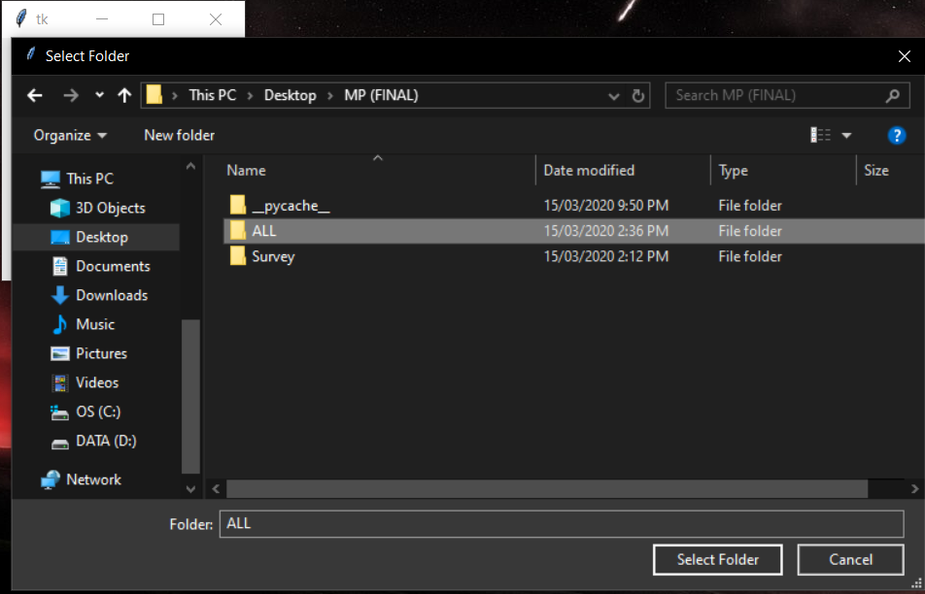

1. **Login page. Click “REGISTER HERE” here if you don’t have an account**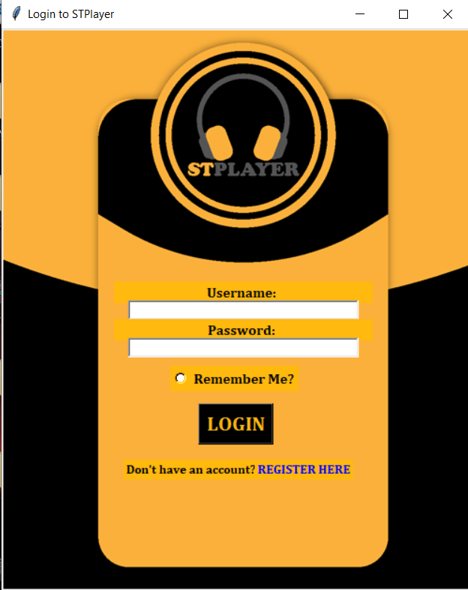
2. **Register Account**

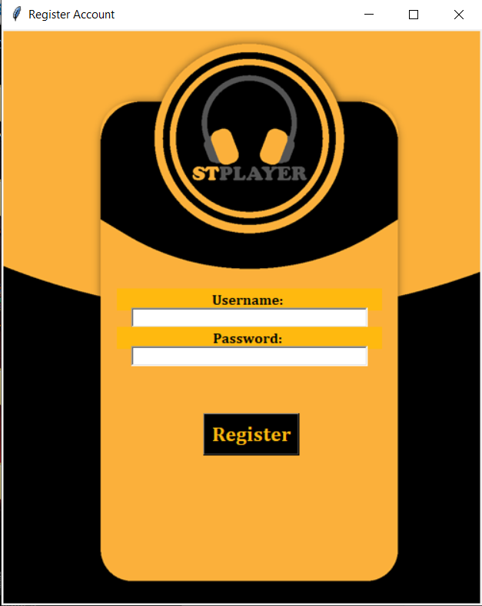

1. **Home Page. You can create, remove, edit, check, or play a playlist.**

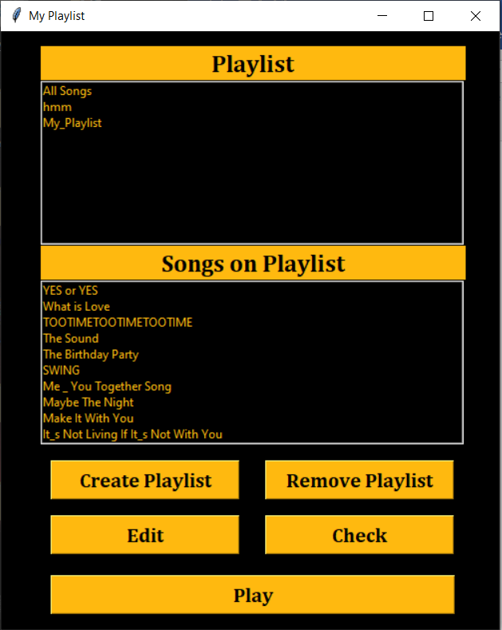

1. **Create Playlist. You can create your own playlist accessible only by your account and after creating a playlist you can insert songs on your playlist.**

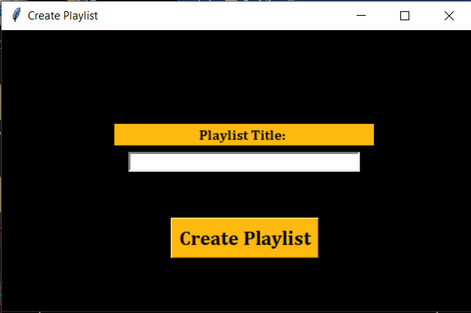

1. **Edit Playlist. You can edit a playlist you created. You can add or remove a songs you want**

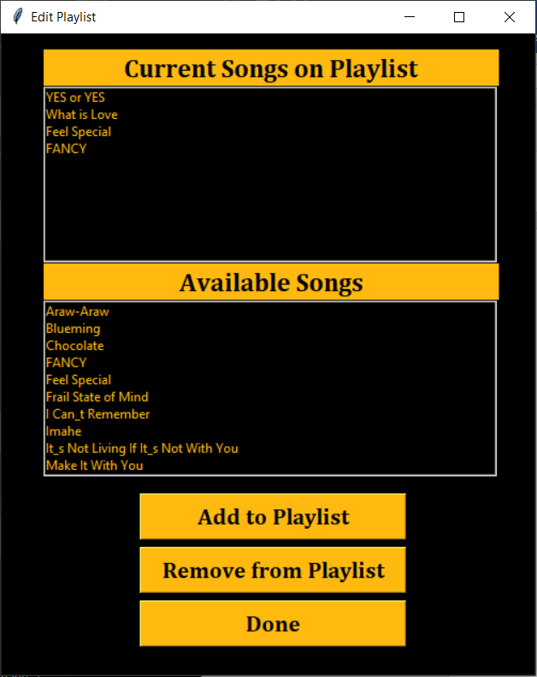

1. **STPlayer Window**

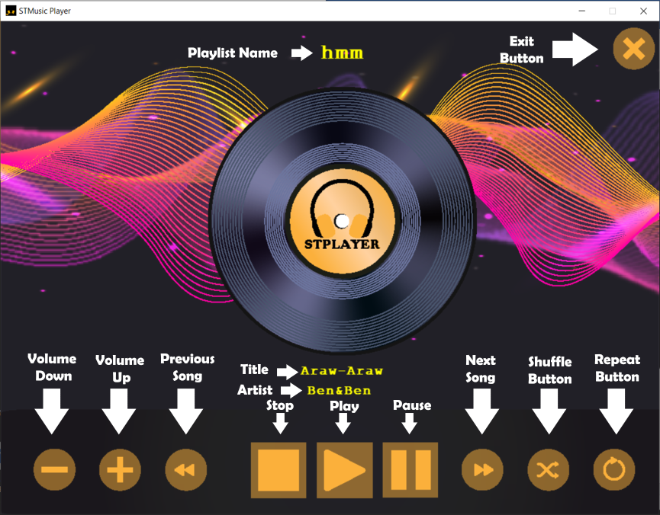  
  
  
  
  
STPlayer Instruction

1. Install the following library:  
   - Pygame (pip install pygame)  
   - Pillow (pip install PIL)  
   - tinytag (pip install tinytag)
2. Run the main program (main.py) and select the ALL folder (Program will ask you a directory) which includes the downloaded MP3’s



1. Login page. Click “REGISTER HERE” here if you don’t have an account

1. Register Account



1. Home Page. You can create, remove, edit, check, or play a playlist.



1. Create Playlist. You can create your own playlist accessible only by your account and after creating a playlist you can insert songs on your playlist.



1. Edit Playlist. You can edit a playlist you created. You can add or remove a songs you want



1. STPlayer Window

