

**THE IMAGINATION UNIVERSITY PROGRAMME**

**RVfpgaEL2 Lab 5**

**Creating a Vivado Project**

# Introduction

In order to work with and modify the RVfpgaEL2 System, you will need to build a project that includes all of the Verilog, SystemVerilog, header, configuration, and text files that define the system. In this lab, we show how to create a Vivado project that targets the SoC used in this course to Digilent’s Basys 3 FPGA board, the -50T version (i.e. RVfpgaEL2-Basys3). By following these same steps, you will be able to modify RVfpgaEL2-Basys3 and resynthesize it.

**IMPORTANT:** If you haven’t already done so, install Xilinx’s Vivado 2022.2 as explained in the Getting Started Guide.

**IMPORTANT:** The core frequency of the default RVfpgaEL2 System for a Basys 3 board is 12.5 Mhz (bitstream provided at ***[RVfpgaBasysPath]/src/rvfpgabasys.bit***). A core with a frequency of 25 MHz also works in all our exercises, but it provides some timing violations when the bitstream is created in Vivado, thus we do not use it as the default frequency. The specific configuration used for the core is specified in Lab 11.

# Creating a Vivado Project for RVfpgaEL2-Basys3

You will use Xilinx’s Vivado Design Suite to build the RVfpgaEL2-Basys3 system using the RTL, the Verilog files that define the system. Follow these steps, detailed below, to build the RVfpgaEL2-Basys3 system and target it to a Basys 3 FPGA board.

**Step 1. Open Vivado**

**Step 2. Create a new RTL project**

Step 3. Add the RTL source files and the constraint files

**Step 4. Select Basys 3 board’s FPGA as the target**

**Step 5. Set rvfpgabasys as the Top Module, set *common_defines.vh* as global, set *el2_pdef* both as global and as a System Verilog file, add *boot_main.mem* to the project, include folders, and add *–sweep* option**

**Step 6. Generate bitstream**

**Step 1. Open Vivado**

If you did not install Vivado on your machine as described in the RVfpga Getting Started Guide, do so now. Be sure to install the board files as well.

Now, run Vivado (in **Linux**, open a terminal and type: vivado; in **Windows**, open Vivado from the Start menu). The Vivado welcome screen will open. Click on Create Project (see Figure 1).

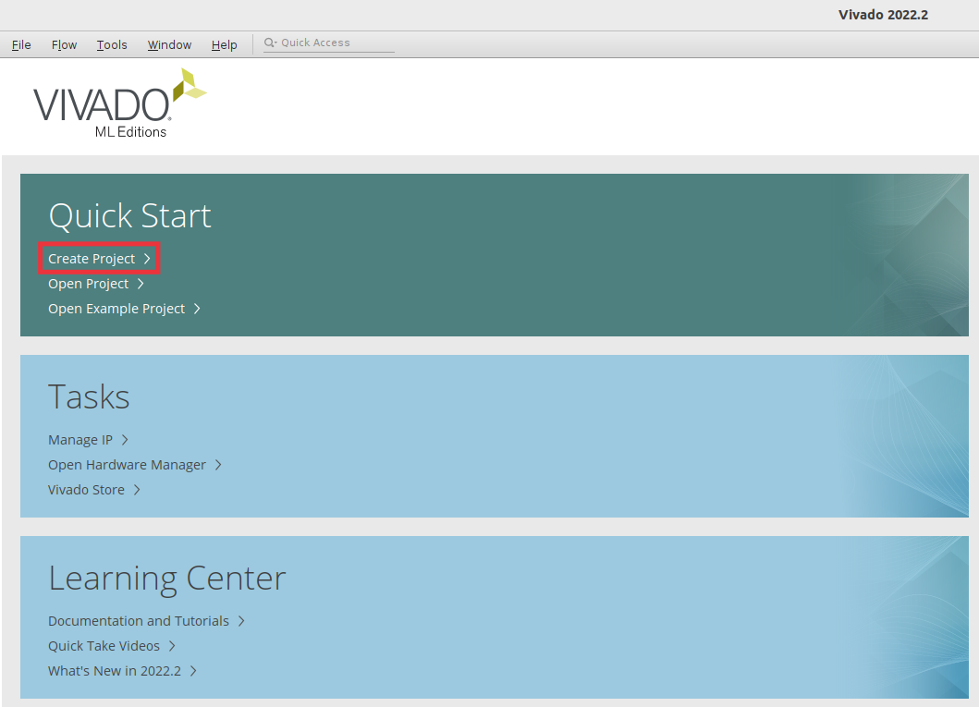

Figure 1. Vivado welcome screen: Create Project

**Step 2. Create a new RTL project**

The Create a New Vivado Project Wizard will now open (see Figure 2). Click Next.

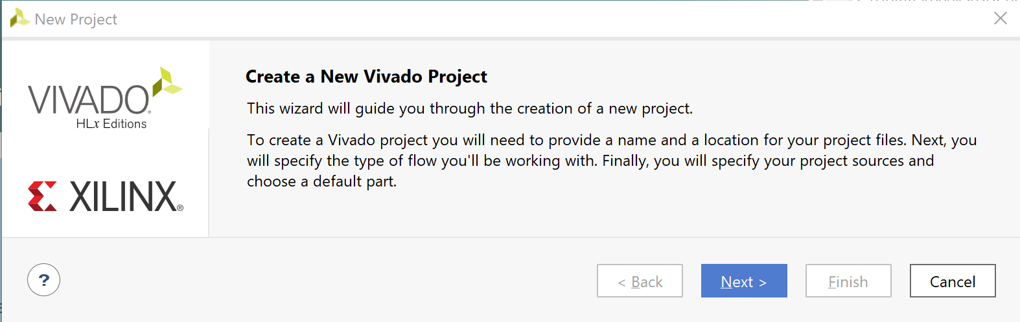

Figure 2. Create a New Vivado Project Wizard

Give a name to your project and place it in the *[RVfpgaBasysPath]/Labs/Lab05* folder. Select option *Create project subdirectory*. Then click Next (see Figure 3).

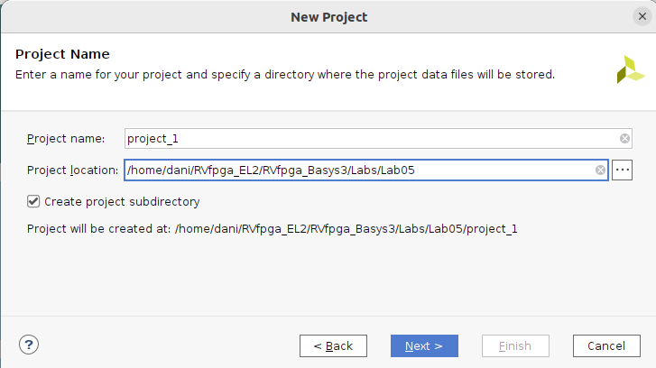

Figure 3. Project Name

Select the project type as RTL Project, and click Next (see Figure 4).

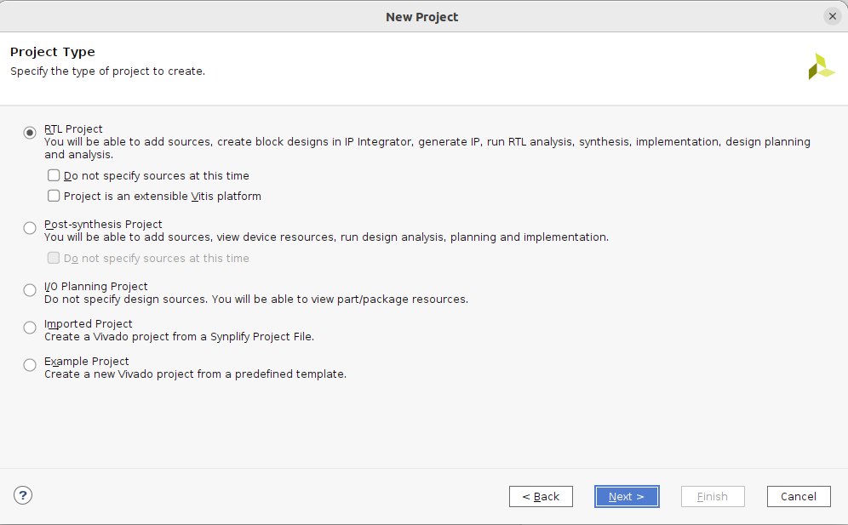

Figure 4. RTL Project

Step 3. Add the RTL source files and the constraint files

In the Add Sources window, click on Add Directories, and select *[RVfpgaBasysPath]/src* (see Figure 5). Make sure both of the following options are selected (as shown in Figure 5):

* Scan and add RTL include files into project
* Add sources from subdirectories

Then click Next.

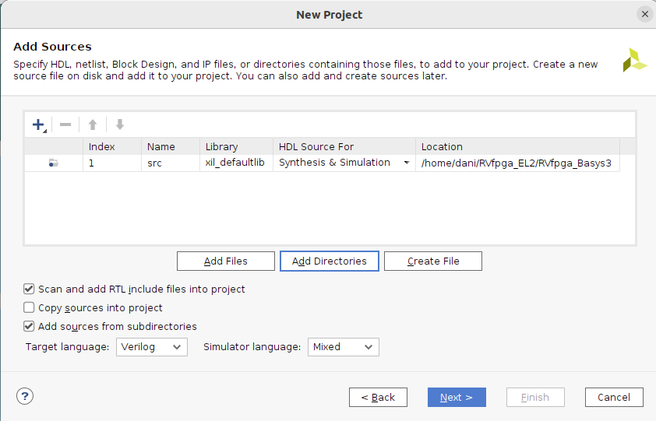

Figure 5. Add Sources

You will now add the constraints for the system. These files map the signal names to the pins on the board. For example, the LEDs on the Basys 3 FPGA board are connected to FPGA pins on the board through traces in the PCB. Vivado must know this so that it maps the correct signal name in the RTL to the correct FPGA pin.

Note that the signal name o_led is the name used in the Verilog code to drive the Basys 3 board’s LEDs.

In the Add Constraints window, click on Add Files and select the following file (see Figure 6):

*[RVfpgaBasysPath]/src/rvfpgabasys.xdc*

Then click Next.

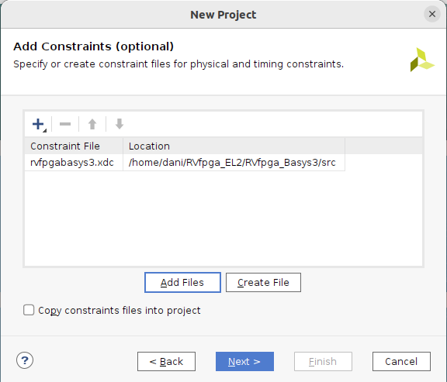

Figure 6. Add Constraints

**Step 4. Select Basys 3 board’s FPGA as the target**

In the Default Part window, click on Boards and then select Basys3 (see Figure 7). You may use the Search box to narrow down the results.

Click Next.

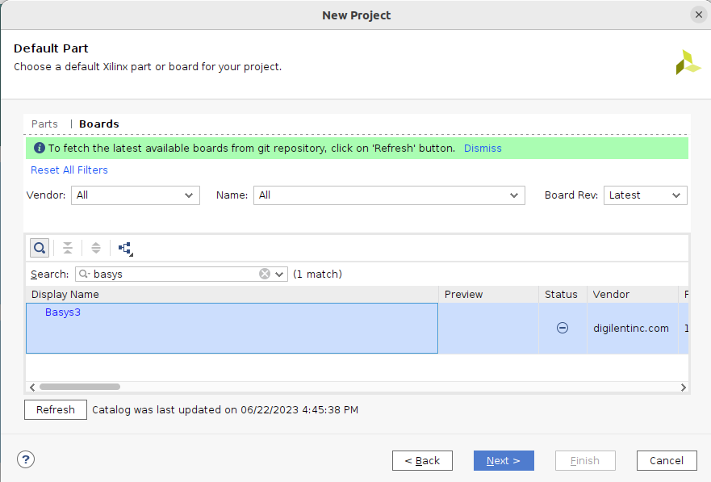

Figure 7. Select target part

In the New Project Summary window, click Finish (see Figure 8).

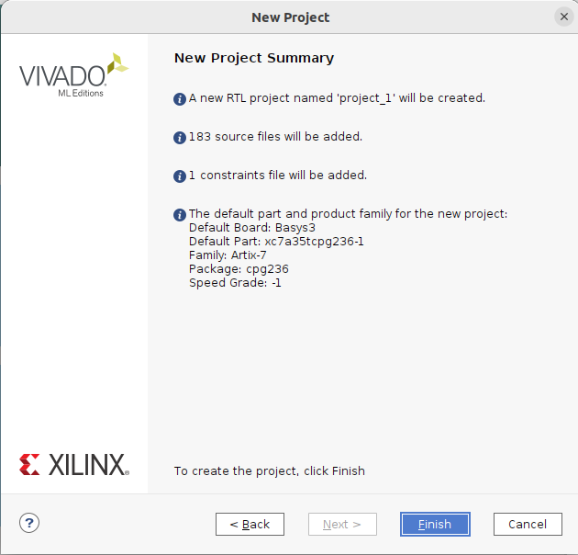

Figure 8. New Project Summary Window

**Step 5. Set rvfpgabasys as Top Module, set common_defines.vh as global, set *el2_pdef* as global and System Verilog, add *boot_main.mem* to the project, include folders, and add *–sweep* option.**

Set rvfpgabasys as the Top Module: In the Sources pane, scroll down under Design Sources, right-click on the rvfpgabasys module, and select Set as Top (see Figure 9). (You can also find the rvfpgabasys module by typing this name in the search box, as shown.) This sets rvfpgabasys as the highest-level module in the hierarchy and the target to be synthesized and implemented onto the FPGA. After setting rvfpgabasys as the top module, the hierarchy will update.

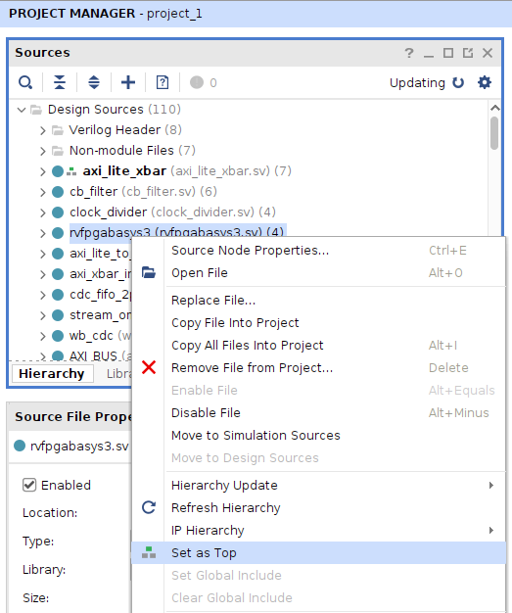

Figure 9. Set rvfpgabasys as top module

**Set files *common_defines.vh* and *el2_pdef* as Global Include and *el2_pdef* as SystemVerilog:** Now, still in the Sources pane under Design Sources, expand the Non-modules file group and click on *common_defines.vh*. The properties of the file will then open in the Source File Properties pane, just below the Sources pane. Click on Global Include to tick that box (see **Figure 10**). The hierarchy will now update and include that file in Design Sources/Global Include.

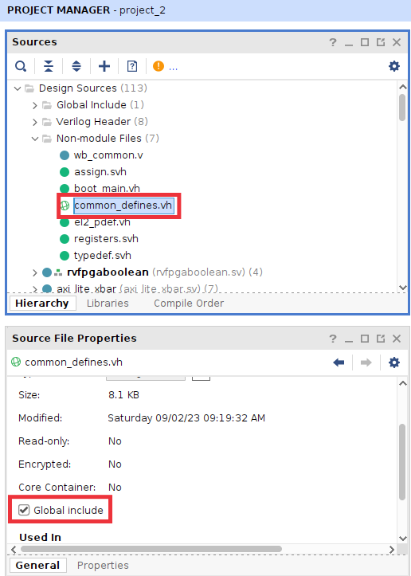

**Figure 10. Set *common_defines.vh* as a Global include file**

Do the same with file *el2_pdef*. Then, on the same Window (Source File Properties), set the type of this file as SystemVerilog (see Figure 11).

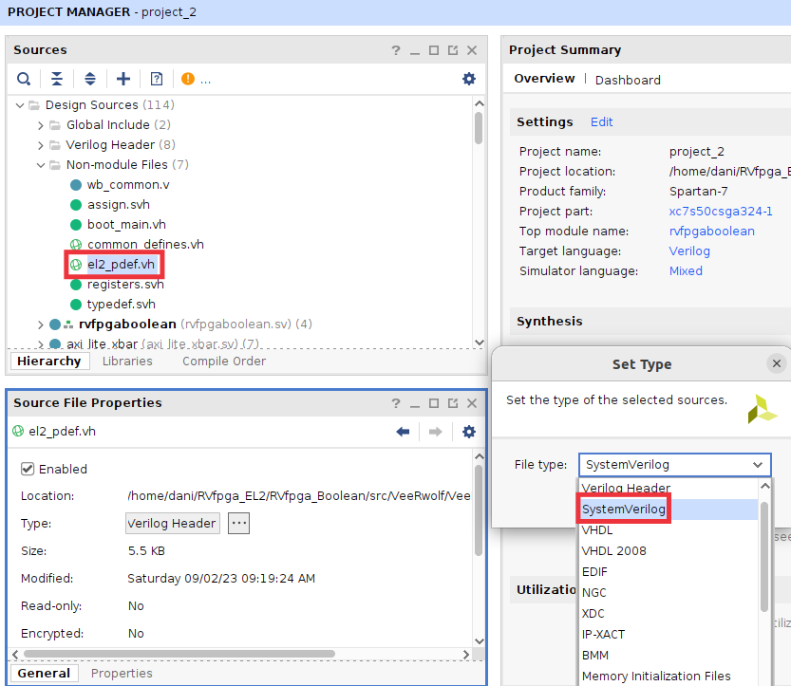

Figure 11. Set the type of *el2_pdf.vh* as SystemVerilog

**Add *boot_main.mem* to the project:** In the Flow Navigator pane, click on Add Sources, leave the default option (“Add or create design sources”), and click on Add Files (see Figure 12). Navigate to *[RVfpgaBasysPath]/src/VeeRwolf/BootROM/sw* and select *boot_main.mem* (as shown in Figure 12). The hierarchy will update and include that file in Design Sources/Memory File.

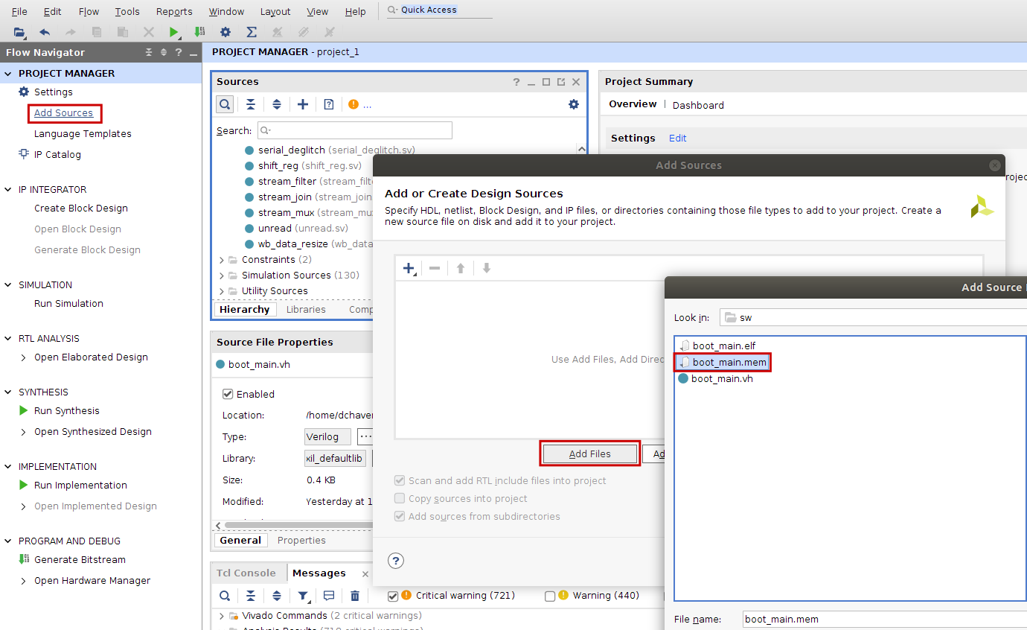

Figure 12. Add Memory File *boot_main.mem*

This file (*boot_main.mem*) is used for initializing the Boot ROM of our SoC by invoking it as a parameter in file *[RVfpgaBasysPath]/src/rvfpgabasys.sv*:

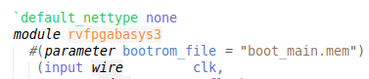

The Getting Started Guide contains more information about this file.

**Include folders:** Include two folders for the Pulp Platform (see Figure 13), which we use for the AXI Interconnect and for some generic modules in our SoC (see <https://pulp-platform.org/>). In the Flow Navigator pane, click on *Settings*, and on the window that opens click on *General* and then on *Verilog options* (). In the new window, add the two following include directories by clicking on  and browsing to the directories:

[RVfpgaBasysPath]/src/VeeRwolf/Interconnect/AxiInterconnect/pulp-platform.org__axi_0.25.0/include

[RVfpgaBasysPath]/src/OtherSources/pulp-platform.org__common_cells_1.20.0/include

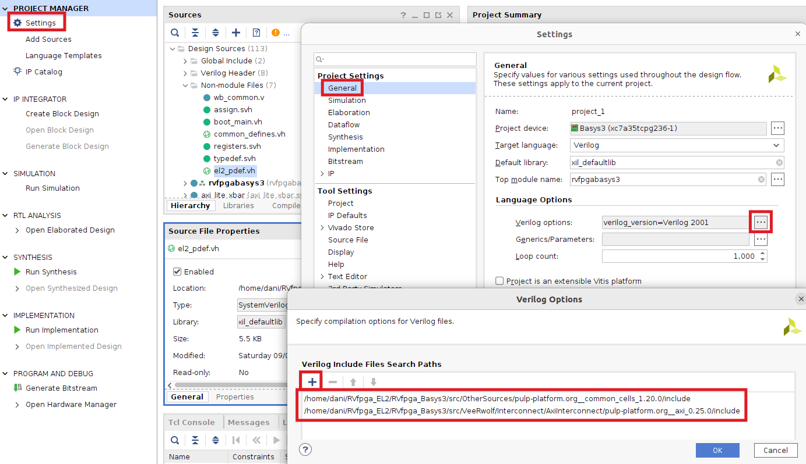

Figure 13. Include folders for the Pulp Platform

**Add *-sweep*:** Finally, add the –sweep option to the **Implementation – Opt Design**. See Figure 14.

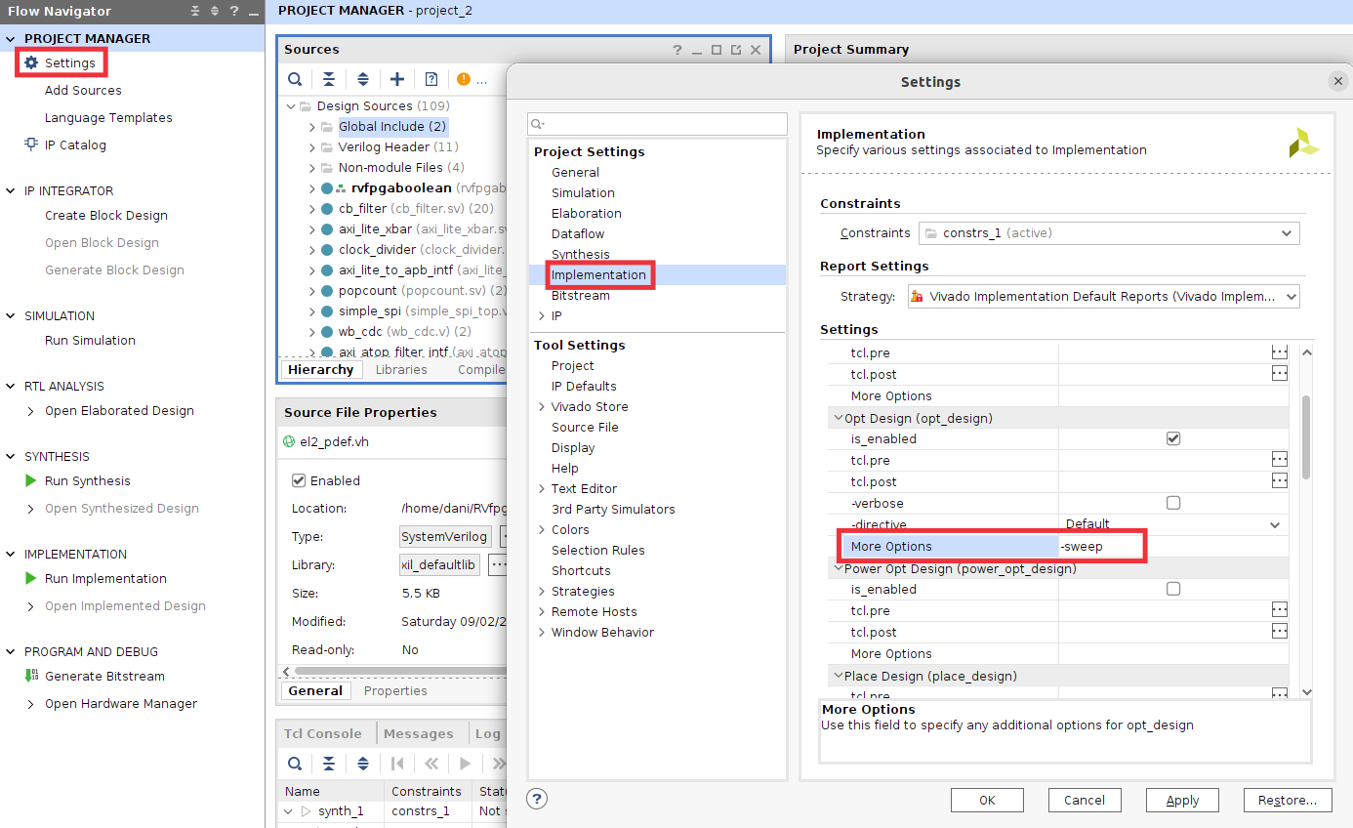

Figure 14. Add the –sweep option

**Step 6. Generate Bitstream**

Now Click on Flow → Generate Bitstream as shown in Figure 15. This process typically takes around 20 minutes, depending on the speed of your computer.

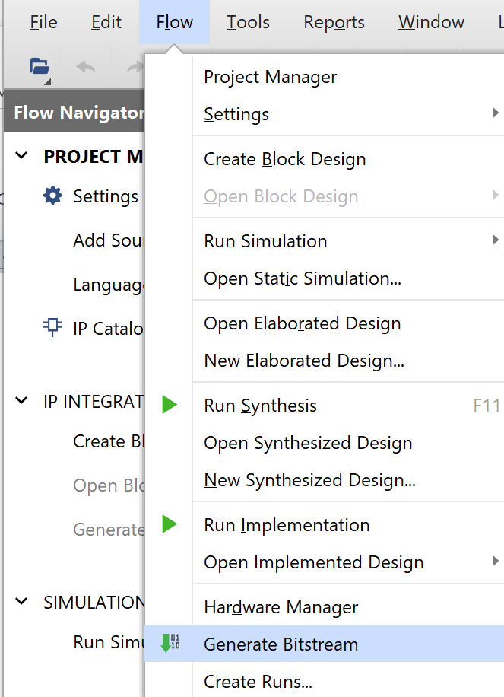

Figure 15. Generate Bitstream

After the bitstream has been generated a window will pop up as shown in Figure 16. Click on the  button in the top-right corner to close the window.

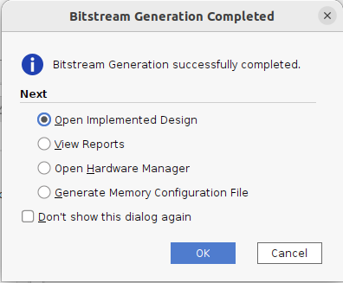

Figure 16. Bitstream Generation Completed

Now that you have built the RVfpgaEL2-Basys3 system yourself, you will be able to rebuild RVfpgaEL2-Basys3 after you make modifications to it in Labs 6-9. You can now also use the RVfpgaEL2-Basys3 system you just built to download and run programs on it.

**IMPORTANT:** You can find the bitstream just generated by Vivado in folder:

[RVfpgaBasysPath]/Labs/Lab05/project_1/project_1.runs/impl_1

It is recommended that you use Catapult SDK to download RVfpgaEL2-Basys3 onto the Basys 3 board, as described in Labs 1-4 and in the RVfpgaEL2 Getting Started Guide (GSG) in detail. As also described in the GSG and Labs 1-4, after downloading the RVfpgaEL2-Basys3 system onto the FPGA on the Basys 3 board, you will use Catapult SDK to download and run/debug programs on RVfpgaEL2-Basys3.