**TASK:** Remove all nop instructions in the example from Figure 2. Generate the trace with the RVfpga-Trace simulator, analyse the simulation on RVfpga-Pipeline, and then compute the IPC by using the Performance Counters while executing the program on the board (remember that you must uncomment all instructions in the main function, in file *Test.c*).

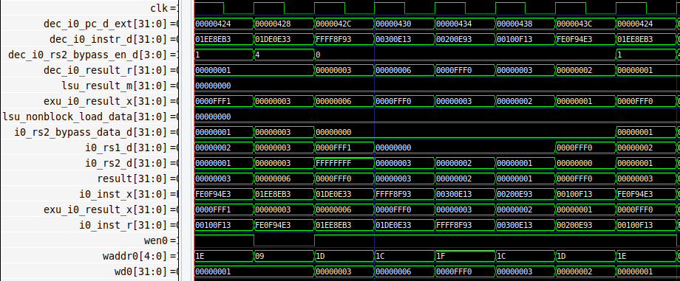

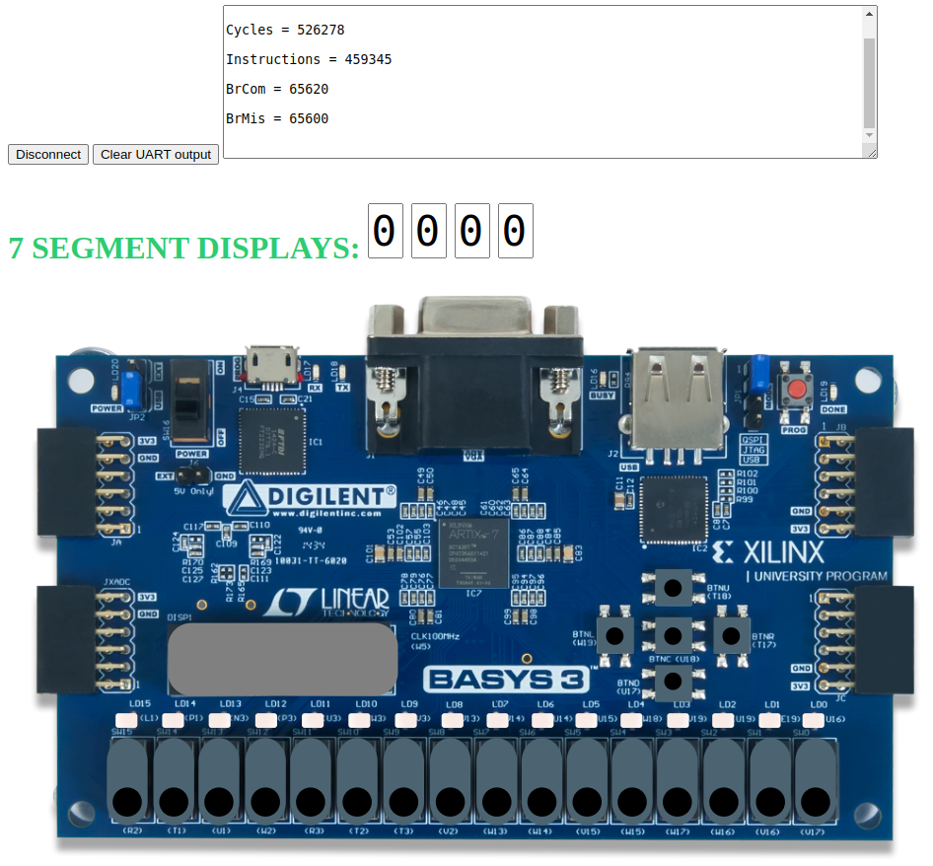

* The forwarding logic allows the dependent instruction to not stall. However, there is 1 bubble due to the branch. So, the number of cycles = 7 instructions + 1 bubble.
* The number of cycles is as expected 0xffff * 8 = 524280

**Exercise 1:** In the example from Figure 2, analyse and explain similar situations where you replace the dependent add instruction for other dependent instructions, such as:

- add t4,t4,t5

**mul** t3,t3,t4

- add t4,t4,t5

**div** t3,t3,t4

- add t4,t4,t5

**lw** t3, 0(t4)

Solution not provided for this exercise.