**TASK:** Verify that these 32 bits (0x0042a303) correspond to instruction lw t1,4(t0) in the RISC-V architecture.

**0x0042a303 → 000000000100 00101 010 00110 0000011**

**imm11:0 = 000000000100**

**rs1 = 00101 = x5 (t0)**

**funct3 = 010**

**rd = 00110 = x6 (t1)**

**op = 0000011**

From Appendix B of DDCARV:

  




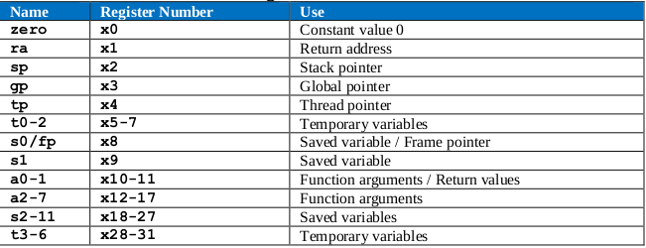

**TASK:** Perform a more detailed analysis of the lw instruction, similar to the one performed in Section 2.B of Lab 12 for an add instruction, or to the one performed in Section 2.B of Lab 13 of the RVfpga package for VeeR EL2.

Solution not provided for this exercise.

**TASK:** Verify that these 32 bits (0x0062a023) correspond to instruction sw t1,0(t0) in the RISC-V architecture.

**0x0062a023 → 0000000 00110 00101 010 00000 0100011**

**imm11:0 = 000000000000**

**rs2 = 00110 = x6 (t1)**

**rs1 = 00101 = x5 (t0)**

**funct3 = 010**

**op = 0100011**

From Appendix B of DDCARV:





**TASK:** Analyse in the simulation the load instruction that follows the store to verify that the value has been correctly written to the DCCM.

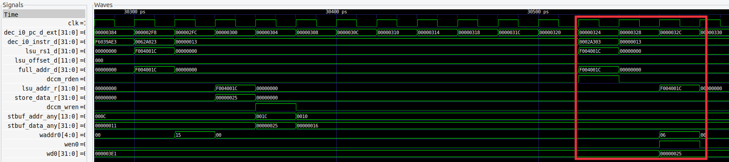

**TASK:** Extend the basic analysis performed in this section for the sw instruction in a similar way as the advanced analysis performed for the lw instruction in Section 2.B.

Solution not provided for this exercise.

**TASK:** Analyse unaligned stores to the DCCM, as well as sub-word stores: store byte (sb) or *store half-word* (sh).

Solution not provided for this exercise.

**TASK:** Modify the program from Figure 9 in order to analyse an unaligned load access that needs to send two addresses to the Main Memory through the AXI Bus and then combine the 64-bit data.

We simulate the following modified program:

REPEAT:

lw t3, **6**(t4)

add t5, t5, -1

INSERT_NOPS_10

add t6, t3, t6

add t4, t4, 4

INSERT_NOPS_9

bne t5, zero, REPEAT # Repeat the loop

INSERT_NOPS_4

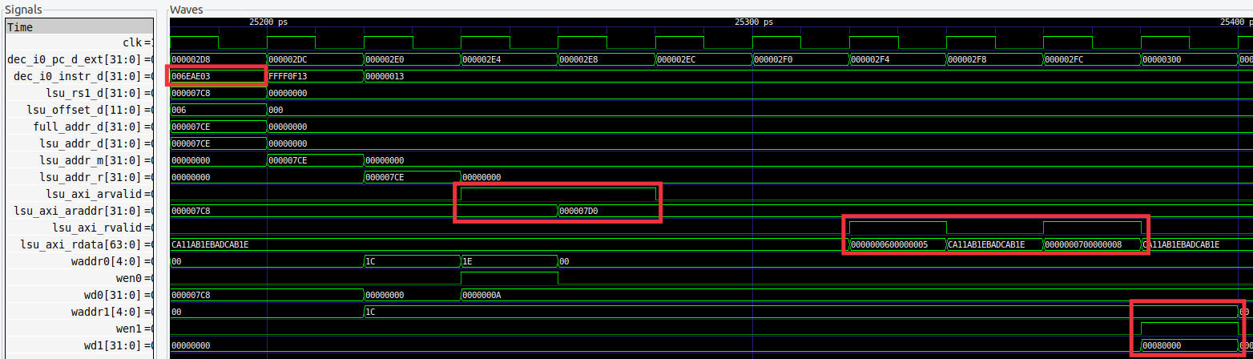

**TASK:** It can be interesting to analyse the AXI Bus implementation for accessing the DRAM Controller, for which you can inspect the **lsu_bus_intf** module.

Solution not provided for this exercise.