**TASK:** Remove all nop instructions in the example from Figure 2. Generate the trace with the RVfpga-Trace simulator, analyse the simulation on RVfpga-Pipeline, and then compute the IPC by using the Performance Counters while executing the program on the board (remember that you must uncomment all instructions in the main function, in file *Test.c*).

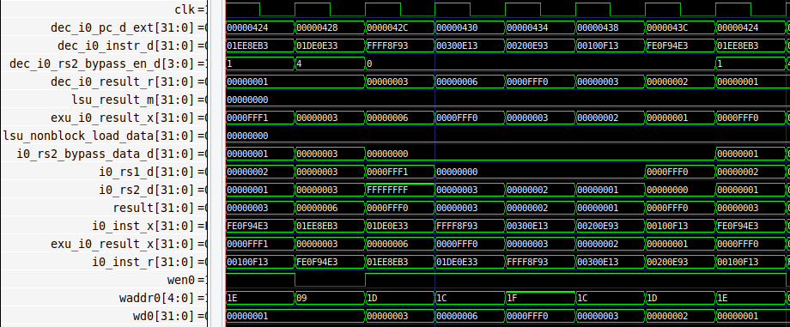

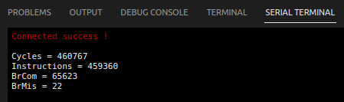

* The IPC = 1, thanks to the forwarding logic that allows the dependent instruction to not stall.
* The number of cycles is as expected 0xffff * 7 = 458745

**Exercise 1:** In the example from Figure 2, analyse and explain similar situations where you replace the dependent add instruction for other dependent instructions, such as:

- add t4,t4,t5

**mul** t3,t3,t4

- add t4,t4,t5

**div** t3,t3,t4

- add t4,t4,t5

**lw** t3, 0(t4)

Solution not provided for this exercise.

**Exercise 2:** Use the project called *DataHazards_LW-AL* to analyse a hazard between a load and an add instruction. Analyse the following two situations:

- **DCCM**: The load reads from the DCCM in a single cycle. You can use the tcl script called *test_DCCM.tcl*. For mapping the data to the DCCM, uncomment, in file Test_Assembly.S, line: .section .midccm, and comment line: .section .ram

- **Main Memory**: The load reads from Main Memory in several cycles. You can use the tcl script called *test_MainMemory.tcl*. For mapping the data to Main Memory, uncomment, in file Test_Assembly.S, line: .section .ram, and comment line: .section .midccm

Simulate the program both in RVfpga-Trace and RVfpga-Pipeline.

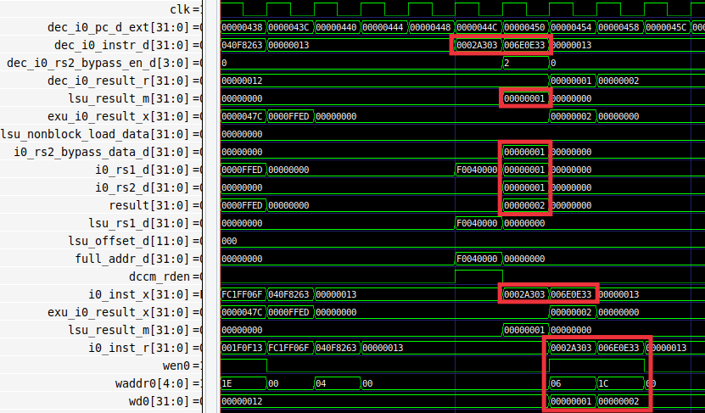

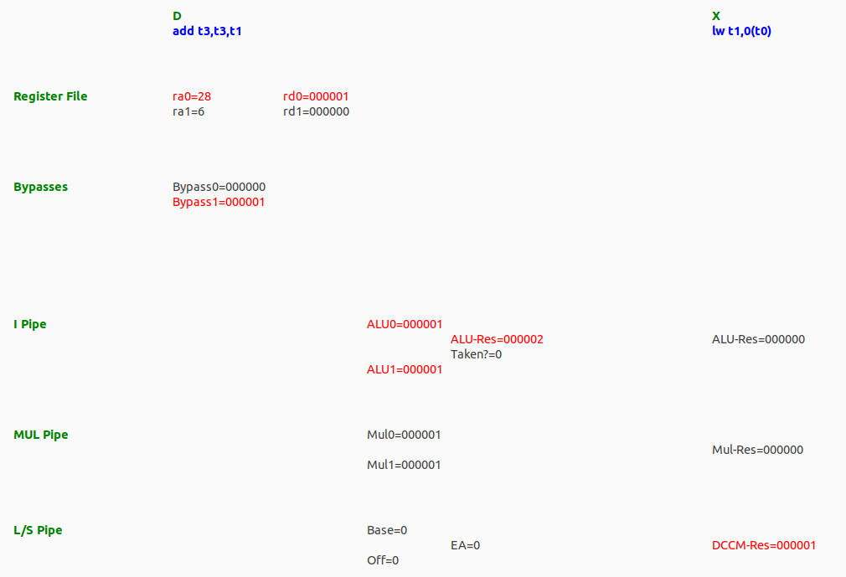

* The DCCM provides the data in one cycle.
* That data (0x1) is forwarded to the add instruction, which uses it as its second operand instead of the data read from the Register File, which is incorrect.
* There are no stalls thank sto the DCCM low-latency.

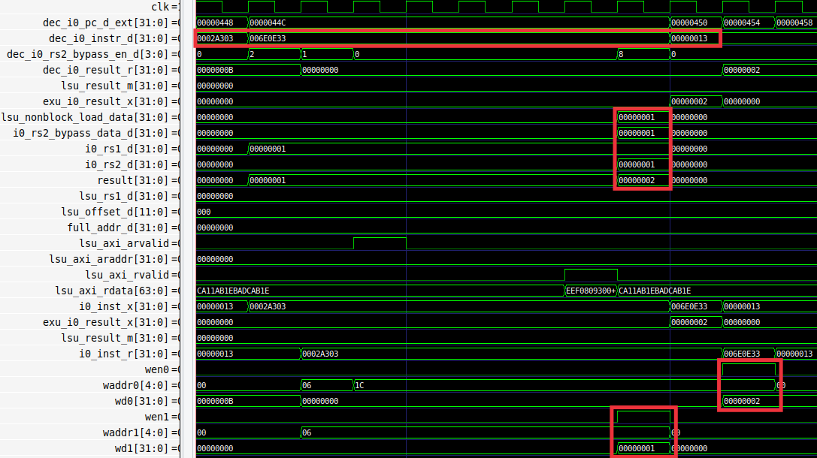

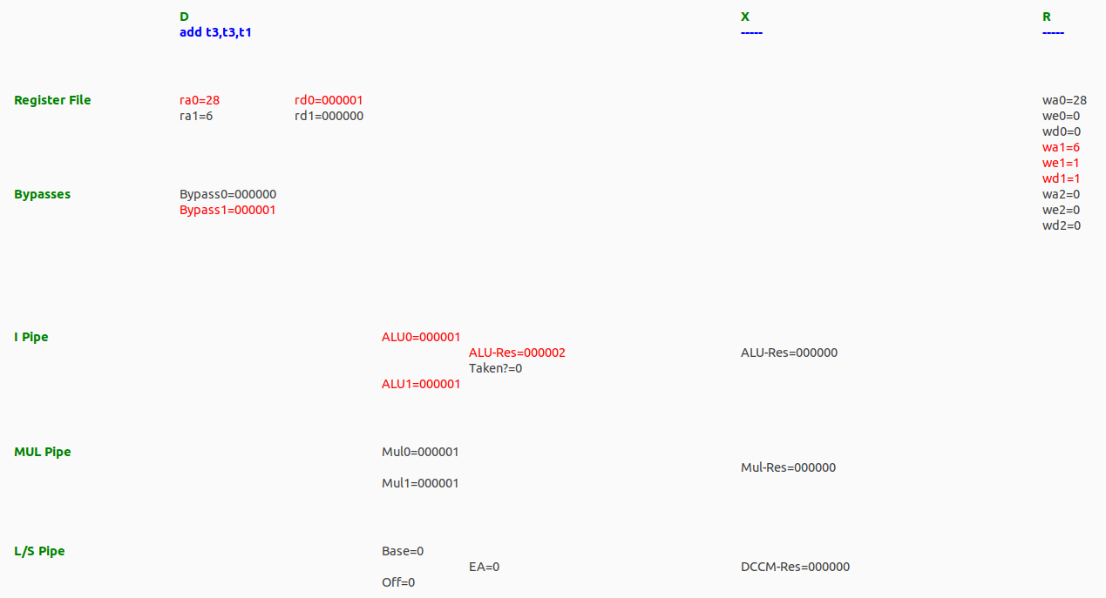

* The Main Memory needs several cycles for providing the result, due to the latency of the memory itself and the AXI bus protocol.
* When data is available, it is written to the RF and provided to the add instruction through forwarding, so that it can start right away.