**TASK:** Explain how signals rden_bank, wren_bank, and addr_bank are obtained in module **lsu_dccm_mem**.

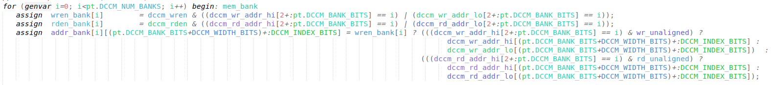

Signal wren_bank

* In our case, DCCM_NUM_BANKS=4, thus signal wren_bank[3:0] contains 4 bits, one per bank. Writing bank *i* is enabled when wren_bank[i]==1.
* If the LSU sets signal dccm_wren (we analysed this signal in Lab 13), one or two banks are written (depending on the access being aligned or unaligned), as determined by field Bank of the address provided in: dccm_wr_addr_lo and dccm_wr_addr_hi.

Signal rden_bank

* In our case, DCCM_NUM_BANKS=4, thus signal rden_bank[3:0] contains 4 bits, one per bank. Reading of bank *i* is enabled when rden_bank[i]==1.
* If the LSU sets signal dccm_rden (we analysed this signal in Lab 13), one or two banks are read (depending on the access being aligned or unaligned), as determined by field Bank of the addresses provided in: dccm_rd_addr_lo and dccm_rd_addr_hi.

Signal addr_bank

* Signal addr_bank[3:0][9:0] contains 8 10-bit addresses, one per bank.
  + In case of a write, the address is obtained in signal dccm_wr_addr_lo (upon an aligned write), or signals dccm_wr_addr_lo and dccm_wr_addr_hi (upon an unaligned write).
  + In case of a read, the address is either in signal dccm_rd_addr_lo (upon an aligned read), or signals dccm_rd_addr_lo and dccm_rd_addr_hi (upon an unaligned read).

**TASK:** Simulatean unaligned read to the DCCM and analyse how it is handled inside the DCCM. You can use the program used above (*[RVfpgaBooleanPath]/Labs/Lab20/LW-SW_Instruction_DCCM/*) and simply substitute the load instruction as follows:

lw t3, (t4) à lw t3, **1**(t4)

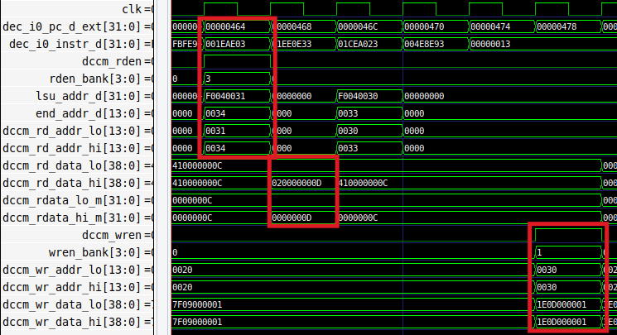

* Signal dccm_rden = 0x03, thus two banks are enabled for reading.
* Two values are provided to the core:
  + dccm_rd_data_lo = 0x410000000C
  + dccm_rd_data_hi = 0x020000000D
* The core aligns the value into signal lsu_ld_data_m = 0x0D000000
* A few cycles later, the value plus one is written in the DCCM: dccm_wr_data_lo = 0x1E0D000001

**TASK:** Simulatea DCCM bank conflict by modifying the program from *[RVfpgaBooleanPath]/Labs/Lab20/LW-SW_Instruction_DCCM/*).

**1st modification:** Remove the 20 nop instructions, regenerate the simulation, and analyse the lw and the sw in a random iteration of the loop.

**2nd modification:** Replace the sw instruction for 4 consecutive sw instructions (each accessing a different bank), making the lw and sw try to access the same bank in the same cycle:

sw t3, (t4) à sw t3, (t4)

sw t3, 4(t4)

sw t3, 8(t4)

sw t3, 12(t4)

Test different offset combinations and compare a program with no conflicts and a program with bank conflicts.

REPEAT_Access:

lw t3, (t4)

add t3, t3, t5

sw t3, (t4)

sw t3, 4(t4)

sw t3, 8(t4)

sw t3, 12(t4)

add t4, t4, 4

bne t4, t6, REPEAT_Access # Repeat the loop

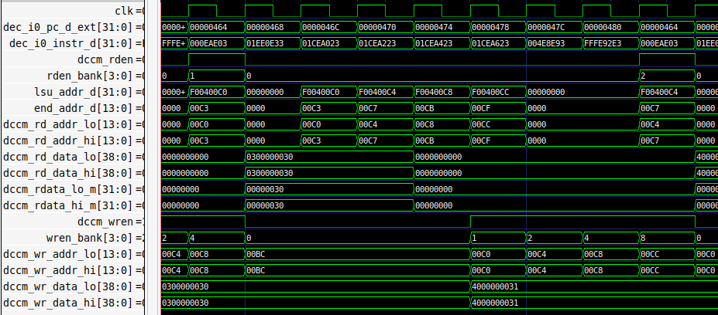

In this case, the load to bank 2 and the store to bank 8 (last cycle shown in the figure) can happen in the same cycle.

REPEAT_Access:

lw t3, (t4)

add t3, t3, t5

sw t3, 8(t4)

sw t3, 12(t4)

sw t3, (t4)

sw t3, 4(t4)

add t4, t4, 4

bne t4, t6, REPEAT_Access # Repeat the loop

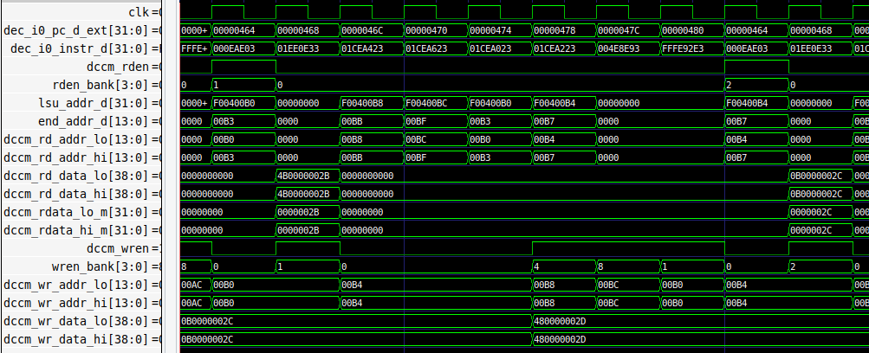

In this case, the store to bank 2 has to be delayed 1 cycle as it conflicts with the load to the same bank (last two cycles shown in the figure).

# EXERCISES

1. Do the same analysis as was done for CoreMark but this time using the Dhrystone benchmark. A Catapult project that contains the Dhrystone benchmark is in: *[RVfpgaPath]/RVfpga/Labs/Lab20/RealBenchmarks/Dhrystone*. As required by all benchmarks, this Dhrystone benchmark has been adapted to the specific system, in this case the RVfpgaEL2 System. File *Test.c* is similar the one used in CoreMark but it invokes function main_dhry(), which includes the Dhrystone benchmark itself.

Execution using Main Memory:

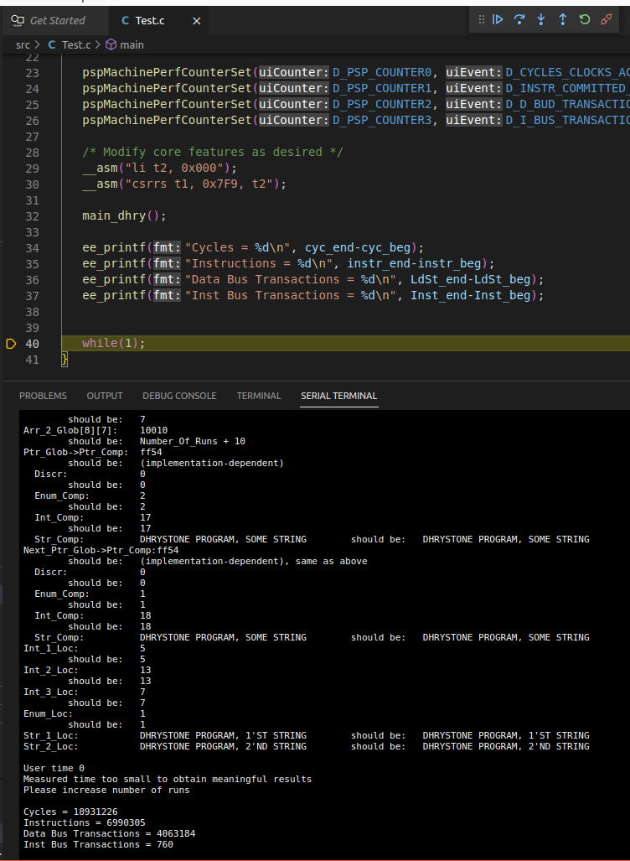

Execution using -O3:

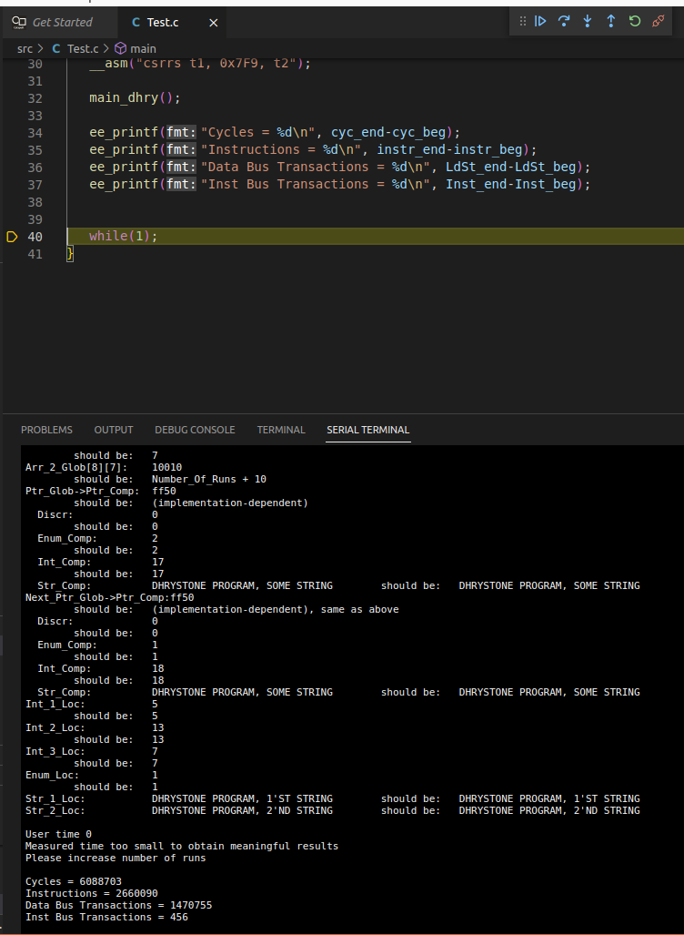

1. Enable/disable various core features as described in Lab 11. Compare the performance results – that is, values of the HW Counters when executing the programs on these modified cores. Run all programs (CoreMark, Dhrystone) on these modified RVfpga Systems on the Boolean board. Variations include:
   1. Using different Branch Predictor configurations and implementations (such as always not-taken, Gshare, and the bimodal predictor implemented in Lab 16).
   2. Using various I$/DCCM/ICCM configurations (such as different sizes or different I$ Replacement Policies).

Solution not provided.