

**THE IMAGINATION UNIVERSITY PROGRAMME**

**RVfpga Lab 10**

**Serial Buses**

# INTRODUCTION

In this lab,we first describe how serial buses work and the main features of one of the most typical serial buses currently used, the SPI bus (Section 2). We then focus on the SPI accelerometer available on the Nexys A7 board: we analyse the high-level specification for this peripheral and propose fundamental exercises (Sections 3 and 4), and then we analyse its low-level implementation and propose some advanced exercises (Sections 5 and 6).

# SERIAL BUSES – THE SPI BUS

# Parallel buses send several bits at once, whereas serial buses send one bit at a time. We first compare these two communication schemes and then describe the SPI (serial peripheral interface) protocol, which is one of the most common serial buses currently used. You can find lots of information on the internet for extending your knowledge about this important communication protocol.

# As already demonstrated in previous labs, the main purpose of embedded electronics is to connect processors and circuits to create desired functions. In order for processors and circuits to share information, they must share a common communication protocol. Hundreds of communication protocols have been defined to achieve this data exchange, and, in general, they can be separated into two main categories: parallel or serial interfaces.

Parallel interfaces transfer multiple bits in parallel, i.e., at the same time. They require buses (multiple wires) of data. For example, the protocol may transmit eight, sixteen, or more bits at the same time (see Figure 1). They also require a clock to time when new groups of *N* data bits are ready to transfer.



Figure 1. Example of a parallel 8-bit data bus.

In contrast to parallel communication, serial interfaces stream their data one bit at a time. These interfaces can operate using as few as one wire and usually never more than four. Figure 2 shows an example serial interface with one wire for data and one for a clock. At each new clock edge, a new data bit is transferred.



Figure 2. Example of a serial 1-bit data bus.

Parallel communication has the benefits of being fast, straightforward, and relatively easy to implement. However, it requires many more input/output (I/O) lines. So, because pins are limited, embedded systems often opt for serial communication, sacrificing potential speed for pin real estate.

**SPI Bus:**

The Serial Peripheral Interface (SPI) protocol is one of the most widely used interfaces between microcontroller and peripheral ICs such as sensors, ADCs, DACs, shift registers, SRAM, and others. SPI is a synchronous, full duplex interface based on controller-peripheral (formerly called master-slave) communication.

The SPI bus usually communicates via 4 ports (see Figure 3):

* **SDO** – Serial Data Out: Controller’s output to peripheral device
* **SDI** – Serial Data Input: Controller’s input from peripheral device
* **SCK** – Serial Clock: Sent from controller to peripheral device
* **CS** – Chip Select: Active low signal; Controller sends signal (0 when peripheral is selected) to peripheral

**Note:** historically, SDO has also been called MOSI (master data out, slave data in) and SDI has been called MISO (master data in, slave data out). Those terms are outdated and offensive, but they still exist in the literature and in documentation.



Figure 3. Example of a system with one SPI controller and one SPI peripheral.

The serial data is synchronized to the rising or falling clock edge. SPI is a full-duplex interface; the controller and the peripheral can send data at the same time via the SDO and SDI lines, respectively. SPI interfaces only have one controller, but they may have multiple peripherals. When more than one peripheral is connected, multiple low-asserted chip select signals (CSbar) from the controller are used to select which peripheral is being accessed. SDO and SDI are the serial data lines: SDO (serial data out) is the output data from the controller to the peripheral and SDI (serial data in) is the input data from the peripheral to the controller.

To initiate SPI communication, the controller must select the peripheral device (by asserting the CSbar signal, i.e., CSbar = 0) and then sending the clock signal to the peripheral. During SPI communication, the data is simultaneously transmitted from and to the controller through the SDO and SDI signals, respectively. The serial clock (SCK) edge synchronizes the sampling of the data.

The SPI interface also provides additional signals, CPOL and CPHA, for selecting the idle state of the clock and the phase for sampling the signal. The clock polarity (CPOL) signal is 0 when the clock (SCK) idles at 0 and 1 when it idles at 1. The clock phase (CPHA) signal selects the phase of the clock to send and sample data. When CPHA = 0, data (on SDI or SDO) is sampled on the leading edge (i.e., the first edge after SCK stops idling - and on every cycle thereafter); so data (SDI and SDO) must change on the trailing edge, as shown in the top two timing diagrams of Figure 4. CPHA = 1 does the opposite: data is sampled on the trailing edge and data changes on the leading edge, as shown in the bottom two figures of Figure 4. The edge on which new data is transmitted is also called the *shifting edge*, because this serial communication is typically implemented using a shift register.

The SPI interface we use in this lab is CPHA = 0 and CPOL = 0, so SCK idles low and the controller and peripheral sample data on the rising edge and shift new data onto the line (SDO or SDI) just after each falling edge, as shown in the top timing diagram of Figure 4. Note that when SCK is idle, and just before it rises, SDO and SDI must carry the most significant bit of the next data byte.



**Figure 4. Relationship of CPHA/CPOL with sampling/sending data**

# SPI ACCELEROMETER: HIGH-LEVEL SPECIFICATION

Many peripherals include an SPI interface. For example, the accelerometer on the Nexys A7 board has an SPI interface. In this section we describe the high-level specification of the RVfpga System’s SPI controller and introduce the ADXL362 accelerometer included on the Nexys A7 board. We also introduce an exercise that uses the accelerometer.

1. **SPI controller specification**

The RVfpga System’s SPI module is from OpenCores (<https://opencores.org/projects/simple_spi>). If you download the package, a document is provided that describes the high-level specification of the module. This document is also provided here:

*[RVfpgaEL2NexysA7NoDDRPath]/src/VeeRwolf/Peripherals/spi/docs/simple_spi.pdf*

We summarize the main operation and features of the SPI module; however, refer to the above document for additional information.

This module has the following main features:

* It is compatible with Motorola’s SPI specifications
* It uses the 8-bit WISHBONE RevB.3 classic interface
* It contains a 4-entry read FIFO buffer and a 4-entry write FIFO buffer
* It allows interrupt generation after 1, 2, 3, or 4 transferred bytes
* It can operate with a wide range of input clock frequencies
* It is fully synthesizable

Section 3 of the SPI core specification describes the control and status registers available inside the SPI module, each of which is assigned to a different address (see Table 1). The base address of the SPI controller is **0x80001100**. These registers are described in detail below.

Table 1. SPI Registers

|  |  |  |  |  |
| --- | --- | --- | --- | --- |
| **Name** | **Address** | **Width** | **Access** | **Description** |
| SPCR | 0x80001100 | 8 | R/W | Control register |
| SPSR | 0x80001108 | 8 | R/W | Status register |
| SPDR | 0x80001110 | 8 | R/W | Data register |
| SPER | 0x80001118 | 8 | R/W | Extensions register |
| SPCS | 0x80001120 | 8 | R/W | CS register |

The SPI Control Register (SPCR) controls the SPI module; Table 2 shows the function of each of its bits.

Table 2. SPCR bits

|  |  |  |
| --- | --- | --- |
| **Bit** | **Access** | **Name & Description** |
| 0:1 | R/W | **SPR**  SPI clock Rate: These bits select the SPI clock rate. |
| 2 | R/W | **CPHA**  Clock Phase: Determines the phase of sampling and sending data. When CPHA = 1, new data is shifted onto the wire at the leading edge and data is sampled on the trailing edge. When CPHA = 0, new data is shifted onto the wire at the trailing edge and sampled on the leading edge. |
| 3 | R/W | **CPOL**  Clock Polarity: Determines idle state of SPI clock (SCK). When CPOL = 0, SCK idles at 0, when CPOL = 1, SCK idles at 1. |
| 4 | R/W | **MSTR**  Mode Select: When MSTR = 1, the SPI core is a controller device. This is the only supported mode for this controller. |
| 6 | R/W | **SPE**  SPI Enable: When SPE = 1, the SPI core is enabled. When it is cleared (SPE = 0), the SPI core is disabled. |
| 7 | R/W | **SPIE**  SPI Interrupt Enable: When SPIE = 1, when the SPI Interrupt Flag in the status register is set, the host is interrupted. |

The SPI Status Register (SPSR) provides the status of the SPI module; Table 3 shows the function of each of its bits.

Table 3. SPSR bits

|  |  |  |
| --- | --- | --- |
| **Bit** | **Access** | **Description** |
| 0 | R/W | **RFEMPTY**  Read FIFO Empty: If RFEMPTY = 1, the read FIFO is empty. |
| 1 | R/W | **RFFULL**  Read FIFO Full: If RFFULL = 1, the read FIFO is full. |
| 2 | R/W | **WFEMPTY**  Write FIFO Empty: IF WFEMPTY = 1, the write FIFO is empty. |
| 3 | R/W | **WFFULL**  Write FIFO Full: IF WFFULL = 1, the write FIFO is full. |
| 6 | R/W | **WCOL**  Write Collision flag: When WCOL = 1, the SPDATA register was written to while the Write FIFO was full. Writing a 1 to WCOL clears this bit. |
| 7 | R/W | **SPIF**  SPI Interrupt Flag: SPIF = 1 upon completion of a transfer block. If SPIF is asserted (‘1’) and SPIE is set, an interrupt is generated. Writing a 1 to SPIF clears it. |

The SPI Data Register (SPDR) provides the data to read or write. The SPI controller includes 4 x 8-bit Write Buffer and a 4x 8-bit Read Buffer.

The SPI Extended Register (SPER) provides some additional functionality; Table 4 describes the different fields that it contains.

Table 4. SPER bits

|  |  |  |
| --- | --- | --- |
| **Bit** | **Access** | **Description** |
| 0:1 | R/W | **ESPR**  Extended SPI Clock Rate Select: Add two bits to the SPR (SPI Clock Rate Select). |
| 6:7 | R/W | **ICNT**  Interrupt Count: Determine the transfer block size. The SPIF bit is set after ICNT transfers. Thus, it is possible to reduce kernel overhead due to reduced interrupt service calls. |

Finally, the SPI Chip Select (SPCS) register selects which peripheral to use. The width of this signal is configurable through parameter SS_WIDTH (SPI Select Width). In the RVfpga System, only one peripheral exists for each SPI interface, so SS_WIDTH = 1.

**TASK:** Locate the declaration of registers SPCR, SPSR, SPDR, SPER and SPCS in the SPI module, as well as the definition of their addresses. The SPI module is available inside folder *[RVfpgaEL2NexysA7NoDDRPath]/src/VeeRwolf/Peripherals/spi*.

R

1. **ADXL362 accelerometer specification**

The Nexys A7 board includes an Analog Devices ADXL362 accelerometer. You can find the complete information for the device in its data sheet, located here:

<https://www.analog.com/media/en/technical-documentation/data-sheets/ADXL362.pdf>

The ADXL362 is a 3-axis MEMS accelerometer that consumes less than 2μA at a 100Hz output data rate and 270 nA when in motion triggered wake-up mode. It provides 12-bit output resolution, although 8-bit formatted data is also provided for more efficient single-byte transfers when a lower resolution is sufficient. Measurement ranges of ±2 g, ±4 g, and ±8 g are available with a resolution of 1 mg/LSB on the ±2 g range. While the ADXL362 is in Measurement Mode, it continuously measures and stores acceleration data in the X-data, Y-data, and Z-data registers.

The ADXL362 accelerometer includes several registers (Table 5) that allow the user to configure it and to read the acceleration data. The device is configured by writing to the control registers, and the accelerometer data is found by reading the device registers. All communication with the device must specify a register address and a flag that indicates whether the communication is a read or a write. Data transfer occurs after the register address and communication flag are sent to the device.

This accelerometer acts as a peripheral device using an SPI communication scheme. The interface between the FPGA and accelerometer is shown in Figure 5.

# 

Figure 5. ADXL362 Accelerometer interface with the Nexys A7 board

The recommended SPI clock frequency ranges from 1-5 MHz. The SPI operates in SPI mode 0 (CPOL = 0 and CPHA = 0). The SPI port uses a multibyte structure wherein the first byte indicates if the communication performs a register read (0x0B) or a register write (0x0A):

**<CS down> <Write/Read (0x0A/0x0B)> <address byte> <data byte> <CS up>**

Figure 6 and Figure 7 illustrate two examples of the communication between the SPI controller (controller) and the accelerometer (peripheral): Figure 6 shows the reading of a register and Figure 7 shows the writing of a register.

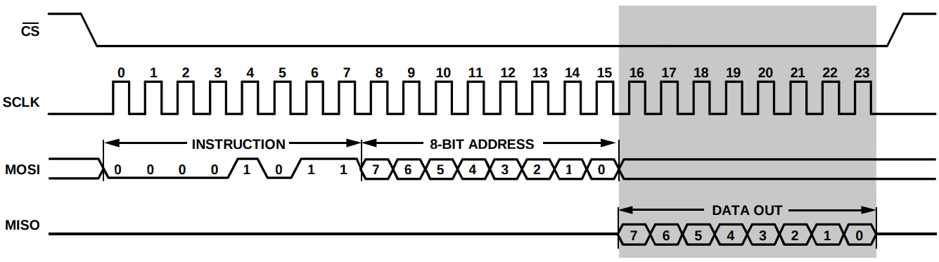

Figure 6. Register read

(Figure from <https://www.analog.com/media/en/technical-documentation/data-sheets/ADXL362.pdf>)

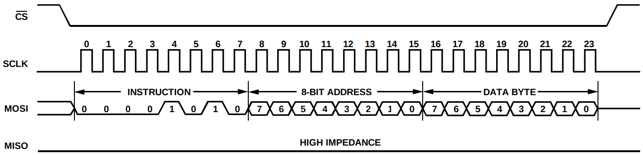

Figure 7. Register write

(Figure from <https://www.analog.com/media/en/technical-documentation/data-sheets/ADXL362.pdf>)

Table 5 shows the registers available in the ADXL362 accelerometer. For the complete registers description, refer to the ADXL362 data sheet: <https://www.analog.com/media/en/technical-documentation/data-sheets/ADXL362.pdf>.

Table 5. ADXL362 accelerometer registers

(Table from <https://www.analog.com/media/en/technical-documentation/data-sheets/ADXL362.pdf>)

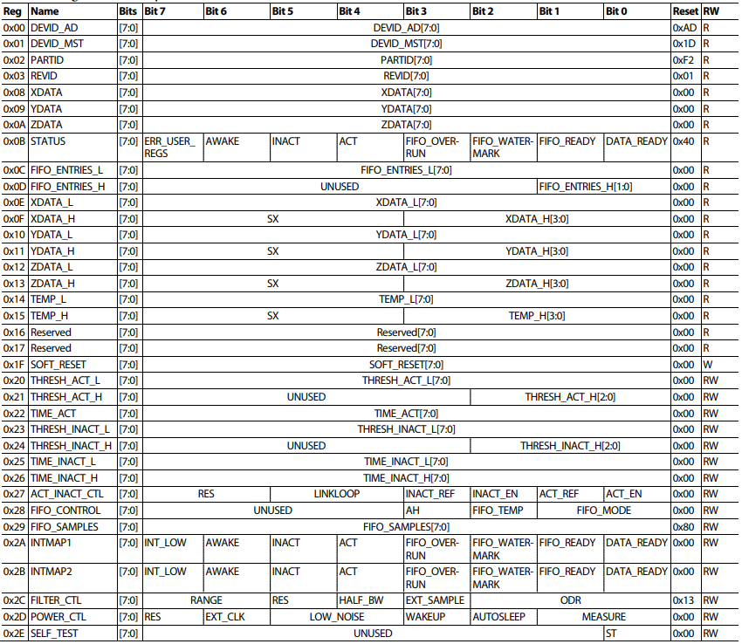

# LOW-LEVEL IMPLEMENTATION

1. **SPI Accelerometer low-level implementation**

In the first part of this lab, we showed how to use the RVfpga System’s SPI modules, and in this last part of the lab we describe how the SPI module is implemented in RVfpga. Similar to the format from previous labs, we divide the analysis of the SPI controllerinto three phases:

1. Physical connection between the SoC and the accelerometer (left shadowed region in Figure 8)
2. Integration of the SPI controller, which is included inside the VeeRwolfX System Controller (middle shadowed region in Figure 8)
3. Connection between the SPI controller and the VeeR EL2 Core (right shadowed region in Figure 8)

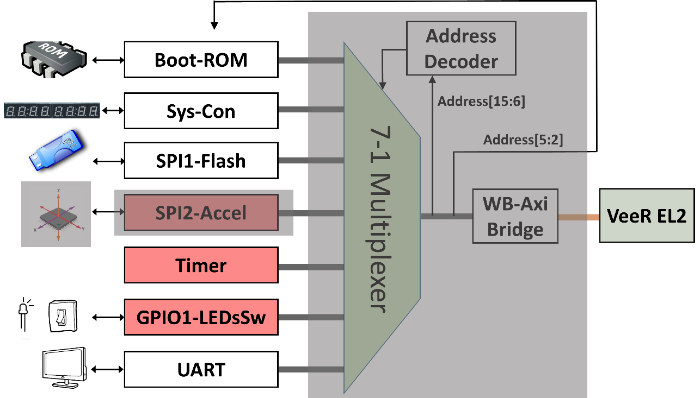

Figure 8. SPI controller integrated into the RVfpga System

INSTRUCT

1. **Physical connection of the accelerometer and the SoC**

As with other peripherals, the RVfpgaEL2-Nexys constraints file must include the physical connections to the accelerometer. The constraints file of the project (*[RVfpgaEL2NexysA7NoDDRPath]/src/rvfpganexys.xdc*) defines the connection between the input/output SoC signals and the board devices. The signals that connect the four pins of the accelerometer with the SoC are called: *o_accel_cs_n*, *o_accel_mosi* (equivalent to signal SDO), *i_accel_miso* (equivalent to signal SDI) and *accel_sclk*. Note that these signals refer to outdated names, but we maintain them in order to be coherent with the names used by the OpenCores’s SPI module that we use in the RVfpga System (you can see the instantiation of this module at Figure 11). Figure 9 shows the piece of Verilog code where these 4 connections are defined.

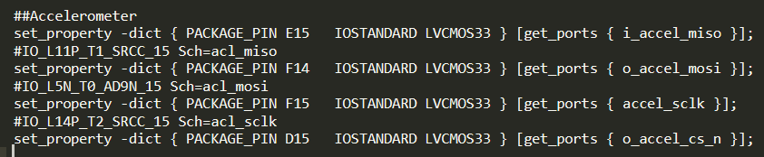

Figure 9. Connection of the SoC and the accelerometer (file *rvfpganexys.xdc*).

In lines 52-55 of the top-module of RVfpgaEL2-Nexys (i.e., the **rvfpganexys** module) you can see these four signals connected to the SoC (left part of Figure 10), and the end of that module are their connection with the **veerwolf_core** module (right part of Figure 10).

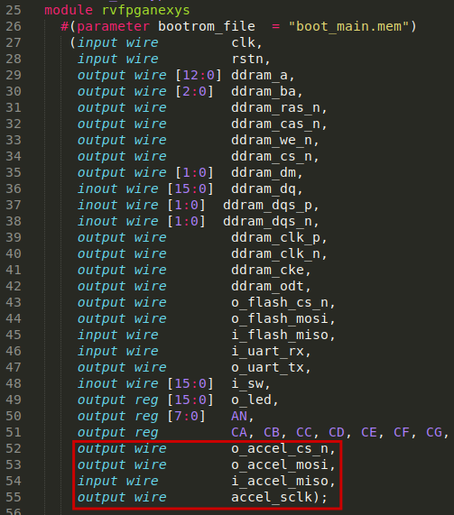 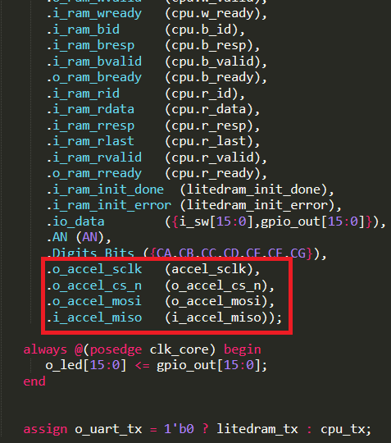

Figure 10. Connection of the accelerometer with the top-module (file *rvfpganexys.sv*).

**TASKS:** Follow these four signals (*o_accel_cs_n*, *o_accel_mosi*, *i_accel_miso* and *accel_sclk*) from the constraints file to the VeeRwolfX SoC module. You will need to inspect the following files:

*[RVfpgaEL2NexysA7NoDDRPath]/src/rvfpganexys.xdc*

*[RVfpgaEL2NexysA7NoDDRPath]/src/rvfpganexys.sv*

*[RVfpgaEL2NexysA7NoDDRPath]/src/VeeRwolf/veerwolf_core.v*I

1. **Integration of the SPI2-Accelerometer module in the SoC**

At lines 387-403 of module **veerwolf_core** (*[RVfpgaEL2NexysA7NoDDRPath]/src/VeeRwolf/veerwolf_core.v*) the SPI module for the accelerometer is instantiated (see Figure 11).

Figure 11. Integration of the SPI2-Accelerometer module (file *veerwolf_core.v*).

As usual with peripherals, the interface of the module can be divided into two blocks: Wishbone signals (Table 6) and external I/O signals (Table 7). The Wishbone signals enable the VeeR EL2 Core to communicate with the ADC using the SPI protocol.

Table 6. Wishbone Signals

|  |  |  |  |
| --- | --- | --- | --- |
| **Port** | **Width** | **Direction** | **Description** |
| cyc_i | 1 | Inputs | Indicates valid bus cycle (core select) |
| adr_i | 15 | Inputs | Address inputs |
| dat_i | 32 | Inputs | Data inputs |
| dat_o | 32 | Outputs | Data outputs |
| sel_i | 4 | Inputs | Indicates valid bytes on data bus (during valid cycle it must be 0xf) |
| ack_o | 1 | Output | Acknowledgment output (indicates normal transaction termination) |
| err_o | 1 | Output | Error acknowledgment output (indicates an abnormal transaction termination) |
| rty_o | 1 | Output | Not used |
| we_i | 1 | Input | Write transaction when asserted high |
| stb_i | 1 | Input | Indicates valid data transfer cycle |
| inta_o | 1 | Output | Interrupt output |

Table 7. External I/O Signals

|  |  |  |  |
| --- | --- | --- | --- |
| **Port** | **Width** | **Direction** | **Description** |
| miso_i | 1 | Input | Controller data Input - Peripheral data Output |
| mosi_o | 1 | Output | Controller data Output - Peripheral data Input |
| ss_o | 1 | Output | Chip Select |
| sck_o | 1 | Output | System clock |

As shown in Figure 11, bits [5:2] of the address provided by the core in the Wishbone bus signal (*wb_m2s_spi_accel_adr[5:2]*) are used for selecting one among the 5 available SPI registers (Table 1).

1. **Connection between the SPI Controller and the VeeR EL2 Core**

As explained in previous labs, the device controllers are connected to the VeeR EL2 Core through a multiplexer and a bridge (Figure 8). Remember that the 7:1 multiplexer is instantiated in file *[RVfpgaEL2NexysA7NoDDRPath]/src/VeeRwolf/Interconnect/WishboneInterconnect/wb_intercon.v*. Then, the **wb_intercon** module is instantiated in file *[RVfpgaEL2NexysA7NoDDRPath]/src/VeeRwolf/Interconnect/WishboneInterconnect/wb_intercon.vh*. This latter file is included in the **veerwolf_core** module located here: *[RVfpgaEL2NexysA7NoDDRPath]/src/VeeRwolf/veerwolf_core.v*.

The multiplexer selects which peripheral to read or write, connecting the CPU (wb_io_* signals) with the Wishbone Bus of one peripheral, depending on the address. For example, if the address generated by the CPU is in the range 0x80001100-0x8000113F, the accelerometer module is selected, and thus signals *wb_io_\** are connected to signals *wb_spi_accel_\**.

Figure 12. 7-1 multiplexer selects the peripheral to connect to the CPU (*wb_intercon.v*).

# EXERCISES

**Exercise 1.** Create a RISC-V assembly program that reads the eight most significant bits of the X-axis, Y-axis, and Z-axis acceleration data and then displays those values on the 8-digit 7-Segment Displays.

**Exercise 2.** Another common serial communication protocol is called I2C (pronounced “eye two see” or also “eye squared see”). The temperature sensor on the Nexys A7 board uses this protocol. Expand the RVfpga System to include an I2C controller, and connect it with the Nexys A7 board’s ADT7420 temperature sensor (<https://www.analog.com/media/en/technical-documentation/data-sheets/adt7420.pdf>). Then write a program that communicates with this new peripheral and displays the temperature on the 7-segment displays.