**TASK:** Measure different events (cycles, instructions/loads committed, etc.) using the Performance Counters available in VeeR EL2, as explained in Lab 11. Remember that you must uncomment the code that configures and uses the Performance Counters. Is the number of cycles as expected after analysing the simulation from Figure 2? Justify your answer.

EXECUTION ON RVfpgaEL2-Nexys (physical board):

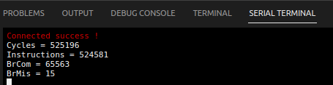

EXECUTION ON RVfpgaEL2-ViDBo (virtual board):

EXPLANATION:

* IPC=1, which is reasonable as there are no stalls.
* The loop contains 8 instructions and the number of iterations is 65563. Thus, in theory it takes 65563*8=524504. The number of cycles obtained is almost the same.

**TASK:** Measure different events (cycles, instructions/loads committed, etc.) using the Performance Counters available in VeeR EL2, as explained in Lab 11. Remember that you must uncomment the code that configures and uses the Performance Counters. Is the number of cycles as expected after analysing the simulation from Figure 4? Justify your answer.

EXECUTION ON RVfpgaEL2-Nexys (physical board):

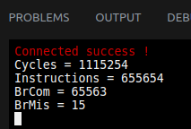

EXECUTION ON RVfpgaEL2-ViDBo (virtual board):

EXPLANATION:

* IPC is around 0.5. The poor performance is caused by the stalls introduced due to the structural hazard between the two div instructions.

1. Like loads, div instructions are non-blocking, thus independent instructions can continue executing while the div is being computed in the divisor. Also like in the case of loads, it can happen that when the division finishes and progresses to the R Stage, another instruction is also at this stage and needs to write its result to the Register File. The solution is again the same as the one used for load instructions: a third write port (port 2, see Lab 11) is included in the Register File so that the two writes can happen in the same cycle. Illustrate this situation simulating the program provided in folder *[RVfpgaEL2NexysA7NoDDRPath]/Labs/Lab14/Div_Instruction*.

The example below illustrates this situation. It executes a div instruction followed by several add instructions contained within a loop that repeats for 0xFFFF iterations (i.e. 65,535). The div instruction is highlighted in red. The add instruction that arrives at the Writeback Stage in the same cycle as the div instruction is also highlighted. As usual, the program does nothing useful and is only intended to illustrate the example of this lab.

REPEAT:

**div a6, x28, x29**

add x30, x30, -1

add a1, a1, 1

add a2, a2, 1

add a3, a3, 1

**add a4, a4, 1**

add a5, a5, 1

bne x30, zero, REPEAT # Repeat the loop

The following figure shows the RVfpgaEL2-Trace simulation for the previous example program for a random iteration of the loop.

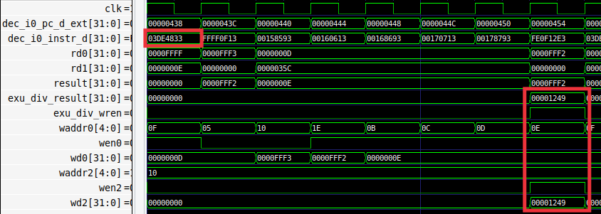

In the final cycle, the div instruction and the conflicting add instruction arrive at the R Stage, where they must write the register file. This is possible thanks to the three write ports available in VeeR EL2’s register file.

1. Create a program, similar to the one from Section 2.B, where two sequential independent load instructions are executed. How is this scenario handled in VeeR EL2? Is it equal to or different from the solution used for the two sequential divisions.

The program is provided at *Labs/RVfpgaLabsSolutions/Lab14/Lw_Sequential_Instructions*. This is the code:

.data

D: .word 11, 10, 9, 8, 7, 6

.text

Test_Assembly:

la x29, D

li x30, 0xFFFF

add a1, zero, 1

add a2, zero, 1

add a3, zero, 1

add a4, zero, 1

add a5, zero, 1

REPEAT:

lw x28, (x29)

lw x31, 20(x29)

add x30, x30, -1

add a1, a1, 1

add a2, a2, 1

add a3, a3, 1

add a4, a4, 1

add a5, a5, 1

bne x30, zero, REPEAT # Repeat the loop

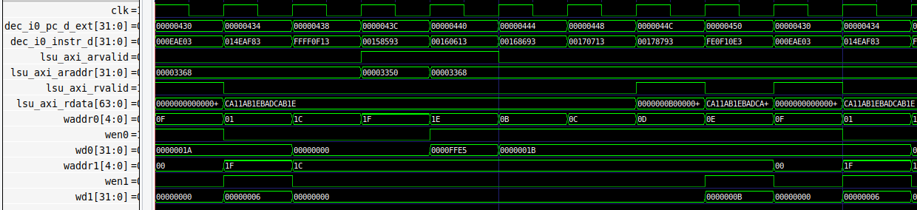

The AXI bus allows requests to be pipelined, thus no stalls occur in this case.

1. Analyse a scenario where three instructions arrive at the R Stage at the same time: add, lw and div. Is it necessary to stall the processor? Explain it theoretically and demonstrate it with an example program. Simulate the program on RVfpgaEL2-Pipeline.

The program is provided at *Labs/RVfpgaLabsSolutions/Lab14/3InstructionsRstage_Instructions*. This is the code:

.data

D: .word 11, 10, 9, 8, 7, 6

.text

Test_Assembly:

la x29, D

li x30, 0xFFFF

add a1, zero, 1

add a2, zero, 1

add a3, zero, 1

add a4, zero, 1

add a5, zero, 1

li x30, 0xFF

REPEAT:

lw x28, (x29)

add x30, x30, -1

add a1, a1, 1

div x31, x29, x30

add a2, a2, 1

add a3, a3, 1

add a4, a4, 1

add a5, a5, 1

bne x30, zero, REPEAT # Repeat the loop

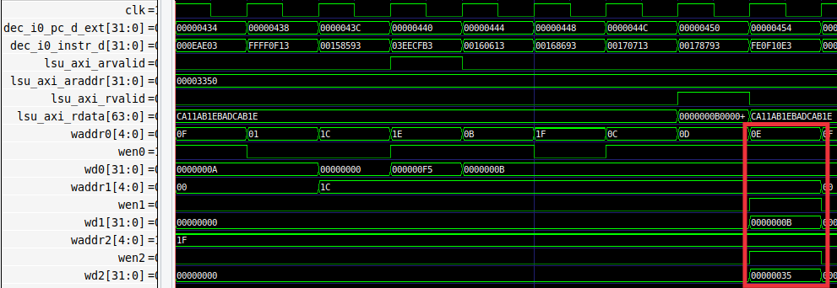

The three writes can be performed in the same cycle as the Register File contains 3 write ports.

This is the simulation on RVfpgaEL2-Pipeline in the cycle when the three instructions write the RF:

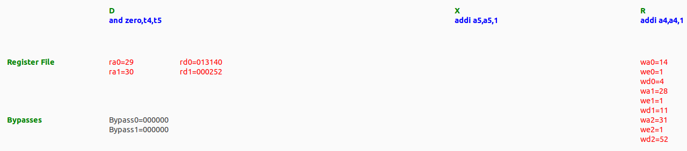

1. You can perform a similar study for the div instruction as the one performed in Lab 12 for arithmetic-logic instructions: view the flow of the instruction through the pipeline stages, analyse the control bits, etc.

Solution not provided for this exercise.

1. Analyse mul instructions in VeeR EL2, both theoretically and practically with example programs.

Solution not provided for this exercise.

1. Replace the divide unit, implemented in module **el2_exu_div_ctl**, with your own unit or an open-source unit downloaded from the Internet.

Solution not provided for this exercise.