9533321 Software Requirement   
Group Project

Fit and Rich Requirement Document

Team member

|  |  |
| --- | --- |
| 642115002 | Krittayoch Jongchisittikul |
| 642115003 | Kan Katpark |
| 642115017 | Dusit Chunviset |
| 642115024 | Thaiphat Sukhumpraisan |
| 642215037 | Poopa Somthawil |

**BACHELOR OF SCIENCE**

**SOFTWARE ENGINEERING PROGRAM**

**COLLEGE OF ARTS, MEDIA, AND TECHNOLOGY**

**CHIANG MAI UNIVERSITY**

# Inception

## Project Description

**“Fit and Rich”** is a **mobile application** which aims to create an innovative insurance platform that integrates fitness and wellness into the insurance experience. Users will be able to exercise to earn discount points and reduce their insurance premiums. The platform will offer personalized fitness plans, tracking of exercise progress, and opportunities to participate in challenges and competitions. Additionally, partnerships with local gyms and fitness centers will enhance user engagement.

## Problems of the User

* Many young adults and middle-aged adults (20 - 40 years old) face a range of challenges in their daily lives, including:
* Balancing work and personal responsibilities often leave little time for fitness and health.
* Finding insurance to be a financial burden rather than an integrated part of their lifestyle.
* Struggling to maintain a consistent exercise routine due to lack of motivation or rewards.

## Goal and Objective

### Goals

The primary goal of this project is to redefine insurance for young adults and middle-aged adults (20 - 40 years old), making it more engaging, relevant, and rewarding.

### Objectives

**Promote Health:** Encourage users to adopt a healthier lifestyle by incorporating regular exercise into their routines.

**Financial Incentives:** Reward users for exercising with discounts on insurance premiums, making insurance more affordable and appealing.

**Personalized Fitness:** Provide users with personalized fitness plans to help them achieve their health and wellness goals.

**Motivation and Engagement:** Keep users motivated and engaged through progress tracking, challenges, and competitions.

**Community Building:** Foster a supportive community of users with similar fitness goals and interests.

## Benefit

**Health and Wellness:** Users will lead healthier lives by incorporating regular exercise, potentially reducing the risk of health issues.

**Financial Savings:** By earning discounts on insurance premiums, users will enjoy financial benefits, making insurance more affordable.

**Motivation and Engagement:** The project will motivate users to stay active and engaged in their fitness journey through rewards, challenges, and tracking.

## Target Users

The primary target users for this project are young adults and middle-aged adults (20 - 40 years old), typically individuals in their early to mid-career stages who have no work-life balance. And also, users, who are seeking affordable insurance options and opportunities to improve their fitness and well-being.

//TODO: Persona

## Fish bone diagram

// TODO: เปลี่ยนหัวก้างปลา

# Elicitation

## Software Progress Plan

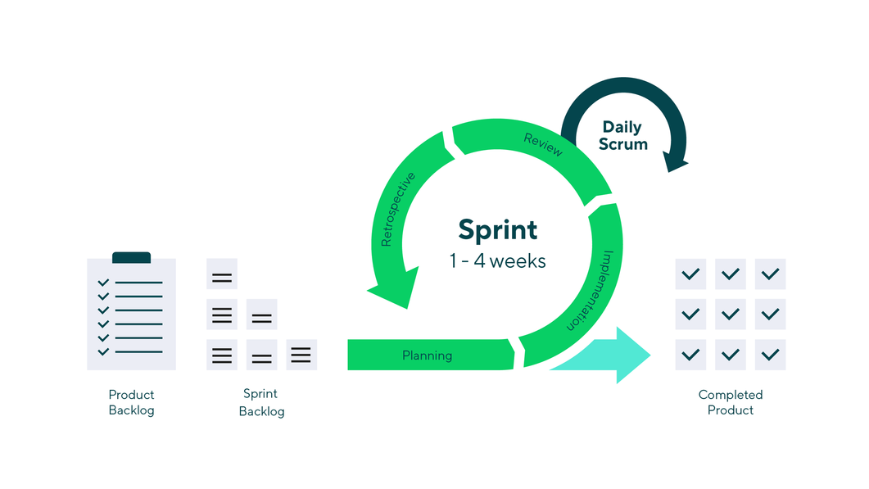

The Scrum framework is a widely used approach in software development that emphasizes iterative and incremental processes. It divides the project into small, manageable units called sprints, typically lasting two to four weeks. During each sprint, a cross-functional team works to complete a set of predefined tasks or user stories, resulting in a potentially shippable product increment. Scrum promotes regular communication and collaboration within the team and with stakeholders through daily stand-up meetings, sprint planning, sprint review, and sprint retrospective sessions. This framework offers flexibility by allowing adjustments and improvements in subsequent sprints based on feedback and changing requirements, making it a valuable methodology for complex and evolving projects.

|  |  |
| --- | --- |
| Sprint | Checkpoint |
| 1 | * Gather requirement. * Raise funds. * Create Prototype. |
| 2 | * Exercise tracking feature |
| 3 | * Insurance subscription feature |
| 4 | * Reward Redemption Feature |
| 5 | * Virtual Event Feature |

## Project Prioritization

The criteria of selecting the feature to be implemented first. We consider the criteria based on effort, impact and risk. We would select the feature which has high impact, effort and low risk. And we can summarize the prioritization as a table:

|  |  |  |  |
| --- | --- | --- | --- |
| **Feature** | **Impact** | **Effort** | **Risk** |
| Exercise Tracking | High | Medium | Low |
| Reward Redemption | Medium | Medium | High |
| Insurance subscription feature | High | High | High |
| Virtual Event and Competition | Medium | Low | Low |

So, this table provides the prioritization based on effort, impact and risk. The feature that should be done first is the **Exercise Tracking feature** because this feature has medium effort, high impact, and low risk.

## Business Review

// TODO: ไปทำ

## SWOT analysis

// TODO: แก้ใหม่ SWOT ไม่ถูก

## Risk analysis

// TODO: อ. บอกทำใหม่ เอาให้เหมือนที่ในคาบ 1. tech risk, 2. people risk, …

Market Risk

|  |  |  |  |  |  |  |
| --- | --- | --- | --- | --- | --- | --- |
| Risk ID | Headline | Description | Priority Level | Impact | Likelihood of Event | Mitigation Strategy |
| 1 | A product similar to “Fit and Rich” appears. | A product that resembles the “Fit and Rich” concept is released during the development. | H | A competitive environment between the products is created. | Somewhat likely | Schedule project meeting and discuss potential requirement changes. |
| 2 | Wellness or Insurance trends decrease. | Wellness or Insurance trends fall off. | N | Potential number of target users decrease. | Very unlikely | Have Marketing department motivate the trend. |

Technology Failure

|  |  |  |  |  |  |  |
| --- | --- | --- | --- | --- | --- | --- |
| Risk ID | Headline | Description | Priority Level | Impact | Likelihood of Event | Mitigation Strategy |
| 3 | Server fail | Some factors lead to the situation where the server cannot provide accurate data. | N | Users may not be satisfied with the application | Certainty | Exception Handling.  Displaying proper messages for the users. |
| 4 | Any technology used in the project faces security risk. | Security risks are found in any technology stack/tools/libraries used in the project.  Example: log4j vulnerability | H | The security vulnerability of the program can be exploited. | Very unlikely | Schedule project meeting and discuss the change in technology stack. |

People Risk

|  |  |  |  |  |  |  |
| --- | --- | --- | --- | --- | --- | --- |
| Risk ID | Headline | Description | Priority Level | Impact | Likelihood of Event | Mitigation Strategy |
| 5 | Not enough members to divide work to | Low number of members such as programmer leading to overworking the rest | H | Could lead to longer development time | Somewhat likely | Hire and train more worker into the team |
| 6 | Lack of responsibility of team’s member | A member of team cannot finish their task on time or cannot meet the requirement of the project | H | The project cannot be delivered on time | Somewhat likely | Report every team member’s work at project meeting, and discuss what should be done. |

Process failure

|  |  |  |  |  |  |  |
| --- | --- | --- | --- | --- | --- | --- |
| Risk ID | Headline | Description | Priority Level | Impact | Likelihood of Event | Mitigation Strategy |
| 7 | Project schedule changes. | Some factors may force the project schedule to change | H | Influence progress | Certainty | Create comprehensive project timeline and adjust the project schedule according to the requirements. |
| 8 | The system faces reliability or stability | Users cannot use the application or cannot get complete information because of unexpected external factors | N | Users may not be satisfied with the application. | Somewhat likely | Manage the application and maintain the system timely. |

## Cost and time estimation

Cost estimation

The total cost of this project is 1M THB. The employee salary would be allocated 44% of all budget. 28% for utility, 17% for marketing, and 11% for research and development.

Time estimation

Estimate time is around 7 months or 28 weeks. This project has 5 sprints. Each sprint takes 3 weeks. The total week spent on the scrum sprint is 15 weeks. And the rest of the time would be the project preparation and requirement gathering.

## Technology Review

|  |  |  |
| --- | --- | --- |
| External Service | | |
| Name | Description | Alternative |
| GitHub | Online version control platform that use to develop the software with a team | GitLab, BitBucket |
| AWS | The PaaS that allows users to rent their service for hosting their software | Microsoft Azure, Google cloud |
| Docker | Container software allows users to create a virtual environment for sharing the software without any hardware issues | - |
| GitHub Action | CI/CD tool to do an automated task | Jenkin, Travis |

|  |  |  |
| --- | --- | --- |
| Library / Framework / Database | | |
| Name | Description | Alternative |
| NodeJS | Server-side JavaScript runtime | Bun, Deno |
| VueJS 3 | JavaScript framework for building user interfaces | React,Svelte |
| Flutter | Cross-platform app development framework | React Native, Xamarin |
| CosmosDB | Globally distributed, multi-model database | - |
| ExpressJS | Web application framework for Node.js | honoJS, elysiaJS |

|  |  |  |
| --- | --- | --- |
| Development Tools | | |
| Name | Description | Alternative |
| Visual studio code | Code editor with a focus on simplicity and performance | Sublime text |
| Webstorm | JavaScript IDE with intelligent coding assistance | - |
| Android Studio | Integrated development environment for Android apps | - |

## Interview

// TODO: แก้ Template question

# Software Requirement Specification

## User journey

Step 1: Open Fit-And-Rich Application

Step 2: Open the exercise tracking section.

Step 3 (URS-01): Select exercise category.

Step 4 (URS-02): Hit start tracking.

Step 5 (URS-03): Application provides the tracking.

Step 6 (URS-04): User hits end the tracking.

Step 7 (URS-05): Application shows post-exercise summary.

Step 8 (URS-06): Claim rewards.

## User Requirement Specification

### **URS-01: Exercise Category Selection**

Users can choose an exercise category from a selection of exercise categories.

### **URS-02: Start/Resume Exercise Tracking**

Users can start or resume tracking the exercise progress from the exercise category chosen by the user in URS-01.

### **URS-03: Real-time Exercise Tracking**

Users can see the progress of their exercise tracking in real time. The information to display:

|  |  |  |
| --- | --- | --- |
| Name | Unit | Format |
| Heart rate | BPM | Text |
| Distance | km | Text |
| Burned calories | cal | Text |
| Duration | minute | Text |

### **URS-04: Stop/Pause Exercise Tracking**

Users can stop or pause the exercise progress tracking. The information to display:

|  |  |  |
| --- | --- | --- |
| Name | Unit | Format |
| Total Distance | km | Text |
| Burned calories | cal | Text |
| Duration | minute | Text |
| Average heart rate | BPM | Text |
| Date and Time | - | dd/mm/yyyy |
| Running route | - | Map or Infographic |

### **URS-05: Post-exercise summary**

Users can see the summary of the exercise progress after URS-04.

### **URS-06: Claim rewards**

Users can claim their exercise reward in terms of points.

## System Requirement Specification

## Wireframe

## Use Case Diagram

## Activity Diagram

## Non-functional Requirement

Usability:

* 90% of a panel that is representative of the public shall successfully start and stop tracking their exercise within 1 minute of handling the program.

Performance Operational:

* The application responds within 1 second in every step of features.

Maintainability & Support Security:

* Customer support should respond to the user within 15 minutes.
* The average cyclomatic complexity of the application should not be more than 14.

Reliability and Availability:

* Application and server downtime should be no longer than 6 hours.

Security:

* Data encryption following AES-256 encryption for sensitive data.

## Traceability matrix

## URS-SRS

## URS-UI

## SRS-UI

## URS-UCD

## UCD-AD

TODO:

* Persona
* Fix Fishbone Diagram
* Business Review
* SWOT
* Fix Feature list (Rewarding)
* Fix URS SRS
* Use case diagram (remove insurance provider)
* Activity diagram (add id)
* Wireframe (alert dialog, exception UI)
* Traceability Table/Matrix
* PowerPoint