Masari Strategy: Getting to Know the Mobile Wallet

This educational activity is designed to show the new user how to use the Mobile Wallet.

Download the Official Masari Mobile Wallet

To start, you will need the official Masari mobile wallet from getmasari.org. in the future, the wallet will be available in the Google Play Store as well as the Apple App Store.

Open the Masari Mobile Wallet

Once you have downloaded and installed the Masari mobile wallet, you may tap to open it. It will prompt you to create a wallet. Tap “Create Wallet,” soon afterwards, you may now choose a password for your wallet. When you do this, it is advisable to pick a password that is complex and not simply “`12345” as you could lose your funds if a malevolent person logs into your wallet.

Setting Up Your Wallet

Once you have picked your password, you will be given a mnemonic seed and private key. The mnemonic seed is a list of words is what is used to restore your wallet if you ever lose it or forget the password. So long as you remember and store this key, you will have access to your funds. It is advised for you not to simply remember this phrase in your head but instead write it down and store it in a secure place.

Daemon Settings

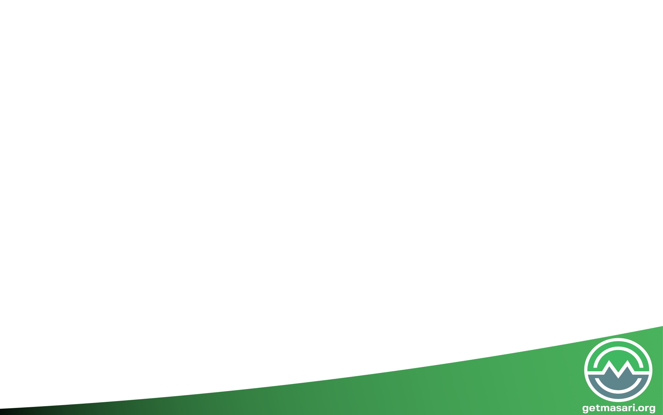When you have chosen your password, the wallet will then attempt to connect to the blockchain. It may take a while for you to synchronize with the network with this selection and your phone may slow, however, this is normal and you have no need to worry. Faster phones will generally not slow much.

Using Mobile Masari

The mobile wallet is designed to give you the simplest experience using Masari. This being the case, sending and receiving Masari is a snap!

Synchronizing

The first thing you must do when using your wallet is wait for the daemon to synchronize to the network. You can see progress in the wallet as it will inform you of how many blocks you are behind. When you are synchronized, the daemon will inform you that you may now use Masari.

Sending Funds

To send funds, all you need to do is click the send tab on the left of the wallet and then enter the amount of Masari you wish to send in the “Amount” field. Lastly, enter in the payment address in the “Address Field” and then click “Send” to send your funds to your recipient. You can even use the camera feature to scan other people’s QR addresses.

*Note: in some cases you may be required to enter in a payment ID to send your funds successfully. This feature is mostly relegated to exchanges such as Cryptopia. If you do not include the payment address that they provide you, you will lose your funds!*

Receiving Funds

To receive funds, simply click on the “Receive” tab on the left. When you do this, you will see an address that starts with a “5.” You can click the clipboard on the right of the address to automatically copy the address to your computer’s clipboard. The QR code on this screen is a visual representation of your address, copy this QR to signs and cards to receive funds in your physical store.

Donating to Masari

Consider donating some spare Masari to the developer of the mobile wallet, Gnock. You can easily do this by copying the address in the “Donate Masari” tab and sending it to him using the steps in “Sending Funds.”

This concludes the Masari wallet activity. Enjoy having Masari readily available on your desktop. If you ever have any questions, look for help at the communities below. Somebody will always be available to help you.

Online Communities

[BitcoinTalk](https://bitcointalk.org/index.php?topic=2159114)

[r/masari](https://www.reddit.com/r/masari/)

[Twitter @masaricurrency](https://twitter.com/masaricurrency?lang=en)

[Discord](https://discord.gg/sMCwMqs)

[Telegram](https://t.me/masaricurrency)

[Forum](https://forum.getmasari.org/)

