**Step by Step add debugger in Visual Studio Code**

* Open your Angular project in Visual Studio Code.  
    
  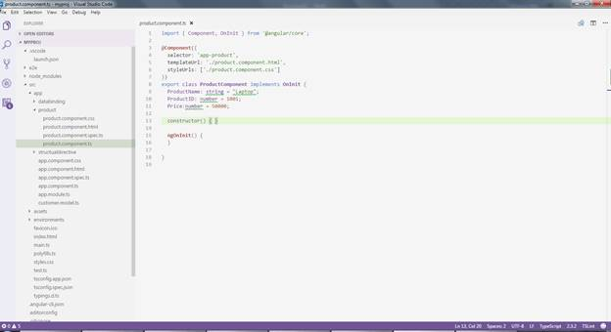
* Install Extension, as shown below.  
    
  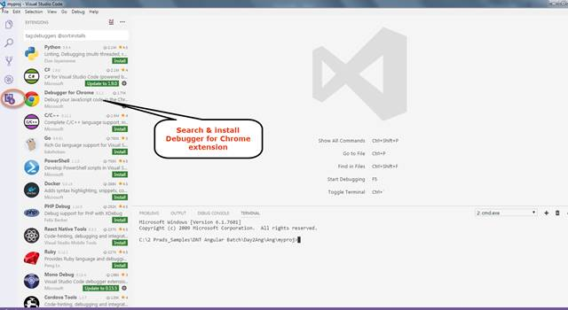
* Click Debug icon & Add Configuration, as shown below.  
    
  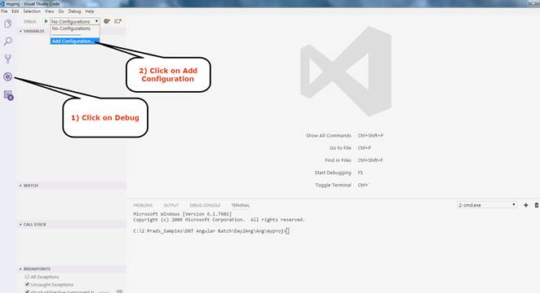
* Select Chrome and add the configuration given below in launch.json file (This file gets created in .vscode folder).  
  1. {
  2. "version": "0.2.0",
  3. "configurations": [{
  4. "name": "Launch Chrome against localhost",
  5. "type": "chrome",
  6. "request": "launch",
  7. "url": "http://localhost:4200",
  8. "sourceMaps": **true**,
  9. "webRoot": "${workspaceRoot}",
  10. "sourceMapPathOverrides": {
  11. "webpack:///./*": "${workspaceRoot}/*"
  12. }
  13. }]
  14. }

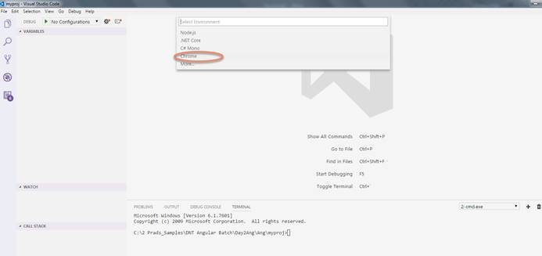

* Open command terminal. As I am using Angular CLI to run my Angular project. I am using   
    
  *> ng serve*  
  command to build and run my application. By default, it runs on port 4200 (Same port is mentioned in my launch.json file).  
    
  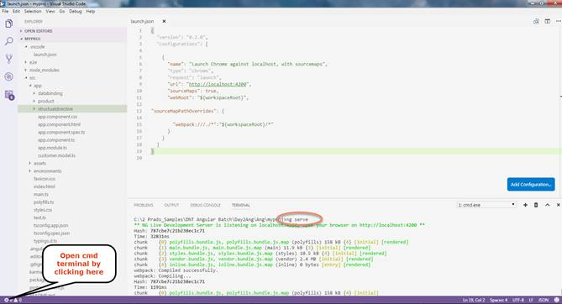

Now, your development Server is running. Now, you can press F5 or play icon in the debug tab. Keep the break point and it will hit the .ts file.

