1. Install java 8
2. Install Eclipse Neon3
3. Install BPMN 2 modeler

Go to Eclipse Market place

Search BPMN2 and select Eclipse BPMN2 and install

1. Go to Eclipse Install new software, Install JBPMN using following url

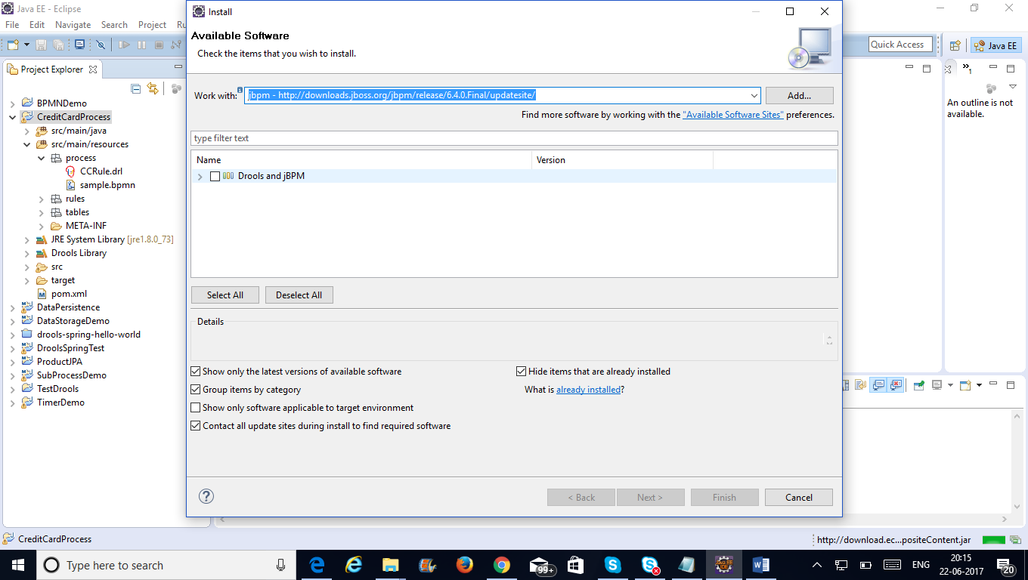

After installation go to installation details and ensure the following are available

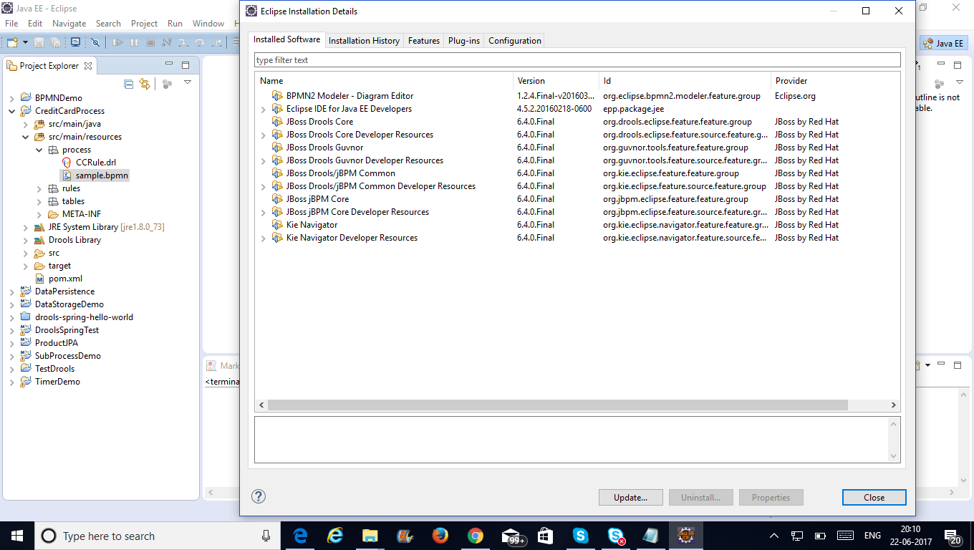

1. Go to File New Project, Choolse Drools Project from Other

Select 2nd option to create sample project with process as option

After that go to project folder, select resources and open sample.bpmn file

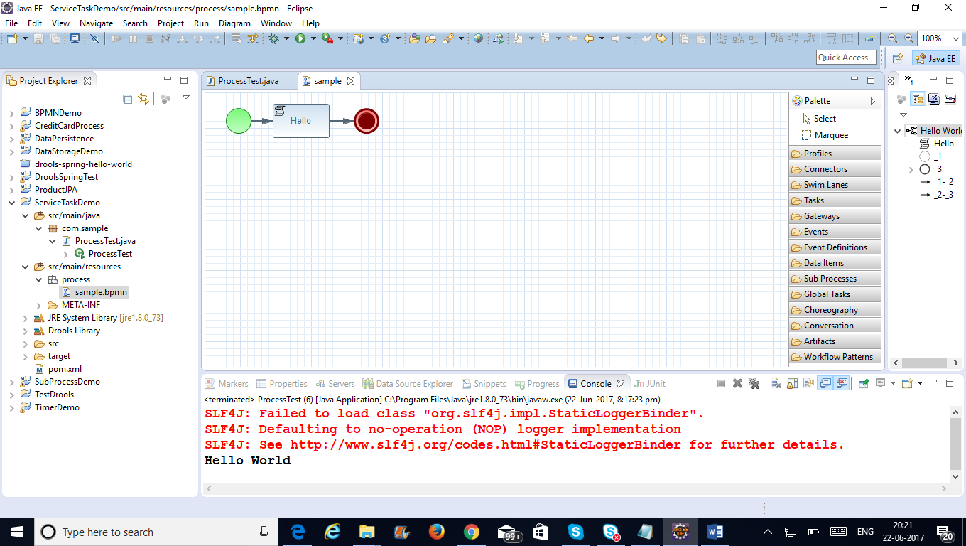

1. Close Eclipse
2. Download Apache MQ

apache-activemq-5.14.0

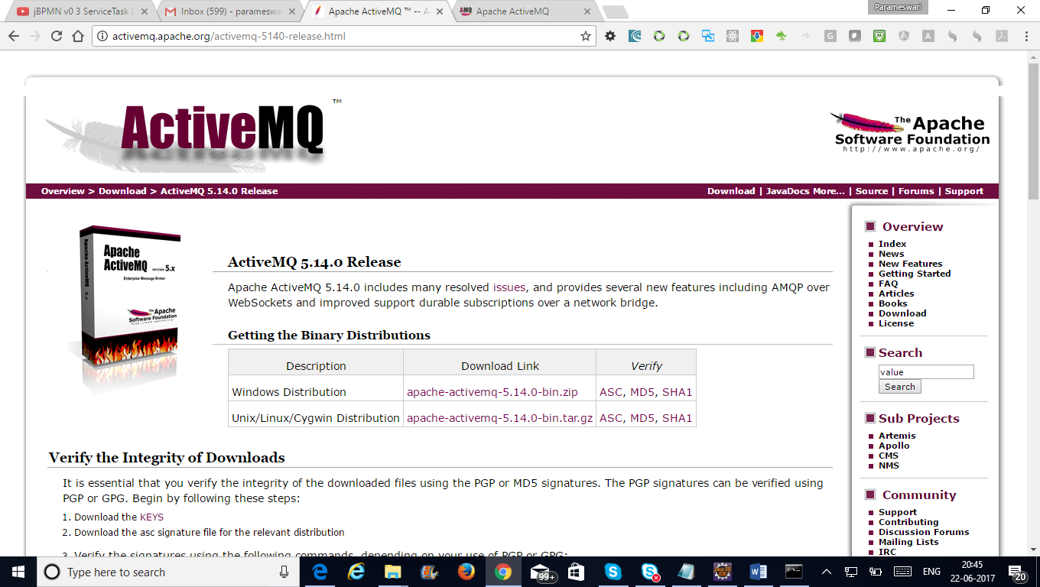

After downloading unzip apache mq

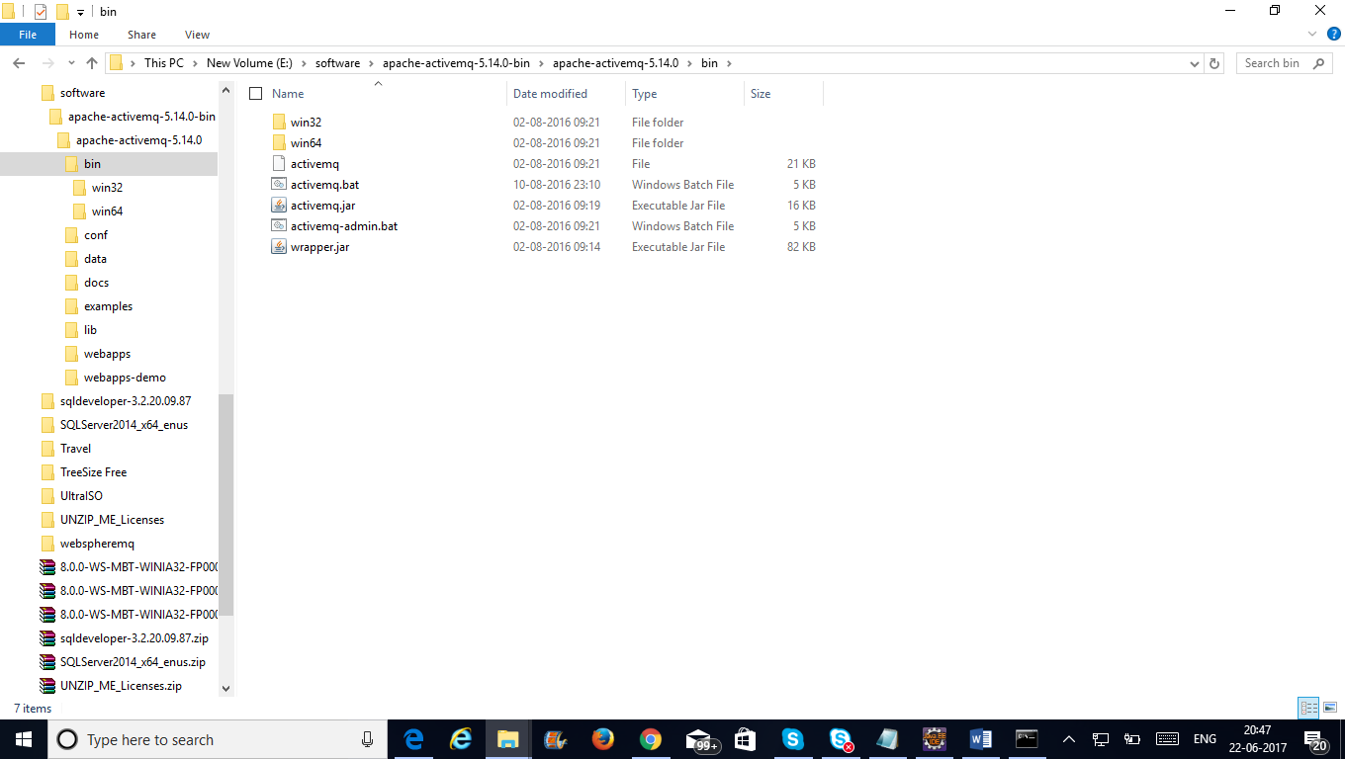

Go to cmd prompt

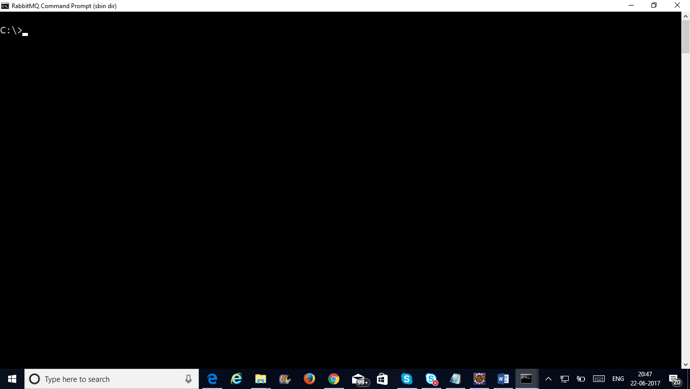

Cd to apachemq bin folder

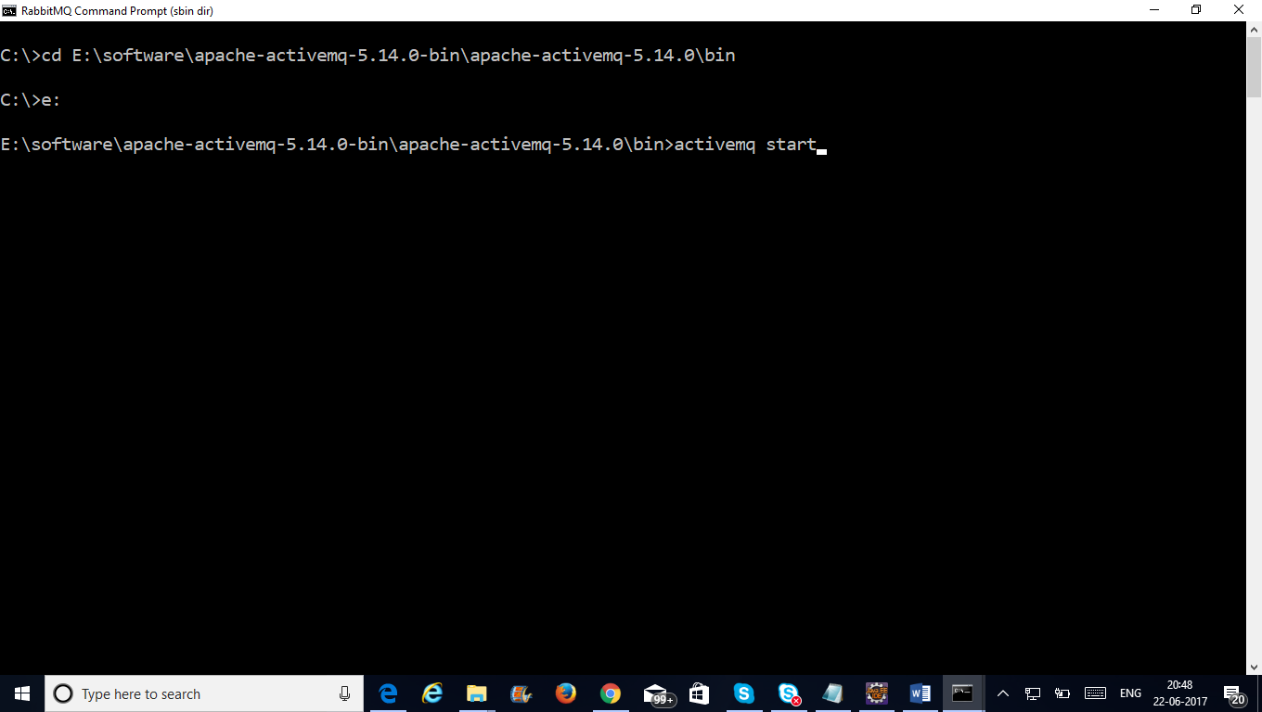

After starting

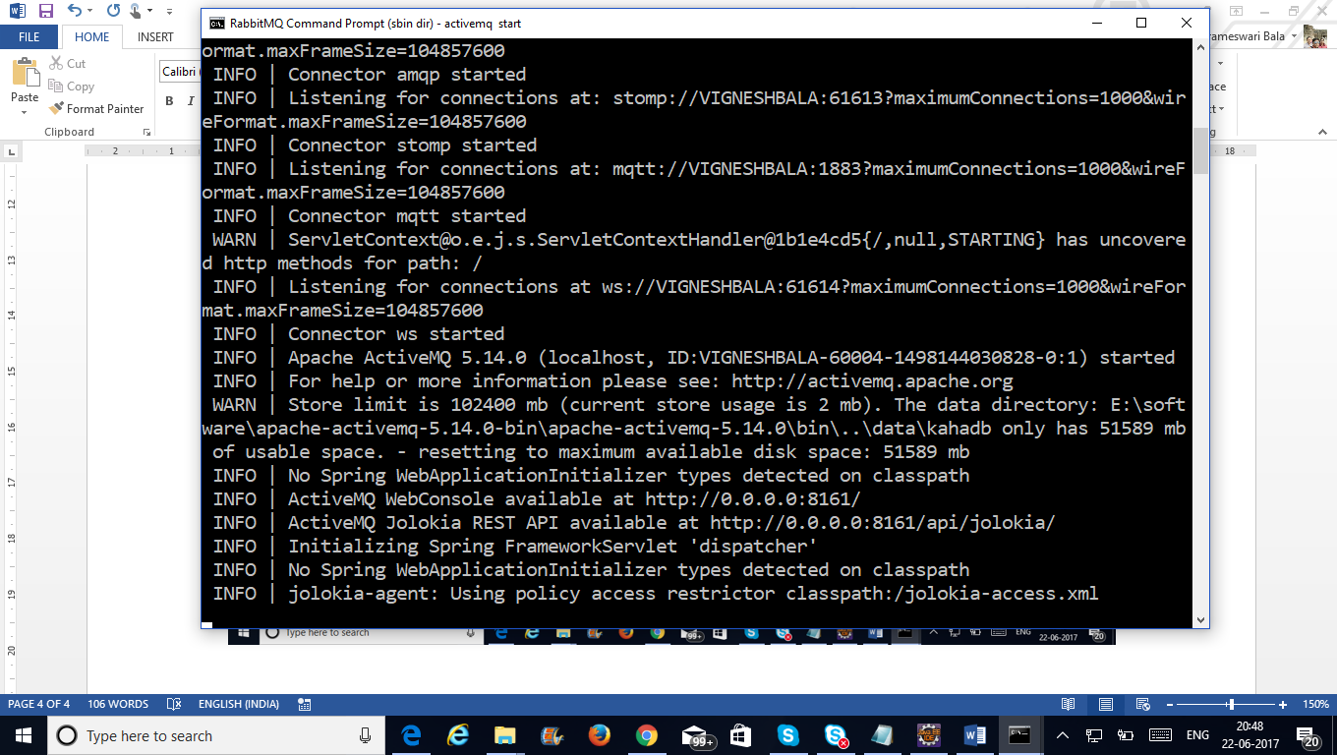

Goto chrome

Type url

<http://localhost:8161/>

