Creating Data Warehouse

Let us execute our T-SQL Script to create data warehouse with fact tables, dimensions and populate them with appropriate test values.

Download T-SQL script attached with this article for creation of Sales Data Warehouse or download from this article “[**Create First Data Warehouse**](http://www.codeproject.com/Articles/652108/Create-First-Data-WareHouse)” and run it in your SQL Server.

Follow the given steps to run the query in **SSMS** (SQL Server Management Studio).

1. Open SQL Server Management Studio 2008
2. Connect Database Engine
3. Open **New Query** editor
4. Copy paste Scripts given below in various steps in new query editor window one by one
5. To run the given SQL Script, press **F5**
6. It will create and populate “Sales_DW” database on your SQL Server

Developing an OLAP Cube

For creation of OLAP Cube in Microsoft BIDS Environment, follow the 10 easy steps given below.

**Step 1: Start BIDS Environment**

Click on **Start Menu** -> Microsoft **SQL Server 2008 R2** -> Click **SQL Server Business Intelligence Development Studio.**

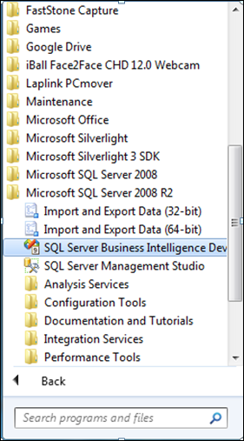

**Step 2: Start Analysis Services Project**

Click **File** -> **New** -> **Project** ->**Business Intelligence Projects** ->select **Analysis Services Project**-> Assign Project **Name** -> Click **OK**

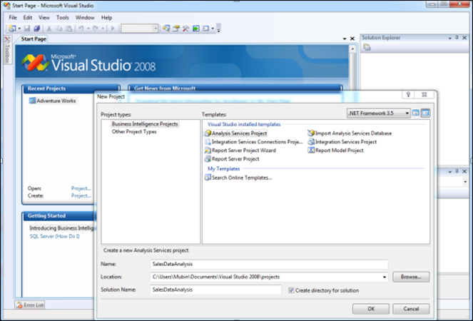

**Step 3: Creating New Data Source**

3.1 In Solution Explorer, Right click on **Data Source** -> Click **New Data Source**

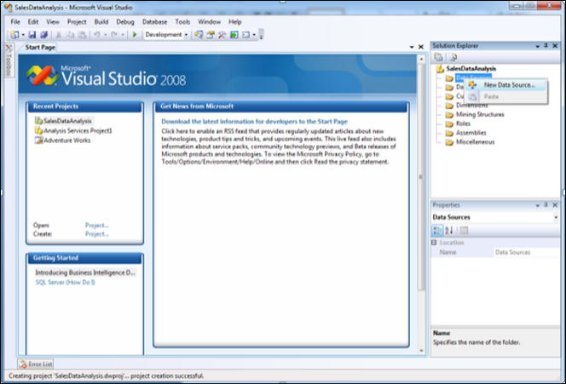

3.2 Click on **Next**

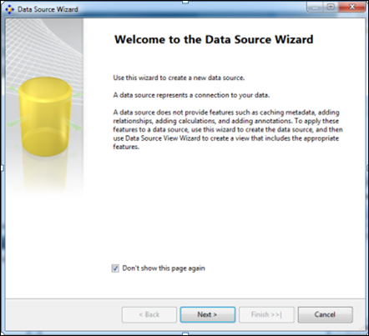

3.3 Click on New **Button**

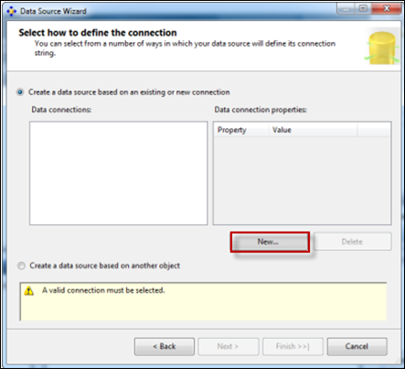

3.4 Creating **New connection**

1. Specify Your SQL **Server Name** where your Data Warehouse was created
2. Select Radio Button according to your **SQL Server Authentication** mode
3. Specify your **Credentials** using which you can connect to your SQL Server
4. Select database Sales_DW.
5. Click on **Test Connection** and verify for its success
6. Click **OK**.

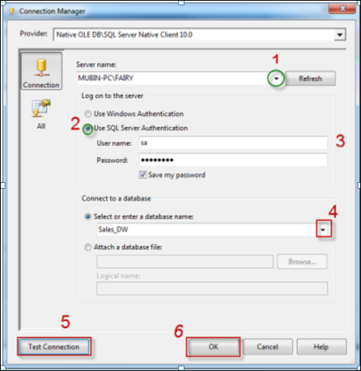

3.5 Select Connection created in **Data Connections**-> Click **Next**

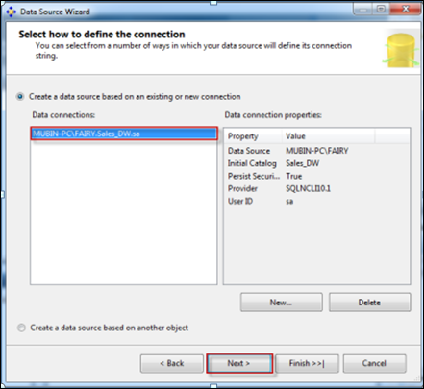

3.6 Select Option **Inherit**

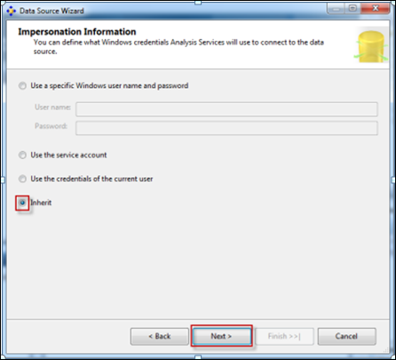

3.7 Assign Data Source **Name** -> Click **Finish**

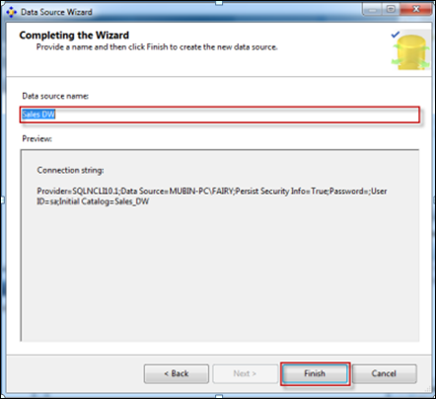

**Step 4: Creating New Data Source View**

4.1 In the Solution Explorer, Right Click on **Data Source View** -> Click on **New Data Source View**

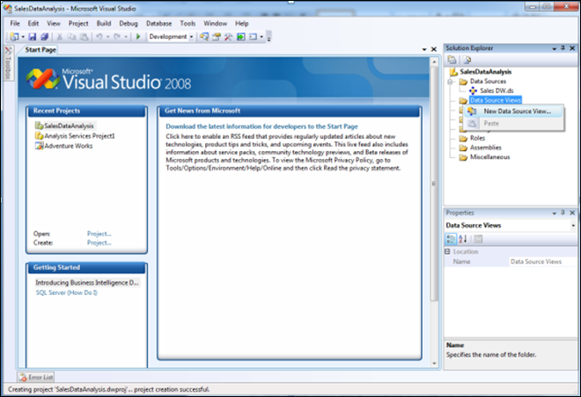

4.2 Click **Next**

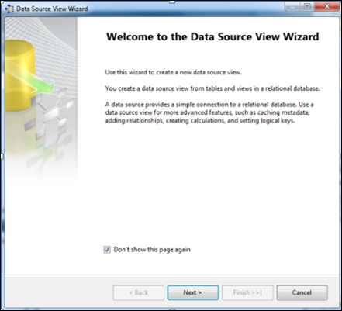

4.3 Select**Relational Data Source**we have created previously (Sales_DW)-> Click **Next**

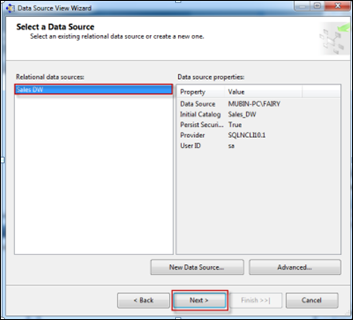

4.4 First move your **Fact Table** to the right side to include in object list.

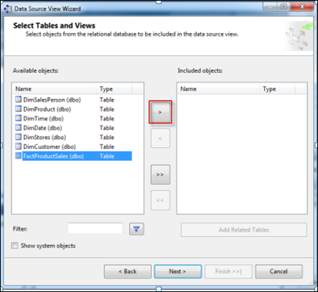

SelectFactProductSales Table -> Click on Arrow Button to move the selected object to Right Pane.

4.5 Now to **add dimensions** which are **related** to your **Fact Table**, follow the given steps:

Select **Fact Table** in Right Pane (Fact product Sales) -> Click On**Add Related Tables**

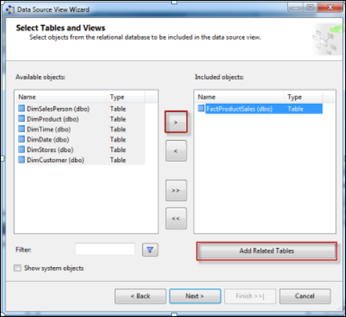

4.6 It will add all associated dimensions to your Fact table as per relationship specified in your SQL DW (Sales_DW).

Click **Next**.

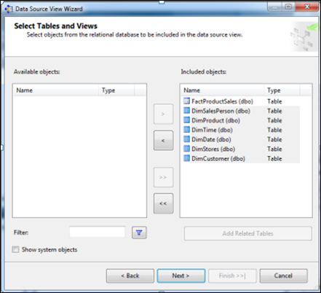

4.7 Assign**Name (SalesDW DSV)->**Click**Finish**

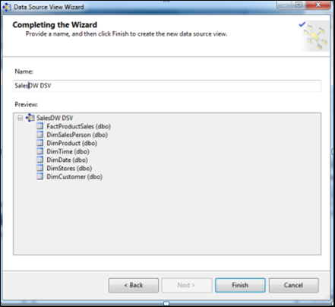

4.8 **Now Data Source View is ready to use.**

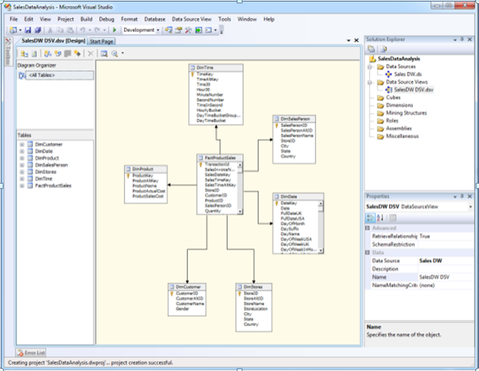

**Step 5: Creating New Cube**

5.1 In Solution Explorer -> Right Click on **Cube->**Click**New Cube**

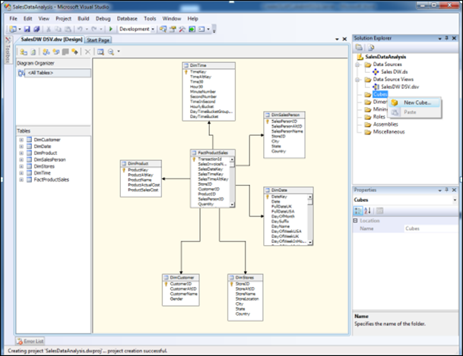

5.2 Click**Next**

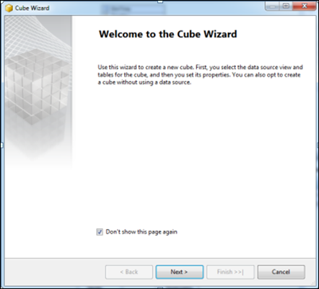

5.3 Select Option**Use existing Tables ->**Click**Next**

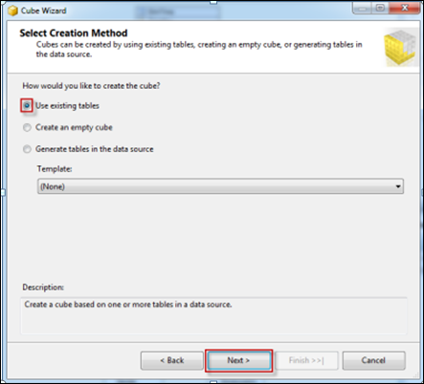

5.4 Select Fact Table Name from**Measure Group Tables (FactProductSales) ->**Click**Next**

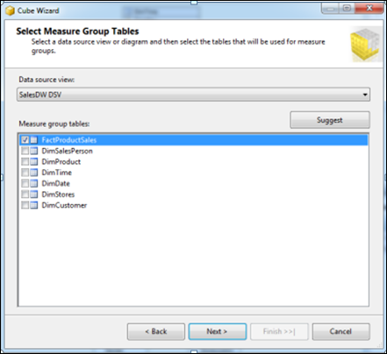

5.5 Choose**Measures**from the List which you want to place in your Cube --> Click **Next**

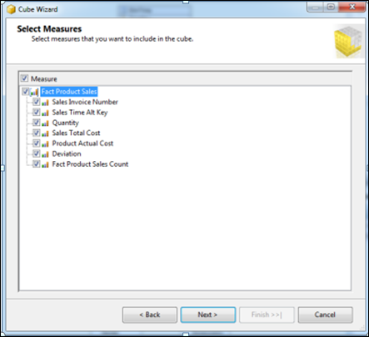

5.6 Select All **Dimensions** here which are associated with your Fact Table-> Click **Next**

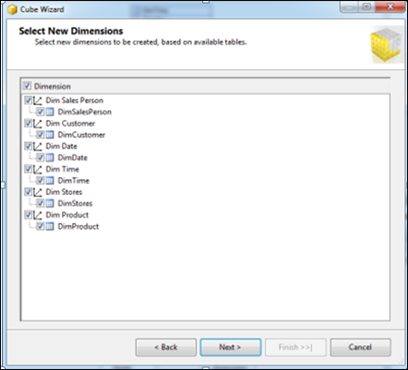

5.7 Assign **Cube Name** (SalesAnalyticalCube) -> Click **Finish**

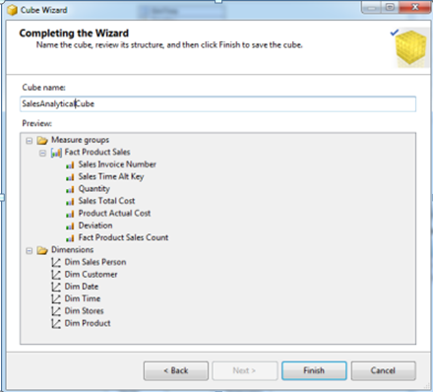

5.8 Now your Cube is ready, you can see the newly created cube and dimensions added in your solution explorer.

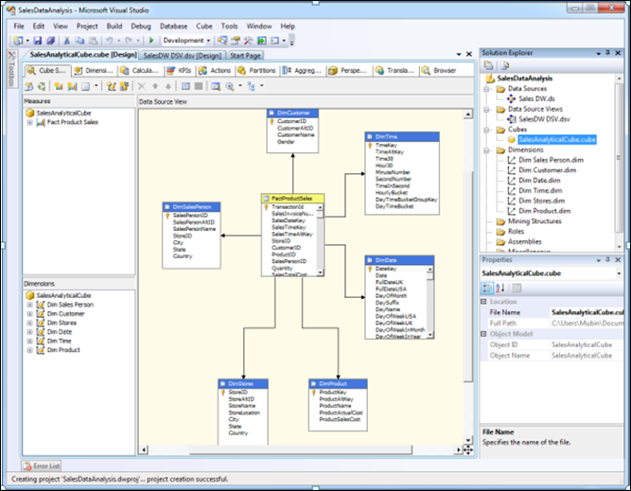

**Step 6: Dimension Modification**

In Solution Explorer, double click on dimension **Dim Product ->**Drag and Drop Product Name from Table in Data Source View and Add in Attribute Pane at left side.

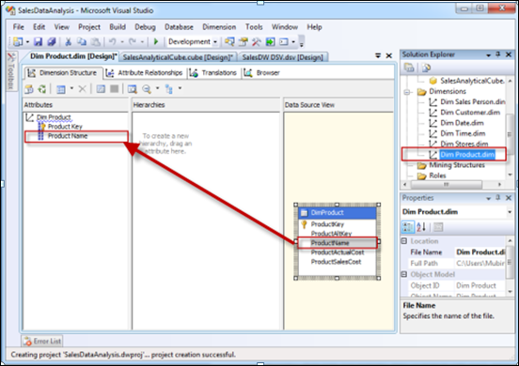

**Step 7: Creating Attribute Hierarchy In Date Dimension**

Double click On **Dim Date** dimension -> Drag and Drop Fields from Table shown in Data Source View to Attributes-> Drag and Drop attributes from leftmost pane of attributes to middle pane of Hierarchy.

Drag fields in sequence from Attributes to Hierarchy window (Year, Quarter Name, Month Name, Week of the Month, Full Date UK),

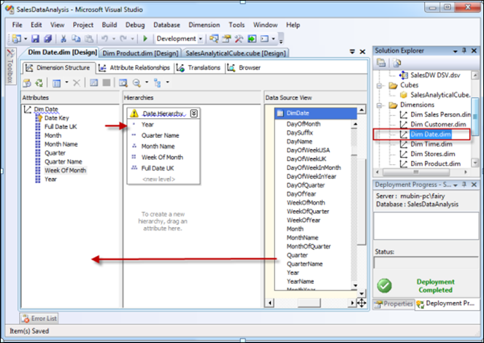

**Step 8: Deploy the Cube**

8.1 In Solution Explorer, right click on Project Name (SalesDataAnalysis) -- > Click **Properties**

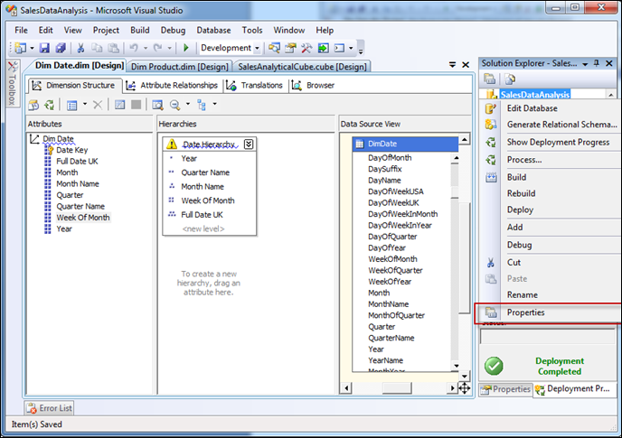

8.2 Set **Deployment Properties** First

In Configuration Properties, Select Deployment-> Assign Your SQL Server Instance Name Where Analysis Services Is Installed (*mubin-pc\fairy*) (*Machine Name\Instance Name*) -> Choose Deployment Mode **Deploy All**as of now ->Select Processing Option **Do Not Process**-> Click **OK**

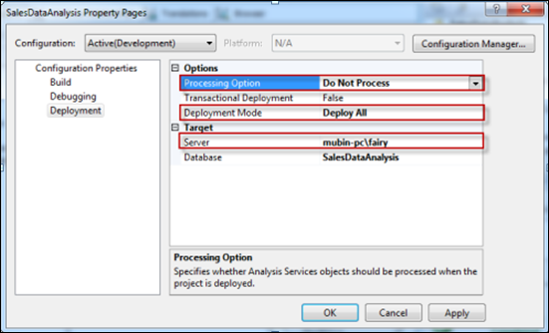

8.3 In Solution Explorer, right click on **Project Name** (SalesDataAnalysis) -- > Click **Deploy**

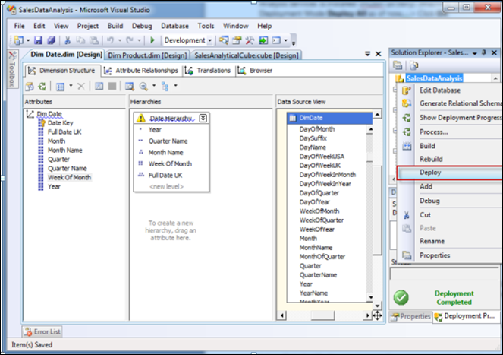

8.4 Once Deployment will finish, you can see the message**Deployment Completed**in deployment Properties.

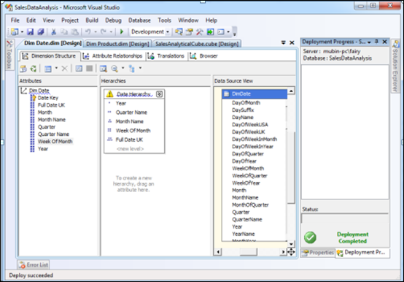

**Step 9: Process the Cube**

9.1 In Solution Explorer, right click on Project Name (SalesDataAnalysis) -- > Click **Process**

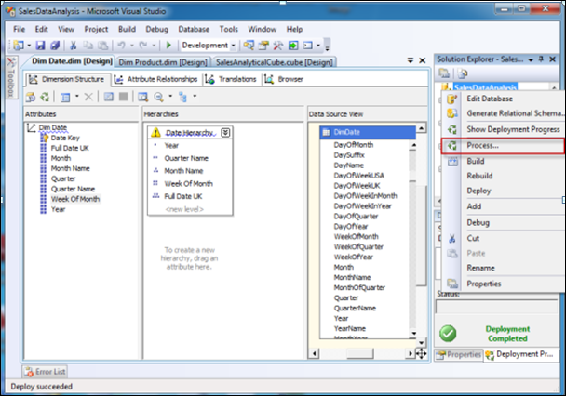

9.2 Click on **Run** button to process the Cube

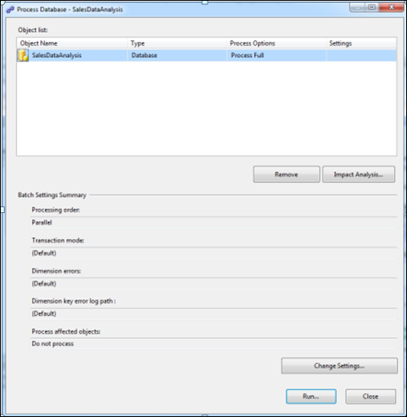

9.3 Once processing is complete, you can see **Status** as **Process Succeeded**-->Click **Close**to close both the open windows for processing one after the other.

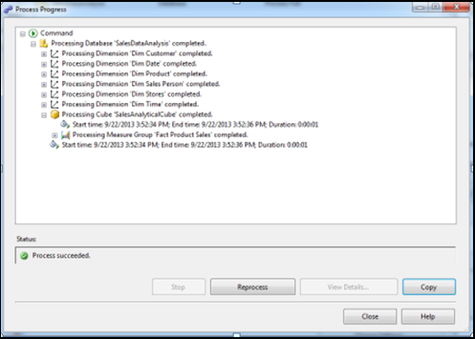

**Step 10: Browse the Cube for Analysis**

10.1 In Solution Explorer, right click on Cube Name (SalesDataAnalysisCube) -- > Click **Browse**

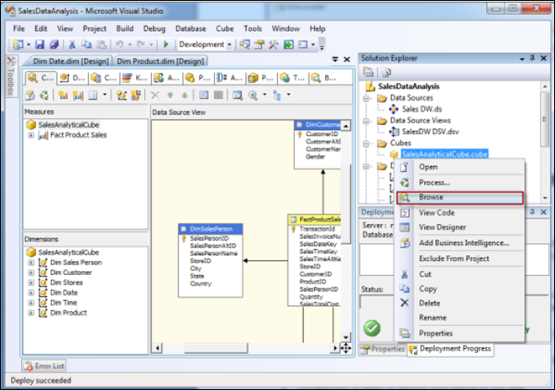

10.2 Drag and drop measures in to Detail fields, & Drag and Drop Dimension Attributes in Row Field or Column fields.

Now to **Browse Our Cube**

1. Product Name Drag & Drop into Column
2. Full Date UK Drag & Drop into Row Field
3. FactProductSalesCount Drop this measure in Detail area

