In the .docx template, you can insert process variables using the following syntax:

<<[myVariable]>>

Since the above method does not perform null checks, an exception will be thrown at runtime if the variable is null. Therefore, use the following method to prevent such errors:

<<[variables.get("myVariable")]>>

If this variable is null, a default value will be inserted instead. You can also provide a default value:

<<[variables.get("myVariable", "myDefaultValue")]>>

**Note: Form field types such as Dropdown, Radio button, and Typeahead use *myVariable_ID*for ID and *myVariable_LABEL* for label value. The ID is the actual value used by service tasks and are inserted by default. To display the label value in the generated document, use *myVariable_LABEL*.**

The document generation method uses the Aspose library in the backend. For more information about the template syntax and options, see [Aspose documentation](http://www.aspose.com/docs/display/wordsnet/Template+Syntax+%28zArchived%29).

When using the **Generate Document** task, make sure to use the correct syntax for your variables and expressions. Surround your variables with <<[..]>> characters. For example:

*<<[variableid]>>*

*<<[variables.get("variableid")]>>*

*<<[variables.get("variableid","adefaultifnull")*

Some more examples:

* If/else conditional blocks (see [Aspose Documentation > Using Conditional Blocks](http://www.aspose.com/docs/display/wordsnet/Using+Conditional+Blocks)):
  + Text type: *<<if [textfield==day]>> AM, <<else>> PM <</if>>*
  + Amount type: *<<if [annualsalary > $40000]>>, it is generous, <<else>> a standard starting salary <</if>>*
  + Checkbox: *<<if [senstitiveflag=="true"]>>it is Confidential, <<else>> Not Confidential <</if>>*
* Date type: *<<[datefield]>>*
  + Format date type: *<<[datefield]>>:"yyyy.MM.dd">>*
* Number/amount: *<<[amountfield]>>*
* String Boolean: *<<[Genericcheckbox]>>*
* Radio button / Typehead / dropdown: Select *<<[Options_LABEL]>>* with an ID *<<[Options_ID]>>*

The audit log is also generated the same way. For example, the following snippet from the template shows advanced constructs:

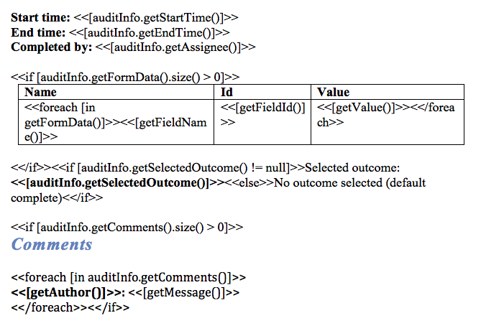

It is also possible to have custom Spring bean that processes the process variables just before rendering the document