Bayes theorem provides a way of calculating posterior probability P(c|x) from P(c), P(x) and P(x|c). Look at the equation below:

[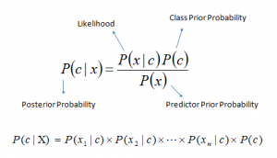](https://www.analyticsvidhya.com/wp-content/uploads/2015/09/Bayes_rule-300x172.png)Above,

* *P*(*c|x*) is the posterior probability of *class* (c, *target*) given *predictor* (x, *attributes*).
* *P*(*c*) is the prior probability of *class*.
* *P*(*x|c*) is the likelihood which is the probability of *predictor* given *class*.
* *P*(*x*) is the prior probability of *predictor*.

How Naive Bayes algorithm works?

Step 1: Convert the data set into a frequency table

Step 2: Create Likelihood table by finding the probabilities like Overcast probability = 0.29 and probability of playing is 0.64.

[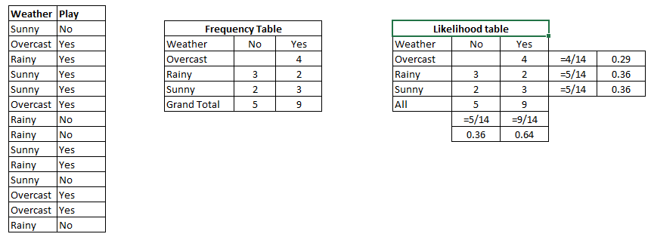](https://www.analyticsvidhya.com/wp-content/uploads/2015/08/Bayes_41.png)

Step 3: Now, use Naive Bayesian equation to calculate the posterior probability for each class. The class with the highest posterior probability is the outcome of prediction.

**Problem:**Players will play if weather is sunny. Is this statement is correct?

We can solve it using above discussed method of posterior probability.

P(Yes | Sunny) = P( Sunny | Yes) * P(Yes) / P (Sunny)

Here we have P (Sunny |Yes) = 3/9 = 0.33, P(Sunny) = 5/14 = 0.36, P( Yes)= 9/14 = 0.64

Now, P (Yes | Sunny) = 0.33 * 0.64 / 0.36 = 0.60, which has higher probability.

## Applications of Naive Bayes Algorithms

* **Real time Prediction:**Naive Bayes is an eager learning classifier and it is sure fast. Thus, it could be used for making predictions in real time.
* **Multi class Prediction:**This algorithm is also well known for multi class prediction feature. Here we can predict the probability of multiple classes of target variable.
* **Text classification/ Spam Filtering/ Sentiment Analysis:** Naive Bayes classifiers mostly used in text classification (due to better result in multi class problems and independence rule) have higher success rate as compared to other algorithms. As a result, it is widely used in Spam filtering (identify spam e-mail) and Sentiment Analysis (in social media analysis, to identify positive and negative customer sentiments)
* **Recommendation System:**Naive Bayes Classifier and [Collaborative Filtering](https://en.wikipedia.org/wiki/Collaborative_filtering) together builds a Recommendation System that uses machine learning and data mining techniques to filter unseen information and predict whether a user would like a given resource or not

## How to build a basic model using Naive Bayes in Python?

* [**Gaussian:**](http://scikit-learn.org/stable/modules/naive_bayes.html)It is used in classification and it assumes that features follow a normal distribution.
* [**Multinomial**](http://scikit-learn.org/stable/modules/naive_bayes.html)**:**It is used for discrete counts. For example, let’s say,  we have a text classification problem. Here we can consider bernoulli trials which is one step further and instead of “word occurring in the document”, we have “count how often word occurs in the document”, you can think of it as “number of times outcome number x_i is observed over the n trials”.
* [**Bernoulli**](http://scikit-learn.org/stable/modules/naive_bayes.html)**:**The binomial model is useful if your feature vectors are binary (i.e. zeros and ones). One application would be text classification with ‘bag of words’ model where the 1s & 0s are “word occurs in the document” and “word does not occur in the document” respectively.