Coordinated Leadership Transfer
Engineering Design
Issue: product-hub#3630
Audience: Distributed Systems team
Status: Draft — open questions noted inline

Problem Statement
Camunda 8 clusters elect a leader per partition using Raft. Each partition has a designated primary member — the node with the highest configured election priority. After events like broker restarts or network partitions, leadership may settle on a non-primary member. This is correct from Raft's perspective but suboptimal for performance: partition leadership is distributed round-robin across brokers by default, giving each broker an equal share of the processing work. When leadership drifts from that intended layout, work becomes unevenly distributed across the cluster. In the future, priority assignment may also encode rack awareness, making reliable rebalancing even more important.
The existing /actuator/rebalance endpoint attempts to correct this by sending a stepDownIfNotPrimary() request to each node simultaneously. It is fire-and-forget: returns 200 immediately, applies no coordination, provides no feedback, and cannot guarantee the desired leader is elected. Operators have no reliable recovery path short of manual intervention.
This design replaces the fire-and-forget implementation with a coordinated leadership transfer protocol that guarantees transfer when all conditions are met (target is online, replication lag is within the configured threshold, and catch-up completes before the fallback timer expires). When conditions are not met, the partition is skipped or the transfer falls back to the existing leader. The protocol processes one partition at a time to limit blast radius, and provides full observability into each decision and its outcome.

Prior Work
Diego Ongaro's dissertation "Consensus: Bridging Theory and Practice" (2014), §3.10 "Leadership transfer extension", defines a TimeoutNow RPC that causes a follower to immediately start an election, bypassing its election timeout. The leader sends TimeoutNow to the intended successor after verifying the follower's log is up-to-date, then stops accepting new client requests. We adopt this mechanism directly, adding pre-checks and coordination on top for operational safety.

Solution Overview
The feature is gated by a feature flag (camunda.cluster.rebalance.enabled, default false) at the existing /actuator/rebalance endpoint. When disabled, the existing fire-and-forget behaviour runs unchanged. When enabled, the new coordinated protocol runs.
The feature spans four layers: the Management API (RebalancingEndpoint, proxies to coordinator if not on the coordinator node), the Coordinator (RebalanceCoordinator in zeebe/broker, in-memory state machine), the Partition layer (PartitionLeadershipTransfer in zeebe/broker, pre-checks and transfer state machine), and the Raft layer (LeaderRole extensions in zeebe/atomix/cluster).
Routing uses the same mechanism as backup scheduling and dynamic-config (lowest broker ID as coordinator). The coordinator node is determined by the RebalancingEndpoint before forwarding.
Note: Ongoing work in the Physical Tenant epic may result in this endpoint being surfaced on the main REST API as well. We do not anticipate significant friction from that transition given the management API context.

Happy path overview
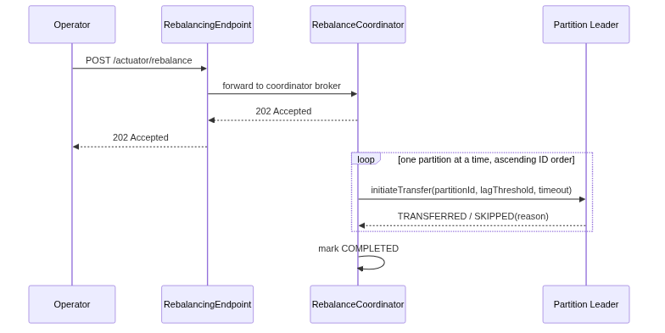

Monitoring a rebalance
Trigger rebalance with a POST, then poll GET to watch progress partition by partition until the operation completes.
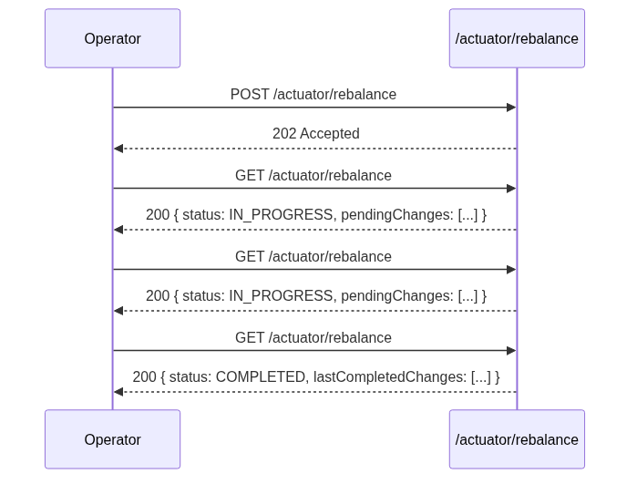

Cancelling a rebalance in progress
Send DELETE at any point to stop after the current partition finishes. Partitions already transferred remain under the new leadership.
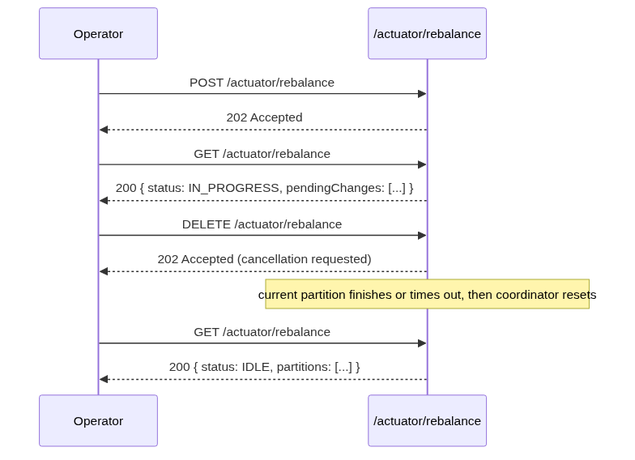

Transfer Protocol
A POST /actuator/rebalance returns 202 immediately. The coordinator then processes each partition in sequence: run pre-checks, skip if any fail, otherwise execute the transfer and wait for the outcome before moving to the next partition.
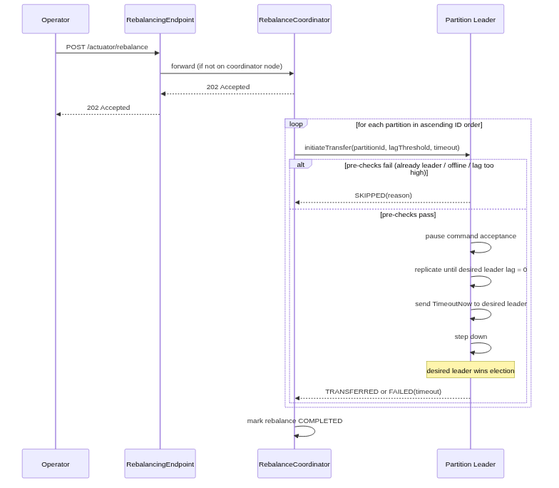

Pre-checks — skip partition if:
- Already leader: desired member is already the current leader → SKIPPED: ALREADY_LEADER
- Offline: desired member is not present in the current cluster topology → SKIPPED: DESIRED_LEADER_OFFLINE
- Lag exceeds threshold: desired member's replication lag in bytes > camunda.cluster.rebalance.replicationLagThreshold → SKIPPED: LAG_EXCEEDS_THRESHOLD

Transfer sequence — if pre-checks pass:
- Pause command acceptance on current leader (see details below)
- Monitor replication lag for the desired member until lag = 0 bytes
- Send TimeoutNow to the desired member → it immediately starts a voting round (one full RequestVote round for correctness; target wins: full log + highest priority)
- Step down — current leader relinquishes leadership
- Coordinator observes topology until partition's leader matches desired member → TRANSFERRED

Fallback — if catch-up stalls:
If the desired member has not reached lag = 0 within camunda.cluster.rebalance.partitionTimeout, abort: current leader resumes accepting commands, partition marked FAILED: TIMEOUT, coordinator moves to next partition. The fallback timer is local to the partition leader — coordinator crashes cannot leave a partition stuck in a paused state.

Rationale for one voting round
The desired member having lag = 0 at the moment TimeoutNow is sent does not guarantee it still has the full log when votes are cast — the old leader may have written one additional entry during the grace period. The voting round lets members reject a stale candidate. The latency cost is one network round trip on an otherwise idle partition (command acceptance is paused), which is negligible.

Failure Modes

Coordinator unreachable or unresponsive
The RebalancingEndpoint distinguishes three forwarding failure modes:
Scenario | HTTP status
Coordinator broker down — connection refused | 503 Service Unavailable
Coordinator reachable but timed out — no response within deadline | 504 Gateway Timeout
Coordinator reachable but returned an unexpected error response | 502 Bad Gateway

Any rebalance already in progress is lost on coordinator restart. Partitions already transferred remain transferred — Raft durably elected their new leaders.
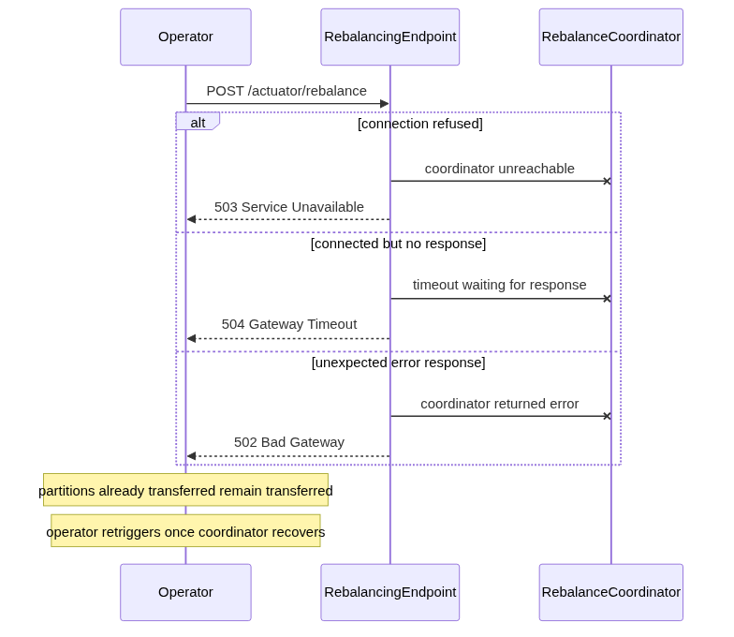

Current leader loses leadership mid-transfer
- Before pause: no state has been touched yet; the now-follower simply rejects initiateTransfer; the coordinator handles this via the topology change path (wait for new leader, retry, or FAILED: TOPOLOGY_CHANGE_TIMEOUT)
- During pause: the node detects it has lost leadership while paused and reports FAILED: LOST_LEADERSHIP_DURING_TRANSFER; the new leader resumes command acceptance naturally as part of its leader role startup — the cluster is never left stuck

Desired leader goes offline after pre-check passes
If the desired leader goes offline after the pre-check but during the catch-up window, the current leader detects this through normal Raft follower health monitoring (heartbeat timeouts). It aborts immediately, resumes command acceptance, and reports FAILED: DESIRED_LEADER_WENT_OFFLINE — minimising the unavailability window.

Desired leader crashes mid-transfer
Same mechanism applies: heartbeat monitoring detects follower loss, leader aborts, resumes commands, reports FAILED: DESIRED_LEADER_WENT_OFFLINE.
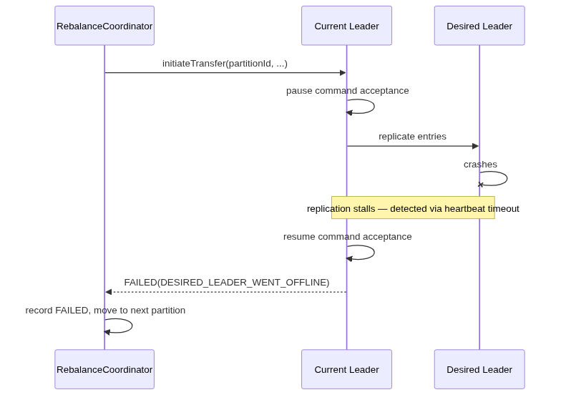

Resume fails after fallback
Leaving a partition stuck in paused state is the worst possible outcome. Three independent layers guarantee this cannot persist:
- Simplicity: resume is an in-memory flag clear + re-enable of the append pipeline — no I/O, no network calls. Minimal failure surface by design.
- Local step-down: any failure on the resume path must trigger a step-down. Step-down is a well-tested Raft path; the new leader elected afterwards will not be in a paused state.
- Follower watchdog: the leader signals to followers (e.g. via a flag in heartbeat/AppendEntries) that it is in "should resume" state. Followers start a timer; if the leader has not resumed within an election timeout, they force an election.

Fallback timer fires (catch-up too slow)
If the desired leader is alive but catching up too slowly, the fallback timer fires, commands resume, partition marked FAILED. The desired leader remains a follower and continues replicating normally after the fallback.
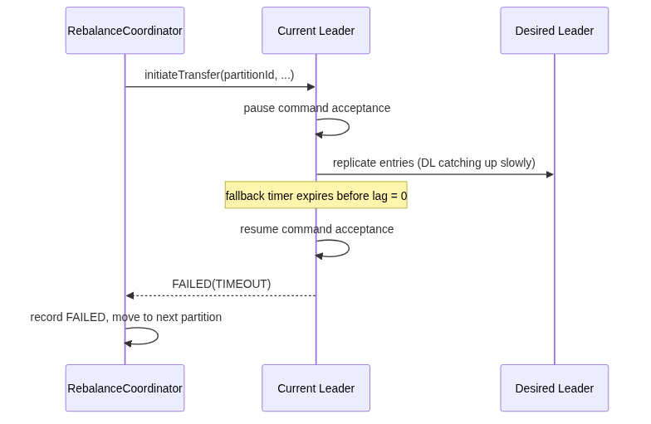

Replication lag counter drift
- Overestimate → partition skipped when it could have been transferred; operator retries when lag genuinely drops. Safe.
- Underestimate → transfer attempted with lag slightly above threshold; pause may last longer than expected; fallback timer is the safety net. Also acceptable.
The lag tracking implementation should bias toward overestimating when uncertain.

TimeoutNow lost in transit
If TimeoutNow is lost, the existing priority election timer (PriorityElectionTimer) ensures the target still wins the next election — just slightly slower. The coordinator observes no topology change within the transfer timeout, marks the partition FAILED, and the operator can retry.

Pausing Command Acceptance
Pausing is modelled as a partial step-down: the leader holds the term and continues replicating, but is functionally unavailable for new writes.
Mechanism:
- The entry currently mid-write completes (one-entry grace)
- All pending append operations fail via the existing append listener failure path (same path as normal leader elections — reuse, do not reinvent)
- ZeebePartition is notified to pause stream processing — the engine cannot write results anyway, so processing must stop
- ZeebePartition is tentatively not paused for exporting — exporting can continue but cannot acknowledge exported positions without writes; final decision during implementation
- Replication to all followers continues normally
On in-flight appends: an alternative would be to only stop accepting new writes and let already-queued appends drain naturally. However, since we stop processing, those queued appends would never receive a response and would time out silently — poor UX. We therefore choose to fail them immediately via the append listener path, mimicking a real leader change.
Throttling considered and rejected: finding a throttle level that allows catch-up while not fully stopping client availability is too imprecise; at e.g. 80% backpressure the user experience is indistinguishable from a full pause.

Replication Lag Tracking (Slice 1 — Independent)
Delivered as an independent slice. Until it ships, the pre-check threshold falls back to entry count as a proxy.
Hard constraint: zero I/O in the hot path.

Log lag — incremental tracking:
- On follower join or reset: calculate initial lag in bytes (some I/O acceptable, infrequent)
- On each append to a follower: lag += size(entry)
- On follower acknowledgment: lag -= size(acknowledged)
- On follower reset: recalculate from scratch

Shortcuts to minimise initial I/O:
- Whole segments: use segment descriptor size (no per-entry I/O)
- Sparse journal index: extend to track cumulative byte offsets between indexed positions — in-memory for most of the range; only the last leg needs any I/O
- Entry metadata (size field only): avoids full deserialization but still touches pages and may trigger mmap pre-fetching

Snapshot lag:
Snapshot metadata file (separate from snapshot ID) contains snapshot size. Read once and cached in-memory in SnapshotStore when a snapshot is committed. If a snapshot install is in progress, snapshot lag = total snapshot size minus bytes already sent.
Metric: zeebe.raft.replication.lag.bytes (GAUGE, labels: partitionId, followerId) — continuously updated, lives in Raft layer, useful beyond rebalancing.

TimeoutNow Raft Message (Slice 2)
New message type in Atomix Raft (does not exist today).
- LeaderRole: after lag = 0, sends TimeoutNow to the desired member
- FollowerRole: on receipt, immediately transitions to candidate state and sends RequestVote to all members, skipping election timeout
- Normal RequestVote processing applies — other members vote based on log completeness and term
This is a direct implementation of §3.10 of the Ongaro dissertation.

Per-Partition Transfer State Machine (Slice 3)
Lives in zeebe/broker, sitting between the coordinator and the Raft layer.
Internal API exposed to coordinator:
initiateTransfer(partitionId, lagThreshold, timeout) → TransferResult
TransferResult: TRANSFERRED | SKIPPED(reason) | FAILED(reason)

State machine:
IDLE → PRE_CHECKING → PAUSED → WAITING_FOR_CATCHUP → SIGNALLING → CONFIRMING
↘ SKIPPED ↘ FAILED(timeout)

The coordinator is logically sequential but asynchronously implemented: it sends the BrokerAdminRequest and registers a callback on the resulting CompletableFuture. When the future completes (transferred, skipped, failed, or timed out), the coordinator schedules the next partition. The coordinator actor is never blocked — it remains free to handle GET and DELETE requests while a transfer is in progress.

Coordinator & REST API (Slice 4)

Coordinator
One designated broker (lowest broker ID — existing cluster topology coordinator, same routing mechanism as backup scheduling/compaction and dynamic-config) owns the rebalance state machine. Any broker receiving a request proxies to it.
The coordinator is topology-aware and reacts to topology events (new leader elections, broker joins/leaves) during a rebalance.
Partition leader changes mid-request: If the current leader rejects initiateTransfer with "I'm not leader":
- Check if the topology already reflects a new leader → if so, retry immediately with the new leader; the transfer timeout starts fresh
- If topology not yet updated → wait for a topology event indicating a new leader, bounded by a separate topology stabilization timeout (distinct from the per-partition transfer timeout — not charged against it)
- If the stabilization timeout expires before a new leader is seen → mark partition FAILED with reason TOPOLOGY_CHANGE_TIMEOUT and move to the next partition
In-memory state:
status: IDLE | IN_PROGRESS | COMPLETED | CANCELLED
pendingChanges: { startedAt, operations: List<OperationResult> } | null
lastCompletedChanges: { startedAt, finishedAt, status, operations: List<OperationResult> } | null

On coordinator restart: state is lost. Already-transferred partitions remain transferred. Operator re-triggers to continue.
Concurrent POST behaviour: 202 vs 409 — open question, to be resolved during proposal review. Depends on whether dynamic partition priorities are imminent.

REST API
Method | Path | Description
POST | /actuator/rebalance | Start rebalance (or dry-run)
GET | /actuator/rebalance | Current status + per-partition balance
DELETE | /actuator/rebalance | Cancel after current partition completes

POST request body: { "dryRun": false }
GET response:
{
"status": "IDLE | IN_PROGRESS | COMPLETED | CANCELLED",
"partitions": [
{ "partitionId": 1, "currentLeader": "broker-1", "desiredLeader": "broker-1" },
{ "partitionId": 2, "currentLeader": "broker-0", "desiredLeader": "broker-1" }
],
"pendingChanges": {
"startedAt": "2026-05-06T14:30:00Z",
"operations": [
{ "partitionId": 1, ..., "status": "ALREADY_LEADER" },
{ "partitionId": 2, ..., "status": "IN_PROGRESS" },
{ "partitionId": 3, ..., "status": "PENDING" }
]
},
"lastCompletedChanges": {
"startedAt": "...", "finishedAt": "...", "status": "COMPLETED | CANCELLED",
"operations": [ ... ]
}
}

Operation statuses: PENDING · IN_PROGRESS · TRANSFERRED · ALREADY_LEADER · OFFLINE · LAG_TOO_HIGH · FAILED · CANCELLED
DELETE when no rebalance is in progress returns 404 with a descriptive body. No global timeout — DELETE is the only way to abort.
Error cases (operation could not start): the controller returns an appropriate HTTP error response with a descriptive message body. FAILED does not appear at the top level.

Configuration
camunda:
cluster:
rebalance:
enabled: false # feature flag; default off
replicationLagThreshold: <TBD> # max bytes lag; default low (conservative)
partitionTimeout: <TBD> # per-partition fallback timer; default low

Direction for defaults: low threshold + low timeout (conservative). Exact values require benchmarking. Designed for future expansion: auto-rebalancing triggers, scheduling config, etc. will fit naturally under camunda.cluster.rebalance.*.

Observability

Metrics
Metric | Type | Labels | Notes
zeebe.raft.replication.lag.bytes | GAUGE | partitionId, followerId | Continuous per-follower lag; Slice 1; general Raft health
zeebe.cluster.balance.ratio | GAUGE | — | Fraction of partitions led by desired leader; 1.0 = fully balanced
zeebe.cluster.rebalance.status | GAUGE | — | 0=idle 1=in_progress 2=completed 3=failed
zeebe.cluster.rebalance.partitions.pending | GAUGE | —
zeebe.cluster.rebalance.partitions.completed | GAUGE | —
zeebe.cluster.rebalance.elapsed | TIMER | — | End-to-end rebalance duration including coordination overhead
zeebe.cluster.rebalance.partition.duration | TIMER | partitionId, outcome | outcome: transferred/skipped/failed
zeebe.cluster.rebalance.partition.attempts | COUNTER | partitionId, outcome
zeebe.cluster.rebalance.partition.skip.reason | COUNTER | reason | already_leader / offline / lag_too_high
zeebe.cluster.rebalance.partition.paused | GAUGE | partitionId | 1 while command acceptance halted
zeebe.cluster.rebalance.partition.pause.duration | TIMER | partitionId | Availability impact per partition
zeebe.cluster.rebalance.fallback.triggered | COUNTER | partitionId | Fires when per-partition timeout expires
zeebe.raft.timeoutnow.sent | COUNTER | partitionId | Maybe — check if existing Raft request tracking covers it

Duration SLO buckets (consistent with dynamic-config): 100ms, 1s, 2s, 5s, 10s, 30s, 60s, 120s, 180s, 300s, 600s.

Structured logs
Level | Content
TRACE | Fine-grained per-event tracing: pre-check outcome, transfer initiated, pause confirmed, lag = 0 reached, TimeoutNow sent, new leader observed, fallback triggered, per-partition outcome
INFO | Rebalancing plan on start (partitions to process, desired leaders, configured thresholds)
INFO | Rebalancing outcome on completion (N transferred, M skipped, K failed — with reasons)

Fallback and transfer failure are expected operational outcomes monitored via metrics and the GET endpoint — they do not warrant WARN-level logging.

Dry-run mode
POST with {"dryRun": true} — coordinator queries all partition leaders in parallel, applies pre-check logic, returns planned operations without executing any transfer. The response mirrors what the first GET after a real POST would return, with a dryRun: true marker. No coordinator state is modified.
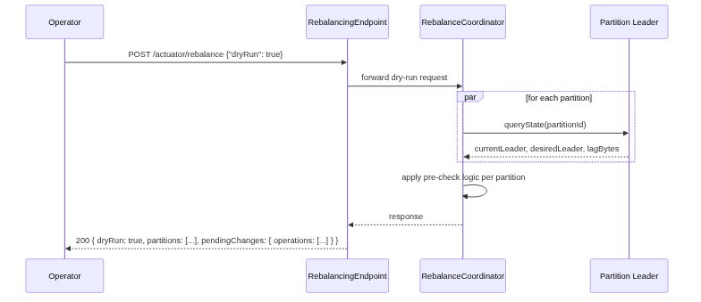

Delivery Slices
Slice | Scope | Dependency
1 — Replication lag tracking | zeebe.raft.replication.lag.bytes; incremental tracking in LeaderRole; snapshot size in SnapshotStore | None — independent
2 — TimeoutNow Raft message | New message type in Atomix; send in LeaderRole, handle in FollowerRole | None — can parallel with Slice 1
3 — Per-partition transfer protocol | Command pause/resume; transfer state machine; initiateTransfer API | Slices 1 & 2
4 — Coordinator + REST API | In-memory coordinator; request routing; POST/GET/DELETE; feature flag; config | Slice 3

Alternatives Considered

Parallel (stateless)
All partitions transferred simultaneously. No coordinator, no state, restart-safe. Rejected: violates the "one partition at a time" user story; worst case all partitions lose their leader simultaneously.

Dynamic-config integration
Sequencing and persistence via the existing dynamic-config module. Rejected:
- Semantic mismatch: dynamic-config is declarative config deltas; this is a live procedural protocol (pause, monitor real-time metric, send Raft signal)
- Blocks the entire dynamic-config queue for potentially 8+ minutes on a 50-partition cluster, preventing unrelated operations
- Partial-failure resume semantics are murky for transient partition pause state
- Coordinator unavailability is equally a problem in both approaches

Open Questions
Question | Status
POST while in-progress: 202 or 409? | Discuss at proposal review — depends on dynamic priority roadmap
Exact defaults for replicationLagThreshold and partitionTimeout | TBD — requires benchmarking
TimeoutNow sent metric: already covered by existing Raft request tracking? | Check during Slice 2 implementation
Exporting during pause: continue (tentative yes) or pause? | Final decision during Slice 3 implementation
Old leader notifies coordinator on new leader discovery | Stretch goal, v2
DELETE with no active rebalance: 404 vs 200 with IDLE body | Consider based on expected operator UX
On TOPOLOGY_CHANGE_TIMEOUT: move partition to end of queue vs mark as FAILED | Optimization, consider for v1 if low implementation cost
Topology stabilization timeout value | TBD — requires input from team on typical election duration
Prevent elections while transfer in progress | Open — revisit during Slice 2/3

