Coordinated Leadership Transfer
Overview
Issue: product-hub#3630
Audience: Application engineers (non-DS teams)
Status: Draft

Background
In a Camunda 8 cluster, each partition has a leader — the broker responsible for processing commands and replicating them to the other brokers (followers). The leader for a given partition is determined by Raft, our consensus algorithm.
By default, partition leadership is distributed round-robin across brokers, giving each broker an equal share of the processing work. Each broker is assigned a priority per partition that encodes this intended layout: the highest-priority broker is the preferred leader and will be elected first under normal conditions. In the future, priority assignment may also encode rack awareness, making reliable rebalancing even more important.

The Problem
After events like broker restarts, rolling upgrades, or network hiccups, leadership can end up on a non-preferred broker. Raft doesn't automatically move it back: the current leader is doing its job correctly, so there's no reason for it to step down. When this happens, work is no longer evenly distributed across the cluster.
Today, operators can call POST /actuator/rebalance on the management API to nudge the cluster back into its preferred layout. But this is a best-effort, fire-and-forget operation: it broadcasts "step down if you're not the preferred leader" to all brokers simultaneously with no coordination and no feedback. It can fail silently — for example, if the preferred broker's log is behind, it will lose the election and the cluster stays unbalanced. Operators are left with no reliable path to recovery and no visibility into what happened.

What This Feature Does
This feature replaces the fire-and-forget rebalance with a coordinated leadership transfer that:
- Checks whether the preferred broker is actually ready to become leader before attempting a transfer — and skips partitions where conditions are not met
- Guarantees transfer only when all conditions are met (preferred broker online, replication lag within threshold, catch-up completes before timeout); otherwise the partition is skipped or falls back to the existing leader
- Pauses new work on the current leader just long enough for the preferred broker to fully catch up, then triggers a fast handover
- Processes one partition at a time to limit the impact on cluster availability
- Falls back safely if something goes wrong — the cluster is never left in a stuck state
- Provides full visibility into what happened per partition — whether a transfer succeeded, was skipped, or failed, and why
The feature is accessed through the same /actuator/rebalance endpoint on the management API that operators already know, and is gated by a feature flag so existing deployments are unaffected until they opt in.

How It Works (High Level)
For each partition, in order:
- Is a transfer needed? If the preferred broker is already the leader, skip. If it's offline or too far behind, skip and move on — no disruption.
- Pause new work on the current leader. The broker stops accepting new commands but keeps replicating existing ones to the followers. From the application's perspective, this partition is briefly unavailable for writes.
- Wait for the preferred broker to catch up fully. Once its log matches the leader's exactly, it's safe to hand over.
- Trigger the handover. The current leader signals the preferred broker to start an election immediately. A quick voting round confirms the new leader.
- Done. The coordinator confirms the topology reflects the new leader and moves to the next partition.
If the preferred broker doesn't catch up within the configured timeout, the current leader resumes accepting commands and the partition is marked as failed — the cluster returns to normal, nothing is left in a broken state.

Impact on the Application

Brief per-partition unavailability
During the catch-up window (steps 2–4 above), the partition being transferred does not accept new commands. In practice this window should be short — the feature is designed to only attempt transfers when the preferred broker is already nearly caught up. The default configuration is conservative: it skips partitions where the catch-up would take too long.
Other partitions continue operating normally throughout. Only one partition is ever in transfer at a time.

Clients receive an immediate error signal
When a partition pauses for transfer, any in-flight commands receive an immediate failure response — the same signal clients get during a normal leader election. This is intentional: silently queuing those commands would leave clients waiting for a response that may never arrive if the transfer ultimately fails. Existing retry logic in clients and the gateway handles this transparently.

No changes to normal operation
When the feature flag is off (the default), nothing changes. Operators enable it explicitly when they want to rebalance their cluster.

Operator API

Monitoring a rebalance
Trigger with POST, then poll GET to watch progress partition by partition.
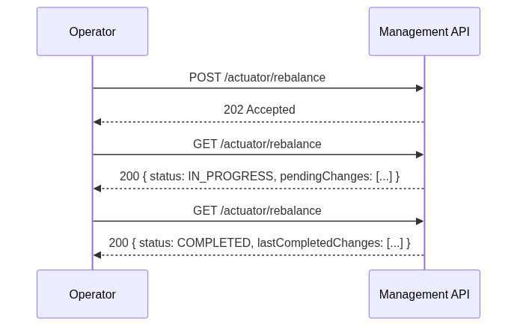

Cancelling a rebalance
DELETE stops the rebalance after the current partition finishes. The coordinator resets to its initial state — a subsequent GET returns IDLE with the current live partition view. Partitions already transferred remain under the new leadership.
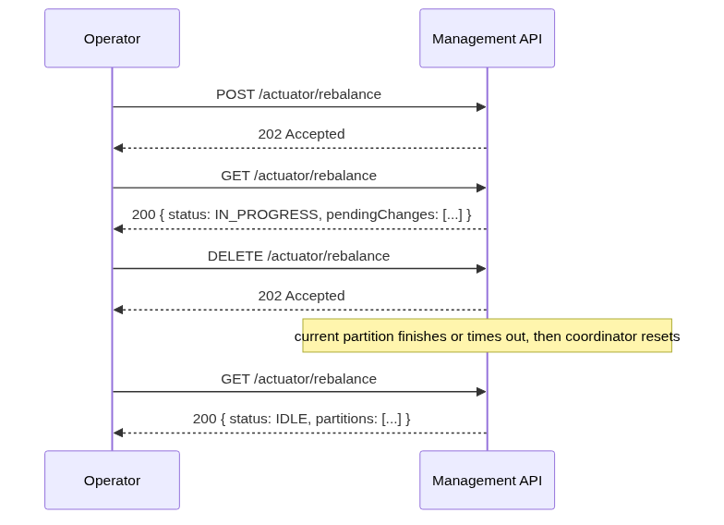

Observability

GET response
GET /actuator/rebalance always returns a live view of partition balance plus the state of any running or recently completed rebalance:
{
"status": "IDLE | IN_PROGRESS | COMPLETED | CANCELLED",
"partitions": [
{ "partitionId": 1, "currentLeader": "broker-1", "desiredLeader": "broker-1" },
{ "partitionId": 2, "currentLeader": "broker-0", "desiredLeader": "broker-1" }
],
"pendingChanges": {
"startedAt": "2026-05-06T14:30:00Z",
"operations": [
{ "partitionId": 1, "status": "ALREADY_LEADER" },
{ "partitionId": 2, "status": "IN_PROGRESS" },
{ "partitionId": 3, "status": "PENDING" }
]
},
"lastCompletedChanges": {
"startedAt": "...", "finishedAt": "...", "status": "COMPLETED | CANCELLED",
"operations": [ ... ]
}
}

pendingChanges is non-null only while a rebalance is running. lastCompletedChanges persists until the next rebalance starts, giving operators a record of the previous run.

Dry-run mode
POST /actuator/rebalance {"dryRun": true} returns what would happen without executing anything — which partitions would be transferred and which would be skipped and why. The response mirrors the first GET a real POST would produce, with a dryRun: true marker.

Key metrics
- zeebe.cluster.balance.ratio — fraction of partitions currently led by their preferred broker (1.0 = fully balanced). Alert on this dropping below 1.0 after a broker restart.
- zeebe.cluster.rebalance.partition.pause.duration — how long each partition was unavailable for writes during its transfer.
- zeebe.raft.replication.lag.bytes — replication lag per broker per partition, updated continuously. Useful for understanding cluster health independently of rebalancing.

Configuration
camunda:
cluster:
rebalance:
enabled: false # off by default; opt in explicitly
replicationLagThreshold: ? # how caught-up the preferred broker must be
partitionTimeout: ? # how long to wait for catch-up before giving up

Defaults are conservative (low threshold, short timeout): the feature prefers skipping over causing disruption. Operators can relax these values to accept longer transfer windows in exchange for more successful transfers.

Delivery Plan
The feature is split into four slices — slices 1 and 2 can run in parallel:
- Replication lag tracking — new metric tracking how far behind each follower is in bytes. Independent; ships first.
- Fast election signalling — a new internal Raft message that tells the preferred broker to start an election immediately.
- Per-partition transfer protocol — the full pause → catch-up → handover → fallback state machine, at the single-partition level.
- Coordinator + Management API — the orchestration layer and the public-facing endpoint, bringing everything together.

Open Question for Team Input
If a rebalance is already in progress and an operator calls POST again, should the endpoint return the current status (202) or reject the request (409 Conflict)?
- 202 is more ergonomic if partition priorities never change — every call wants the same outcome, so returning the current status is harmless.
- 409 is safer if priorities can change dynamically in future — a new rebalance request may want a different target layout than the one currently in progress.
This will be discussed at the proposal review.

