KC social launch plan
  - Launch brief and three draft posts | October 6 2026
Start with three organic image posts per week on a dedicated Facebook Page and Casey’s existing spare Instagram account. Use the assets already made, connect each post to the relevant Amazon products, and measure whether people click and buy. Casey’s real reviews remain the source of firsthand product experience.

Recommended identity
Page name KC’s Finds
Broad enough for toys, home finds, petite clothing, and seasonal products. Check handle availability before changing an account. Backup name: Finds with KC.
Suggested bio PNW mom | Petite style, home & family finds.
As an Amazon Associate I earn from qualifying purchases.
Use Casey’s existing approved profile photo. Choose the category closest to Digital creator in the account’s available options. Keep the same display name across Facebook and Instagram.

Work already available
✓ Product shortlists and Casey’s category feedback; brands contacted and some products purchased by Casey.
✓ Ten Casey portraits, five product boards, seven saved templates, and a review gallery with product and Drive references.
✓ An October 5 affiliate research brief and a local dashboard copy with a daily-news tab.

Decisions needed to launch
☐ Confirm KC’s Finds and identify the spare Instagram handle and the correct Facebook Page.
☐ Agree that Sofía prepares the weekly batch and Casey reviews product accuracy and the final selection.
☐ Confirm Casey’s Amazon.com US account and obtain its generated affiliate links for the three collections.
☐ Finalize the image footers and exact product details, then approve the first three posts for scheduling.
This pilot uses organic posts. No paid-ad budget or new subscription is needed for the proposed workflow. The October 6–7 sale dates were supplied by Casey; these captions make no sale or discount claims.

Account setup and weekly publishing

1 Set up the accounts
Casey confirms the Facebook Page and spare Instagram account. Create the Page if it does not exist, add the agreed name and bio, and connect the intended Instagram professional account. Confirm both destinations appear correctly in Meta Business Suite before scheduling. Exact menu labels should be checked in the live account.

2 Connect shopping destinations
Use the existing Amazon storefront to organize the products into Family Fun Finds, Everyday Home Finds, and Fall Weekend Finds. Generate the collection links through Casey’s account sharing tools. For a single-product post, use SiteStripe on the exact product page. Keep the social URLs current in Associates Central. [1–3]

3 Prepare the weekly batch
Sofía selects three existing assets, checks product and image details, pastes the platform-specific captions, and replaces all link placeholders. On Facebook use the collection link in the caption. For Instagram use a clearly named profile link to the matching collection or storefront and confirm that the collection is easy to find.

4 Review and schedule
Casey reviews the image, selection, and any firsthand claims. In Meta Business Suite create each post, choose the correct destination, upload the image, and enter the platform-specific caption. Preview the mobile presentation and disclosure, select the intended date and account timezone, then confirm the saved item appears in the scheduled calendar. [6]

Proposed first week
Date in 2026 | Post | Pacific time | Córdoba time
Wed Oct 7 | Family activities and gift ideas | 6 p.m. | 10 p.m.
Fri Oct 9 | Everyday home organization | 6 p.m. | 10 p.m.
Mon Oct 12 | Fall weekend ideas | 6 p.m. | 10 p.m.

The 6 p.m. Pacific slot is a starting hypothesis for Casey’s PNW audience, not a proven best time. If setup is incomplete, move the first post to the next suitable slot. After launch, batch three posts for a Monday–Wednesday–Friday rhythm. Keep genuine review videos separate from this image-post quota.
Estimate: allow an initial setup session, then time the first weekly batch before agreeing a fixed workload. Keep Casey’s requested product-research volume separate from the three-post publishing commitment.

Post 01 Family activities and gift ideas
Wednesday October 7 2026 | Proposed collection: Family Fun Finds
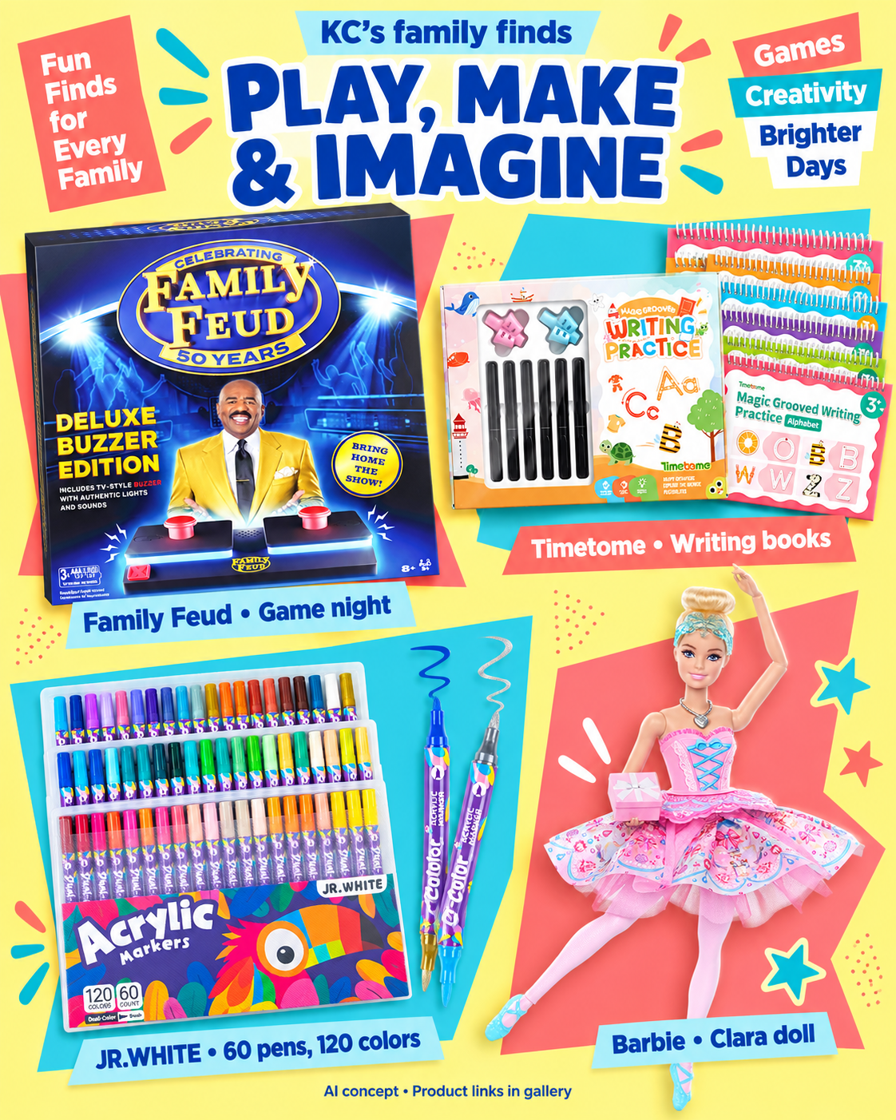
Open the full-size original in Drive

Facebook caption
Ad • I earn commissions from qualifying purchases through these links.
A little game night, a little creativity, a little make-believe. This family-finds board brings together Family Feud, Timetome writing books, JR.WHITE acrylic markers, and Barbie Clara.
Starting a holiday gift list? Take a look at the product details and age guidance to see what fits your family.
Browse the Family Fun Finds collection: [FAMILY_FB_AFFILIATE_URL]
AI-assisted product collage; see listings for exact product details.

Instagram caption
Ad • I earn commissions from qualifying purchases through these links.
Game night or craft time? This board has a little of both, plus writing books and a Barbie Clara doll for the gift list.
Find the products in Family Fun Finds through my profile link. Check the individual listings for details and age guidance.
#FamilyFinds #GiftIdeas #GameNight
AI-assisted product collage; see listings for exact product details.
Before publishing Check age guidance product by product. The marker listing describes an adult craft product; do not present the whole board as suitable for young children.

Post 02 Everyday home organization
Friday October 9 2026 | Proposed collection: Everyday Home Finds
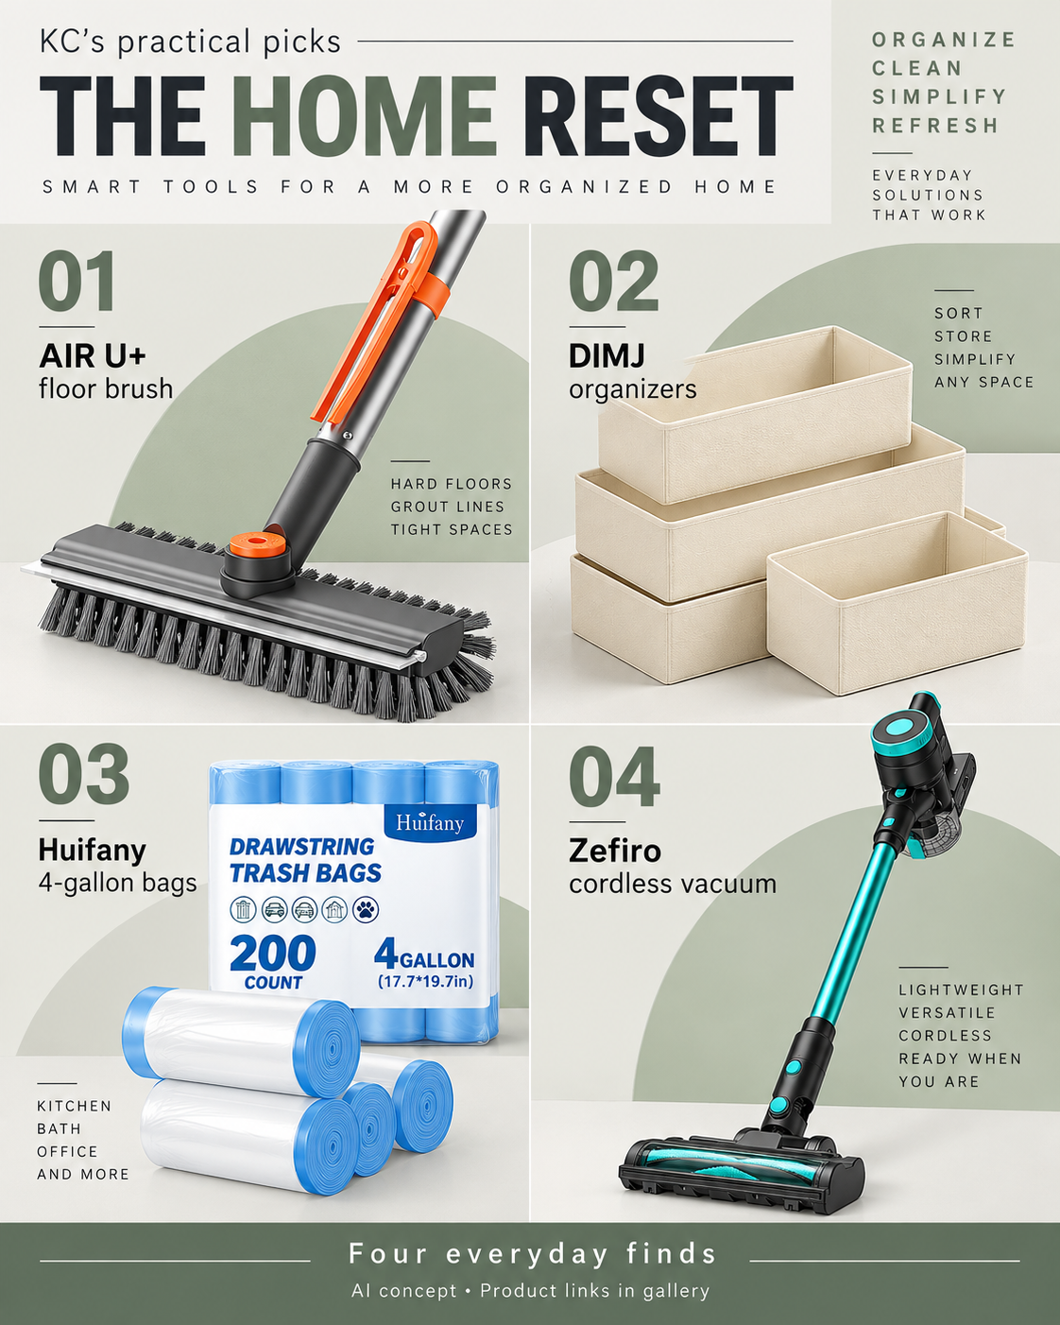
Open the full-size original in Drive

Facebook caption
Ad • I earn commissions from qualifying purchases through these links.
For the next little home reset: drawer organizers, a floor brush, small-bin bags, and a cordless vacuum, all in one place.
The board features DIMJ, AIR U+, Huifany, and Zefiro. Check the listings for dimensions, pack sizes, and product details before choosing what works for your space.
Browse Everyday Home Finds: [HOME_FB_AFFILIATE_URL]
AI-assisted product collage; see listings for exact product details.

Instagram caption
Ad • I earn commissions from qualifying purchases through these links.
The next home reset can start with one drawer. This board gathers organizers and cleaning finds from DIMJ, AIR U+, Huifany, and Zefiro.
Find Everyday Home Finds through my profile link, with the details for each item.
#HomeFinds #HomeOrganization #EverydayFinds
AI-assisted product collage; see listings for exact product details.
Before publishing Match each drawing to the exact listing variant and verify the existing image claims, including floor suitability and vacuum descriptors. Replace unsupported artwork text before publishing.

Post 03 Fall weekend ideas
Monday October 12 2026 | Proposed collection: Fall Weekend Finds
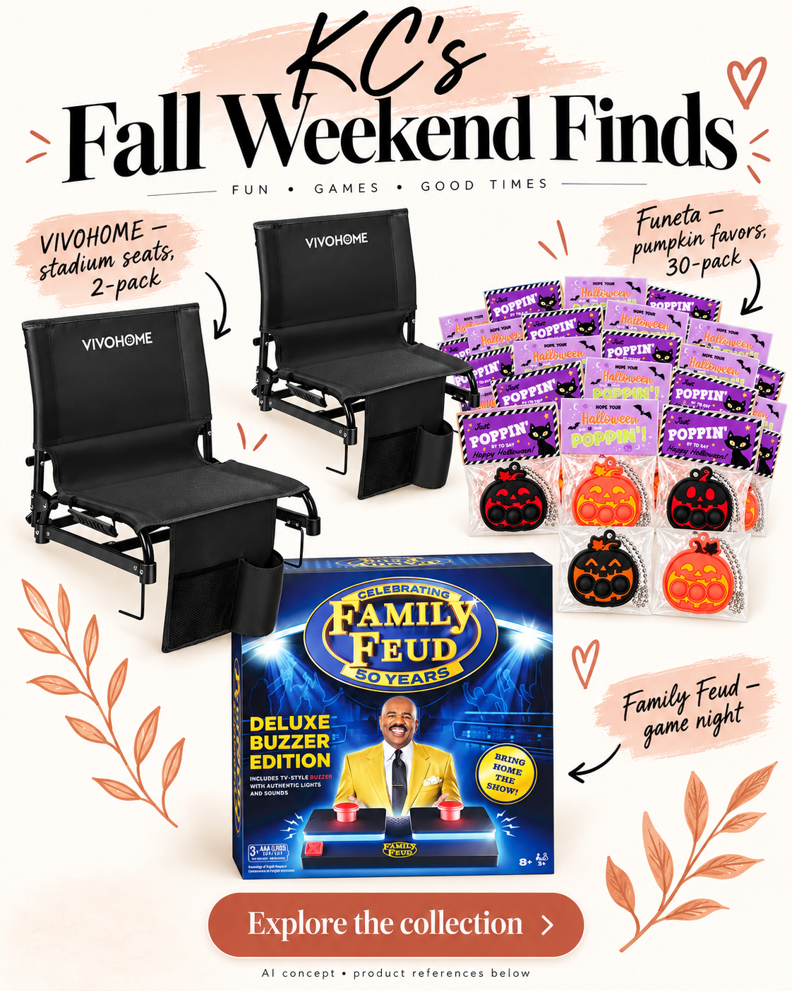
Open the full-size original in Drive

Facebook caption
Ad • I earn commissions from qualifying purchases through these links.
Fall weekends have a way of filling up: a game on the calendar, Halloween plans, and a night in with the family.
This board brings together VIVOHOME stadium seats, Funeta pumpkin favors, and Family Feud. Browse the listings for sizes, age guidance, and delivery estimates for your plans.
Explore Fall Weekend Finds: [FALL_FB_AFFILIATE_URL]
AI-assisted product collage; see listings for exact product details.

Instagram caption
Ad • I earn commissions from qualifying purchases through these links.
Sideline plans, pumpkin favors, and a game night in. Three ideas for the fall calendar, gathered in one board.
Find Fall Weekend Finds through my profile link for the VIVOHOME seats, Funeta favors, and Family Feud game.
#FallFinds #GameNight #FamilyWeekend
AI-assisted product collage; see listings for exact product details.
Before publishing Confirm the favors match the pictured pack and check age guidance and delivery timing. Keep the caption seasonal; do not add a sale deadline without a current offer check.

Product links and final asset preparation
These Amazon links identify the products from the October 1 catalog. They are untagged reference links, not finished affiliate links. Build each named collection with the matching items, then generate Casey’s own link. Five listing titles were matched in retrieved Amazon pages; all ten still need a current variant, availability, and image check.
Collection | Product | Amazon reference
Family Fun Finds | Family Feud Deluxe Buzzer Edition | B0GGV5TZD6
Family Fun Finds | Timetome reusable writing books, 6-pack | B0H2LQX7BK
Family Fun Finds | JR.WHITE acrylic markers, 120 colors in 60 pens | B0FGD7P7K9
Family Fun Finds | Barbie in the Nutcracker Clara doll | B0G441JJWG
Everyday Home Finds | AIR U+ 4-in-1 small floor brush, gray | B0H4R3KP4Y
Everyday Home Finds | DIMJ fabric drawer organizers, beige 20-pack | B0F2238Q26
Everyday Home Finds | Huifany 4-gallon drawstring bags, white unscented 200-count | B0GYWDKK58
Everyday Home Finds | Zefiro 580W cordless vacuum, green | B0H7T2R9KN
Fall Weekend Finds | VIVOHOME ultra-compact stadium seats, black 2-pack | B0G3SWVSW5
Fall Weekend Finds | Funeta Halloween pumpkin Pop Its, 30-pack | B0F4JPWZZR
Fall Weekend Finds | Family Feud Deluxe Buzzer Edition | B0GGV5TZD6

Finish the image text
The three existing boards are included unchanged as review assets. Replace their gallery/reference footers before publishing: use “AI-assisted product collage • Affiliate links in caption” on Facebook and “AI-assisted product collage • Shop through profile link” on Instagram. The drawn buttons are decorative, so the caption must tell people where to click.
Compare AI-rendered products, pack counts, labels, colors, and performance wording with the exact listings. If a product drawing is inaccurate, use an accurate image Casey has permission to use. Casey should not describe an item as tested or a favorite unless that reflects her experience. [5]
Source batch: October 1 shortlist
Asset library: Casey review gallery | Drive originals

Measurement and launch checks
Run the first batch as a small test. On day 7 check that the posts and links work and record early engagement. Review clicks and purchases again after 14 days; extend the observation period if traffic is too low to judge.
Use account-generated tracking IDs to distinguish Facebook from Instagram where the chosen linking tool supports them. Record the actual IDs used. A shared storefront URL may not separate performance by post; do not claim post-level sales attribution unless the reports support it. [4]
Record | How to use it
Post and link | Date, platform, category, published URL, destination and actual tracking ID.
Reach and response | Reach, saves and available outbound clicks. Compare like-for-like platform measures.
Amazon results | Reported clicks, ordered items and commissions, with the reporting date and window.
Next decision | Improve the destination when people click without ordering; revisit the hook or audience fit when reach produces few clicks. Low traffic is inconclusive.

Before the first scheduled post
☐ Correct Page and Instagram account confirmed; Casey and Sofía can perform their agreed roles.
☐ Profile bio contains the Associate statement; disclosures remain visible near the recommendation. [1, 5]
☐ Every placeholder is replaced with a generated, checked affiliate destination.
☐ Product artwork and final caption are reviewed together; no unverified prices, offers, or firsthand claims.
☐ Mobile preview and timezone checked; each scheduled post appears in the calendar.

Sources for the publishing plan
1 Amazon disclosure guidance
2 Amazon SiteStripe link generation
3 Amazon website list updates
4 Amazon tracking IDs
5 FTC Disclosures 101 for Social Media Influencers
6 Meta for Business scheduling tutorial
Checked October 6, 2026. Amazon help pages are undated; FTC guidance is dated November 2019; the Meta tutorial is dated September 9, 2022. Use the tutorial for the scheduling workflow and verify current account controls during setup. Commission eligibility depends on Casey’s account and qualifying purchases; this plan makes no earnings guarantee.

